Discovering Informal Learning Cultures of Blind Individuals Pursuing STEM Disciplines

A Computational Ethnography Using Public Listserv Archives

JooYoung Seo

2021-05-26

Table of Contents

Abstract 4

1 Introduction 5

1.1 Background and Importance of the Topic 5

1.2 Research Problem: A Knowledge Gap 6

1.3 Purpose of the Study 9

1.4 Research Questions 11

1.4.1 Quantitative Research Questions 11

1.4.2 Qualitative Research Questions 12

1.4.3 Hybrid Mixed Methods Question 13

1.5 Significance and Value of the Study 13

1.6 Possible Study Limitations 14

1.7 Chapter Summary 15

2 Literature Review 16

2.1 Introduction 16

2.2 What is STEM? 16

2.3 Growing Trends of STEM Learning 19

2.4 Theoretical Frameworks 24

2.4.1 Ecological Model of STEM Education 25

2.4.2 Political/Relational Model of Disability 26

2.4.3 Sociocultural Perspective towards Collaborative Shared Cognition 27

2.5 Three Issues in Current STEM Education: Equity; Inclusivity; and Accessibility 29

2.5.1 Equity Issue of Gendered Disparity 29

2.5.2 Inclusivity Issue of Ethnic/Racial Diversity 31

2.5.3 Accessibility Issue of Discriminating Dis/Abilities 32

2.6 Overview of Computer-Assisted Text Analysis 34

2.6.1 Deductive Text Classification Using Supervised Machine Learning 37

2.6.2 Inductive Text Clustering Using Unsupervised Machine Learning 37

2.6.3 Abductive Text Interpretation Using Structural Topic modeling 39

2.7 Chapter Summary 43

3 Methods 43

3.1 Introduction 43

3.2 Research Design 44

3.3 Research Ethics and Procedures 46

3.4 Research Questions 48

3.4.1 Quantitative Research Questions 49

3.4.2 Qualitative Research Questions 50

3.4.3 Hybrid Mixed Methods Question 50

3.5 Setting and Sample 51

3.6 Positionality 52

3.7 Data Collection 52

3.7.1 Computational Participant-Observation 52

3.7.2 Semi-Structured Interviews 57

3.8 Data Analysis Procedure 60

3.8.1 Phase I: Data Extraction 62

3.8.2 Phase II and III: Data Cleaning and Transformation 63

3.8.3 Phase IV: Text Mining 67

3.8.4 Phase V: Results Evaluation and Interpretation 71

3.9 Chapter Summary 72

4 Research Findings 73

4.1 Introduction 73

4.2 Results from the Computational Participant-Observation 73

4.2.1 Descriptive Questions 73

4.2.2 Semantic Network Questions 89

4.2.3 Data Clustering Questions 114

4.3 Findings from Semi-Structured Interviews 126

4.3.1 Self-Directed Learning Over Lectures 126

4.3.2 Linear Verbal Learning 129

4.3.3 Positive Attitudes 133

4.4 Comprehensive Results 136

4.4.1 Mixed RQ: What results emerge from comparing the qualitative interviews about the STEM-learning experiences of blind individuals with the computational outcomes derived from the STEM-oriented listservs? 137

4.5 Chapter Summary 143

5 Discussion and Conclusions 144

5.1 Introduction 144

5.2 Discussions and Implications 144

5.2.1 Disconnected Mesosystem 145

5.2.2 Limited Modality of Current Assistive Technologies 146

5.2.3 Lacking Central Resources 147

5.3 Conclusions 148

5.3.1 Summary and Contribution 148

5.4 Suggestions for Future Research 151

5.5 Acknowledgements 152

Appendix 152

6 Determination Letter from the Office for Research Protections 152

7 The National Federation of the Blind (NFB) Materials 156

7.1 Contact with a Gatekeeper of the NFB Community 157

7.2 Research Participant Solicitation Request Form 159

7.3 Official Approvals from the NFB Research Advisory Council 173

8 Interview Materials 175

8.1 Recruitment Materials 176

8.2 Interview Consent Form 179

8.3 Semi-Structured Interview Protocol 183

9 Interview Transcripts 186

9.1 Participant 1 186

9.2 Participant 2 213

9.3 Participant 3 233

9.4 Participant 4 255

9.5 Participant 5 278

9.6 Participant 6 303

9.7 Participant 7 338

9.8 Participant 8 363

10 Unix Shell Commands for Data Extraction 379

11 R Script Used for Text Mining 380

12 R Script Used for Data Cleaning and Transformation 383

13 Supplementary Tables 385

13.1 Table for Term Frequency-Inverse Document Frequency 385

13.2 Tables for Co-Occurrence Network Analysis 388

13.3 Tables for Correlation Network Analysis 399

13.4 Tables for Bigram Network Analysis 407

13.5 Tables for Structural Topic Models 414

14 R Source Code Used for Data Analyses 469

14.1 Customized helper functions 469

References 523

# Abstract

Over the past decade, the importance of Science, Technology, Engineering, and Mathematics (STEM) subjects has received a lot of research attention in formal and informal learning settings. Despite the comprehensive need for STEM literacy and its positive effect on learning, students with disabilities who are increasingly participating in regular classrooms experience significant difficulties in STEM; blind students, in particular, have become even more disenfranchised with the visually-oriented STEM practices. While several attempts have been made to address STEM accessibility issues for the blind, existing studies have been primarily limited to either usability field test or special curriculum design from a top-down approach taken by researchers with little attention devoted to bottom-up research where the lived experiences of blind STEM learners, as central storytellers, are naturally portrayed to yield their own challenges and shared cultures. This study aims to discover collective knowledge sharing patterns and informal learning cultures of blind individuals pursuing STEM disciplines as captured through computer-mediated mailing listservs. Using the National Federation of the Blind Mailing List, which is one of the world’s largest online mailing communities for the blind, this research conducts longitudinal computational ethnography for the four STEM-oriented listserv archives in the public domain (i.e., NFB-Science and Engineering; Computer Science; Artists-Making-Art; BlindMath) between January 2009 and December 2019 to develop a comprehensive understanding of learning experiences voiced by blind individuals. Throughout this study across a total of 24858 messages, the following primary research question will be investigated: What are the sociocultural characteristics of collective knowledge-sharing patterns produced by blind learners pursuing STEM disciplines? The findings of this dissertation study should make an important contribution to the field of Learning Sciences by discussing “How Blind People Learn STEM” and “How a Blind Learning Scientist Researches” through rigorous, reliable, and reproducible methods offered by computational ethnography, where computer-assisted text analysis and humanistic deep interpretation complement each other.

# 1 Introduction

## 1.1 Background and Importance of the Topic

Over the past decade, the importance of Science, Technology, Engineering, and Mathematics (STEM) education has received considerable research attention in formal and informal learning settings. Although the actual definition of STEM education and the consensus of the extent of the subjects’ interconnectedness still remains unclear (D. Bell, 2016; J. Brown, 2012; Capraro et al., 2013; Hwang & Taylor, 2016; A. Roberts, 2013), it is now generally accepted that recent STEM education, as a dynamic process that changes over time, represents the purposeful integration either between the four subjects or with various other disciplines (e.g., languages; designs; the arts) whereby learners are engaged into solving real-world problem practices (Breiner et al., 2012; Labov et al., 2010; Sanders, 2009).

STEM has many implications for current learning systems. From a broader global view, for example, traditional manufacturing jobs have quickly been replaced with careers demanding an applied STEM knowledge in many countries to secure economic prosperity (Basham & Marino, 2013; D. Bell, 2016; Kaku, 2012). Hwang & Taylor (2016), on the other hand, argue, “knowledge in STEM helps students to live a better quality of life because STEM is fully embedded in daily life situations” (p. 40). In fact, recent years have witnessed traditional lecture-based teaching strategies increasingly replaced with more project-based learning design (Breiner et al., 2012) to foster inquiry-driven nature, which in turn enhances high-order thinking, such as fundamental scientific, quantitative, and critical thinking skills, moving beyond low-level cognitive tasks (e.g., recalling facts in isolation) (Basham & Marino, 2013; Beck-Winchatz & Riccobono, 2008).

Taken all together, as Zollman (2012) claims, being STEM proficient can address not only societal, but also personal needs for a fulfilled citizenry in an increasingly global economy (Hughes, 2010; Hwang & Taylor, 2016).

## 1.2 Research Problem: A Knowledge Gap

Despite this comprehensive need for STEM literacy, students with disabilities, who have been increasingly participating in regular classrooms with the legislative support for equal access to general education (Rao et al., 2014; K. D. Roberts et al., 2011), experience significant difficulties in STEM (Israel et al., 2013). Students with disabilities continuously perform below their peers without disabilities on standardized measures in STEM subjects (Basham & Marino, 2013; Hwang & Taylor, 2016; Israel et al., 2013), and often fall behind in STEM content since middle school (Israel et al., 2013; Marino, 2010). This disengagement has led to a rare presence of those with disabilities in the STEM workforce as only about 5 percent of students with disabilities enter STEM careers (Leddy, 2010). However, a few studies have pointed out the struggles come primarily from the dearth of accessible teaching materials, inclusive curricula, and experiences of instructors teaching students with disabilities rather than students’ disabilities themselves (Basham & Marino, 2013; Martin et al., 2011; Thurston et al., 2017). Martin et al. (2011) argue, “In order to be afforded equal opportunity, especially in STEM fields, people with disabilities must be able to work their way through multiple barriers” (p. 295). This implies that more inclusive STEM materials and scaffolding learning designs are imperative for students with disabilities to fully engage with STEM content so that students are not left with all the responsibilities for their own STEM frustration (Basham & Marino, 2013; Samsonov et al., 2006; Thurston et al., 2017).

While each individual with disabilities still lacks accessible STEM curricula, blind students, in particular, experience extra challenges and have become even more disenfranchised with STEM subjects (Beck-Winchatz & Riccobono, 2008; Cryer, 2013; Edwards et al., 2006; Gardner, 2002; Jones et al., 2006; Supalo et al., 2006). According to American Printing House for the Blind (2017), there are approximately 63,657 U.S. children, youth, and adult students in educational settings (between the age of 0 and 21) who are legally blind (i.e., those with central visual acuity of 20/200 or less in the better eye with the best possible correction, or visual field of 20 degrees or less). Globally, there are approximately 1.3 billion people with some varying degree of visual impairments, and 36 million of whom are blind (i.e., visual acuity worse than 3/60, World Health Organization, 2018). These people have consistently faced the following issues when engaging with STEM content. First, material accessibility issue. As STEM materials and curricula are designed in ways that heavily rely on visual models, those who cannot employ visual sense for their learning encounter rudimentary barriers in accessing such information unlike sighted counterparts (Beck-Winchatz & Riccobono, 2008; Cryer, 2013). Second, instructional inclusivity issue. Teachers and instructors in the general education system are often unfamiliar with non-visual teaching methods for STEM content, which keeps unintentionally marginalizing their blind students in classes (Beck-Winchatz & Riccobono, 2008; Fraser & Maguvhe, 2008; Gardner, 2002). Third, networking issue. As blind students have increasingly become integrated into regular classrooms with the support of legislation advocating for equal access for all (e.g., Individuals with Disabilities Educational Act, 1997, 2004; Americans with Disabilities Act, 1990; Sections 504 (1973) and 508 (1998) of the Rehabilitation Act), they are frequently the only non-visual learners in classes. In other words, they lack natural opportunities to meet blind peers or adults who can possibly serve as role models to inspire them to develop confidence in STEM subjects (Beck-Winchatz & Riccobono, 2008). Finally, low social and self- expectation issue. Teachers, parents, and blind students themselves do not hold high expectations towards success in STEM areas because of blindness (Beck-Winchatz & Riccobono, 2008; Martin et al., 2011).

In spite of these critical lags behind their sighted counterparts, scant research has been devoted to investigating “How Blind People Learn STEM” in scientific ways with a hasty conclusion that a costly retrofitted change must be required for their special needs (Beck-Winchatz & Riccobono, 2008). Although several valuable attempts have been made to address these issues by initiating organizations (AccessSTEM, n.d.; The National Center for Blind Youth in Science, 2004), offering STEM workshops and programs (Fraser & Maguvhe, 2008; Supalo et al., 2006, 2009), and designing accessible STEM materials (Ferreira & Freitas, 2004; Jones et al., 2006; Karshmer & Bledsoe, 2002; Levy & Lahav, 2012; Singh, 2008) tailored for blind students, these existing studies have primarily relied upon either usability field test (Edwards et al., 2006; Gardner, 2002) or special curriculum design (Supalo et al., 2009) from a top-down approach taken by researchers where blind individuals are regarded as ultimate subjects for evaluating the usefulness of their proposed products and/or instructions. To put it another way, there still remains a paucity of bottom-up research in which the lived experiences of blind STEM learners, as central storytellers, are naturally portrayed to yield their own challenges and shared cultures in greater detail that can deepen our understanding of their learning patterns. Moreover, currently, neither systematically quantitative nor in-depth qualitative data exists that examines what specifically prevents blind individuals from learning STEM disciplines and how they attempt to address these barriers by themselves as blind STEM learners beyond simply being either passive or dependent on others' help. With the support of the Internet and assistive technology (e.g., screen reading software and refreshable braille display hardware), in the meantime, blind individuals all over the world have increasingly become connected to each other, and the mailing list is one of the widely used accessible bridging media between them. In other words, recently much of informal learning and knowledge sharing communications among blind people has been accumulated through computer-mediated mailing list archives, which could provide us with great investigative value.

## 1.3 Purpose of the Study

This study is proposed to discover such collective knowledge sharing patterns and informal learning cultures of blind individuals pursuing Science, Technology, Engineering, and Mathematics (STEM) disciplines as captured through computer-mediated mailing listservs. Using the world’s largest online mailing lists for the blind (National Federation of the Blind Mailing Lists, n.d.), this research will conduct computational ethnography (Abramson et al., 2018; Zheng et al., 2015) for the four STEM-oriented listserv archives in the public domain (i.e., NFB-Science and Engineering; Computer Science; Artists-Making-Art; BlindMath) between January 2009 and December 2019 to develop a comprehensive understanding of learning experiences voiced by blind individuals.

More specifically, a total of 24858 messages (2099 messages from Science & Engineering; 13199 NFB in Computer Science; 382 Artists-Making-Art; 9178 BlindMath) will be collected and analyzed throughout this study. This is, to my knowledge, one of the largest corpora of texts where blind individuals describe their stories, challenges, and solutions for STEM learning experiences in their own words at a community level (National Federation of the Blind, n.d.) that has not been fabricated by any third-party researcher(s). However, this text-as-data research requires its unique analytical procedures that may differ from other traditional or singular quantitative or qualitative approaches. For example, conventional quantitative methods, which take either numerical or predefined-categorical variable(s) for its analyses, cannot be readily applied to this unstructured text data. On the other hand, it is logistically infeasible for either a single or even multiple researcher(s) to qualitatively read and code all of the 10-year text communications in a reasonable timeframe with a reliable consistency (Nelson et al., 2018; M. E. Roberts et al., 2013).

This study, thus, will employ the concept of computational ethnography defined as using both computer-assisted algorithms and humanistic deep interpretation to explore a meaningful discovery out of a large amount of textual data (Zheng et al., 2015). Computational ethnography is one of the recently developed mixed methods in which exploratory data science techniques (e.g., descriptive analysis; clustering analysis; social network analysis; relational analysis) are applied to a large-scale (or more, big data sized) corpora of texts and employed to help researchers uncover meaningful patterns of the target data in the least intrusive fashion which would otherwise be infeasible to analyze with conventional qualitative approaches (Abramson et al., 2018; Moore et al., 2020; Zheng et al., 2015). In other words, typical computational ethnography study involves descriptive and syntactical pattern discovery assisted by computer algorithms first, then followed by researcher’s deep interpretation of the detected patterns to relate it to semantical explanation, and this mixed-method interaction between data-driven computation and context-driven interpretation iteratively contributes to one another until a comprehensive understanding of the data is saturated (Nelson, 2017; David Williamson Shaffer, 2017). This novel methodology, therefore, requires both computer skills to control algorithms in a technological manner and deep understanding of the target subjects to situate the quantified results within a contextual fashion. As a more than 10-year programmer, I have some proven expertise in software engineering and package development in the open-source statistical computing R community (R Core Team, 2019; Seo & Choi, 2019), and at the same time, I, as a blind researcher, have investigated accessibility issues and STEM-related topics for blind learners for several years (Seo, 2018, 2019; Seo & Richard, 2018). Hence, I believe that my background can meet the readiness of this method in some ways.

## 1.4 Research Questions

This study seeks to answer the following research questions.

* Primary RQ: What are the sociocultural characteristics of collective knowledge-sharing patterns produced by blind learners pursuing STEM disciplines?

The primary research question can be broken down into several sub-questions which are listed below:

### 1.4.1 Quantitative Research Questions

Firstly, as a bird-eye view approach, the following data-driven research questions are explored in order to guide the overall question systematically.

#### 1.4.1.1 Descriptive Questions

* Quan RQ1.1: What are the frequency and variation patterns of collective knowledge participations of members in the target mailing listservs between January 2009 and December 2019?
* Quan RQ1.2: What are the top-10 most participated topics among members found in the target online listservs?
* Quan RQ1.3: What are the most salient words in each of the four target listservs?

#### 1.4.1.2 Semantic Network Questions

* Quan RQ2: What are the semantic network patterns found in each of the four target listservs?
  + Quan RQ2.1: What are the most common co-occurring words in each mailing list?
  + Quan RQ2.2: What are the most correlated words in each mailing list?
  + Quan RQ2.3: What are the most common bigrams (a pair of two words) in each mailing list?

#### 1.4.1.3 Data Clustering Questions

* Quan RQ3.1: What are estimated latent topics across all of the four target mailing lists calculated by Structural Topic Models? (simply stated, What kinds of conversations are provoked across all of the four NFB mailing lists?)
* Quan RQ3.2: In what ways are the estimated structural topics correlated with each other?
* Quan RQ3.3: How does the rate of topics (i.e., topical prevalence) change over time?
* Quan RQ3.4: How do these topical distributions (detected from RQ3.1) vary by the four types of the NFB mailing lists?
* Quan RQ3.5: How do the detected topical distributions vary by the type of mailing lists over time?

### 1.4.2 Qualitative Research Questions

Secondly, the following research questions are addressed based on the semi-structured interviews with the members (i.e., informants) of the NFB STEM-oriented mailing lists.

* Qual RQ1: What are the common STEM-related issues of blind learners?
* Qual RQ2: What strategies are utilized by blind individuals to pursue STEM disciplines

### 1.4.3 Hybrid Mixed Methods Question

At the end, the following research question is answered by combining the quantitative and qualitative research findings.

* Mixed RQ: What results emerge from comparing the qualitative interviews about the STEM-learning experiences of blind individuals with the computational outcomes derived from the STEM-oriented listservs?

## 1.5 Significance and Value of the Study

The findings of this dissertation study should make an important contribution to the field of the Learning Sciences in the following ways. Firstly, this scientific investigation of “How blind people learn STEM” can bring meaningful discussion points to the field. Although “How *People* Learn” should be applied to any inquiries of the Learning Sciences, current scholarly efforts in the field have been largely devoted to learning improvements from and for so-called able-bodied viewpoints. In other words, the field has yet neglected to extend the scope of learners across dis/abilities while leaving the topic for special education. This dissertation will serve not only to shed light on a blind spot of the separation between general VS. special education paradigm, but also to draw holistic attention of researchers, practitioners, policy makers, curriculum developers, and others towards the need for inclusive STEM learning ecology where sighted and blind learners are all taken into account under the fundamental question of “How People Learn.” Secondly, the research can suggest a novel methodology to investigate large corpora of texts in rigorous, reliable, and reproducible ways. Drawing upon analytical procedure of the five phases of “Knowledge Discovery in Textual Databases” [KDT; Feldman & Dagan (1995)] combined with the three-step “Computational Grounded Theory” (Nelson, 2017), this study will detail each phase of the proposed investigative phenomenon, which is often an underexplored approach in traditional qualitative research, to offer the readers reproducible trustworthiness across the study holistically. Finally, this dissertation can describe how a blind learning scientist researches. Unlike either special education or social welfare fields, finding a researcher who is blind is quite rare. Moreover, little is known about the challenges and solutions of a blind person from a researcher’s perspective going beyond study subjects. I, as a lifelong blind person myself, will self-report on how I research from data collection to analysis throughout this study to inspire other sighted and blind learning scientists to look into non-visual techniques in the field where video-based interaction analysis is dominant.

## 1.6 Possible Study Limitations

It should be advised, however, the data that this research deals with cannot represent all blind individuals in the world despite its popularity since: (1) the target listservs only allow English-speaking membership communications which cannot reflect any voices of blind learners who use different languages; (2) some technologies discussed among the members are not available in all countries; and (3) it is hard to retrieve the members’ demographic information, which might have effects on their STEM learning phenomenon, due to the anonymous identity of public email data. Therefore, a full discussion of the study generalizability lies beyond the scope of this study.

## 1.7 Chapter Summary

This chapter has covered some backgrounds and purposes of the dissertation study. Although STEM literacy has become increasingly needed and important, those who are blind or visually impaired are unintentionally disenfranchised within this 21st-century ethos. Several attempts have been made to address STEM accessibility issues for the blind. Yet existing studies have been limited primarily either to usability field testing or to special curriculum design, in the top-down approach taken by researchers. Little attention has been devoted to bottom-up research, where the lived experiences of blind STEM learners, as central storytellers, are portrayed naturally as yielding their own challenges and shared cultures.

This dissertation study aims to discover such collective knowledge sharing patterns and informal learning cultures of blind individuals pursuing STEM disciplines as captured through the National Federation of the Blind Mailing Lists (n.d.).

Utilizing computational ethnography (Abramson et al., 2018; Zheng et al., 2015) that combines data-driven computation and context-driven humanistic interpretation of a large corpus, I as a blind learning scientist will investigate “How blind people learn STEM” and detail “How a blind learning scientist researches.”

The findings of this dissertation study should make an important contribution to the field of the Learning Sciences by shedding light on understudied subject topic, methodological implication of computational ethnography, and scholarly journey of a blind researcher towards an inclusive STEM learning ecology.

# 2 Literature Review

## 2.1 Introduction

This chapter is devoted to outlining some definitions and related literature underpinning this study. There are two lines of literature that this study rests upon. First concerns STEM education; second involves computer-assisted text analysis.

The former, as a content-oriented review, covers the definition, theoretical and pedagogical backgrounds, and existing issues of STEM education in general (see Chapter 2.2 through 2.5). The latter, on the other hand, is method-oriented. This walks through some methodological backgrounds that this research employs (see Chapter 2.6).

## 2.2 What is STEM?

At the outset, what we mean by “STEM” should be defined. A search of the literature from the past 10 years yields that the term “STEM” was first used as a government arrangement, particularly from inside the National Science Foundation (NSF) (Breiner et al., 2012). In the early 1990s, NSF originally utilized the acronym SMET (Science, Mathematics, Engineering, and Technology) to refer to the career areas in those disciplines or educational modules that coordinate information and abilities from those areas. In 2001, however, the term was rearranged to “STEM” (i.e., Science, Technology, Engineering, and Mathematics curriculum) by Judith Ramaley, a former director of education and human resources at NSF to avoid “issues of vulgarity” (Breiner et al., 2012; Christenson, 2011; Sanders, 2009). While Ramaley (2011) originally employed the term to develop a coherent, not necessarily integrated, curriculum where “science and mathematics served as *bookends* for technology and engineering” (as cited in Christenson, 2011, emphasis added), some still follow this initial stance by defining “STEM” as separate knowledge bases (R. L. Bell & Lederman, 2003; Clough, 2000); others perceive the concept as “the generic label of a higher category spanning four areas” (Hwang & Taylor, 2016, p. 39) across various disciplines (Kaufman et al., 2003; Morrison, 2006).

Although the actual definition of STEM education and the consensus of the extent of their interconnectedness still remain unclear parameters (D. Bell, 2016; J. Brown, 2012; Capraro et al., 2013; Hwang & Taylor, 2016; A. Roberts, 2013), it is now generally accepted that recent STEM education, as a dynamic process that changes over time, represents the purposeful integration either between the four subjects or with various other disciplines (e.g., languages; designs; the arts) whereby learners are engaged into solving real-world problem practices (Breiner et al., 2012; Labov et al., 2010; Sanders, 2009). For example, NSF characterizes STEM areas broadly, “including not only the common categories of mathematics, natural sciences, engineering, and computer and information sciences, but also such social/behavioral sciences as psychology, economics, sociology, and political science” (as cited in Breiner et al., 2012, p. 4). In a similar vein, Sanders (2009), one of the leading scholars in STEM education, defines the scope of STEM as follows: “STEM education includes approaches that explore teaching and learning *among any two or more* of the STEM subject areas, and/or *between* a STEM subject and *one or more* other school subjects” (p. 21, emphasis added). Likewise, recently many scholars posit that STEM does not have to be bounded by the four subjects; rather, other disciplines such as the Arts, linguistics, and designs can be integrated with them to better cultivate our problem-solving skills (Christenson, 2011; Heil et al., 2013; Hwang & Taylor, 2016; Kaufman et al., 2003; Zollman, 2012). In sum, as Breiner et al. (2012) stated, “the notion of integration” might be “the most important modern conception of STEM education” (p. 5). Taking this broader viewpoint, in what follows, I will use the term STEM not only to mean the “symbiotic relationship among the four interwoven fields” (Basham & Marino, 2013, p. 9), but also “the purposeful integration” with various other disciplines such as languages, designs, and the arts whereby learners are engaged into solving real-world problem practices (Breiner et al., 2012; Labov et al., 2010; Sanders, 2009).

STEM has many implications for current learning systems. From a broader global view, for example, STEM literacy has been increasingly recognized as being critical for current and future workforce ecologies. Traditional manufacturing jobs have quickly been replaced with careers demanding an applied STEM knowledge in many countries to secure economic prosperity (Basham & Marino, 2013; D. Bell, 2016; Kaku, 2012). According to the U.S. Department of Education (2015), nearly 62 percent of the fastest growing jobs require proficient STEM-related knowledge or skills (Basham & Marino, 2013; Hwang & Taylor, 2016; Kaku, 2012). Breiner et al. (2012) describes as to how this global trend can lead to reshaping education, as follows:

As the federal government has made STEM a top priority in funding, multiple agencies have been vying for these dollars. Programs have been established as joint ventures between various agencies within government, business, institutions of higher education (IHE), parents, and existing K-12 school systems. (p. 3)

Besides the importance of STEM from a global perspective, on the other hand, STEM education possesses valuable impacts on teaching and learning (Hwang & Taylor, 2016). Zollman (2012) highlights we should “move from *learning for STEM literacy* to *the ability to use STEM literacy* for continued learning” beyond defining STEM education (p. 18, emphasis added). Following his emphasis on the need for “STEM literacy,” Hwang & Taylor (2016) argue, “knowledge in STEM helps students to live a better quality of life because STEM is fully embedded in daily life situations” (p. 40). In fact, recent years have witnessed traditional lecture-based teaching strategies have been increasingly replaced with more project-based learning design (Breiner et al., 2012) to foster inquiry-driven nature, which in turn enhances high-order thinking, such as fundamental scientific, quantitative, and critical thinking skills, moving beyond low-level cognitive tasks (e.g., recalling facts in isolation) (Basham & Marino, 2013; Beck-Winchatz & Riccobono, 2008). Taken all together, as Zollman (2012) claims, being STEM proficient can address not only societal, but also personal needs to be a fulfilled citizenry in an increasingly global economy (Hughes, 2010; Hwang & Taylor, 2016).

## 2.3 Growing Trends of STEM Learning

Since the early 2000s when Judith Ramaley coined the term “STEM” (Christenson, 2011), there has been burgeoning research on how to foster such connected learning across STEM content more effectively through innovative tools, curriculum and instructional designs (D. Bell, 2016; R. L. Bell & Lederman, 2003; Breiner et al., 2012; J. Brown, 2012; Capraro et al., 2013; Heil et al., 2013). In order to identify this emerging trend in a holistic and scientific manner, I have conducted a bibliometric analysis (i.e., bibliometrics).

Bibliometrics is a method to summarize scientific publications by measuring certain metadata variables with quantitative statistics (Aria & Cuccurullo, 2017; Thelwall, 2008). Some typical results that bibliometrics can reveal include: growth of papers by year and citations, rankings of most prolific contributors, authorship patterns, rankings of geographical distribution of authors, rankings of most productive institutions, collaboration among institutions, range and percentage of references per paper, and frequency distribution of subject descriptors (Gireesh et al., 2008; Hung, 2012). As its capability of quantifying a large collection of articles can depict research performance evaluation (e.g., growth; maturity; leading authors; conceptual and intellectual maps; and trends of a scientific community), this method has been increasingly employed by policymakers, university and government labs, research directors and administrators, information specialists and librarians, and scholars (Aria & Cuccurullo, 2017).

As of 10:37 AM 7/28/2019, a total of 604 articles were retrieved from the Clarivate Analytics Web of Science database (<http://www.webofknowledge.com>) using the following search query conditions:

* Search Query: AB=("stem education" OR "stem learning") AND LA="english" AND DT="article"
* Language: English
* Document Type: Article
* Timespan: All years
* Indexes: SCI-EXPANDED, SSCI, A&HCI, CPCI-S, CPCI-SSH, BKCI-S, BKCI-SSH, ESCI, CCR-EXPANDED, IC

Using an open-source Statistical language environment R [Version 4.1.0; R Core Team (2019)] and “bibliometrix” package (Aria & Cuccurullo, 2017), I have conducted the following three analyses with the collected metadata: (1) Annual scientific growth by year; (2) Country scientific production by authors’ affiliation; and (3) Conceptual structure with wordcloud and multiple correspondence analysis.

As illustrated in Figure 2.1, there have been rising publications in regards to STEM within learning discourse, and this trend, although western countries are dominant, can also be seen globally (Figure  
2.2).

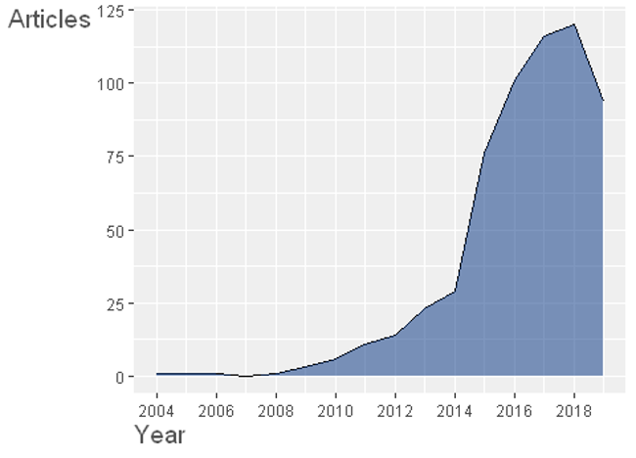

Figure 2.1: Annual scientific production chart of 604 articles on STEM learning and STEM education.

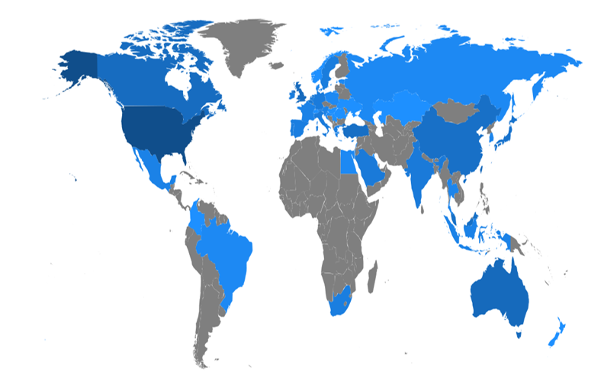

Figure 2.2: Country scientific production chart drawn from authors’ affiliation information.

Figure 2.3, a wordcloud based on Keywords-Plus of each article, illuminates that Science and Math education, in particular, play a central role in STEM education to engage students with high performance in inquiry-based instructions using technology-enhanced design. A conceptual structure map made by multiple correspondence analysis of the most top-20 cited articles with five clusters further depicts this paradigm in detail (see Figure 2.4). While the cluster results are subject to researcher’s interpretation, I would label them respectively as follows: (1) Inquiry-based learning in higher education; (2) STEM-oriented content components; (3) Curriculum for professional development; (4) Pedagogical relationship between STEM and making (while highlighting equity issues across gender and ethnicity); and (5) Integrated instructional design focusing on collaborative project-based learning experience.

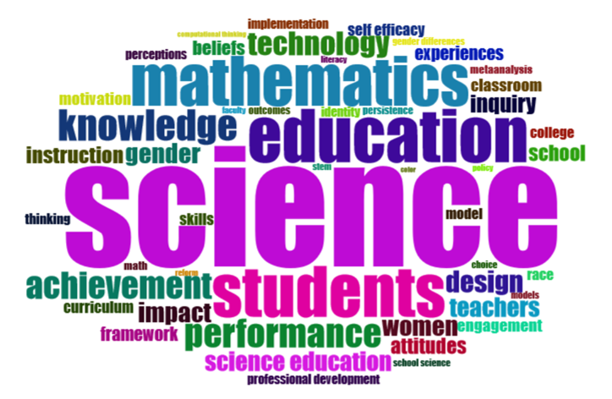

Figure 2.3: A wordcloud made by term frequency of the Keywords-Plus (ID) field of each article.

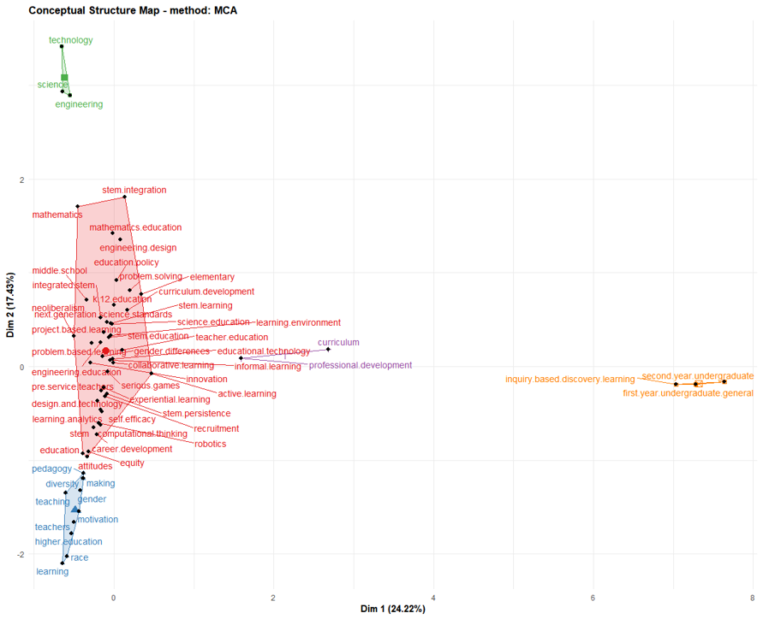

Figure 2.4: A conceptual structure map made by multiple correspondence analysis of the most top-20 cited articles with 5 clusters.

## 2.4 Theoretical Frameworks

There are three lines of theoretical perspectives that this study rests upon. The first is concerned with the viewpoint on STEM education’s interconnectedness and complexity in relation to social, cultural, and political ecosystems. The second is about a critical lens on how a disability can be positioned within a society. The final one is the pedagogical framework explaining how socioculturally learning happens within communities of practice.

### 2.4.1 Ecological Model of STEM Education

Among various perceptions of STEM education, this dissertation, in particular, follows the “Ecological Model of STEM Education” proposed by Basham et al. (2010). Resting upon the four nested ecological model systems (Bronfenbrenner, 1977, 1994) have proposed a framework that offers “more accessible, relevant, and effective instruction in science, technology, engineering, and mathematics (STEM) education to all students” (p. 9) as follows. First, the macrosystem speaks to the social and political goals that drive the instructive needs related to STEM. At the foremost worldwide level, STEM instruction activities reflect the interaction of cultural, financial, and social beliefs, and the political objectives that develop from those convictions. Second, exosystem represents the interconnected systems influencing the student; however, any of these systems does not directly interact with the learner yet (Bronfenbrenner, 1977). According to Basham et al. (2010), “this is where the state, regional, and community impact on STEM is important” (p. 13). Third, mesosystem refers to connections between the systems that impact the student (e.g., the association between the individual’s domestic environment, the school, and the exosystem). All of the systems, at this level, directly impact the learner and are linked with one another. Bronfenbrenner (1994) describes the mesosystem as the complex interaction of different microsystems, the fourth model. This crossing point incorporates components for integrating STEM instruction into different situations such as home, school, and work (Basham et al., 2010). And finally, microsystem that is “characterized by a focus on the student and the interactions the student has with the environment, peers, teachers, and family” (Basham et al., 2010, p. 15). This includes all the connections that are associated specifically with the student as they relate to STEM (Basham et al., 2010). Taken all together, it is not unreasonable to contend that the current STEM education, which is somewhat blurry, should possess complex and nested systems that call for multi-dimensional approaches.

### 2.4.2 Political/Relational Model of Disability

As this dissertation study addresses the relationship between STEM education and visual impairments, a clear perspective on how a disability is defined is required. I rest upon Alison Kafer’s political/relational model of disability, where disability is viewed as a product of social relations (Kafer, 2013). This perspective is in line with the social model of disability (Oliver, 2013) that distinguishes between an impairment (physical, sensory, and cognitive challenge) and a disability, which describes a form of social exclusion perpetuated against people who have impairments.

In the political/relational model of disability, a disability is enacted through structural and environmental factors, not by their impaired bodies (Kafer, 2013; Thomson, 2017). This rejects the medical model of disability which focuses on managing and/or curing the disability until it disappears as much as possible (Hamraie, 2012). Instead of treating disability as dependency or deficit, I take the perspective of disability as social, political, and cultural result (Shakespeare & others, 2006). For instance, in a Deaf community, in which everyone uses sign language, deafness is a source of cultural pride instead of deficit or disability. In a hearing society, on the other hand, hearing impairment is often treated as a disability that requires accommodation through medical intervention (Mankoff et al., 2010; Novak & Sakakeeny, 2020).

In a similar vein, blindness may not be perceived as a disability in a society where and when non-visual communications and tools (e.g., Braille and screen readers) are readily accessible. However, visual impairment becomes a critical disability and barrier in a visually extensive environment. Given that many STEM classes are visually standardized, I assume that blind people may face “disabilities” beyond their impairments in such environments. Throughout the study, I will look into how a disability is perpetuated in STEM learning context against blind people.

### 2.4.3 Sociocultural Perspective towards Collaborative Shared Cognition

As a pedagogical framework, I subscribe to sociocultural perspective that explains learning as a situated and constructive process within social and cultural contexts. Sociocultural perspective is recognized as its fundamental contribution to shared cognition in STEM education where collaboration plays a central role.

Sociocultural perspective, although it takes a wide range of forms of variations, is originally based on Vygotsky’s social constructivism (Vygotsky, 1980). He differentiated his theories from Piaget’s cognitive constructivism by highlighting social and cultural impact on human learning going beyond biological, physiological, and cognitive development within individual level (see Piaget & Cook, 1952; Vygotsky, 1980). In other words, Vygotsky claims how a person is situated within a society and culture inevitably leads to his/her learning including knowledge and experience as we cannot bracket the individual out of sociocultural value he/she is standing. The Zone of Proximal Development (ZPD) illustrates well such idea about how imperative social interaction with other peers and experts would be in broadening a learning scope of individuals (Chaiklin, 2003). This social interaction is important in most STEM disciplines in which students develop their working knowledge by directly and indirectly engaging with their peers and experts through collaborative problem-solving practices (R. L. Bell & Lederman, 2003; Capraro et al., 2013; Kaufman et al., 2003; Labov et al., 2010; Tsui, 2007; Zollman, 2012).

Subscribing to his emphasis on sociocultural facet of learning, much of learning science research has evolved towards shared learning by meaningfully connecting individuals and deeply considering the impact of social and cultural factors in learning. The most well-known early scholarly work was done by J. S. Brown et al. (1989). Brown and colleagues, in their article, introduced the term “Situated Learning” that mirrors Vygotsky’s sociocultural perspective in learning context. They claim traditional didactic education separates between “knowing” and “doing” ignoring integral learning cognition of activity and situation. As solutions, knowledge through activity, learning through cognitive apprenticeship, and cognitive apprenticeship and collaborative learning are suggested throughout the piece to situate authentic cognition between “know what” and “know how” (J. S. Brown et al., 1989). The apprenticeship-based learning is congruent with experiential learning (Dewey, 2013) and constructionism (Martinez & Stager, 2013; Papert & Harel, 1991) in the sense that they all support learning by doing; that is, the crux of STEM education.

In 1991, Lave and Wenger published historical paper concerning participation in learning that offered the early model of communities of practice (see Lave & Wenger, 1991). In the paper, “Legitimate Peripheral Participation” (LPP) is discussed that can be best described from the following lines:

A person’s intentions to learn are engaged and the meaning of learning is configured through the process of becoming a full participant in a sociocultural practice. (Lave & Wenger, 1991, p. 29)

Seven years later, Wenger brought scholarly attention again into the confluence of communities and participation in learning through his another influential study (see Wenger, 1998). The term “Communities of Practice” (CoP) has been widely popularized and recognized in both formal and informal learning settings since this publication. Extending the early work discussed in the LPP article (Lave & Wenger, 1991), he discussed how a community, as a collaborative learning environment around a shared domain of interest, fosters an identity of a learner as a member of the community (Wenger, 1998).

Their work has an important meaning in STEM-oriented learning environments in which a community (e.g., labs, classes, and teams) continuously witnesses the occurrence of learning when legitimate peripheral participants (newcomers) move towards becoming full participants with a shared identity of the community to which he/she belongs (Halverson & Sheridan, 2014; Lave & Wenger, 1991). Furthermore, this resonates with the current STEM education which by nature seeks “knowledge building community” (Scardamalia & Bereiter, 2006) where “transforming school classes to inquiry communities” is focused (Hakkarainen et al., 2013, p. 59). In a knowledge building community, shared ideas (i.e., conceptual artifacts) as well as physical objects actively emerge (Hakkarainen et al., 2013). When it comes to meaning negotiation within a community, the “Activity Theory” (Cole, 1998; Engeström et al., 1999) should also offer us a great insight in the sense that our learning itself can be seen as mediated activities by artifacts, which turns back to the idea that learning is “object-oriented” within “knowledge creation activities” where collaboration takes place around them (Hakkarainen et al., 2013, p. 59).

## 2.5 Three Issues in Current STEM Education: Equity; Inclusivity; and Accessibility

Despite the growing importance of “STEM literacy” (Zollman, 2012) and its promising values for learning (Hwang & Taylor, 2016), occupational (Breiner et al., 2012), and economic (Basham & Marino, 2013; D. Bell, 2016; Kaku, 2012) benefits, there have been three primary critiques that call for scholarly and practical attention: (1) Equity issue of gendered disparity; (2) Inclusivity issue of ethnic/racial diversity; and (3) Accessibility issue of discriminating dis/abilities. In the following sections, each of these three issues will be covered briefly.

### 2.5.1 Equity Issue of Gendered Disparity

Several scholars have investigated the relationship between STEM disciplines and gender as a predicting factor to see how much gendered equity issue exists in our learning systems. A recent study conducted by Ganley et al. (2018), for example, highlights underrepresented women population in postsecondary STEM majors. Based upon both the Education Longitudinal Study of 2002 and newly gathered data on students’ perceptions of college major traits, they reported “perceived gender bias against women” plays a critical role in predicting the gender balance in college majors with “the perception of the major” (e.g., math- or science-oriented) being less important (Ganley et al., 2018). This suggests that the society, at macro-system level (Basham et al., 2010; Bronfenbrenner, 1977, 1994), should recognize the tacit perceptions of gender discrimination against college major choices.

Simlar findings were discovered in STEM faculty ecology. Xu (2008) pointed out that women had a significantly higher likelihood to change positions within academic careers in STEM although the two genders seemed to be equally devoted to their jobs. An academic culture such as research support, advancement opportunities, and free expression of ideas had put barriers providing women fewer opportunities, which in turn led to dissatisfaction with their work (Xu, 2008). Furthermore, as cited in Torres (2012), 16 percent of women were reported to had resigned after three years, which was 4 percent for men.

There are a few studies, however, which have explored the interplay between maker toolkits used in STEM-oriented classes and gender participation. According to Buechley et al. (2008), e-textiles, such as the Lilypad Arduino, could engage girls with hands-on coding and engineering activities that typically had held them back from central participation due to male-friendly designs. In a similar vein, but from deeper historical and cultural perspectives, Buchholz et al. (2014) also found that such e-textiles improved girls’ empowered access to maker learning by overcoming pre-assumptions separating gendered interests and skills. Together, current STEM environments, ranging from curricula, to career paths, and to electronic toolkits, have been primarily designed with males in mind while a small step towards equitable gendered access could make a big difference.

### 2.5.2 Inclusivity Issue of Ethnic/Racial Diversity

On the other hand, many learning scientists have also underscored the importance of cultural aspects and its educational impact on students’ identity behind instructions, tools, and designs. For instance, Nasir et al. (2014) have posited our learning involves cultural assumptions; thus, using cultural diversity as an educational and research design asset is imperative to foster more inclusive learning environments for all backgrounds. Following this stance, some have attempted to bring culturally-responsive approaches into teaching computing and making settings (Scott et al., 2015); others have further centered on the cultural facets nested within our content creation tools used in STEM classes (Lachney et al., 2016; Richard & Kafai, 2016).

Similarly, researchers have found that e-textiles, as mentioned above, can be also utilized to interweave cultural practices with computational skills (Kafai et al., 2014), and this has led to the recently advancing studies such as the bidirectional media design activities tailored for culturally and ethnically diverse youth using seamless integration between a plug-and-play physical electronics (e.g., Lilypad; the MaKeyMaKey( and digital block-based coding environments (e.g., Scratch) (Richard & Giri, 2017; Richard & Kafai, 2015a, 2015b). Richard and colleagues, through their research, have highlighted that using multiple combination of various toolkits with different material affordances fostered for more inclusive collaboration across not only genders, but also diverse cultural background, which was also found effective for a collegiate hardware and software hackathon (Richard et al., 2015).

Overall, we can understand that current lerning design as well as content creation tools in STEM education are not value-free in terms of cultural pre-assumption; thus, multi-dimentional approaches, while not prefixing in favor of a certain dominant group, would serve to create new STEM culture welcoming diversity.

### 2.5.3 Accessibility Issue of Discriminating Dis/Abilities

Despite this comprehensive need for STEM literacy, students with disabilities, who have been increasingly participating in regular classrooms with the legislative support for equal access to general education (Rao et al., 2014; K. D. Roberts et al., 2011), experience significant difficulties in STEM (Israel et al., 2013). Students with disabilities continuously perform below their peers without disabilities on standardized measures in STEM subjects (Basham & Marino, 2013; Hwang & Taylor, 2016; Israel et al., 2013), and often fall behind in STEM content since middle school (Israel et al., 2013; Marino, 2010). This disengagement has led to rare presence of those with disabilities in STEM workforce as only about 5 percent of students with disabilities enter the STEM careers (Leddy, 2010). However, a few studies have pointed out the struggles come primarily from the dearth of accessible teaching materials, inclusive curricula, and experiences of instructors teaching student with disabilities; rather than students’ disabilities themselves (Basham & Marino, 2013; Martin et al., 2011; Thurston et al., 2017). Martin et al. (2011) argue, “In order to be afforded equal opportunity, especially in STEM fields, people with disabilities must be able to work their way through multiple barriers” (p. 295). This implies that more inclusive STEM materials and scaffolding learning designs are imperative for students with disabilities to fully engage with STEM content before leaving them taking all responsibilities for the STEM frustration (Basham & Marino, 2013; Samsonov et al., 2006; Thurston et al., 2017).

#### 2.5.3.1 Challenges of Blind Learners in STEM Education

While each individual with disabilities still lacks accessible STEM curricula, blind students, in particular, experience extra challenges and have become even more disenfranchised with STEM subjects (Beck-Winchatz & Riccobono, 2008; Cryer, 2013; Edwards et al., 2006; Gardner, 2002; Jones et al., 2006; Supalo et al., 2006). According to American Printing House for the Blind (2017), there are approximately 63,657 U.S. children, youth, and adult students in educational settings (between the age of 0 and 21) who are legally blind (i.e., those with central visual acuity of 20/200 or less in the better eye with the best possible correction, or visual field of 20 degrees or less). Globally, there are approximately 1.3 billion people with some varying degree of visual impairments, and 36 million of whom are blind (i.e., visual acuity worse than 3/60, World Health Organization, 2018). These people have faced consistantly the following issues when engaged with STEM content. First, material accessibility issue. As STEM materials and curricula are designed in the ways of heavily relying on visual model, those who cannot employ visual sense for their learning encounter rudimentary barriers in accessing such information unlike sighted counterparts (Beck-Winchatz & Riccobono, 2008; Cryer, 2013). Second, instructional inclusivity issue. Teachers and instructors in general education system are often unfamiliar with non-visual teaching methods for STEM content, which keeps unintentionally marginalizing their blind students in classes (Beck-Winchatz & Riccobono, 2008; Fraser & Maguvhe, 2008; Gardner, 2002). Third, networking issue. As blind students have increasingly become integrated into regular classrooms with the support of legislation advocating for equal access for all (e.g., Individuals with Disabilities Educational Act, 1997, 2004; Americans with Disabilities Act, 1990; Sections 504 (1973) and 508 (1998) of the Rehabilitation Act), they are frequently the only non-visual learner in classes. In other words, they lack natural opportunities to meet blind peers or adults who can possibly serve as role models to inspire them to develop confidence in STEM subjects (Beck-Winchatz & Riccobono, 2008). Finally, low social and self- expectation issue. Teachers, parents, and blind students themselves do not hold high expectation towards success in STEM areas as being blind (Beck-Winchatz & Riccobono, 2008; Martin et al., 2011).

Although there have been many challenges for blind students to engage in STEM education, some scholars demonstrated that these issues may be the matter of sociotechnical accessibility (Lundgard et al., 2019) rather than students’ visual disabilities. In other words, when accessible tools are introduced in an appropriate manner, it is likely that students with visual impairments can find some potential interests in STEM regardless of their visual challenges. For example, Seo & Richard (2018) have conducted an exploratory study tailored for high school students with visual impairments and young adult (aged between 14 through 20) utilizing a wooden block-based physical robot platform called Kibo. They found, while a small modification (e.g., attaching Braille labels; using audible output modules) could improve not only blind individuals’ interest in computer programming, but also group cognition and their computational thinking (Seo & Richard, 2018). Similarly, instead of visual disabilities, less tangible bread board design in electronic kits (e.g., Arduino; Raspberry PI), inaccessible maker toolkits instruction documents for assistive technology, and a lack of multi-sensory modules have been pointed out as three critical challenges of engaging blind individuals into a tinkering culture which is the virtue of STEM-focused disciplines (Seo, 2018, 2019). Taken together, it can be assumed that blind people have especially been excluded in STEM learning cultures due in part to its visually extensive and inaccessible sociotechnical systems, not just because of their visual impairments or level of (dis)abilities.

## 2.6 Overview of Computer-Assisted Text Analysis

This section will explain about some methodological backgrounds that this study will rest upon by focusing on computer-assisted text analysis.

Over the years, content analysis has been widely used in various social science disciplines to examine patterns within communication artifacts in a systematic and replicable fashion. As opposed to traditional methods of qualitative research, which have been often criticized by postpositivists for its vague reliability and validity, content analysts have attempted to actively address such issues using the following techniques (Nelson, 2017): (1) Developing a coding scheme (i.e., codebook) based upon researchers’ expertise and established theories through iterative phases that can be used as a reasonable basis to categorize given data for internal validity. (2) Coding consistently according to the developed code reference throughout each of researchers’ analytical processes for within-researcher reliability. (3) Testing inter-rater reliability coefficients (e.g., Cohen’s $κ$; Krippendorff’s $α$) to ensure statistically valid agreements between different coders on assigned labels (i.e., codes) across each segmented unit of analysis for between-researcher reliability (J. Cohen, 1960; Jacob Cohen, 1968; Conger, 1980; Fleiss et al., 1969; Fleiss, 1971; Krippendorff, 2018; Light, 1971). (4) Detailing each step of data processing and analytical strategies transparently to make sure other researchers can reproduce the full analysis for external validity.

Despite its ideal methodological rigor, on the other hand, there exist certain problems with the use of conventional hand-coding content analysis (Nelson, 2017). First, generating coding categories is limited to researchers’ pre-assumed knowledge, which may or may not capture hidden patterns out of target complex communication texts. Thus, to what extent a subjectively-developed coding scheme can explain underlying patterns within data (internal validity) can remain in the researchers’ black box. Second, either within- or between-researcher reliability, or both can be unstable. For a human rater, Consistently coding the same text in the same way several times is very difficult due to fatigue, emotion, and other environmental factors. Furthermore, it is even more challenging for different individuals to steadily agree on coding processes over a long transcript. Third, study replicability (i.e., external validity) is not realistically secured. Repeatedly-trained coding results, in favor of a person holding more powerful authority, until team members reach a certain level of reliability coenfficient make it often difficult for other researchers to reproduce the same analysis. Finally, due to the time-consuming nature of hand-coding procedures, the traditional content analysis cannot deal with large corpora of texts exceeding human-manageable amount, which unintentionally leaves out other available data holding value of discovery.

Computer-assisted text analysis has emerged to address these issues with the growing advances in computing power and natural language processing (NLP) algorithms. While there have been some scholarly debates revolving around what specific combination of methods and algorithms can offer social scientists the best meaningful patterns from text data (Bail, 2014; Biernacki, 2012, 2015; DiMaggio et al., 2013; Lee & Martin, 2015; Nelson, 2017; Reed, 2015), it is commonly agreed that using computer-assisted content analysis can be more efficient than hand-coding analysis alone in terms of the capability to process any size of data in more consistent, scalable, and less timelier ways (Grimmer & King, 2011; Hillard et al., 2008; Lowe & Benoit, 2013; Reich et al., 2015). Moreover, as cited in Reich et al. (2015), some experimental studies have provided scientific evidence to computer-automated text clusters can be “more semantically coherent than even a taxonomy created by the documents’ authors” (p. 158) (Grimmer & King, 2011; Grimmer & Stewart, 2013), which has increasingly attracted many social scientists’ interests in applying computational text analysis to their disciplines including political science (Grimmer, 2010; King et al., 2013; Schwartz & Ungar, 2015), sociology (Bohr & Dunlap, 2018; Chakrabarti & Frye, 2017; Nelson, 2017; Nelson et al., 2018), psychology (Tausczik & Pennebaker, 2010; Yu & Ho, 2014), and education (Anaya & Boticario, 2011; Reich et al., 2015).

Computer-assisted text analysis is typically carried out using machine learning, which is defined as “a general field in computer science that seeks to develop ways for computers to learn without being explicitly programmed” (Nelson, 2017, p. 8), and it can take either of two forms: supervised text classification or unsupervised text clustering. In what follows, I will briefly introduce the two different types of computer-assisted text analysis.

### 2.6.1 Deductive Text Classification Using Supervised Machine Learning

The first flavor of computer-assisted text analysis is using supervised machine learning algorithms to classify text into predefined categories. Just as in conventional content analysis of text done by hand, researchers need to manually prepare for some complete dataset (i.e., training data) that contains pairs of text as inputs and their each corresponding codes (i.e., labels) as outputs. Based on the training data created by humans as a supervisor, computational analysis is carried out to elicit parameters for classifying the rest of the data to predict how humans would have labelled them (Reich et al., 2015). In summary, supervised machine learning is utilized when categorizing texts into existing coding schemes deductively to overcome some limitations of hand-coding conventions as pointed out above.

However, supervised machine learning comes at cost of a non-trivial number of efforts including manually-coded train, validation, and test datasets, which encourages researchers to look into more automated methods (Nelson et al., 2018).

### 2.6.2 Inductive Text Clustering Using Unsupervised Machine Learning

The second form of computer-assisted text analysis is using unsupervised machine learning algorithms to automatically and inductively cluster text into computationally-derived themes without any predetermined labels (Nelson, 2017; Reich et al., 2015). Unlike either hand-coding or supervised content analysis, this type of methods does not require user input besides raw data along with the number of desired output clusters (denoted with K), “from which parameters of interest are derived” (Reich et al., 2015, p. 159). Drawing upon syntactic features in a corpus (e.g., word co-occurrence), computers first identify patterns within and across texts, which are then further examined by humans for its substantial meaning in the line of text content and structure (Reich et al., 2015), and it often proves “to have semantically meaningful correlates” (Reich et al., 2015, p. 159).

One of the well-established unsupervised methods is probabilistic topic modeling (Blei, 2012). Based on the co-occurrence of words in the document corpus and repeated sampling methods, probabilistic topic models “simultaneously estimate topics and assign topic weights to each document” (Nelson et al., 2018, p. 21). To put it another way, probabilistic topic models treats each document as a mixture of topics (denoted with either $γ$ or $θ$ probability), and each topic as a mixture of words (denoted with $β$ probability) (see Blei, 2012; Grimmer, 2010; Grimmer & King, 2011; M. E. Roberts et al., 2013). Using these calculated and featured topical proportion, therefore, researchers can estimate general semantic themes within a corpus of documents (Blei, 2012; Reich et al., 2015). The following description by Reich et al. (2015) further explains how topic modeling can support human reading of large corpora of texts:

Topic models use the patterns of word co-occurrences to infer semantic relationships. Loosely speaking, if two words frequently co-occur across many of the documents, we infer that they reference a similar concept or theme. The topics themselves are distributions over words. For example, consider an assignment where students write a paragraph about what they do in a typical day. One topic might be about learning, and give high probability to words such as “learning,” “homework,” “class,” but low probability to words such as “cooking” or “eating.” Each document exhibits a mixture over the topics, which encode the proportion of words within the document that the software estimates to have come from each topic. The semantic themes uncovered by the model provide a useful structure for summarizing large sets of documents. These methods complement human reading by organizing the unstructured corpus. Topic models have been widely applied throughout the social sciences and digital humanities (see Blei, 2012, and references therein). (p. 159)

The following description is also instrumental for those who new to topic modeling:

Briefly, the intuition behind topic modeling is that each document in a corpus is produced or “structured” from a set number of topics. Topic modeling algorithms analyze the co-occurrence of words within a document over a large number of documents to, in effect, reverse engineer these topics from the larger corpus. More practically, topic modeling algorithms . . . . serve to reduce a complicated corpus to simpler, interpretable, groups of words. The output of a topic modeling algorithm is lists of weighted words, where each list is a topic and where higher weighted words in a list are more indicative of that topic, and it represents each document as a distribution over topics, which can be used to detect thematic patterns across documents. (Nelson, 2017, pp. 14–15)

There exist many algorithms available for topic modeling including, but not limited to, the Latent Dirichlet Allocation [LDA; Blei et al. (2003)], the most basic topic model method; the Correlated Topic Model [CTM; Blei & Lafferty (2007)], the hierarchical model of document collections based on LDA; and the Structural Topic Model [STM; M. E. Roberts et al. (2013)], the similar algorithm to CTM but having an added capability to estimate a topic model with document-level metadata as covariates. For this dissertation, I employ the STM algorithm, in particular, which will be described in the following section for its benefits.

### 2.6.3 Abductive Text Interpretation Using Structural Topic modeling

Although unsupervised topic modeling can alleviate laborious work of either hand-coding or supervised machine learning content analysis, it cannot be perfect alone without humans’ explicit and iterative interpretation (Nelson, 2017; Nelson et al., 2018; M. E. Roberts et al., 2013). In other words, automated results calculated by any computer algorithms is subject to a human’s critical scrutiny, and the abductive interaction between computer algorithms and human interpretation is required for meaningful discovery out of a large corpus of texts.

Unlike other topic models, the STM algorithm provides social scientists, who deal with complex sociocultural phenomena, with some advanced features supporting for human-centered meaning discovery going beyond being passive to automated results. One of the distinctive capabilities is that researchers can consider the effects of covariates (e.g., information about the author or document; year; gender) on their estimated topic models (i.e., themes) by incorporating document-level metadata into their model just as in formulating a linear regression model (Reich et al., 2015). Hence, researchers can “leverage this existing information [the covariates] and facilitate accurate inferences for how the observed variables relate to the latent topics” (Reich et al., 2015, p. 161).

The STM algorithm has been developed in and for open-source statistical R language (R Core Team, 2019; M. Roberts et al., 2019), and the package developers describe its four key affordances as follows (Reich et al., 2015, p. 161):

1. Estimated topics, including a small set of label words most indicative of that topic and archetypal documents from each topic.
2. Relationships between covariates and topics.
3. The prevalence of each topic throughout the corpus along with documents most heavily focused on each topic.
4. Correlation patterns between topics (i.e., which topics are most likely to occur together within a document).

Since the package provides users with a wide range of features such as text pre-processor, data transformation, estimation for the likelihood of a held-out test, visualization and evaluation of each exploratory procedure fitting topic models [see Figure 2.5 for its detailed workflow; M. Roberts et al. (2019)], researchers can preserve “the superior abilities [of humanistic insights] to interpret text holistically” while benefitting from “the formal rigor, reliability, and reproducibility of computer-assisted methods” (Nelson, 2017, p. 6). With its versatile applicability for large unstructured textual data, in fact, recently there have been a growing body of research in social science disciplines using the STM algorithm (Bohr & Dunlap, 2018; Chakrabarti & Frye, 2017; Grajzl, 2019; Mishler, 2015; Nelson et al., 2018; Reich et al., 2015; M. E. Roberts et al., 2013; see Tvinnereim et al., 2017). Given the study purpose that aims at uncovering informal STEM learning cultures of blind people and its data involving large corpora of texts which cannot be read by humans in a reasonable timeframe (see Chapter 1.3), I employ the STM package (M. Roberts et al., 2019) throughout this dissertation study to abductively explore both “topical prevalence” (how often a topic is discussed) and “topical content” (the words used in discussing a topic) (Reich et al., 2015; M. E. Roberts et al., 2013).

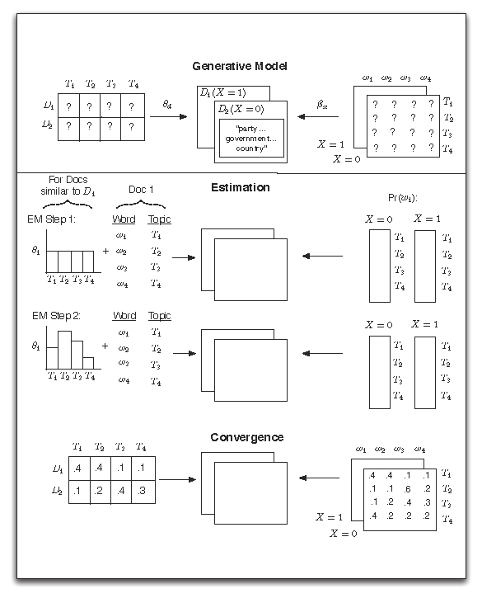

Figure 2.5: Heuristic description of generative process and estimation of the STM (adapted from M. E. Roberts et al., 2014, p. 4).

## 2.7 Chapter Summary

This chapter introduced some undergirding literature, theoretical frameworks, and methodological backgrounds for this study. While STEM education has become more prevalent across formal and informal learning, it also possesses some unexplored areas that need both scholarly and practical attention. Taking “political/relational model of disability” (Kafer, 2013), I see STEM education as “Ecological Model” (Basham et al., 2010), in which individuals with visual impairmentes or blindness are politically, socially, and culturally situated with four dimensional intersection (i.e., macro-; exo-; meso-; and microsystem). Resting upon sociocultural learning [Vygotsky (1980); ] as well as communities of practice (Lave & Wenger, 1991), I will explore how blind people are socioculturally situated within current STEM learning systems as captured through a large-scale textual corpus. To conduct this research, I will employ computer-assisted content analysis in general, and utilize structural topic model as an abductive approach (M. E. Roberts et al., 2013).

# 3 Methods

## 3.1 Introduction

This chapter delineates methodological aspects of conducting this research. At the outset, I will cover research design this study adopts from both technical and methodological perspectives. I will then explain in detail how I attempted to address ethical concerns in following procedures. Next, I will outline a set of research questions that this study aims to answer. I will also describe the study settings and samples, and my unique positionality within this research. Finally, this chapter will talk about how data were collected and analyzed.

## 3.2 Research Design

The overall design of this mixed methods research subscribes to the concept of “computational ethnography” (Abramson et al., 2018). Traditionally, ethnography is often defined as a qualitative approach focused in depth on a shared culture or a bounded group of people, usually based on contextual data immersion such as participant-observation, interviews, and micro-level archival research (Griffin & Bengry-Howell, 2007).

However, as Abramson et al. (2018) argue, social scientists conducting ethnography encounter challenges concerned with internal and external validity, generalization, reliability, and bias (Goldthorpe, 2000; King et al., 1994; Sánchez-Jankowski, 2002). Such challenges lead to “a *tripartite criticism* which frames ethnography as an *exploratory*, *anecdotal*, and *opaque* method that is less scientific than quantitative alternatives” (Abramson et al., 2018, p. 258, emphasis added). Computational ethnography extends ethnography’s conventional qualitative scope by employing data-driven computational methods that can help address the common critiques of ethnography with enhanced scalability, replicability, and transparency (Abramson et al., 2018). It continues to embrace the strength of qualitative ethnography to comprehend the shared cultures of people who give that data meaning, while holding a participatory lens on how larger systems, such as norms, values, assumptions, are culturally, historically and politically encoded in and reproduced through the design of sociotechnical data-driven systems (Abramson et al., 2018; Abramson & Dohan, 2015; Dohan & Sanchez-Jankowski, 1998; Moore et al., 2020; Zheng et al., 2015).

Computational ethnography, as an emerging mixed method, often applies exploratory data science techniques (e.g., descriptive analysis; clustering analysis; social network analysis; relational analysis) to a large-scale (or more, big data sized) corpora of texts to help researchers uncover meaningful patterns of the target data in the least intrusive fashion which would otherwise be infeasible to analyze with conventional qualitative approaches (Abramson et al., 2018; Zheng et al., 2015). Typical computational ethnography study first involves descriptive and syntactical pattern discovery assisted by computer algorithms, then is followed by researchers’ deep interpretation of the detected patterns to relate it to semantical explanation. This mixed-method interaction between data-driven computation and context-driven interpretation iteratively contributes to one another until a comprehensive understanding of the data is saturated (Abramson et al., 2018; Nelson et al., 2018).

As described in Chapter 1.3, the purpose of this study is to discover collective knowledge sharing patterns and informal learning cultures of blind individuals pursuing STEM disciplines as captured through computer-mediated mailing listservs. Given that such online communications are often saved as large-scale archived knowledge, computational ethnography is a well-suited methodological approach that can bring scalable benefit to observe the longitudinal cultural heritage of blind people. On top of the computer-assisted data exploration on the large-scale archived online data, this research also conducts small-scale semi-structured interviews with few blind learners pursuing STEM disciplines to enrich understanding of the discovered patterns. As such, from a mixed-method research design perspective, this study also aligns with what Creswell (2015) categorizes as a convergent design which is defined as follows:

The intent of a convergent design is to merge the results of the quantitative and qualitative data analyses. This merging then provides both a quantitative and a qualitative picture of the problem, and because both forms of data provide different insight, their combination contributes to seeing the problem from multiple angles and multiple perspectives. In short, quantitative results yield general trends and relationships, which are often needed, while qualitative results provide in-depth personal perspectives of individuals. Both are useful results, and their combination adds up to not only more data, but also a more complete understanding than what would have been provided by each database alone. (Creswell, 2015, pp. 35–36)

## 3.3 Research Ethics and Procedures

This computational ethnography has been carefully carried out with appropriate ethics following the typical five procedures of ethnographic study (Griffin & Bengry-Howell, 2007).

1. Gaining Access

The foremost important step is to gain an official access to the target community. Although the primary data of this research is in the public domain, I passed through all the possible ethical review processes across the Pennsylvania State University as well as internal to the NFB (Table 3.1). This way secured me a safer position while protecting the vulnerable community before obtaining and analyzing mailing lists.

As of May 21 2019, the Office for the Research Protections of the university determined the proposed study, entitled “Exploring Knowledge Sharing and Online Interactions in the Public Mailing Lists for Blind People,” as “Not Human Research” category, and the follow-up interview protocol was exempted on December 19 2019 (Appendix 6). As a double-checking process to address any unexpected ethical issues at a community level, on the other hand, I have also contacted gatekeepers of the NFB organization and was officially permitted by the NFB Research Advisory Council to conduct this study (see Appendix 7).

Table 3.1: Ethical review for this study.

|  |  |  |  |
| --- | --- | --- | --- |
| Date | Committee | Subject | Determination |
| 2019-05-21 | Office for Research Protections at the Pennsylvania State University | Exploring Knowledge Sharing and Online Interactions in the Public Mailing Lists for Blind People | Non-human research: Study #00012478 |
| 2019-12-19 | Office for Research Protections at the Pennsylvania State University | Follow-Up Interview: Exploring Knowledge Sharing and Online Interactions in the Public Mailing Lists for Blind People | Exempt research: Study #00014119 |
| 2020-01-10 | NFB Research Advisory Council | NFB Research Participant Solicitation Request Form | Approved |
| 2020-01-22 | Office of the NFB President | Permission Request for Using the NFB Email Archives for Research Purposes | Approved |

1. Introducing to the Community

After gaining access to the community, I sent an official email to the NFB mailing listservs to introduce myself and the purpose of this study to the subscribers. I also highlighted that this study would be performed in a way that does not disclose their personal information using aggregated data science techniques. However, I asked if anyone wanted to opt out so that I could remove their data before I dived into data analysis. Nobody expressed any rejection or willingness to opt out. Thus, I accepted it as a tacit agreement and included all the archived email communications for my computational observation process.

1. Participant Observation

The participant-observation was conducted using archived data of the target NFB listservs. Typically there are two approaches in terms of participant-observation: overt vs. covert (Griffin & Bengry-Howell, 2007). While an overt approach discloses researcher’s identity to the members of the group being studied, a covert approach hides researcher’s intent to the community to conduct the study in the least intrusive manner.

Computational ethnography with archived data provides researchers with a unique position. As it is derived from past data that already happened, I did not need to be concerned about the dichotomy (i.e., overt vs. covert approaches). Instead, I could benefit from the temporality that archived data offered which enabled me to vividly observe and backtrace the phenomena. Chapter 3.7.1 and 3.8 detail how I performed the participant-observation using computational approaches.

1. Working with Informants

I recruited eight blind members of the target NFB listservs who could inform me of the community culture and study topics. Chapter 3.7.2 details the procedure that I went through for this interaction (see also, Appendix 8 and Appendix 9).

1. Sharing Findings with the Community

This is the final procedure to complete this ethnographic study. As this research involves various data science results along with text descriptions, I write this dissertation in multi-formatted outputs including Word (docx) and web (html) files so that the blind community can find the study details in accessible ways following their needs. For some data visualization results, I use the SAS Graphics Accelerator (SAS Accessibility Team, n.d.) to produce accessible audio charts and tables for the blind community to alternatively consume the information.

## 3.4 Research Questions

This study seeks to answer the following research questions.

* Primary RQ: What are the sociocultural characteristics of collective knowledge-sharing patterns produced by blind learners pursuing STEM disciplines?

The primary research question can be broken down into several sub-questions which are listed below:

### 3.4.1 Quantitative Research Questions

Firstly, as a bird-eye view approach, the following data-driven research questions are explored in order to guide the overall question systematically.

#### 3.4.1.1 Descriptive Questions

* Quan RQ1.1: What are the frequency and variation patterns of collective knowledge participations of members in the target mailing listservs between January 2009 and December 2019?
* Quan RQ1.2: What are the top-10 most participated topics among members found in the target online listservs?
* Quan RQ1.3: What are the most salient words in each of the four target listservs?

#### 3.4.1.2 Semantic Network Questions

* Quan RQ2: What are the semantic network patterns found in each of the four target listservs?
  + Quan RQ2.1: What are the most common co-occurring words in each mailing list?
  + Quan RQ2.2: What are the most correlated words in each mailing list?
  + Quan RQ2.3: What are the most common bigrams (a pair of two words) in each mailing list?

#### 3.4.1.3 Data Clustering Questions

* Quan RQ3.1: What are estimated latent topics across all of the four target mailing lists calculated by Structural Topic Models? (simply stated, What kinds of conversations are provoked across all of the four NFB mailing lists?)
* Quan RQ3.2: In what ways are the estimated structural topics correlated with each other?
* Quan RQ3.3: How does the rate of topics (i.e., topical prevalence) change over time?
* Quan RQ3.4: How do these topical distributions (detected from RQ3.1) vary by the four types of the NFB mailing lists?
* Quan RQ3.5: How do the detected topical distributions vary by the type of mailing lists over time?

### 3.4.2 Qualitative Research Questions

Secondly, the following research questions are addressed based on the semi-structured interviews with the members (i.e., informants) of the NFB STEM-oriented mailing lists.

* Qual RQ1: What are the common STEM-related issues of blind learners?
* Qual RQ2: What strategies are utilized by blind individuals to pursue STEM disciplines

### 3.4.3 Hybrid Mixed Methods Question

At the end, the following research question is answered by combining the quantitative and qualitative research findings.

* Mixed RQ: What results emerge from comparing the qualitative interviews about the STEM-learning experiences of blind individuals with the computational outcomes derived from the STEM-oriented listservs?

## 3.5 Setting and Sample

The complete (i.e., ideal) population pool of this research is blind people who cannot (either completely or partially) employ their functional visions for learning STEM content. While there is no internationally agreed definition on blindness, this study has used the statutory definition of legally blind, “those who have a central visual acuity of 20/200 or less in the better eye with the best possible correction, or a visual field of 20 degrees or less” (as cited in American Printing House for the Blind, 2017).

In order to access this population more realistically, a purposeful convenience sampling strategy has been used, and the National Federation of the Blind (n.d.) has been selected as a primary target community. The National Federation of the Blind is the oldest and largest organization led by blind people in the United States founded in 1940, and currently headquartered in Baltimore. The NFB has affiliates, chapters, and divisions in all fifty states, Washington, DC, and Puerto Rico. Through their wide network of blind members, the NFB runs various programs, services, and resources (e.g., teaching Braille; organizing STEM membership programs; supporting assistive technology design and development) to advocate for the rights of blind people, provide information and support to blind children and adults, and build a community that creates more opportunities for blind individuals. The NFB has their clear philosophy of blindness as follows:

The National Federation of the Blind knows that blindness is not the characteristic that defines you or your future. Every day we raise the expectations of blind people, because low expectations create obstacles between blind people and our dreams. You can live the life you want; blindness is not what holds you back. (National Federation of the Blind, n.d.)

While the NFB orchestrates many physical events, it also provides more than 257 online mailing listservs where members of the NFB can exchange ideas with each other on various topics. All the email communication is archived in the public domain on the NFB website (National Federation of the Blind Mailing Lists, n.d.). As such, the primary setting of this study is online, including the archive analysis as well as follow-up Zoom interviews.

## 3.6 Positionality

I, as a blind individual myself, have been a local chapter (aka, Happy Valley) member of the NFB in Pennsylvania for about seven years since 2014, and also have subscribed to most of the target mailing listservs for more than five years. The only exception is the Artists-Making-Art because I found the existence of this listserv while preparing for this study. My double identity as a blind researcher and a member of the NFB naturally leads to a deep understanding of the study context and permits a strong reflexivity on the study findings and implications.

## 3.7 Data Collection

The data collection of this study comes from two sources (1) large-scale textual archives produced by the NFB community members for computational participant-observation; and (2) small-scale semi-structured interviews from the community informants for in-depth interpretation.

### 3.7.1 Computational Participant-Observation

To conduct data-driven participant-observation, longitudinal text data that contains members’ textual communication between January 2009 and December 2019 has been obtained by the publicly downloadable mailing list archives on their website [National Federation of the Blind Mailing Lists (n.d.); <https://www.nfbnet.org/mailman/listinfo>]. Among 257 active mailing lists, the following four STEM-oriented archives have been included for this research (Table 3.2: (1) Science and Engineering; (2) Computer Science; (3) Artists-Making-Art; and (4) BlindMath . All personally identifiable information (e.g., names; email addresses; email signature lines; and other sensitive or private portions) have been systematically either removed or replaced with pseudonyms for the data analyses and report procedures.

Table 3.2: A summary of the target NFB mailing lists.

|  |  |  |  |  |  |
| --- | --- | --- | --- | --- | --- |
| Categories | Mailing Lists | Topics | Number of Subscribers | Number of Messages (Jan 2009-Dec 2019) | URL |
| Science & Engineering | NFB Science and Engineering Division | To promote education solutions for the blind, share professional successes, and encourage new solutions and techniques to succeed in science and engineering as a blind person. | 259 | 2099 | http://nfbnet.org/mailman/listinfo/nfb-science_nfbnet.org |
| Technology | NFB in Computer Science | The Discussion of the business and operation of the NFB in Computer Science. To share information about the worlds of computer science and technology. | 302 | 13199 | http://nfbnet.org/mailman/listinfo/nfbcs_nfbnet.org |
| Arts | Artists-Making-Art | explore art with all senses. | 83 | 382 | http://nfbnet.org/mailman/listinfo/artists-making-art_nfbnet.org |
| Math | BlindMath | Sources for accessible texts, information about tactile and auditory graphing programs, suggestions for insuring that math lectures are accessible to blind students, and strategies used by blind math instructors. | 655 | 9178 | http://nfbnet.org/mailman/listinfo/blindmath_nfbnet.org |

### 3.7.2 Semi-Structured Interviews

To triangulate the computational participant-observation, I also have conducted semi-structured interview with the members of the NFB listservs who met the following criteria:

* Those self-identifying themselves as an individual who is blind or visually impaired;
* age 18 or older;
* having any learning experiences with Science, Technology, Engineering, and Mathematics (STEM) disciplines;
* and having a membership of any of the NFB mailing lists specified above (i.e., NFB-Science; NFBCS; Artists-Making-Art; BlindMath).

As a result of the recruitment (Appendix 8.1), eight individuals participated in the Zoom interview. Table 3.3 includes some demographic information of the participants.

Table 3.3: Demographic information on interview participants.

|  |  |  |  |  |  |  |  |  |  |  |
| --- | --- | --- | --- | --- | --- | --- | --- | --- | --- | --- |
| Participant_ID | Blindness_Level | NFB_Membership | Subscription_Period | Role_In_NFB_Listservs | Highest_Degree | Major | Age | Gender | Ethnicity | Living_Area |
| P1 | Severe vision impairment | Science and engineering; BlindMath | 4 months | Peripheral observer | Bachelor | Physics | 32 | Male | Caucasian | San Francisco |
| P2 | Blindness | Computer science; BlindMath | 18 months | Peripheral observer | Master | Applied Mathematics | 24 | Male | Asian | India |
| P3 | Blindness | BlindMath | 18 years | Peripheral observer | Ph.D. | Particle Physics | 41 | Male | Asian | Arizona |
| P4 | Severe vision impairment | Science and engineering; BlindMath | 2 years | Peripheral observer | Bachelor | Biochemistry | 22 | Female | Caucasian | Delaware |
| P5 | Blindness | Computer science | More than 10 years | Peripheral observer | Bachelor | Business Information Systems (Computer Science minor) | 40 | Male | Caucasian | Arkansas |
| P6 | Blindness | Computer science; science and engineering; BlindMath; artistis-making-arts | 10 years | Mentee | Bachelor | Business Management | 27 | Male | Arabic | Texas |
| P7 | Blindness | Computer science; science and engineering; artists-making-arts | 20 years | Mentor | Bachelor | Mathematics | 45 | Male | Caucasian | Pennsylvania |
| P8 | Severe vision impairment | Computer science; science and engineering; BlindMath | 8 years | Peripheral observer | Ph.D. | Biology (genetics) | 28 | Male | Caucasian | North Carolina |

* *Note*: Blindness_Level is based on each participant’s self-reported visual acuity status chosen from the World Health Organization (2018) four categories (i.e., normal vision; moderate vision impairment; severe vision impairment; blindness). Full description on each column can be found in Appendix 8.3.

The interview took place between February 2020 and December 2020, and each of the eight interviews was carried out on Zoom Conference platform due to its great accessibility features for screen readers. Each session lasted approximately an hour following carefully prepared semi-structured interview protocol, which included few questions about their visual impairments, learning experiences in STEM subjects, experience with the NFB mailing lists, and demographic information (see Appendix 8.3). With the participants’ consent, all the interviews were audio-recorded and transcribed for further analysis (Appendix 9 includes interview transcripts).

## 3.8 Data Analysis Procedure

The analytical procedure of this study is based upon “Knowledge Discovery in Textual Databases” (KDT) model (Feldman & Dagan, 1995). The KDT model involves “the process of extracting meaningful, non-trivial patterns or knowledge from a set of unstructured texts” (Hung, 2012, p. 4). As an extension of “Knowledge Discovery in Databases” (KDD, U. M. Fayyad et al., 1996), text data mining (Feldman & Dagan, 1995) is typically conducted in the five procedures: (1) data extraction; (2) data cleaning; (3) data transformation; (4) text mining; and (5) results evaluation and interpretation. The first three phases involve data preprocessing; the latter (4 and 5) requires human-centered analysis and evaluation of text mining algorithms, which leads to an iterative cycle until a meaningful discovery is sufficiently saturated (U. Fayyad et al., 1996; Feldman & Dagan, 1995; Hung, 2012). In addition to the KDT model, three-step “Computational Grounded Theory” (Nelson, 2017) has also been combined as a check-point framework to make sure the quality of detected text patterns (see Figure 3.1).

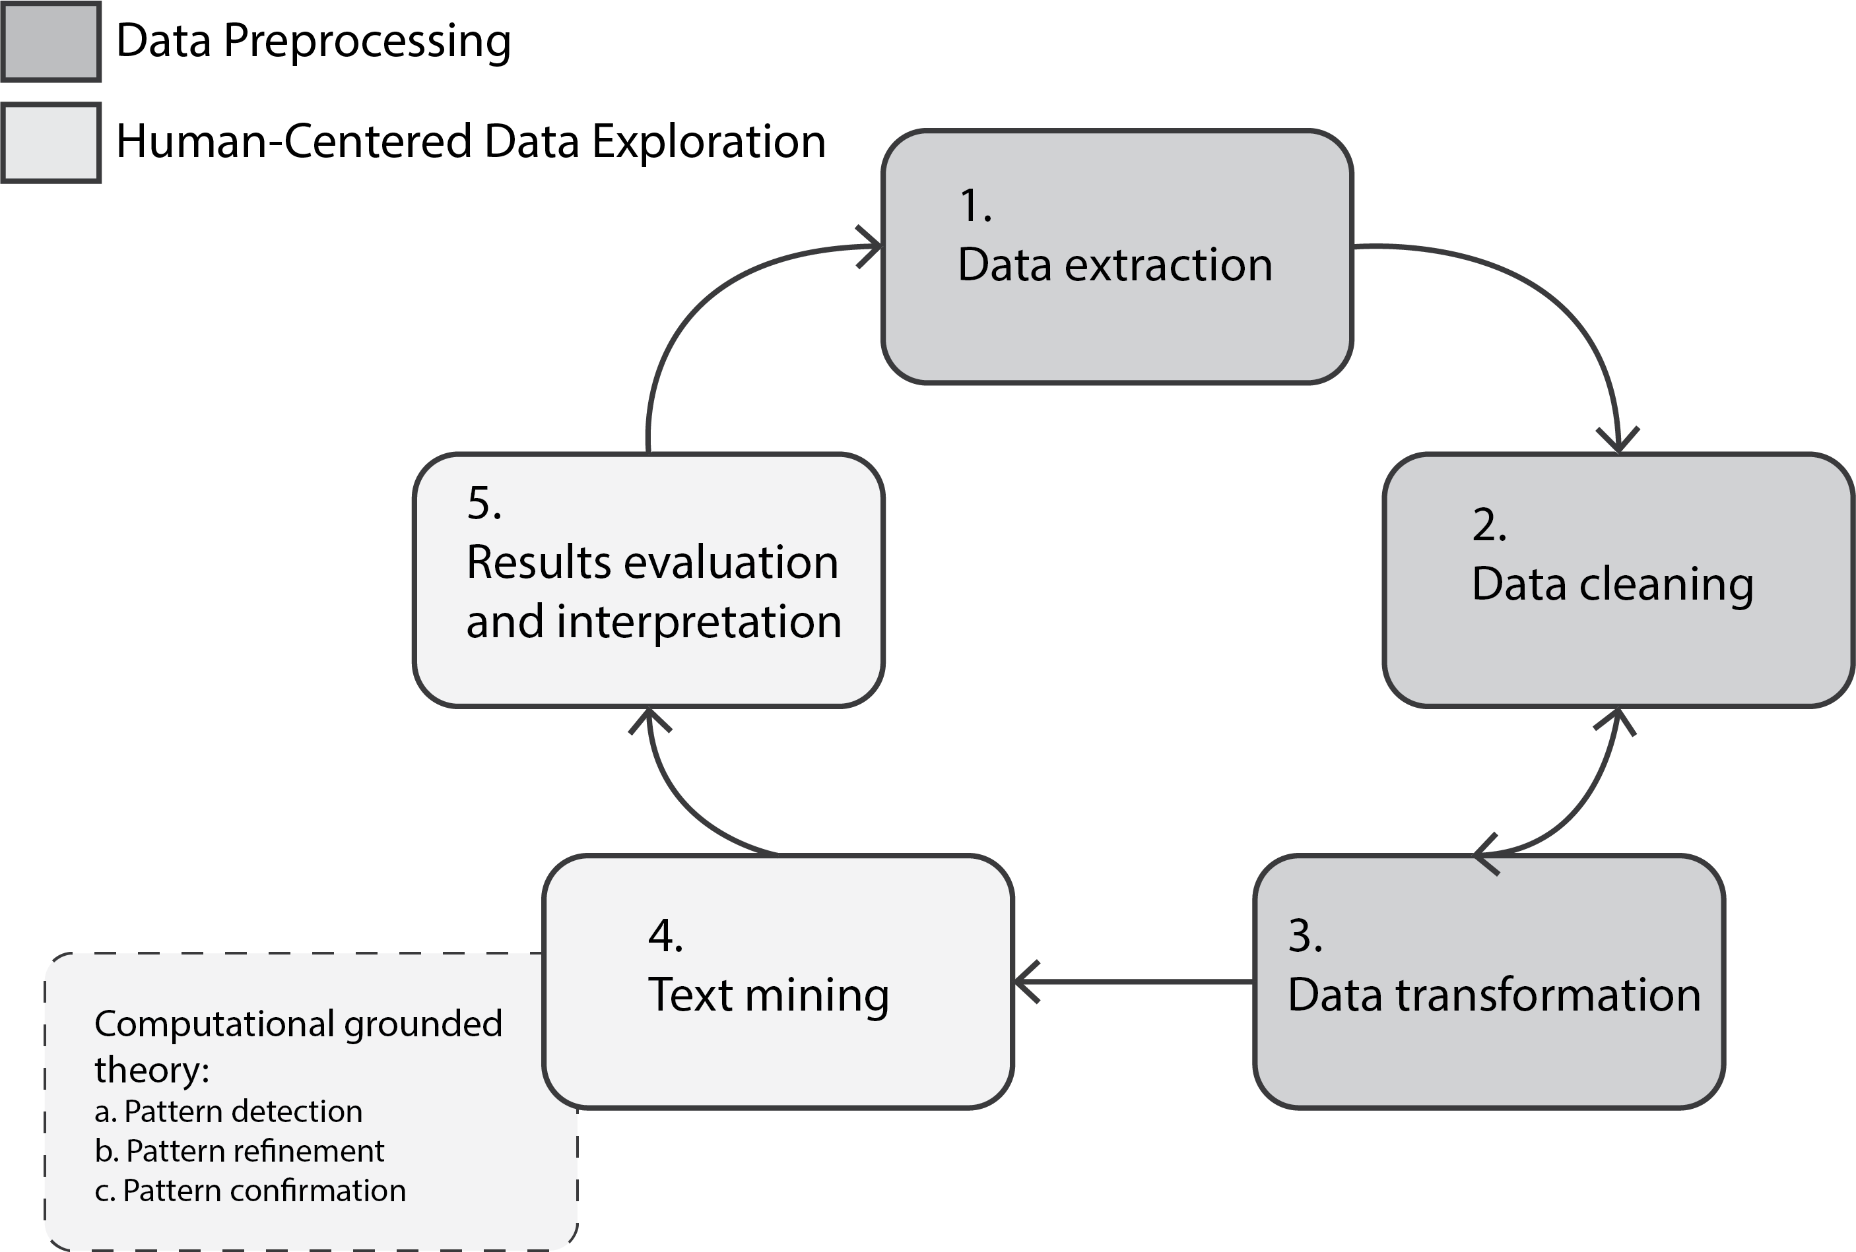

Figure 3.1: An analytical procedure chart following the five phases of Knowledge Discovery in Textual Databases (Feldman & Dagan, 1995) combined with Computational Grounded Theory (Nelson, 2017).

Data management and analysis have been performed using statistical computing language R [Version 4.1.0; R Core Team (2019)] environment and required packages. All coding process employed for this research is provided as supplemental material (see Appendix 10; Appendix 12; Appendix 14) subscribing to the recent trend of reproducible research to demystify computer-assisted text analysis and enhance its reliability (H. E. Brown, 2013; Nelson, 2017; Nelson et al., 2018). The subsections below outline each step of the data analysis following the KDT procedure.

### 3.8.1 Phase I: Data Extraction

The first phase of the KDT model is preparing for data to analyze. As described in Chapter 3.7, this research focuses on the four STEM-oriented mailing list archives between January 2009 and December 2019 (see Table 3.2). The following criteria has been implemented for choosing these four mailing lists:

1. The list topic must be closely related to STEM (Science, Technology, Engineering, and Mathematics) subjects.[1]
2. The list must have a sufficient history (at least 8 to 10 years) to play a role in capturing longitudinal STEM activities of blind people including their challenges and solutions.
3. The list must have a sufficient number of memberships (at least 50).
4. The list communication must be done in English.

Although the National Federation of the Blind Mailing Lists (n.d.) allows anyone with a modern Internet browser to manually download their public mailing archives in a zipped (i.e., gzip) format, I used Unix shell commands instead to extract the target archive files in a systematic and replicable fashion (see Appendix 10). No “robots exclusion protocol” (i.e., robots.txt) that defines the allowed level of web crawling has been found in the site root. This implies any search engine can parse each content tree available on this site (Drott, 2002), which in turn justifies using shell commands to crawl these public archives.

At the end of this initial stage, I was able to retrieve all required target archives from the National Federation of the Blind Mailing Lists (n.d.) website and extract them as an mbox format. Mbox is a plain-text file type that holds concatenated email messages.

### 3.8.2 Phase II and III: Data Cleaning and Transformation

The second (Data Cleaning) and third (Data Transformation) steps are carried out simultaneously until a researcher finds the transformed data good to proceed towards actual analysis. Ideal data shape through these steps would take “tidy data” structure (Wickham & others, 2014) in which rows correspond to individual observations (i.e., samples), and columns represent variables (also known as either features or attributes).

To complete this goal, I developed an R package, called “mboxr” (Seo & Choi, 2019), which takes mbox-formatted file(s) as an input and converts it into a structured data as its output in a tidy form (also called “tibble” in R environment, Müller & Wickham, 2019). Since “mboxr” package (Seo & Choi, 2019) has been published in the peer-reviewed “Comprehensive R Archive Network” (CRAN; <https://cran.r-project.org/>), its stability has been validated by other computational statisticians to some reliable degree. Furthermore, the package has been under active development at GitHub repository (<https://github.com/jooyoungseo/mboxr>); thus, the source code of this package is transparently available to analyze.

In light of the seamless nature between data cleaning and transformation, the following were undertaken together at this stage:

1. Cleaning the mbox files extracted through the previous stage (Chapter  
   3.8.1). As some mbox files retrieved had to be fixed for non-escaped issues for a new line starting with “From” in message body, I addressed this problem by replacing “From” with “>From” following the standard email message protocols (see Appendix 12).
2. Transforming mbox files into a tibble format [the tidy data structure used in R; Wickham & others (2014)] using “mboxr” package (Seo & Choi, 2019).
3. Removing the unnecessary prefix from subject fields of each archive. Since each mailing archive has a unique prefix within their subject lines (e.g., NFB-CS; NFB-Science; Arts-Making; BlindMath respectively), it needed to be taken them out to help the next text mining phase to uncover more pronounced results.

At the end of this process, the mbox files obtained in the previous section had been transformed into a large data frame with one-message-per-row structure along with 11 variables (see Table 3.4 for the sample dataset), and a total of 24858 messages (2099 messages from Science & Engineering; 13199 NFB in Computer Science; 382 Artists-Making-Art; 9178 BlindMath) had been ready for analysis. Consult with Appendix 12 to learn about how to reproduce this stage in detail.

Table 3.4: A structured sample of email texts.

|  |  |  |  |  |  |  |  |  |  |  |  |
| --- | --- | --- | --- | --- | --- | --- | --- | --- | --- | --- | --- |
| Variable | date | weekday | message_ID | in_reply_to | references | num_discussants | from | to | cc | subject | content |
| Description | Date and time of message sent (UTC/GMT). | Day of the week for current message sent as an abbreviated three-character string. | A globally unique message identifier containing url-encoded characters. | Message-ID to which current message is replying, if any. | All appended Message-ID(s) involved in current message thread, if any. | The number of discussants for current message thread calculated by using references field. | Sender’s Name along with email address. | Recipient’s name along with email address. | Copied member(s) along with their email address(es). | Message subject. | Message content. |
| Example | 2018-02-23 12:12:47 UTC | Fri | <002501d3ac3b$095e76b0$1c1b6410$@gmail.com> | <007802c3bz3b$095e76b0$1c1b6410$@pseudo.pseu> | <007802c3bz3b$095e76b0$1c1b6410$@pseudo.pseu> <008901z4dq3p$095e76b0$1c1b6410$@pseudo.pseu> | 3 | sjysky at gmail.com (JooYoung Seo) | NA | NA | [nfbcs] Pseudo Subject | This is message. Sincerely, JooYoung |

* *Note*: This demonstrates one sample message instance (i.e., the unit of analysis for this study) along with each description and example. *to* and *cc* are not retrievable from NFB mailing list archives; instead, in_reply_to and references provide alternative information respectively. from field has been systematically replaced with pseudonyms for this study to protect personal information.

### 3.8.3 Phase IV: Text Mining

This phase is the crux of this research in which computational algorithms are utilized to help humanistic deep reading of the structured textual data. At this stage, I performed the following three analyses that respond to each of the quantitative research questions (Chapter 1.4.1):

First, descriptive statistics (i.e., counting and central tendency analysis) were performed to systematically capture the frequency and variation of message exchange patterns within each listserv over time. Through this initial analysis, the research questions under Chapter 1.4.1.1 were answered by counting the frequency of each categorical variables (i.e., message_ID; from; subject; num_discussants [as a covariate] columns) out of the 11 available features. Second, semantic network analysis had been carried out to elicit the linguistic patterns among subscribers within each listserv. Through this analysis, the research questions in Chapter 1.4.1.2 were examined with co-occurrence; Karl Pearson’s $ϕ$ correlation; and bigram network analysis respectively. Finally, structural topic modeling (M. E. Roberts et al., 2013) – one of the natural language processing algorithms that probabilistically discovers latent structural topics within a large corpus of documents – had been employed to identify common themes within the four mailing list archives. Through this analysis, the data clustering questions (Chapter 1.4.1.3) were addressed using content variable as a text input coupled with some document-level metadata as covariates (i.e., mailing_list_type; date; num_discussants).

In order to systematically perform human-centered text mining analysis, I followed the three-step methodological framework called “computational grounded theory” proposed by Nelson (2017) that by definition “combines expert human knowledge and hermeneutic skills with the processing power and pattern recognition of computers, producing a more methodologically rigorous but interpretive approach to content analysis” (p. 1). A standard workflow for the framework proceeds as follows: (1) pattern detection; (2) pattern refinement; and (3) pattern confirmation. The following details each step tailored for this study (see Appendix 14 for reproducible scripts for this text mining section).

#### 3.8.3.1 Step 1: Pattern Detection

The first step involves using unsupervised machine learning techniques to inductively explore novel patterns in a large collection of texts (Nelson, 2017). To reduce complicated corpus to interpretable groups of words, probabilistic topic modeling algorithms (Chapter  
2.6.2) were utilized to cluster documents to syntactically correlated topics of words. Among various unsupervised topic modeling algorithms, the Structural Topic Model [STM; M. Roberts et al. (2019)] had been employed for this study as detailed in Chapter 2.6.3 for its investigative benefits including the estimation capability of topic models with document-level metadata as covariates.

Fitting a basic Structural Topic Model requires the following components:

1. Structured data frame containing both document texts and each corresponding meta data.

These were prepared from the phase II (Data Cleaning and Transformation; Chapter 3.8.2) as a tidy data form called “tibble” just like Table 3.4. In the table with 11 variables, content field was employed for document text input; the remaining attributes for metadata. I created a new covariate list that defined what category of STEM a document belongs to. For example, the new categorical variable, list, have four levels (Science_Eng for NFB-Science; Technology for NFB-CS; Arts for Arts-Making; and Math for BlindMath respectively). More detailed examples on how to formulate hypotheses using document-level metadata is described in the next section 3.8.3.2.

1. The number of desired topics (denoted with K) to cluster documents within a corpus.

As mentioned in Chapter 2.6.2, this parameter is used to control “the granularity of the requested summary” (Reich et al., 2015). Although the K value, in the computer science field, is commonly set “by maximizing the predictive power of the model on a heldout sample” (Mimno et al., 2011; Reich et al., 2015, p. 164), some research highlight such methodology may not always lead to the most useful and interpretable model (Chang et al., 2009). Hence, the choice of K, on substantive grounds, should be made by comparing several values to reflect the best granularity of the corpus summary (Reich et al., 2015).

Taken both structured text input and the number of topics all together, a parametric (i.e., probabilistic) topic model was defined by the STM algorithm based upon Bayesian inference and the posterior distribution (Reich et al., 2015; M. Roberts et al., 2019).

#### 3.8.3.2 Step 2: Pattern Refinement

The second step involves “an interpretive engagement with the data through qualitative deep reading or further exploration of the data” (Nelson, 2017, p. 1). Whereas the prior step remains in syntactic pattern recognition calculated by computer algorithms; this stage more concerns semantic pattern interpretation from humanistic deep reading of the texts. However, there is continuity between the step 1 and 2.

To result in coherent relationship between such syntactic and semantic patterns, the STM package functions (e.g., stm::cloud() and stm::plot.findThoughts()), which plot most representative documents for a particular topic, were employed to get a better sense of the content of actual documents with a high topical content (M. Roberts et al., 2019).

Another refinement that was carried out at this stage was formulating hypotheses. As noted in Chapter 3.8.3.1, there were some document-level metadata (e.g., date; num_discussants; and list field) that could be used as covariates to estimate a topic model. After a topic model had been established to a satisfactory level with content field being text input, such metadata covariates were used in the estimation of topic prevalence (how often a topic is discussed)" and “topical content (the words used in discussing a topic)” (Reich et al., 2015, p. 161). Two hypotheses used for the pattern refinement included:

* The topical distributions (detected from step 1) vary by the type of mailing lists and the number of discussants over time.
* Kinds of conversations are provoked differently by the type of mailing lists.

With such metadata covariates added, the topic model was re-estimated to offer richer contextual information. Consequently, at the end of this step 2, a more holistic interpretation of the data was made by incorporating both syntactical and semantical patterns and returning to a human-centered hypotheses refinement (Nelson, 2017; Reich et al., 2015).

#### 3.8.3.3 Step 3: Pattern Confirmation

The last step of the Phase III involves “using computational methods to more reliably test the validity of the inductively identified patterns in the text” (Nelson, 2017, p. 7). To put it another way, this will concern assessment of the detected and refined patterns through the prior steps by utilizing further computational and statistical techniques.

At this stage, the semantic coherence and exclusivity for high likelihood models; LOESS (Locally Weighted Scatterplot Smoothing) line of the topic proportions on a covariate; and topic correlations were tested for the model validity in a rigorous manner.

Going through this Pattern Confirmation step, I was able to uncover the most salient patterns within and across the four NFB mailing lists over the past eleven years.

### 3.8.4 Phase V: Results Evaluation and Interpretation

This last phase of the KDT model plays a conclusive role in integrating all prior analytical points into the study results through the researcher’s humanistic interpretation (U. M. Fayyad et al., 1996; Feldman & Dagan, 1995). All of the computational results have been repeatedly double-checked with my own interpretive reflexivity as one of the lifelong blind individuals pursuing STEM disciplines.

Furthermore, I utilized the qualitative sources collected from the in-depth semi-structured interviews with eight blind members of the target NFB listservs (see Chapter 3.7.2) as an interpretive lens at a community level to triangulate the data-driven results. For the analysis of the qualitative interview data, I took fieldnotes and used my self-reflexivity as an autoethnographic tool (Ellis et al., 2011) to iteratively cross-check meaning of each interview response until I reached data saturation (Griffin & Bengry-Howell, 2007).

## 3.9 Chapter Summary

This chapter covered detailed methodological facets of conducting this research. The nature of a large-scale archived data introduced a new methodological challenge in conventional ethnography that used to adapting some limited boundary of data. Computational ethnography is well-suited emerging mixed methods with its scalable benefit to meet any size of data.

On top of the computational participant-observation on the National Federation of the Blind STEM-oriented mailing archives (N = 24858), this research attempts to triangulate the data-driven research findings by mixing my unique positionality as a blind person along with the semi-structured interviews with eight informants of the target community.

In terms of the data analysis, the five-phase “Knowledge Discovery in Textual Databases” (KDT) model (Feldman & Dagan, 1995) have been implemented as a guiding framework, combined with the three-step “Computational Grounded Theory” (Nelson, 2017). Data management and analysis have been performed using statistical computing language R [Version 4.1.0; R Core Team (2019)] environment and required packages. All coding process employed for this research is provided as supplemental material (Appendix 10; Appendix 12) subscribing to the recent trend of reproducible research to demystify computer-assisted text analysis and enhance the study reliability.

In the next chapter, I will report study findings corresponding to each of the research question.

# 4 Research Findings

## 4.1 Introduction

This chapter reports the study findings. As detailed in the previous Chapter, this computational ethnography takes convergent mixed methods design (Creswell, 2015) across quantitative and qualitative research. Firstly, a set of data-driven results from computational linguistics will be addressed corresponding to each of the quantitative research questions. Secondly, findings derived from in-depth semi-structured interviews will be shared to respond to two of the qualitative research questions. Finally, I will integrate these two strands to complement each other for a deeper understanding of the hybrid mixed-methods research question. However, a more extensive response to the primary research question will be covered in the next chapter.

## 4.2 Results from the Computational Participant-Observation

In this section, I will report all the data analysis results addressing Chapter 1.4.1. For the sake of clarity, each of the data analysis results will be listed under their corresponding research questions.

### 4.2.1 Descriptive Questions

#### 4.2.1.1 Quan RQ1.1: What are the frequency and variation patterns of collective knowledge participations of members in the target mailing listservs between January 2009 and December 2019?

This question is concerned with the general trends on the four target listservs. As I transformed semi-structured mailing text into one-message-per-row structured tidy data-frame (Chapter 3.8.2), I was able to analyze overall trends of the target communities that I would have otherwise not been able to do with unstructured text in reproducible and efficient ways (Appendix 14). Table 4.1 shows some descriptive information on the four NFB mailing lists. The following include descriptions of what each column indicates.

* Analysis period: calculated based on the timestamp of the first and the last message instances within each listserv. Greenwich Mean Time (GMT) was used to normalize different timezones of message senders.
* Total active participants: the total number of individuals involved within each listserv calculated by counting each unique email address of message senders.
* Total msg instances: the total number of messages sent in the listservs, comprising Number of msg to undefined references (messages replying to undefined message_ID within the given archive) and Number of identifiable msg (messages replying to another identifiable message).

To get more accurate results, I removed Number of msg to undefined references from the calculations for the outcomes below.

* Number of thread: the total number of the messages having more than one conversation participants.
* Number of single msg: the total number of the messages having only one conversation participant.
* Number of collaborative msg: is the sum of Number of referenced initial msg (the total number of the identifiable original messages referenced by other replies) and Number of replying msg (the number of the replying messages referencing the initial messages).
* Total topics: the total number of the unique topics derrived from identifiable unique message_ID within each listserv, which can be broken down into Total replied topics and Total unreplied topics.
* Unreplied rate: the ratio of the total number of unreplied original messages to the total number of all the original messages across replied and unreplied ones.[2]
* Replied rate: the inverse index to Unreplied rate ($1-\text{Unreplied Rate}$).
* Discussion start msg ratio to a total collaborative msg: the ratio of Number of referenced initial msg to Number of collaborative msg.

Table 4.1: Descriptive summary of each of the four NFB mailing lists.

|  |  |  |  |  |  |  |  |  |  |  |  |  |  |  |  |  |
| --- | --- | --- | --- | --- | --- | --- | --- | --- | --- | --- | --- | --- | --- | --- | --- | --- |
| list | Analysis period | Total active participants | Total msg instances | Number of msg to undefined references | Number of identifiable msg | Number of thread | Number of single msg | Number of collaborative msg | Number of referenced initial msg | Number of replying msg | Total topics | Total replied topics | Total unreplied topics | Unreplied rate | Replied rate | Discussion start msg ratio to a total collaborative msg |
| arts | 2011-11-17 21:26:17 - 2019-01-04 02:34:32 | 44 | 382 | 15 | 367 | 186 | 181 | 270 | 84 | 186 | 177 | 80 | 97 | 0.5359 | 0.4641 | 0.3111 |
| cs | 2009-01-01 00:03:20 - 2019-12-31 19:25:02 | 538 | 13199 | 646 | 12553 | 8537 | 4016 | 10610 | 2073 | 8537 | 4023 | 2080 | 1943 | 0.4838 | 0.5162 | 0.1954 |
| math | 2009-01-08 16:27:00 - 2019-12-31 20:18:59 | 684 | 9177 | 882 | 8295 | 6054 | 2241 | 7379 | 1325 | 6054 | 2245 | 1329 | 916 | 0.4087 | 0.5913 | 0.1796 |
| science | 2009-01-06 02:29:16 - 2019-12-25 05:02:08 | 287 | 2099 | 191 | 1908 | 821 | 1087 | 1100 | 279 | 821 | 1088 | 280 | 808 | 0.7433 | 0.2567 | 0.2536 |

According to the analysis, computer science (CS) was the most active and the Arts was the least participated listserv. For example, the analysis of total msg instances (Figure 4.1) revealed that cs had the most participation (13,199 messages), followed by math (9,177), science (2,099), and arts (382). This rank pattern was found in other analyses such as period and number of collaborative msg. However, total active participants showed that math had more active members (684) than cs (538), and also higher replied rate (0.5913) than cs (0.5162).

Although science listserv had more active members (287) than arts (44), it recorded much lower replied rate (0.2567) than arts (0.4641). In terms of discussion start ratio, the arts had the highest rate (0.3111) and the math showed the lowest (0.1796). This suggests members in math list were more likely to reply to other members’ messages than they initiated new messages while members in the arts more tended to start new messages. Table 4.2 briefly illustrates these patterns by the order of higher rank per category.

Table 4.2: Pattern summary of the target listservs sorted by the top rank for each category.

|  |  |  |  |  |  |
| --- | --- | --- | --- | --- | --- |
| period | active_participant | total_instances | collaborative_msg | replied_rate | discussion_start_ratio |
| cs | math | cs | cs | math | arts |
| math | cs | math | math | cs | science |
| science | science | science | science | arts | cs |
| arts | arts | arts | arts | science | math |

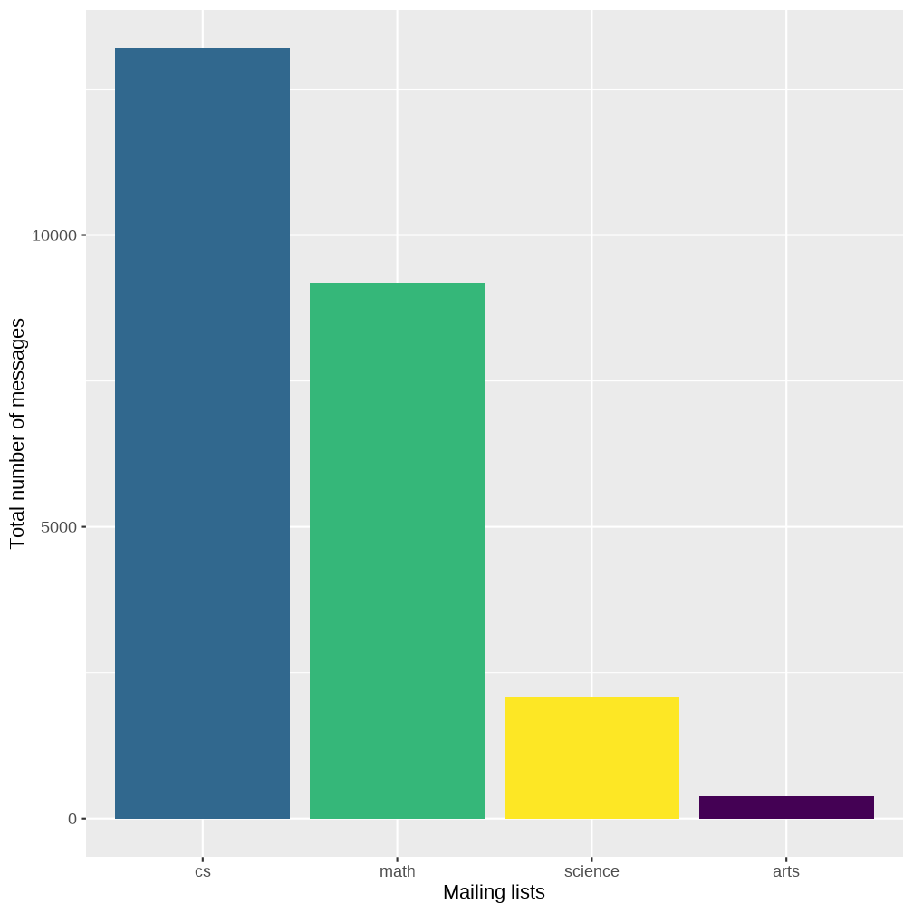

Figure 4.1: Bar chart showing the number of messages by the NFB listservs between 2009 and 2019. Accessible audio-chart can be found [here](https://jooyoungseo.com/a11y-viz/g_msg_per_list.html).

On the other hand, I counted total number of messages sent by each listserv member and compared the dispersion patterns across different listservs using a box plot. Figure 4.2 shows that all the mailing lists had narrow box areas between the first and third quartiles while having long upper whiskers between the third quartiles and maximum values, suggesting highly positive skewness. This implies that all the listservs, regardless of their absolute number of message instances exchanged, were led by few active members. This characteristic was found the most pronounced in the cs list given that it had the largest number of outliers.

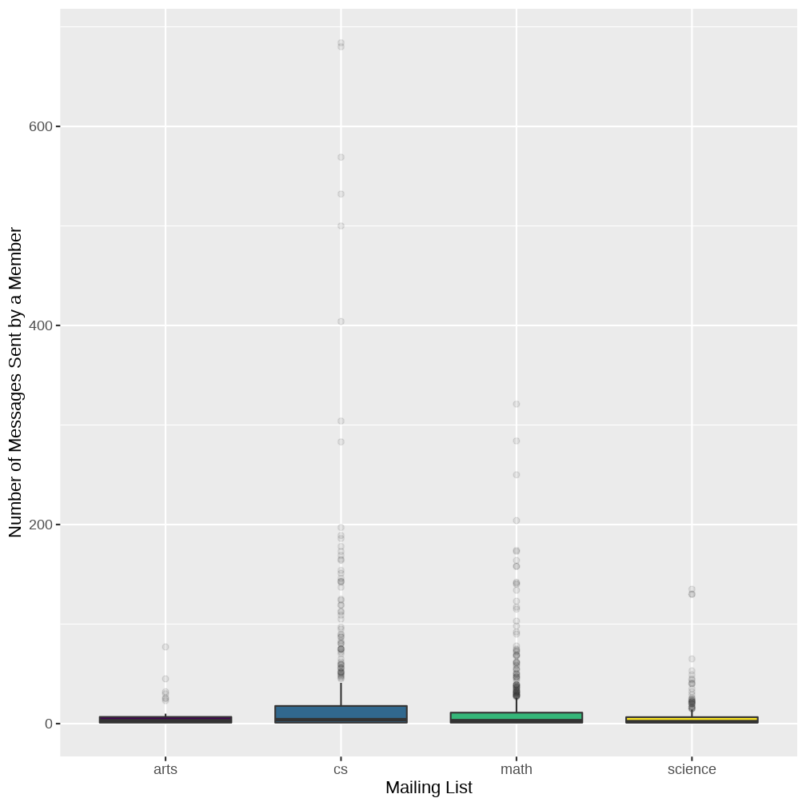

Figure 4.2: Box plot showing number of messages sent by each member, grouped by list. Accessible audio-chart can be found [here](https://jooyoungseo.com/a11y-viz/g_list_member_msg.html).

Finally, time series analysis indicated that the period between 2011 and 2014 was the most participated years across listservs (Figure 4.3) while the rate was relatively decreasing towards the end.

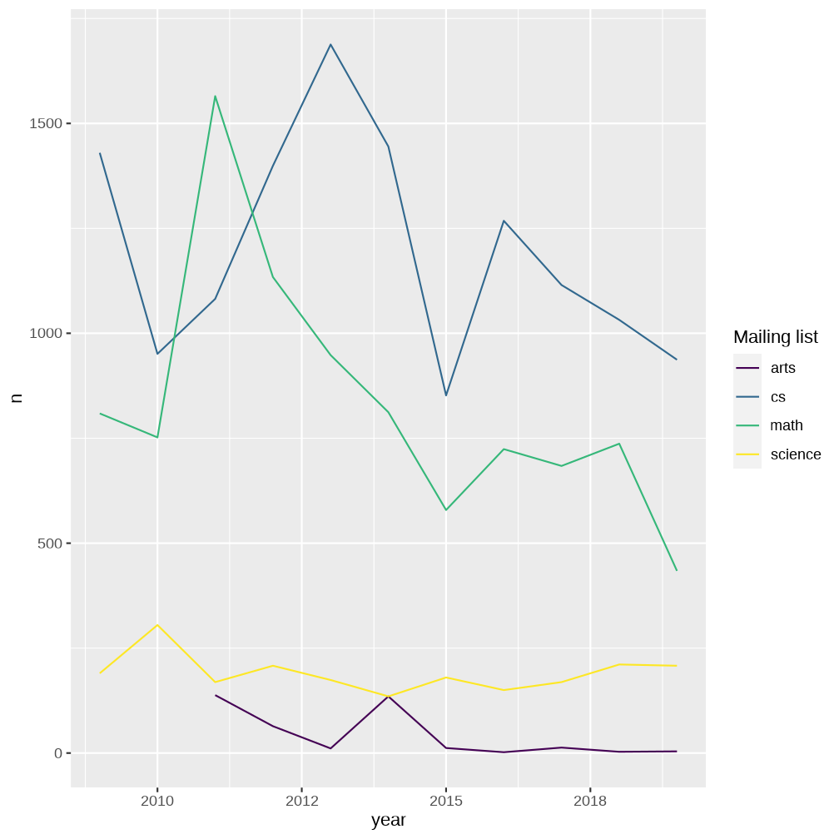

Figure 4.3: Line chart showing Total n by year, grouped by list. Accessible audio-chart can be found [here](https://jooyoungseo.com/a11y-viz/g_list_year_n.html).

#### 4.2.1.2 Quan RQ1.2: What are the top-10 most participated topics among members found in the target online listservs?

Table 4.3 is the result of the analysis on the top-10 most participated topics found within each listserv. For this analysis, I used subject variable and counted its unique factor levels (i.e., subject lines) to identify what subjects were discussed the most among list members (Appendix 14).

Table 4.3: The top-10 most participated topics within the four NFB mailing lists.

|  |  |  |
| --- | --- | --- |
| list | subject | n |
| arts | In the NEWS today! | 25 |
| arts | Introduction from Jewel | 22 |
| arts | exhibit | 19 |
| arts | marketing art | 15 |
| arts | Introduction | 13 |
| arts | Summer Exhibit Plans | 13 |
| arts | tips for getting clay fired | 13 |
| arts | raised line drawing boards | 10 |
| arts | April Invitation | 9 |
| arts | arts or crafts new member | 9 |
| cs | Innovation, Usability, Accessibility, standards, and legal requirements. | 94 |
| cs | Research | 91 |
| cs | Amazon and Sony Are Requesting That The Accessibility Requirement Be Waived for E-Book Readers | 60 |
| cs | A+ Certification | 54 |
| cs | The Mac Beckens | 54 |
| cs | Computer science major college question | 46 |
| cs | Ethics of screen reader friendly development | 43 |
| cs | Linux users | 43 |
| cs | Seeking suggestions for helping blind students with math | 42 |
| cs | The Future of Technology: A Journey | 42 |
| math | Accessible display format for matrices | 73 |
| math | Extracting bitmap images from pdf files | 57 |
| math | Facial recognition – food for thought | 45 |
| math | mathplayer, jaws, and math in graphics? | 42 |
| math | Issues with electronic math files and screen readers/braille displays | 40 |
| math | Mathematical document accessibility | 39 |
| math | Typing in Nemeth Braille | 38 |
| math | Using Java Draw2D in an SWT GUI | 36 |
| math | JAWS and Nemeth - Newbie question | 33 |
| math | First attempt at an SWT/SVG based drawing program | 32 |
| science | How do I best deal with making graphs and using scientific instruments in my environmental science class? | 24 |
| science | note taker development | 18 |
| science | [nobe-l] Looking for Suggestions: Moon Project for Next Year’s BELL Program | 14 |
| science | Introduction | 13 |
| science | Accessible scale in grain units | 12 |
| science | Braille Displays | 12 |
| science | High school biology help needed | 12 |
| science | introduction | 12 |
| science | Math query: | 12 |
| science | qualifying exam accommodations | 12 |

#### 4.2.1.3 Quan RQ1.3: What are the most salient words in each of the four target listservs?

To answer this question, I used term frequency–inverse document frequency (tf-idf), which is a weighting term statistic that reflects how important a word is to a document in a corpus (Sammut & Webb, 2010). Theorem 4.1 concisely explains this concept.

Theorem 4.1 (tf-idf theorem.)

$$\text{IDF}=\text{log}\frac{\text{N}}{\text{DF}}$$

$$\text{TF-IDF}=TF×\text{log}\frac{\text{N}}{\text{DF}}$$

The tf-idf value is useful in the sense that it can isolate a document’s most important words from the kinds of words that tend to be highly frequent across a set of documents in that language (Sammut & Webb, 2010; Silge & Robinson, 2017). Figure 4.4 and Table 13.1 illustrate what kinds of words appeared to be salient within each listserv based on the top-10 tf-idf values.

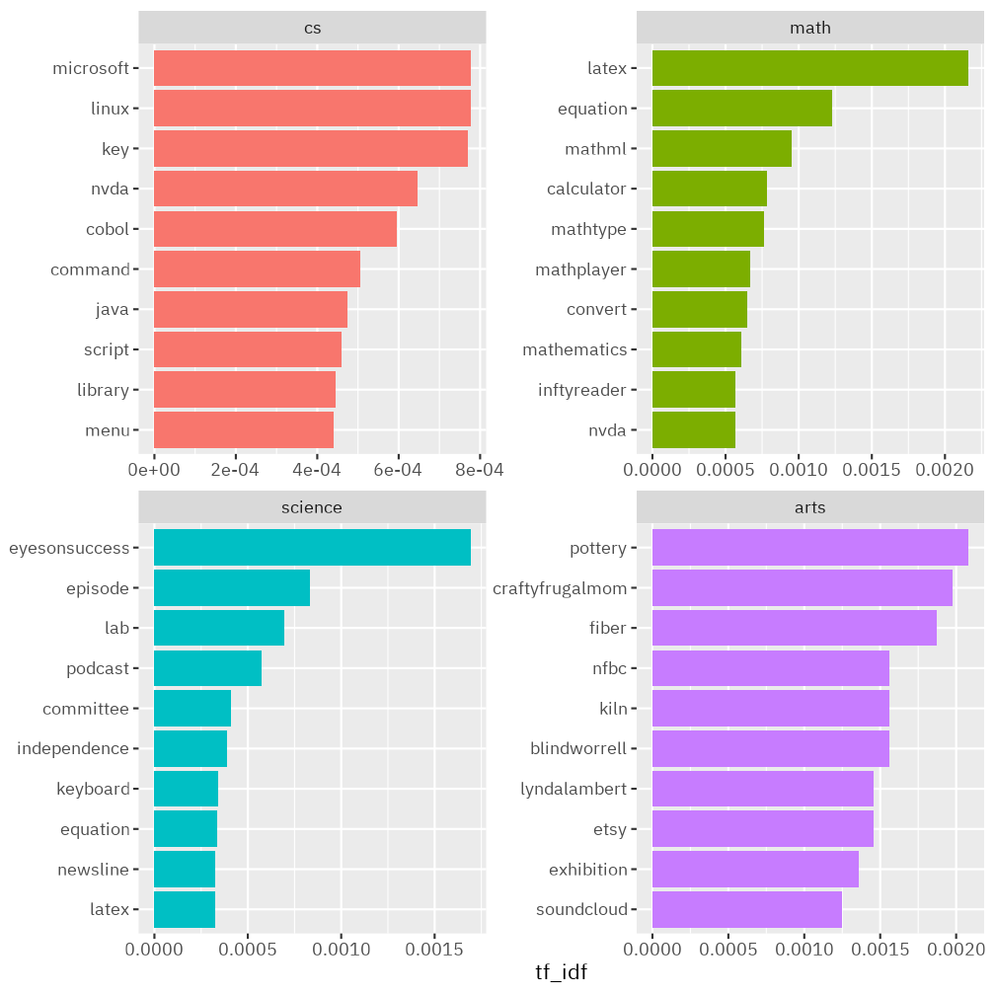

Figure 4.4: The top-10 most salient words in each of the four NFB mailing lists.

The tf-idf results indicated what keywords were the most important concepts within each mailing list. In the arts list, tangible materials (e.g., pottery, fiber, kiln) seemed to be subject to active discussion. The word “craftyfrugalmom” was emergent because it was the online site where one of the list members whose nickname was “crafty frugal mom” sold her handmade products, such as tissue covers. Another active member in the arts list had advertised his music production on the Sound Cloud under the artist name “blindworrell.” Given the small number of membership, the arts corpus was highly affected by few members, resulting in their messages as representative words.

In contrast, the other three mailing lists having relatively larger memberships yielded some reliable results. The cs had operating system keywords (Linux; Microsoft) as well as their keyboard accessibility. Programming languages, such as Java and Cobol, were actively discussed with command line options and an open-source screen reader NVDA. For the math list, many technical terms emerged, such as LaTeX, MathML, MathPlayer because these were the assistive technologies that blind people used when accessing digital Math content in an accessible way. In other words, the members of the math listserv were actively discussing how to utilize such assistive technologies for their math classes, and these were the topics for which people were asking help the most.

Finally, the science listserv revealed some intresting keywords, such as “eyesonsuccess,” “episode,” and “podcast.” This is because the eyes on success podcast (<http://eyesonsuccess.net/>) hosted and produced by Peter Torpey and Nancy Goodman Torpey played a central role in the science mailing list corpus. The Torpey’s both have PhD’s in Physics and retired from Xerox Corporation after over 25 years in corporate research. Nancy is sighted and Pete is blind, and the couple produces weekly online podcast episode that contains a wide range of content concerning science accessibility for the blind. Their podcast (EyesOnSuccess) continuously delivered and advocated for science topics for blind individuals to connect with each other.

### 4.2.2 Semantic Network Questions

Although the tf-idf analysis provided few important terms in the mailing lists, it did not offer relational information between the words. To investigate semantic network patterns of the target listservs, I conducted the following three network analyses on the corpus. (1) Co-occurrence network analysis; (2) Correlation analysis; and (3) bigram network analysis.

The co-occurrence network analysis, as the collective interconnection of terms, was made based on paired presence of the words within the email corpus. It was calculated by how frequent two words appeared together within a document (Silge & Robinson, 2016). The correlation network analysis was computed by $ϕ$ coefficient, introduced by Karl Pearson (Silge & Robinson, 2016). While the co-occurrence analysis was only focused on the paired presence and their frequencies, the correlation analysis was useful in that it revealed statistically significant interrelation between words. The bigram network analysis was employed to discover more contextual nuance, which the other networks could have had missed, as the nodes’ relations indicated sequential patterns between words (Silge & Robinson, 2016). I analyzed what kinds of word sequences were highly populated within each listserv using bigram (a pair of sequential two words). Across all the three different networks, I used R package tidygraph’s default centrality (Barrat et al., 2004), and added community structure that minimized the expected description length of a random walker trajectory (Rosvall et al., 2009; Rosvall & Bergstrom, 2007).

The following include the three network analysis results per listserv.

#### 4.2.2.1 Quan RQ2.1: What are the most common co-occurring words in each mailing list?

Figure 4.5 depicts the co-occurrence network analysis result across all the four mailing lists. The corresponding table is also provided as an accessible format (Table 13.2).

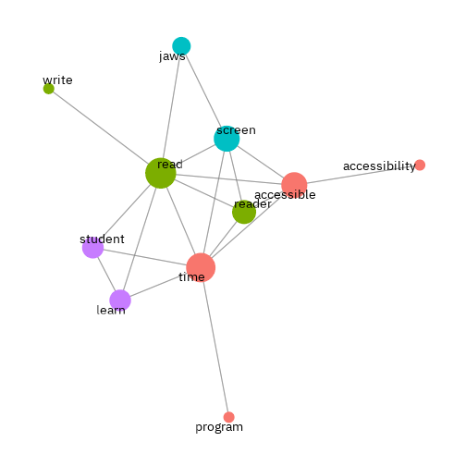

Figure 4.5: Co-occurrence network graph across the four NFB mailing lists (sorted by the top-40 most co-occurring pairs).

4.2.2.1.1 Computer Science Co-Occurrence Network Graph

Figure 4.6 illustrates co-occurrence network analysis result of the cs listserv, and its corresponding table is provided as an accessible format (Table 13.3).

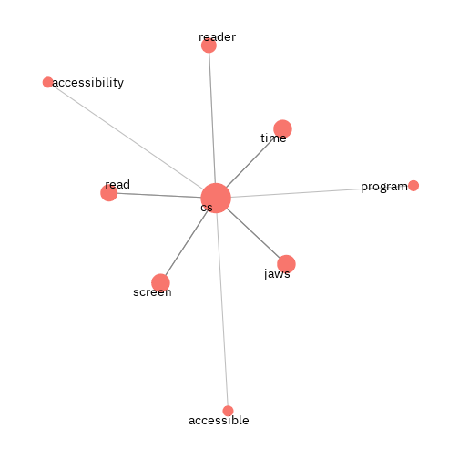

Figure 4.6: Computer science co-occurrence network graph (sorted by the top-20 most co-occurring pairs).

The top words having the highest centrality are as follows.

Table 4.4: The top words with the highest centrality in the NFB CS list.

|  |  |  |
| --- | --- | --- |
| name | centrality | group |
| cs | 20 | 1 |
| screen | 4 | 1 |
| jaws | 4 | 1 |
| time | 4 | 1 |
| read | 3 | 1 |
| reader | 2 | 1 |
| program | 1 | 1 |
| accessibility | 1 | 1 |
| accessible | 1 | 1 |

4.2.2.1.2 Math Co-Occurrence Network Graph

Figure 4.7 is the co-occurrence network analysis result of the math listserv, and its corresponding table is provided as an accessible format (Table 13.4).

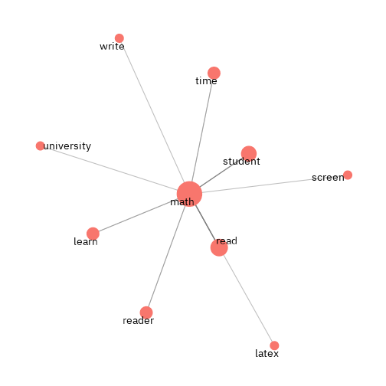

Figure 4.7: Math co-occurrence network graph (sorted by the top-20 most co-occurring pairs).

Let’s take a look at the top words having the highest centrality.

Table 4.5: The top words with the highest centrality in the NFB math list.

|  |  |  |
| --- | --- | --- |
| name | centrality | group |
| math | 20 | 1 |
| read | 6 | 1 |
| student | 4 | 1 |
| reader | 2 | 1 |
| time | 2 | 1 |
| learn | 2 | 1 |
| screen | 1 | 1 |
| write | 1 | 1 |
| latex | 1 | 1 |
| university | 1 | 1 |

4.2.2.1.3 Science Co-Occurrence Network Graph

Figure 4.8 shows the co-occurrence network analysis result of the science listserv, and its corresponding table is provided as an accessible format (Table 13.5).

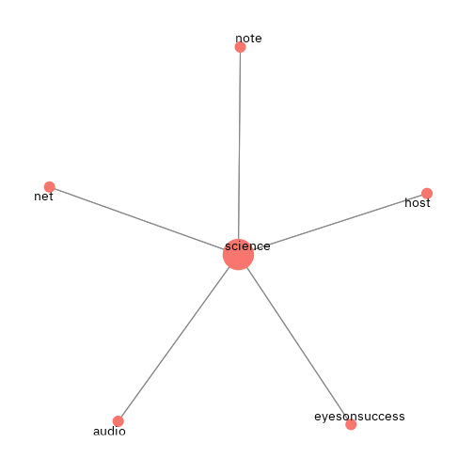

Figure 4.8: Science co-occurrence network graph (sorted by the top-20 most co-occurring pairs).

The highest centrality is as follows:

Table 4.6: The top words with the highest centrality in the NFB science list.

|  |  |  |
| --- | --- | --- |
| name | centrality | group |
| science | 20 | 1 |
| eyesonsuccess | 4 | 1 |
| net | 4 | 1 |
| note | 4 | 1 |
| audio | 4 | 1 |
| host | 4 | 1 |

4.2.2.1.4 Arts Co-Occurrence Network Graph

Figure 4.9 illustrates the co-occurrence network analysis result of the arts listserv, and its corresponding table is provided as an accessible format (Table 13.6).

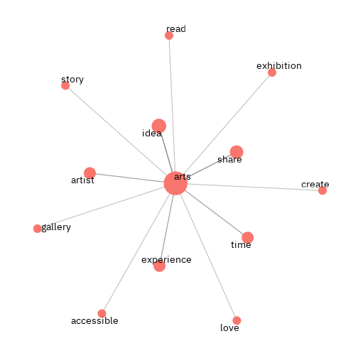

Figure 4.9: Arts co-occurrence network graph (sorted by the top-20 most co-occurring pairs).

The top words having the highest centrality are as follows.

Table 4.7: The top words with the highest centrality in the NFB arts list.

|  |  |  |
| --- | --- | --- |
| name | centrality | group |
| arts | 20 | 1 |
| idea | 4 | 1 |
| share | 3 | 1 |
| experience | 2 | 1 |
| artist | 2 | 1 |
| time | 2 | 1 |
| gallery | 1 | 1 |
| exhibition | 1 | 1 |
| create | 1 | 1 |
| love | 1 | 1 |
| story | 1 | 1 |
| accessible | 1 | 1 |
| read | 1 | 1 |

#### 4.2.2.2 Quan RQ2.2: What are the most correlated words in each mailing list?

4.2.2.2.1 Computer Science Correlation Network Graph

Figure 4.10 illustrates the correlation network analysis result of the cs listserv, and its corresponding table is provided as an accessible format (Table 13.7).

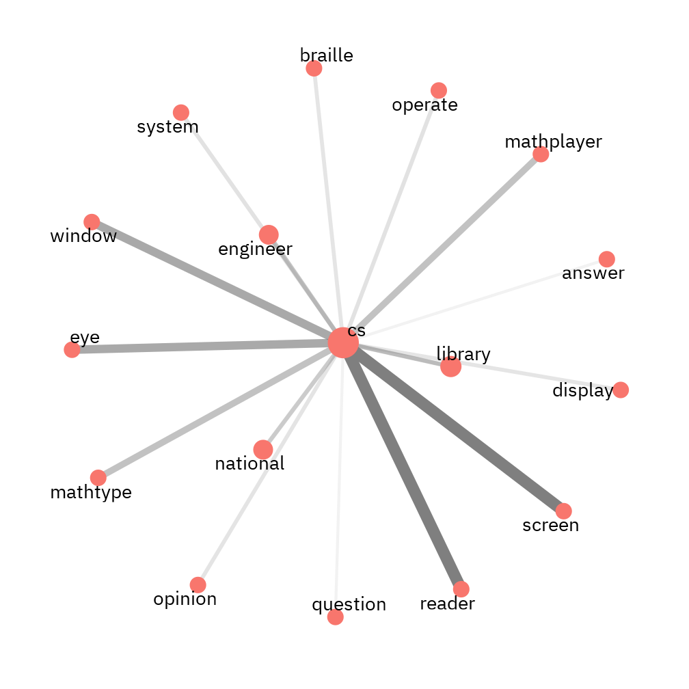

Figure 4.10: Computer science correlation network graph (sorted by the top-20 most correlated pairs).

Let’s take a look at the top words having the highest centrality.

Table 4.8: The top words with the highest centrality in the NFB CS list.

|  |  |  |
| --- | --- | --- |
| name | centrality | group |
| cs | 20 | 1 |
| library | 3 | 1 |
| engineer | 2 | 1 |
| national | 2 | 1 |
| reader | 1 | 1 |
| screen | 1 | 1 |
| eye | 1 | 1 |
| window | 1 | 1 |
| mathplayer | 1 | 1 |
| mathtype | 1 | 1 |
| operate | 1 | 1 |
| system | 1 | 1 |
| opinion | 1 | 1 |
| braille | 1 | 1 |
| display | 1 | 1 |
| answer | 1 | 1 |
| question | 1 | 1 |

4.2.2.2.2 Math Correlation Network Graph

Figure 4.11 illustrates the correlation network analysis result of the math listserv, and its corresponding table is provided as an accessible format (Table 13.8).

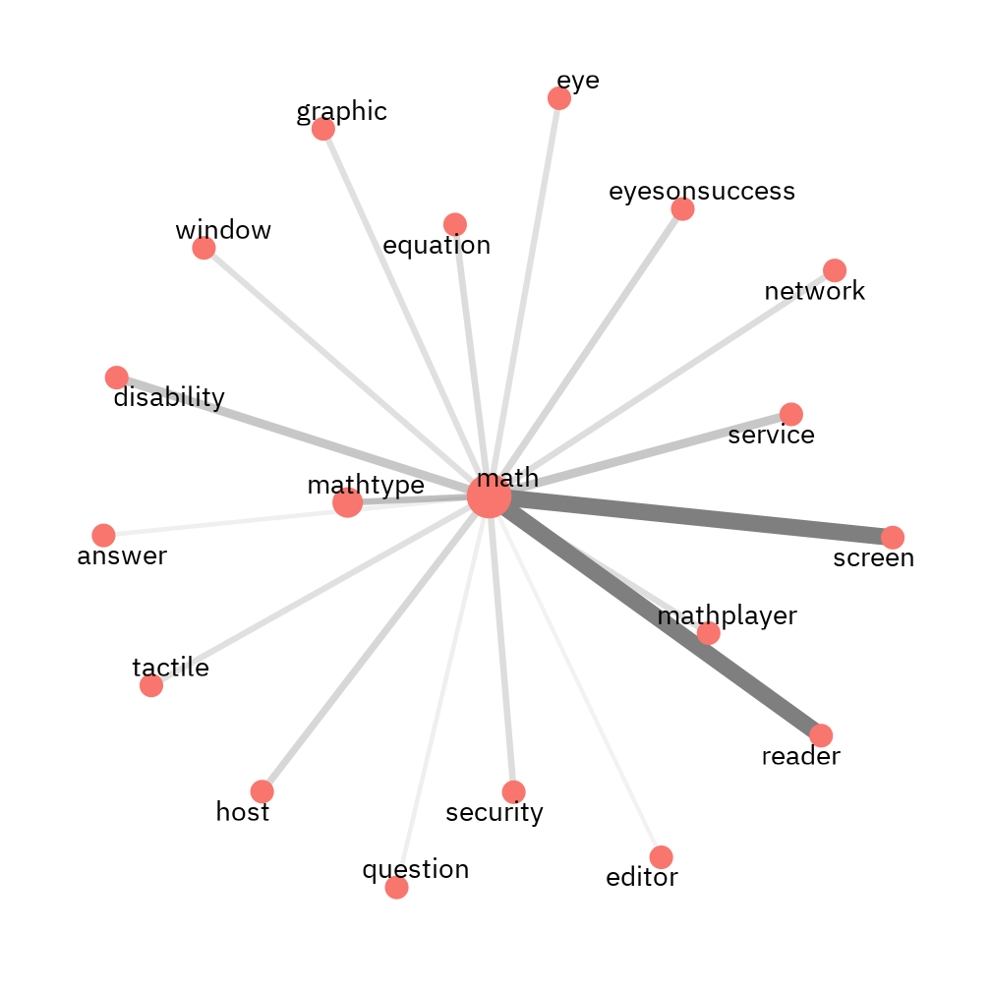

Figure 4.11: math correlation network graph (sorted by the top-20 most correlated pairs).

Let’s take a look at the top words having the highest centrality.

Table 4.9: The top words with the highest centrality in the NFB math list.

|  |  |  |
| --- | --- | --- |
| name | centrality | group |
| math | 20 | 1 |
| mathtype | 3 | 1 |
| reader | 1 | 1 |
| screen | 1 | 1 |
| service | 1 | 1 |
| disability | 1 | 1 |
| eyesonsuccess | 1 | 1 |
| host | 1 | 1 |
| equation | 1 | 1 |
| network | 1 | 1 |
| security | 1 | 1 |
| mathplayer | 1 | 1 |
| graphic | 1 | 1 |
| tactile | 1 | 1 |
| eye | 1 | 1 |
| window | 1 | 1 |
| answer | 1 | 1 |
| question | 1 | 1 |
| editor | 1 | 1 |

4.2.2.2.3 Science Correlation Network Graph

Figure 4.12 illustrates the correlation network analysis result of the science listserv, and its corresponding table is provided as an accessible format (Table 13.9).

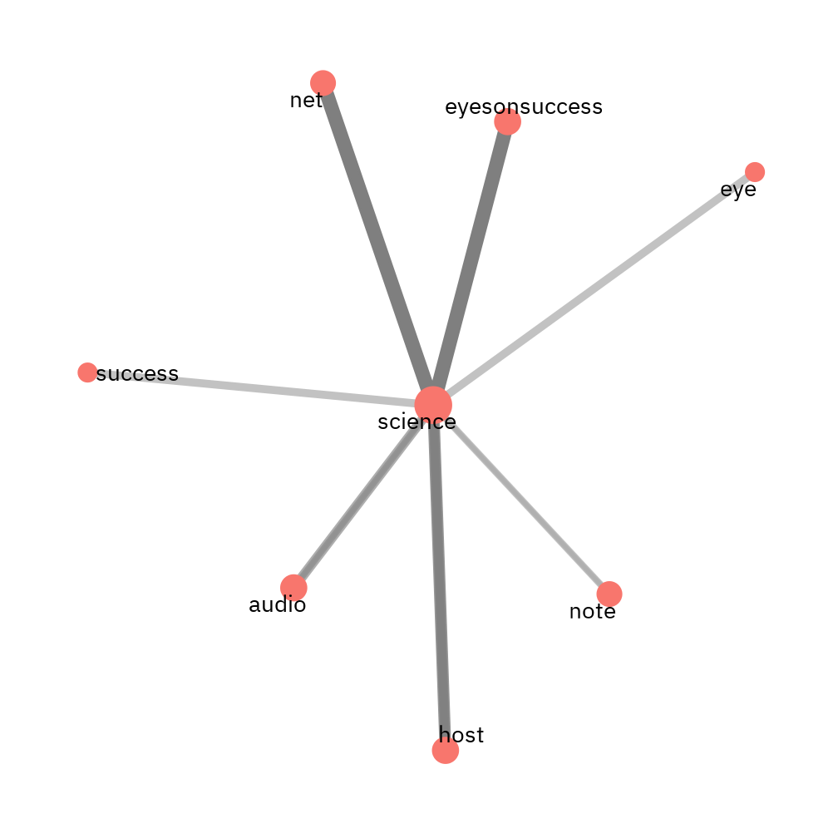

Figure 4.12: science correlation network graph (sorted by the top-20 most correlated pairs).

Let’s take a look at the top words having the highest centrality.

Table 4.10: The top words with the highest centrality in the NFB science list.

|  |  |  |
| --- | --- | --- |
| name | centrality | group |
| science | 20 | 1 |
| eyesonsuccess | 4 | 1 |
| host | 4 | 1 |
| audio | 4 | 1 |
| net | 3 | 1 |
| note | 3 | 1 |
| success | 1 | 1 |
| eye | 1 | 1 |

4.2.2.2.4 Arts Correlation Network Graph

Figure 4.13 illustrates the correlation network analysis result of the arts listserv, and its corresponding table is provided as an accessible format (Table 13.10).

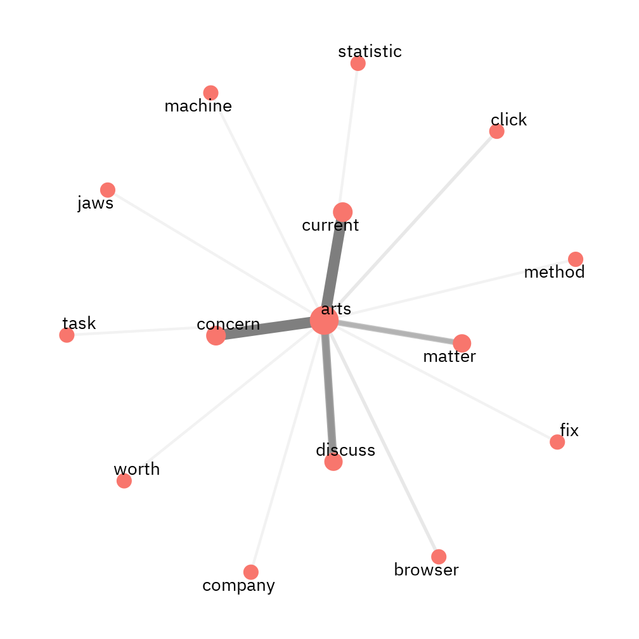

Figure 4.13: arts correlation network graph (sorted by the top-20 most correlated pairs).

Let’s take a look at the top words having the highest centrality.

Table 4.11: The top words with the highest centrality in the NFB arts list.

|  |  |  |
| --- | --- | --- |
| name | centrality | group |
| arts | 20 | 1 |
| current | 3 | 1 |
| concern | 3 | 1 |
| discuss | 2 | 1 |
| matter | 2 | 1 |
| browser | 1 | 1 |
| click | 1 | 1 |
| statistic | 1 | 1 |
| task | 1 | 1 |
| company | 1 | 1 |
| machine | 1 | 1 |
| fix | 1 | 1 |
| jaws | 1 | 1 |
| method | 1 | 1 |
| worth | 1 | 1 |

#### 4.2.2.3 Quan RQ2.3: What are the most common bigrams (a pair of two words) in each mailing list?

4.2.2.3.1 Computer Science Bigram

Figure 4.14 illustrates the bigram network analysis result of the cs listserv, and its corresponding table is provided as an accessible format (Table 13.11).

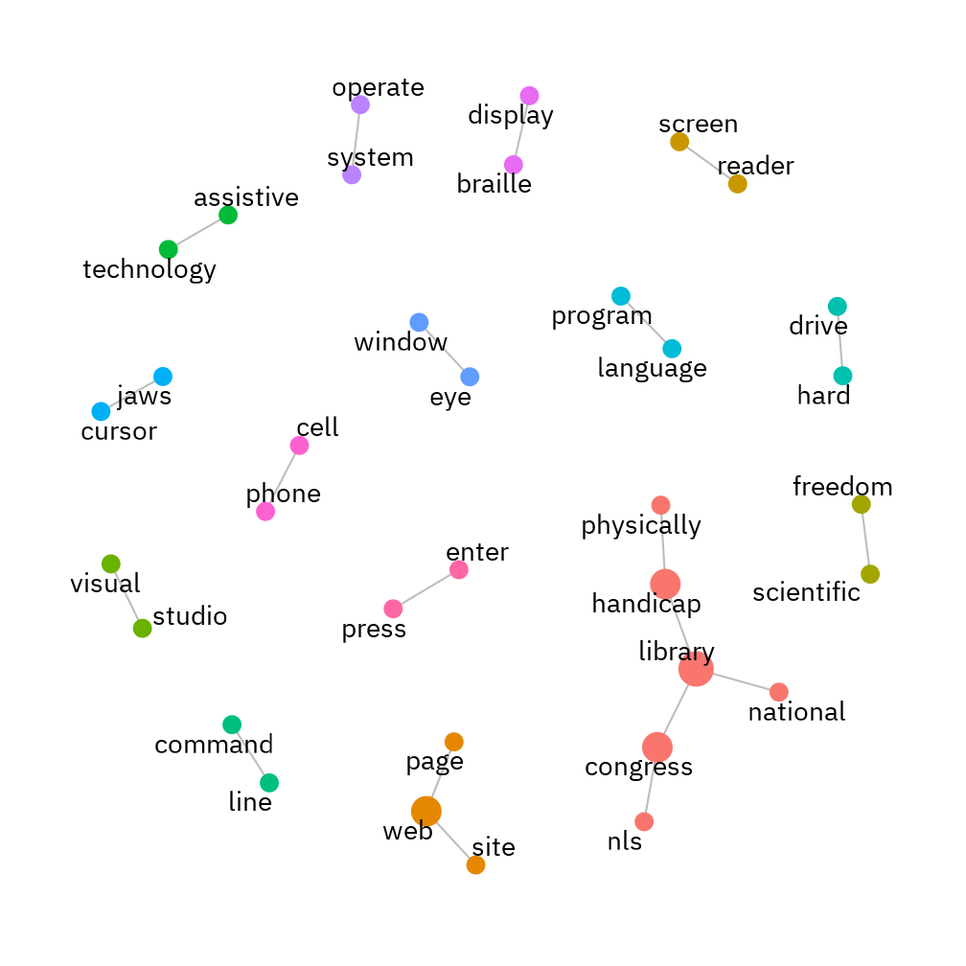

Figure 4.14: Bigram network graph with the top-20 pairs for cs listserv.

4.2.2.3.2 Math Bigram

Figure 4.15 illustrates the bigram network analysis result of the math listserv, and its corresponding table is provided as an accessible format (Table 13.12).

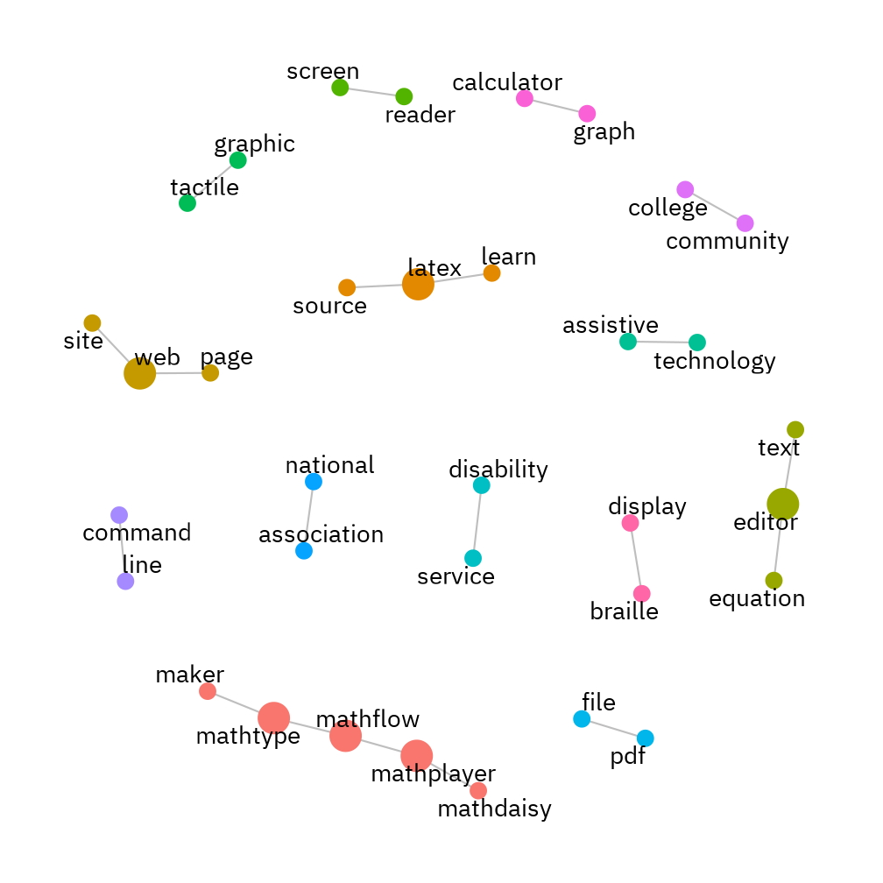

Figure 4.15: Bigram network graph with the top-20 pairs for math listserv.

4.2.2.3.3 Science Bigram

Figure 4.16 illustrates the bigram network analysis result of the science listserv, and its corresponding table is provided as an accessible format (Table 13.13).

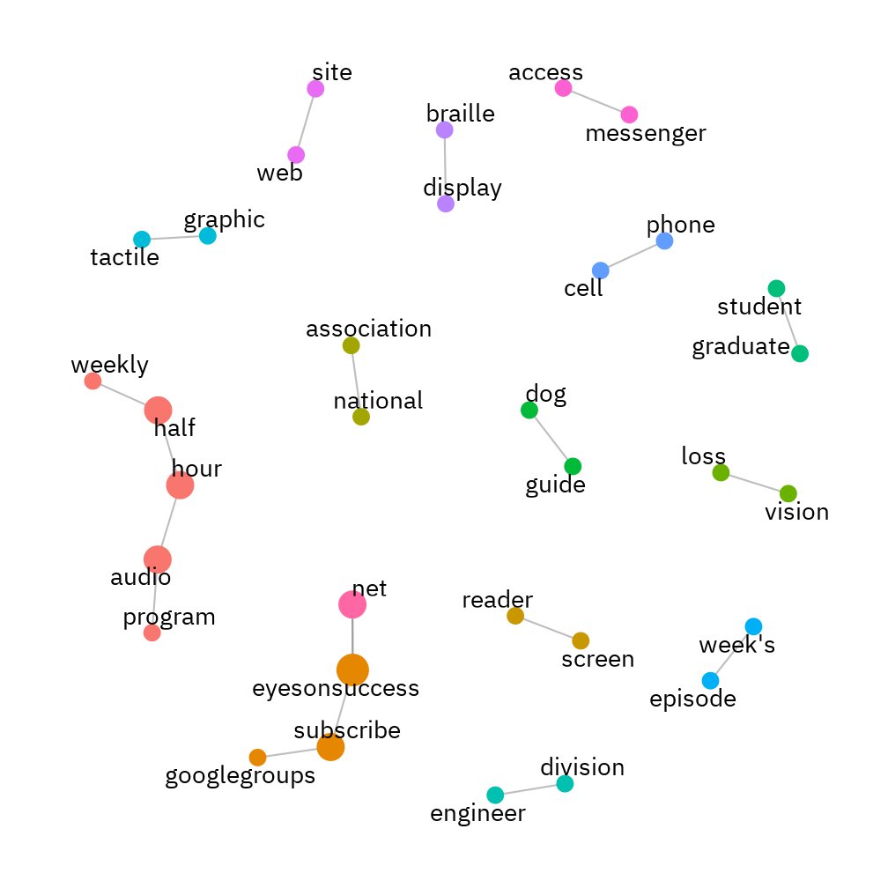

Figure 4.16: Bigram network graph with the top-20 pairs for science listserv.

4.2.2.3.4 Arts Bigram

Figure 4.17 illustrates the bigram network analysis result of the arts listserv, and its corresponding table is provided as an accessible format (Table 13.14).

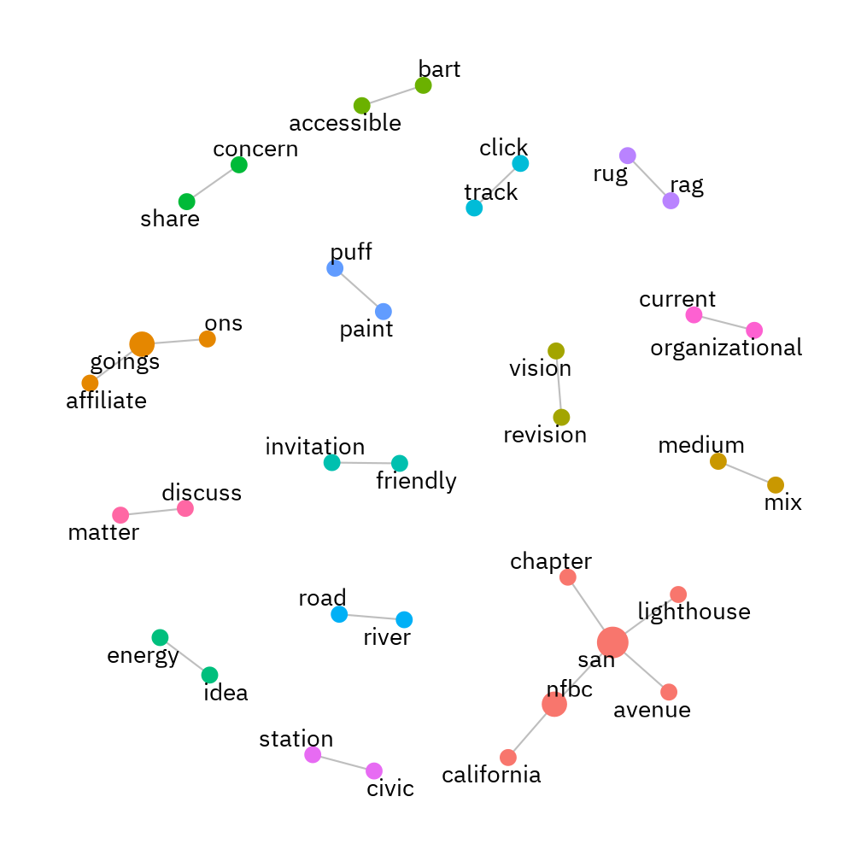

Figure 4.17: Bigram network graph with the top-20 pairs for arts listserv.

### 4.2.3 Data Clustering Questions

#### 4.2.3.1 Quan RQ3.1: What are estimated latent topics across all of the four target mailing lists calculated by Structural Topic Models? (simply stated, What kinds of conversations are provoked across all of the four NFB mailing lists?)

While semantic network provides general ideas, topic modeling offers more nuenced themes. To estimate latent topics, I trained multiple Structural Topic Models (M. E. Roberts et al., 2013) with different number of topics (K = 20 | 40 | 50 | 60 | 70 | 80 | 100) based on the content variable that included message body text. The optimal number of topics (K) was chosen based on two strategies: (1) the diagnostic analysis on held-out likelihood and residuals (Figure 4.18), and (2) relationship analysis between semantic coherence and exclusivity (Figure 4.19).

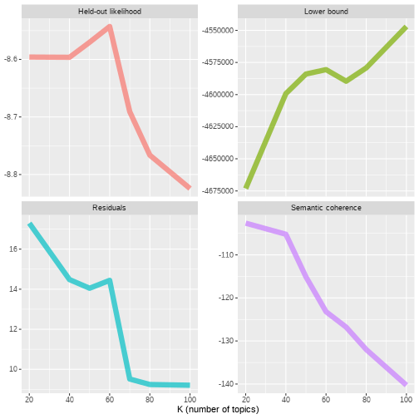

Figure 4.18: Model diagnostics by number of topics. The held-out likelihood is highest between 20 and 50, and the residuals are lowest around 40.

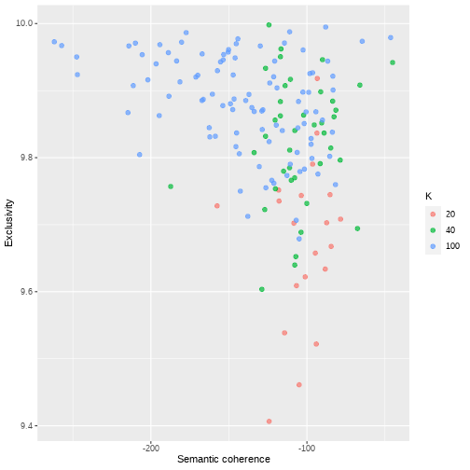

Figure 4.19: Comparing exclusivity and semantic coherence. Models with fewer topics have higher semantic coherence than more topics, but lower exclusivity.

Drawing upon these holistic diagnostics, I determined 40 as the optimal number of topics for the given corpus and extracted the topic prevalence in the corpus (Table 4.12). In the Table, $θ$ matrix indicates the probabilities that each document is generated from each topic; each topic is a mixture of probabilistically contributing words.

Table 4.12: Document-Topic prevalence in the corpus with the top 6 words that contribute to each topic.

|  |  |  |
| --- | --- | --- |
| topic | theta | term |
| Topic 26 | 0.0580 | key, control, enter, press, type, button |
| Topic 27 | 0.0439 | jaws, screen, reader, read, software, nvda |
| Topic 32 | 0.0434 | job, agree, company, world, accessibility, hard |
| Topic 10 | 0.0430 | question, experience, answer, understand, issue, specific |
| Topic 9 | 0.0413 | student, college, class, school, university, learn |
| Topic 19 | 0.0413 | latex, document, format, convert, file, pdf |
| Topic 8 | 0.0390 | accessible, accessibility, web, site, link, free |
| Topic 18 | 0.0369 | microsoft, fix, issue, update, happen, office |
| Topic 21 | 0.0361 | program, code, language, write, java, learn |
| Topic 36 | 0.0326 | drive, laptop, machine, usb, pc, system |
| Topic 12 | 0.0326 | hear, send, hope, call, post, day |
| Topic 20 | 0.0320 | linux, run, install, system, machine, server |
| Topic 6 | 0.0317 | file, download, copy, save, xp, message |
| Topic 4 | 0.0316 | engineer, student, meet, research, stem, national |
| Topic 17 | 0.0304 | braille, book, print, display, code, text |
| Topic 34 | 0.0293 | symbol, write, line, table, dot, formula |
| Topic 28 | 0.0287 | easy, reason, remember, sort, wrong, correct |
| Topic 39 | 0.0284 | device, app, display, iphone, phone, buy |
| Topic 38 | 0.0266 | graph, calculator, teacher, sight, understand, concept |
| Topic 37 | 0.0257 | graphic, image, tactile, diagram, embosser, produce |
| Topic 2 | 0.0231 | test, stuff, start, break, suppose, week |
| Topic 11 | 0.0229 | product, company, feature, freedom, software, scientific |
| Topic 25 | 0.0203 | net, audio, host, note, success, eyesonsuccess |
| Topic 31 | 0.0195 | public, organization, national, agency, contact, job |
| Topic 15 | 0.0185 | phone, service, twitter, technology, fax, facebook |
| Topic 23 | 0.0177 | mathplayer, mathml, mathtype, equation, en, support |
| Topic 33 | 0.0175 | support, process, standard, add, exist, involve |
| Topic 5 | 0.0171 | aph, draw, paper, tactile, board, model |
| Topic 16 | 0.0170 | excel, datum, software, command, statistic, spss |
| Topic 29 | 0.0160 | love, life, story, idea, artist, time |
| Topic 22 | 0.0138 | field, benefit, career, skill, time, favor |
| Topic 40 | 0.0132 | time, idea, solution, sound, mind, share |
| Topic 1 | 0.0127 | article, news, visit, excellent, book, publication |
| Topic 24 | 0.0120 | svg, file, program, tutorial, draw, java |
| Topic 7 | 0.0119 | error, receive, intend, information, immediately, attachment |
| Topic 14 | 0.0117 | pay, address, talk, complaint, personal, doubt |
| Topic 13 | 0.0104 | library, opinion, engineer, national, nls, physically |
| Topic 30 | 0.0052 | id, aim, radio, spanish, zone, english |
| Topic 3 | 0.0045 | register, missouri, registration, wednesday, convention, contest |
| Topic 35 | 0.0022 | coin, child, literacy, percent, independence, vehicle |

I found that most of the topics were focused on questions and answers about how to use Windows (topics 26; 6) and Microsoft Office suite (topic 18) with screen-reading software (topic 27). Topic 26, in particular, showed that blind people rely heavily on keyboard shortcuts when using computers. This is because mouse control is challenging for blind people to interact with GUI interfaces. While general computer usage on the Windows operating system seemed to be the most active listserv topics, there were other topics concerning STEM accessibility. For example, topic 9 illustrated active discussions on disability services and accommodations at universities. Topics 19 and 23, on the other hand, were very specific to discussions on math accessibility while topic 4 was about the general information on STEM accessibility meeting at the NFB community.

More advanced listserv discussions were also found. Java programming (topic 21) and Linux system engineering (topic 20) and computer device management (topic 36) revealed that blind people can achieve high-level computational work as long as the related environments are configured to their assistive technologies (e.g., refreshable Braille display = Topic 17; screen readers = Topic = 27).

There were some topics very specific to tactile alternatives. Topics 5, 36, and 38 were concerned about how to use tactile products, such as braille embossers and tactile drawing kits, to alternate visual outcomes which is a critical modality in learning STEM subjects.

However, there were few topics that needed to be filtered out. Topic 7 and 14 were a set of texts for either the listserv email header or email footer. This suggests that unsupervised topic modeling is also useful to identify such trivial patterns that predefined regular expressions could have missed.

#### 4.2.3.2 Quan RQ3.2: In what ways are the estimated structural topics correlated with each other?

To calculate sophisticated correlation matrix, I used the semiparametric procedure in the R package “huge” (Zhao et al., 2012) and Meinshausen et al. (2006) graph estimation. Such estimated topic correlations were visualized using the “igraph” (Csardi et al., 2006) package to plot a network where nodes are topics and edges indicate a positive correlation (Figure 4.20).

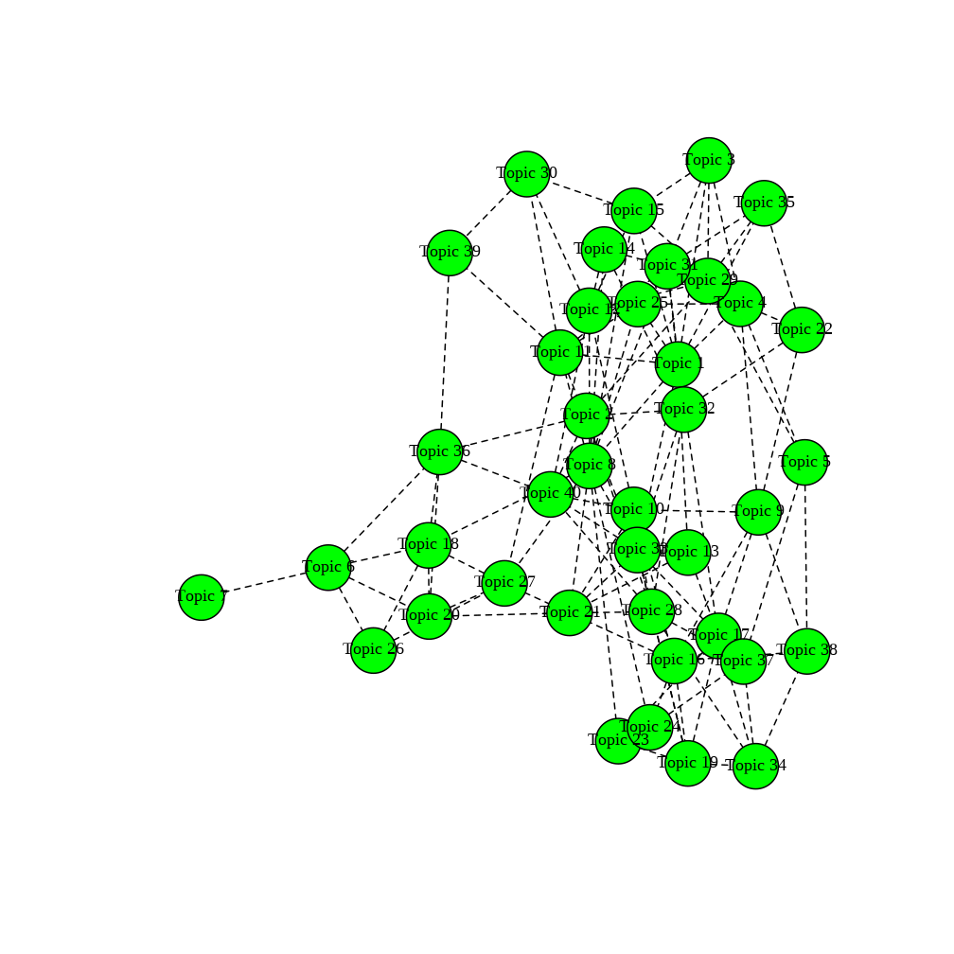

Figure 4.20: Topic correlation plot.

I also created hierarchical correlation clustering plot using Data-Driven Documents (, Bostock et al., 2011) which is accessible as an [online resource](https://jooyoungseo.com/%5Btbd%5D).

#### 4.2.3.3 Quan RQ3.3: How does the rate of topics (i.e., topical prevalence) change over time?

To answer this question, I fitted a regression model using “stm” package (M. Roberts et al., 2019) with “year” being a single covariate after a base spline transformation (see Table 13.15 for the complete regression result). I then visualized the topic-by-year prevalence ($θ$) patterns using a heatmap (Figure 4.21).

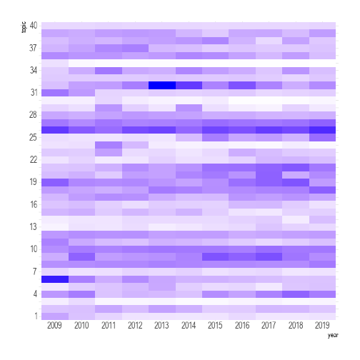

Figure 4.21: Heatmap showing topic prevalence by year.

#### 4.2.3.4 Quan RQ3.4: How do these topical distributions (detected from RQ3.1) vary by the four types of the NFB mailing lists?

This time, I fitted a regression model using “stm” package (M. Roberts et al., 2019) with “list” being a single factor covariate (see Table 13.16 for the complete regression result). I then visualized the topic-by-list prevalence ($θ$) patterns using a heatmap (Figure 4.22).

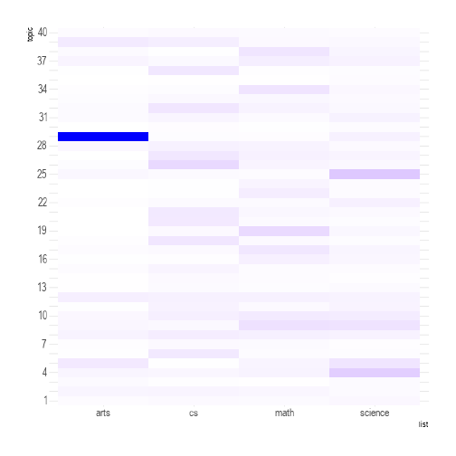

Figure 4.22: Heatmap showing topic prevalence by list.

#### 4.2.3.5 Quan RQ3.5: How do the detected topical distributions vary by the type of mailing lists over time?

I fitted multi-regression models using “stm” package (M. Roberts et al., 2019) with two covariates (i.e., “list” factor and spline-transformed “year” predictor). No interaction effect between the two covariates was considered for this analysis (see Table 13.18 for the complete regression result). I then visualized the topic-by-year prevalence ($θ$) patterns for each of the four listservs using a heatmap (Figure 4.23).

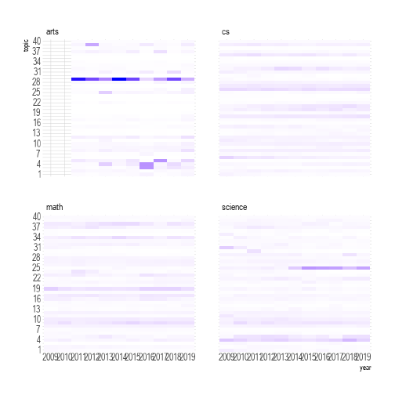

Figure 4.23: Heatmap showing topic prevalence by year for each of the four listservs.

## 4.3 Findings from Semi-Structured Interviews

In parallel with the computational results above, I also conducted semi-structured interviews with eight individuals recruited from the NFB mailing lists to better understand meaning of the discovered knowledge patterns (see Chapter 3.7.2).

The interview took place between February 2020 and December 2020, and each of the eight interviews was carried out on Zoom Conference platform due to its great accessibility features for screen readers. Each session lasted approximately an hour following carefully prepared semi-structured interview protocol, which included few questions about their visual impairments, learning experiences in STEM subjects, experience with the NFB mailing lists, and demographic information (see Appendix 8.3). With the participants’ consent, all the interviews were audio-recorded and transcribed for further analysis (Appendix 9 includes interview transcripts).

Throughout the interview process, I was attempting to find answers to the following two research questions. (1) Qual RQ1: What are the common STEM-related issues of blind learners? (2) Qual RQ2: What strategies are utilized by blind individuals to pursue STEM disciplines?

Below are the three saturated thematic results cutting across the two research questions.

### 4.3.1 Self-Directed Learning Over Lectures

The first thematic result found from the interview is that blind people tend to rely on self-directed learning strategies over classroom lectures due to inaccessible classroom environments. This means blind people often fall behind in classrooms where instructors use a visual channel as a primary communication. Because of the lack of verbally understandable content, blind learners choose to catch up with the classroom content later on following their pace and alternative learning strategies. To highlight this point, I’d like to share an example of my participants’ experiences.

Participant 1 (P1) was a 32-year-old Caucasian man in San Francisco who was pursuing his Bachelor degree in Physics. He identified his visual impairment level as “Severe vision impairment.” He had been a member of two NFB STEM listservs (i.e., “Science and engineering”; “BlindMath”) for four months as of the interview.

R: Okay, so what are the most challenging issues for you to learn stem related content as being blind.

P1: So, right now, what’s really difficult is Math and diagrams. Getting math and any sort of diagram or model in an accessible format. And that’s been kind of the biggest hurdle in the classroom so far. In physics, there are a lot of a lot of things are taught using visual aids diagrams and models and stuff so I don’t have access to that.

R: So that’s been probably the biggest issue.

P1: Yeah, as well as getting math equations that are accessible. Ton of equations. I still don’t want to have to memorize them so nice to have a formula sheet.

R: I see, then, how have you addressed those problems and what strategies have you utilized?

P1: So for the formulas I my professor hands out a formula at the beginning of the term. So I’ve made my own accessible version of …

R: Oh, how do you do that?

P1: I just typed it up in word, it’s not very fancy or anything. It’s basically if anyone else were to read it in. Yeah, be confusing, but it works for me. So I just need a generally I have the formulas mostly memorize. Anyways, after hearing all so it’s it’s really just jogged my memory. Basically, when I can. So I am I am starting to learn latex just swing and actually do real good looking math formulas, but just for now I just read stuff in Word documents, that’s

R: WOW Incredible!

P1: Me. Yeah. So my own kind of like personal notes.

P1 developed his own strategies to organize math formulas against visual and inaccessible classroom learning. In terms of how much information a blind person gets out of STEM lectures, participant 3 (P3) shared related experience during his interview. P3 is a 41-year-old post-doctoral researcher holding a Ph.D. degree in Particle Physics. P3 identified himself as “a totally blind person with zero vision.” He was originally from Pakistan, and moved to the United States when he was 23 for his second Bachelor in Physics. He had been a member of the NFB BlindMath listserv since 2001 (about 18-year subscription).

P3: The classrooms were a little funky because when teachers started writing on the board, it becomes hard to follow. The university used to provide note takers. Some students would be hired to take notes and give them to me, but following the lecture itself was always. I didn’t get too much out of the lectures. I didn’t get that much out of lectures, that was always a problem.

R: I understand.

P3: Even in grad school at times I felt like it was a waste of time to even go to a lecture, so I would stay at home and read. But although I did attend lectures, but in hindsight. If I could do it again, I’m not sure if I would attend the lectures as much or who knows maybe I would, but following lectures was difficult. Even now when I’m attending seminars, people start writing on the board the equations, that’s the part that’s bad, that’s difficult. I do my homework, the same kind of WinTriangle format.

The similar struggles of blind learners in STEM classrooms could be found in the collected email corpus as a pronounced pattern. Figure 4.24 represents some of these voiced by the NFB listserv members.

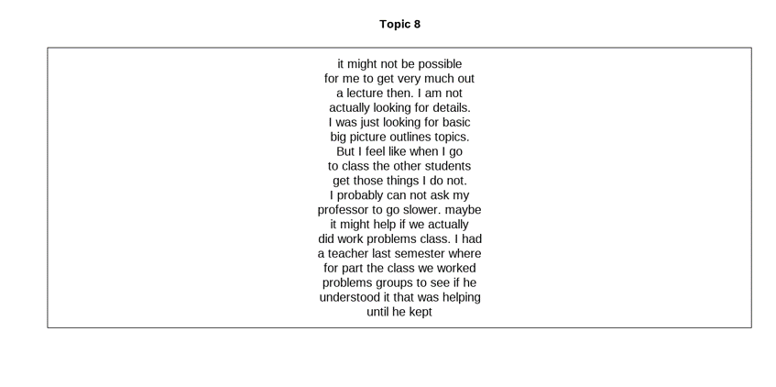

Figure 4.24: Email corpus representing blind students’ challenge in lectures.

### 4.3.2 Linear Verbal Learning

The second thematic characteristic is concerned with in what ways blind STEM learners digest such highly vision-dominant information. In other words, I focused on what technologies and modalities blind individuals had been using for their STEM learning.

According to my interviews with eight STEM learners with visual impairments, the most common issue with learning STEM content was math accessibility. Since Mathematics plays a critical role in STEM disciplines as a logical backend (Christenson, 2011), math accessibility was directly related to students’ success in STEM (Beck-Winchatz & Riccobono, 2008). Thus, the following include some excerpts as to how blind learners approached math content. Participant 4 (P4) was a 22-year white female undergrad student pursuing Biochemistry in Delaware. She self-identified her level of visual impairment as “Severe vision impairment.” She had been subscribing to both “Science and engineering” and “BlindMath” listservs for two years.

R: Do you tend to go to and ask disability office to provide you with some accessible materials? Or do you communicate directly with your professor first?

P4: It depends on the material so if it’s something that has a lot of mathematical formula, I’ve had some calculus professors who write all of their tests and things in LaTeX. So I knew how to read LaTeX and so they just gave me a digital copy of the test. But for other professors, for example for chemistry, where it is very image-based and does involve a lot of translation and transcription of something visual and something tactile. That’s definitely where I’d involve, disability services because it’s not the professor’s area of expertise.

R: Yeah. Okay. Let me ask this question, you mentioned you’re using LaTeX.

P4: Yes.

R: What other technology do you use specifically for your math and science classes like MathML or other?

P4: I do use MathML in a lot of cases, when I get textbooks, for example my physics textbook is in MathML. And so I use that in grids for the braille display so I can read equations for easily, it’s helpful to have the braille display as well as speech to make sure I’m not missing anything. So I’d say that’s primarily what I do, I tend to avoid hard copy braille whenever I can. And lately as you know [crosstalk 00:14:22].

R: Because of the bulky volume.

P4: Yeah. So bulky, yeah.

R: LaTeX is really complex when it gets longer.

P4: It is. Yes.

R: So do you primarily use LaTeX for a writing purpose or reading purpose?

P4: I would say primarily for reading purposes, I have a shorter hand notation that I use to work problems. But if the professor asks that to be translated into LaTeX I can. Typically what I will do is write, if the professor knows LaTeX, I’ll write my final answer in LaTeX and if they’re curious about my work, they can go back and look at the shorthand notation that… I typically just use Computer Braille when I’m writing out because I realized Nemeth is great and everything; but it takes up a little bit more room than Computer Braille does. So I’ve realized that because in Computer Braille you don’t have to have the number symbol at the front, you don’t have to have the equal sign takes up two cells instead of one. So that was just a decision I made based on efficiency.

R: Awesome. What’s your special strategy for the back translation between Braille Nemeth Code and sided print.

P4: So it depends, I would say since I do a lot of my stuff visually, it just depends on what the professor wants. Like I said, if the professor knows LaTeX then I just write out my answers in LaTeX and use MathType or some other add-on to convert that to a PDF and then either email it to a TA or whoever’s grading it. Or for example, if I’m taking a test in the disability office, they’ll typically put the test on a flash drive, I will take the test and then they’ll somehow either print it out; or get it to the professor that way or somehow find a way to get it to them digitally. And especially this semester, professors have been great about TAs or whoever’s grading has been great about getting me things back in a digital format. So that I can actually see, “Okay, here’s what I wrote,” potentially any comments or anything the professor made. So that I’m not having to rely on sighted assistance to read me back my graded papers, which is nice.

R: Cool. P4, did you go to special school for the blind?

P4: I did not. I was mainstreamed my whole life.

R: Then, how did you learn the math code and LaTeX and other blind skills for STEM.

P4: So in early life, I had a teacher of the visually impaired so it was from, I would say early childhood all the way up until eighth grade. And then in high school, I was actually in a private high school so I did not have a teacher of the visually impaired. So a lot of the STEM related skills that I learned other than, I learned Nemeth in early elementary school and things like that. But I really did teach myself a lot, I taught myself LaTeX so it was very much… My motivation was there and so I pretty much told myself, “Okay, here’s a solution to this problem, here’s how to…” Because it’s hard for someone to teach you a programming language [crosstalk 00:17:49] you have to teach yourself. So that’s how it ended up working out.

As mentioned in the excerpt above, blind students rely heavily on LaTeX, a plaintext typeset system, when reading and writing Math content. This general tendency can be found in the Math list corpus as reported in Figure 4.11. According to Seo & McCurry (2019), LaTeX has been widely used and recommended among blind people in STEM disciplines; however, it requires a steep learning curve. For example, the Theorem 4.2 illustrates what LaTeX markup looks like.

Theorem 4.2 (LaTeX example theorem.)

$${\left(\sum_{i=1}^{n}{i}\right)}^{2}={\left(\frac{n\left(n-1\right)}{2}\right)}^{2}=\frac{n^{2}{\left(n-1\right)}^{2}}{4}$$

is the result of the following LaTeX code:

\left( \sum_{i=1}^{n}{i} \right)^2 = \left( \frac{n(n-1)}{2}\right)^2 = \frac{n^2(n-1)^2}{4}

Since LaTeX markup is presented in a linear fashion, it demands a heavier cognitive cost than image display in human short-term memory (Clark & Paivio, 1991). As P4 mentioned, on the other hand, blind students often utilize refreshable braille display, the hardware device for presenting literary braille chords in a tactile form (Figure 4.25).

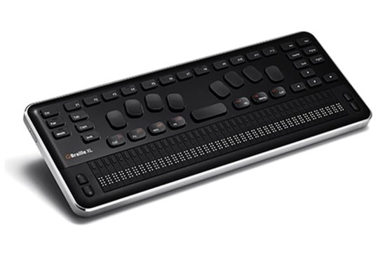

Figure 4.25: Refreshable braille display..

Although such assistive technology can reduce some short-term memory cost, the linear nature of braille system makes it hard for blind people to get a high level picture of complex equations which would typically be represented in a two-dimensional visual form for sighted people (Beck-Winchatz & Riccobono, 2008; Seo & McCurry, 2019).

### 4.3.3 Positive Attitudes

The third thematic finding suggests that the interviewees did not consider their visual impairments as a stumbling block for learning STEM content; rather, they leveraged the visual challenges as a source of problem-solving efforts. The following interview excerpt of the participant 4 (P4) clearly illustrates this point.

P4: And then in college I actually started out at a small liberal arts school in Virginia and then I realized as I got more involved with my degree, I was originally a pre-med student. And then I realized I enjoyed chemistry and that there wasn’t a lot of computational chemistry opportunities. And a lot of people ask me, “Did you go into computational chemistry because you’re blind? Was it something you felt relegated to?” And I felt like I love computer science and I love writing code and so I was excited because computational chemistry was my two loves all in one thing. [00:02:30 - 00:03:08] . . . . . . R: As far as I understand, the reason why you were seeking computational chemistry specifically is because of your blindness?

P4: Actually not necessarily, I just personally really enjoy computational chemistry and I’ve always really liked the theory behind chemistry more than I’ve liked being in the lab. So I wouldn’t say that it’s because of my blindness, I’d just say more of that’s what I enjoy most about chemistry. [00:09:49 - 00:10:21]

Likewise, most of the interviewees had positive attitudes towards STEM disciplines regardless of their visual impairments. To highlight this point, I am sharing the three questions about their perception on STEM that I asked to each of the eight participants. The participants’ major and demographic information can be found in Table 3.3.

* Q1. I feel learning STEM subjects is ___.

P1: Fascinating rewarding but very difficult.

P2: [inaudible]

P3: Interesting and exciting.

P4: Challenging and rewarding.

P5: Challenging, but ultimately rewarding.

P6: Empowering.

P7: A wise career path for blind students.

P8: Hard.

* Q2. I think pursuing STEM disciplines as being blind is ___.

P1: It’s great. I wish more people did it.

P2: It’s challenging, and it’s very hard work and a deep attention to pursue STEM filling in.

P3: Possible, but requires determination.

P4: There’s so much I want to say. I’m trying to… Okay, let’s see. I would say an adventure.

P5: A viable goal.

P6: Powerful.

P7: Challenging but not impossible.

P8: Worth it.

* Q3. To succeed in STEM fields, a blind person needs ___.

P1: Support and opportunities from friends, family and basically faculty.

P2: HTML. He has to. He has to put an extra effort.

P3: Hard work and determination and somewhat more than your other sighted peers.

P4: To be a strong advocate and to be a problem solver.

P5: I’m not sure of how to keep it to one sentence, but I think that the biggest thing is that they need to not have a fear of failure. What worked for one person might not work for them, you might need to try five different sources of information until you finally find one that clicks or maybe you need to try something multiple times before you find the way. There’s almost always a way as long as you can keep whatever drives you internally to continue moving forward, as long as you can keep that, then you can find a way.

P6: Persevere.

P7: Motivation and perseverance.

P8: Tenacity.

As stated in each of the participants’ excerpts, STEM is perceived as an area of possible adventure. The general trend of blind people’s positive attitude for STEM fields can be found in the sentimental analysis of the NFB mailing corpus (Figure 4.26). In sum, despite various challenges, blind people pursuing STEM disciplines tended to focus on their capabilities rather than difficiencies.

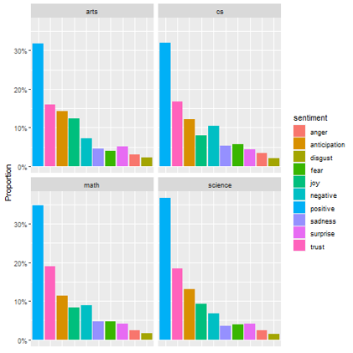

Figure 4.26: Sentiment analysis on the four NFB STEM mailing listservs.

## 4.4 Comprehensive Results

Although each separate strand of the computational and qualitative data analyses offers their own investigative values, it is not quite clear for audience to get a sense of the analytical points in a concise manner. For example, interpretation of the results from the computational linguistics may be challenging for those not having any prior contextual information or knowledge on the target community. The structural topic modeling results, in particular, do not make sense without an extensive further exploration and/or interactions with the original document sources. Furthermore, the patterns that emerged out of the structural topic models makes it difficult to understand due to its massive information (K = 40). The qualitative data, on the other hand, offers a deeper interpretative ground for audience. Still, it may miss general patterns as it tends to highlight some detailed phenomena out of discourse text.

One of the effective ways to address these issues is mixing the strong points of the two strands. That is, integrating the computational patterns into the qualitative interpretations.

From the unsupervised machine learning offered by abductive structural topic models (Chapter 4.2.3), I obtained various patterns of the 40 topics. From the semi-structured interviews with eight individuals with visual impairments in STEM fields (Chapter 4.3), I developed how to interpret these patterns. What I am trying to do in the next section is to deductively refine the computationally captured patterns through an interpretative lense developed by the iterative communication with my eight blind informants.

### 4.4.1 Mixed RQ: What results emerge from comparing the qualitative interviews about the STEM-learning experiences of blind individuals with the computational outcomes derived from the STEM-oriented listservs?

To respond to this hybrid mixed-method research question, I reduced the 40 topics of the structural topic models into 9 interpretative codes. For this pattern refinement process, I rested upon the “Ecological Model of STEM Education” (Basham et al., 2010) as primary categories (see Chapter 2.4.1). Although Basham et al. (2010) originally suggested four nested systems for inclusive STEM education (i.e., macro-; exo-; meso-; and microsystem), the macrosystem–the foremost worldwide level including social and political impact on global STEM education system–was excluded for this coding process as the scope went beyond the current target corpus data. Table 4.13 shows how I refined the coding schemes.

Table 4.13: Coding scheme based on the STM results.

|  |  |  |  |
| --- | --- | --- | --- |
| system | code | definition | topic |
| exo | community_support | State and regional meetings, informative online broadcasts, National Library Service (NLS), exhibition, and gallery tailored for blind people in pursuing STEM disciplines. | 3, 4, 13, 29, 31, 35 |
| meso | classroom_a11y | Discussions on classroom accessibility, such as instructional design, disability services, textbook, and communications with instructors and peers. | 9 |
| meso | job_a11y | Questions and answers concerning job hunting and workplace accommodations in relation to accessibility. | 22, 32 |
| micro | screen_reader | (Text-to-speech); discourse about screen readers (e.g., JAWS/NVDA/VoiceOver/Window Eyes) general usage on Windows, Mac, and Linux with keyboard shortcuts. It can also include questions and answers about Microsoft Office suites, website navigation, and other desktop application accessibility. | 6, 8, 18, 26, 27 |
| micro | braille | (Text-to-tactile); refreshable braille display, braille notetaker, literary ((e.g., Unified English Braille) and scientific braille notations (e.g., Nemeth Math Braille), and braille ready format (BRF) translation applications. | 17 |
| micro | tactile_graphs | (image-to-tactile) embossed or 3D tactile graphs; tangible objects assisting blind people in interacting with visual diagrams. | 5, 24, 37 |
| micro | math_tech | (Math-to-text) accessible technologies related to Mathematics (e.g., LaTeX; MathML; MathType; MathPlayer; talking calculator). Discussions on equations, formula, and math-demanding applications (e.g., Excel, and SPSS) are included. | 16, 19, 23, 34, 38 |
| micro | programming | Programming languages (Java, Cobol) and their integrated development environments. Unix system engineering is also included. | 20, 21 |
| micro | mobile_apps | iOS, Android, Blackberry, | 11, 39 |

Based on the coding scheme, I deductively and interpretively assigned binary code (1 or 0) to each of the mailing list documents. More specifically, I used nested $θ$ mean threshold (grouped by list, year, and topic) to determine the code assignment. I gave “TRUE” (i.e., 1) value to topics higher than the mean threshold, otherwise “FALSE” (i.e., 0) value (see Appendix 14).

Figure 4.27 is the visualized result of code-by-year patterns that I obtained by counting the number of “TRUE” binary code by year across all the four NFB STEM mailing lists.

Discussions on screen-reader use emerged as the most significant pattern over time, followed by math-related technologies (e.g., LaTeX; MathML), which belong to “microsystem” of the ecological STEM education. That is, blind people were active in discussing how to utilize assistive technologies that could play a critical role in their STEM learning contexts. There were few relatively weaker, yet stable, patterns within macrosystem, such as discussions on tactile graphs, programming, and mobile_apps. I assume that these were special topics discussed among some groups of members over time. The text-to-tactile system for blind people, Braille and its related technologies, was the least emerging code within the “microsystem” category, which may be related to “braille literacy crisis” that less than 10 percent school-age children in the United States can read and write braille (Jernigan Institute, 2009; National Braille Press, n.d.).

Interestingly, community support, such as the NFB Annual Convension, STEM extension workshop tailored for blind students, and online broadcast programs (e.g., EyesOnSuccess Podcast) showed a consistently strong trend over. This indicates “exosystem,” which speaks to how well state and regional community supports STEM education (Basham et al., 2010).

On the other hand, codes representing “mesosystem,” such as job and classroom accessibility revealed fewer frequencies, which could be interpreted in either way: (1) Blind people were more intersted in technical topics on how to use a set of assistive technologies for learning STEM content at their individual level rather than discussing the STEM accessibility at a mesosystem level; or (2) This pattern may reveal the lack of mesosystem accessibility consideration in STEM classrooms and workplaces. I will revisit this point in the next chapter for further discussions.

These all the patterns had on-and-off trends, and the frequencies in 2010, 2015, and 2019 years were found to be the lowest.

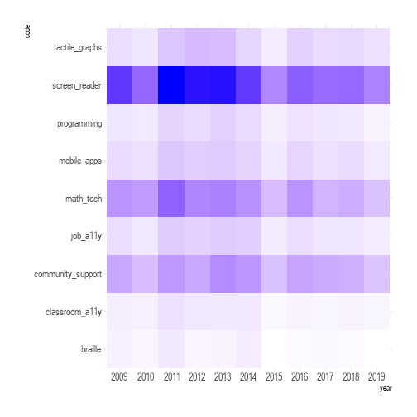

Figure 4.27: Heatmap showing code count by year.

To take a closer look at these captured patterns, I also visualized code-by-year nested by each of the four NFB STEM mailing lists. Figure 4.28 illustrates the results.

While the overall patterns discovered in Figure 4.27 can also be found this time, there are few notable interesting points.

First, the cs and math lists seemed active over time whereas the arts and science were less participated. This aligns with the first result conducted in Chapter 4.2.1. Second, while the cs had stable patterns until 2019, the math, which had stronger participation than the cs in 2011, became somewhat decreasing in recent years. Finally, despite the importance of braille literacy in the math, the discourse concerning braille was not found to be significant among the members of the listserv compared to other codes.

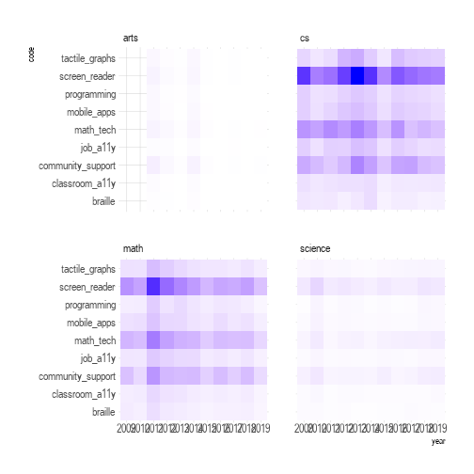

Figure 4.28: Heatmap showing code count by year for each of the four listservs.

## 4.5 Chapter Summary

This chapter reported computational and qualitative results separately and combine the two strands at the end. The computational analyses revealed that computer science (CS) was the most active and the Arts was the least participated listserv. Although science listserv had more active members (287) than arts (44), it recorded much lower replied rate (0.2567) than arts (0.4641).

The dispersion patterns of the total number of messages sent by each listserv member showed that all the listservs, regardless of their absolute number of message instances exchanged, were led by few active members. This characteristic was found the most pronounced in the cs list given that it had the largest number of outliers (Figure 4.2).

Semantic analyses including co-occurrence, correlation, and bigram networks, revealed that unique linguistic and knowledge-sharing patterns on each of the mailing lists, and these were confirmed with more advanced structural topic models (STM) fitted with 40 topics.

The semi-structured interview findings with eight individuals who are blind or visually impaired yielded three themes: (1) Self-directed learning over lectures; (2) Linear verbal learning; and (3) Positive attitudes. These were repeatedly confirmed with both computational results as well as cross-interview checking.

The hybrid mixed-method result that combined both computational and interpretative strands allowed me to deductively reduce the structural topic model patterns into 9 codes based on the nested systems introduced in “Ecological Model of STEM Education” (Basham et al., 2010). By analyzing both “code-by-year” and “code-by-year-by-list” patterns, it was found that microsystem-level technologies, such as screen readers and math-technologies accounted for most of the code patterns across all the corpus documents. In contrast, mesosystem-level conversations, such as support from and for schools and workplaces in STEM learning, was lacking. Furthermore, despite the importance of braille literacy in STEM education and its positive correlation with employment rate (National Braille Press, n.d.), knowledge-sharing patterns around braille was less pronounced compared to other microsystem technologies. This was in congruent with current braille literacy crisis (Jernigan Institute, 2009).

In the next chapter, I will conclude this study by circling back around to primary research question.

# 5 Discussion and Conclusions

## 5.1 Introduction

This chapter shares discussion points and concludes this dissertation. In the previous chapter, both computational results and qualitative findings were reported, and hybrid mixed-methods results were also suggested as a form of deductively and interpretatively refined code patterns. I will begin this chapter by highlighting some discussion points on how these findings can contribute to the primary research question of this study. Next, I will conclude this chapter by talking about suggestions for future research.

## 5.2 Discussions and Implications

The purpose of this study was to discover collective knowledge sharing patterns and informal learning cultures of blind individuals pursuing Science, Technology, Engineering, and Mathematics (STEM) disciplines as captured through computer-mediated mailing listservs (Chapter 1.3). With this research goal, I proposed a set of research questions including computational and qualitative strands under the following primary research question:

* Primary RQ: What are the sociocultural characteristics of collective knowledge-sharing patterns produced by blind learners pursuing STEM disciplines?

In the section below, I will circle back to this fundamental research question. To answer this question, I will frame my discussions within the “Ecological Model of STEM Education” (Basham et al., 2010) and will also take Alison Kafer’s political/relational model of disability, where disability is viewed as a product of social relations (Kafer, 2013).

### 5.2.1 Disconnected Mesosystem

According to “Ecological Model of STEM Education” (Basham et al., 2010), inclusive and accessible STEM education takes place when the following four systems are ecologically connected. (1) “Macrosystem” which refers to social and political values in STEM; (2) “Exosystem” concerned with regional and state impact on and community-level support for STEM; (3) “Mesosystem” covering school and workplace environments for STEM support; and “Microsystem” representing any individual-level communication and technical support for STEM education. These are not exclusive; rather, they contribute to each other towards a more inclusive STEM ecosystem (Basham et al., 2010). As stated in Chapter 4.4.1, the macrosystem went beyond the scope of this study so I attempted to capture the rest three dimensions out of the NFB STEM-oriented email corpus (see the coding scheme Table 4.13).

One of the notable patterns found out of coding results is that there were considerably fewer mesosystem-level discussions (e.g., classroom and workplace accessibility issues) than either microsystem-level technologies (e.g., screen readers; accessible math technologies) or exosystem, such as community support (Figure 4.27 and Figure 4.28). This implies that blind STEM learners were likely to address their STEM accessibility within their microsystem level, such as training themselves assistive technologies, or within exosystem by developing community-level support (e.g., the NFB Annual Convension; the NFB STEM mentoring workshop; EyesOnSuccess Podcast).

To put it another way, how blind STEM learners dealt with mesosystem-level support, such as schools, classrooms, workplaces and their environments was not as pronounced as its importance and necessisity. This trend was also confirmed with the semi-structured interviews with blind STEM learners, resulting in the second qualitative theme, “Self-Directed Learning Over Lectures” (Chapter 4.3.1). As shared in participant 3’s (P3) excerpt, he explicitly stated that he did not get much out of lectures; instead, he went back home and had to do his own catch-up studies.

The disconnected mesosystem (e.g., inaccessible classroom settings) may force blind STEM learners to be left with all the responsibilities for their own STEM frustration (Basham & Marino, 2013; Samsonov et al., 2006; Thurston et al., 2017). From a viewpoint inspired by political/relational model of disability (Kafer, 2013), this current trend may also be understood as a form of perpetuating social exclusion against “disability.”

### 5.2.2 Limited Modality of Current Assistive Technologies

Another implication we can take out of this study is concerned with limitations of current assistive technologies. The most salient patterns discovered across all the mailing lists’ corpus revealed that blind people had relied heavily on text-to-speech screen readers for their STEM content access, which utilizes humans’ verbal channel. According to “dual coding theory” (Clark & Paivio, 1991), humans learn better when information is double-encoded through both verbal (e.g., text) and non-verbal (e.g., images) because it helps reduce heavy cognitive load in our short-term memory.

Although people with visual impairments or blindness have some difficulties accessing non-verbal images in a direct way, it does not mean that there is no way for them to digest such visual information. For example, images can be expressed in tangible and tactile forms or in non-speech 3-dimensional auditory forms (i.e., sonification). Despite some alternative non-verbal modalities, however, current assistive technologies used among blind STEM learners seemed to remain in verbal channel exclusively. For instance, accessible math technologies (e.g., LaTeX; MathML; MathType) are all the math-to-text assistive technologies relying on verbal channel as does screen readers use text-to-speech verbal channel. Likewise, refreshable braille display also rests upon text-to-tactile linear verbal channel (Figure 4.25). These technologies, while largely contributing to information access in general for blind people, demand cognitvely extensive load in their working memory. This implies that such limited modality of current assistive technologies may cause another layer of barrier against blind STEM learners. Consequently, much more research on assistive technologies reducing heavy cognitive load through the use of non-verbal channel is required. If active research and development can lead to some practical success (e.g., image-to-sound (sonification) and image-to-tactile haptics), we will witness that more blind learners engage into STEM subjects.

### 5.2.3 Lacking Central Resources

Finally, the knowledge-sharing patterns discovered within the NFB listservs highlighted the lack of central resources supporting blind STEM learners’ socio-technical needs. For the social aspect, most of the email conversations were produced and contributed by few groups of members as analyzed in the positively skewed disperssion patterns (Figure 4.2). Semi-structured interviews with eight informants confirmed such characteristic–six out of the eight informants stated that they defined their role in the listservs as a peripheral observer who does not actively participate in the conversation, although tracks down what people talk about in the list (Table 3.3).

From a technical viewpoint, this highly skewed participation indicates that blind STEM learners’ know-hows (i.e., collective knowledge) had been shaped by few members, leaving other remaining knowledge of the peripheral observers, whose know-hows could have been instrumental to other members, undiscoverable. Again, the lack of central socio-technical resources may perpetuate the situation in which each individual has to figure out how to tackle STEM accessibility issue within a microsystem domain. Thus, more attention needs to be paid to how we can systematically build community-level knowledge archives using both large-scale corpus produced by the NFB listserv members as well as collecting hands-on experience and knowledge from blind STEM professionals.

## 5.3 Conclusions

### 5.3.1 Summary and Contribution

Thus far, this dissertation study has attempted to respond to the paucity of scholarly and practical attention to how blind individuals learn STEM subjects. The study aim was to discover collective knowledge sharing patterns and informal learning cultures of blind individuals pursuing STEM disciplines as captured through computer-mediated mailing listservs. Using the National Federation of the Blind Mailing List, which is one of the world’s largest online mailing communities for the blind, this research conducted longitudinal computational ethnography for the four STEM-oriented listserv archives in the public domain (i.e., NFB-Science and Engineering; Computer Science; Artists-Making-Art; BlindMath) between January 2009 and December 2019 to develop a comprehensive understanding of learning experiences voiced by blind individuals. A total of 24858 messages was computationally analyzed and approximately 15-hour interviews with eight blind STEM learners were qualitatively analyzed.

The dispersion patterns of the total number of messages sent by each listserv member showed that all the listservs, regardless of their absolute number of message instances exchanged, were led by few active members. This characteristic was found the most pronounced in the cs list given that it had the largest number of outliers (Figure 4.2). Semantic analyses including co-occurrence, correlation, and bigram networks, revealed that unique linguistic and knowledge-sharing patterns on each of the mailing lists, and these were confirmed with more advanced structural topic models (STM) fitted with 40 topics. The semi-structured interview findings with eight individuals who are blind or visually impaired yielded three themes: (1) Self-directed learning over lectures; (2) Linear verbal learning; and (3) Positive attitudes. These were repeatedly confirmed with both computational results as well as cross-interview checking. The hybrid mixed-method result that combined both computational and interpretative strands allowed me to deductively reduce the structural topic model patterns into 9 codes based on the nested systems introduced in “Ecological Model of STEM Education” (Basham et al., 2010). By analyzing both “code-by-year” and “code-by-year-by-list” patterns, it was found that microsystem-level technologies, such as screen readers and math-technologies accounted for most of the code patterns across all the corpus documents. In contrast, mesosystem-level conversations, such as support from and for schools and workplaces in STEM learning, was lacking. Furthermore, despite the importance of braille literacy in STEM education and its positive correlation with employment rate (National Braille Press, n.d.), knowledge-sharing patterns around braille was less pronounced compared to other microsystem technologies. This was in congruent with current braille literacy crisis (Jernigan Institute, 2009).

Building upon these results and findings, I discussed the implications of this study by highlighting the three aspects: (1) Disconnected mesosystem; (2) Limited modality of current assistive technologies; and (3) Lacking central resources. The findings of this dissertation study should make an important contribution to the field of the Learning Sciences in the following ways. Firstly, this scientific investigation of “How blind people learn STEM” can bring meaningful discussion points to the field. Although “How *People* Learn” should be applied to any inquiries of the Learning Sciences, current scholarly efforts in the field have been largely devoted to learning improvements from and for so-called able-bodied viewpoints. In other words, the field has yet neglected to extend the scope of learners across dis/abilities while leaving the topic for special education. This dissertation serves not only to shed light on a blind spot of the separation between general VS. special education paradigm, but also to draw holistic attention of researchers, practitioners, policy makers, curriculum developers, and others towards the need for inclusive STEM learning ecology where sighted and blind learners are all taken into account under the fundamental question of “How People Learn.” Secondly, the research suggested a novel methodology to investigate large corpora of texts in rigorous, reliable, and reproducible ways. Drawing upon analytical procedure of the five phases of “Knowledge Discovery in Textual Databases” [KDT; Feldman & Dagan (1995)] combined with the three-step “Computational Grounded Theory” (Nelson, 2017), this study detailed each phase of the proposed investigative phenomenon, which is often an underexplored approach in traditional qualitative research, to offer the readers reproducible trustworthiness across the study holistically. Finally, this dissertation described how a blind learning scientist researches. Unlike either special education or social welfare fields, finding a researcher who is blind is quite rare. Moreover, little is known about the challenges and solutions of a blind person from a researcher’s perspective going beyond study subjects. I, as a lifelong blind person myself, self-reported on how I researched from data collection to analysis throughout this study to inspire other sighted and blind learning scientists to look into non-visual techniques in the field where video-based interaction analysis is dominant.

## 5.4 Suggestions for Future Research

Although this study has attempted to respond the paucity of STEM learning accessibility for blind people, there are few areas that require further attention for future research. First, supervised and semi-supervised algorithms should be considered. The computational algorithms that I implemented was based soely on unsupervised machine learning. Although it was an appropriate choice given that there was no label information corresponding to each document, recurrent neural network (RNN) algorithms, such as long short-term memory ((LSTM) could have been utilized to deeply investigate linguistic sequential patterns out of the NFB corpus. Future research needs to expand the current topic modeling results as deductive labels to build more rigorous knowledge detection models.

Second, other network analysis should be collectively applied to the hybrid mixed-methods coding results. I only implemented networks for linguistic pattern detections (Chapter 4.2.2); however, “epistemic network analysis” (ENA, David W. Shaffer, 2006) could be also employed to capture how community members’ epistemic concepts are interrelated over time across different listservs.

Finally, the “num_discussants” variable that contains the number of participants per message can be used for guiding more weighted models or hybrid coding results. For the sake of simplicity, I did not factor in this variable as a covariate when fitting the structural topic models. As each message document has different level of participation within corpus, it is advisable for future researchers to consider the weighted effect to capture more pronounced results.

This is, to my knowledge, the first study using the largest corpus where blind individuals describe their stories, challenges, and solutions for STEM learning experiences in their own words at a community level (National Federation of the Blind, n.d.) that has not been fabricated by any third-party researcher(s). I have high hopes that my dissertation study could initiate meaningful scholarly and practical discussions on how to better foster a more inclusive, accessible, and equitable STEM education in which sighted and blind students enjoy the ecological value of STEM.

## 5.5 Acknowledgements

I would like to thank the National Federation of the Blind and the members who generously shared their collective wisdom, experience, and materials for the purposes of this research. This study was supported by the Dissertation Research Initiation Grant by the College of Education at the Pennsylvania State University (fund #1001).

# Appendix

# 6 Determination Letter from the Office for Research Protections

The following includes two official Letters from the Office for Research Protections at the Pennsylvania State University.

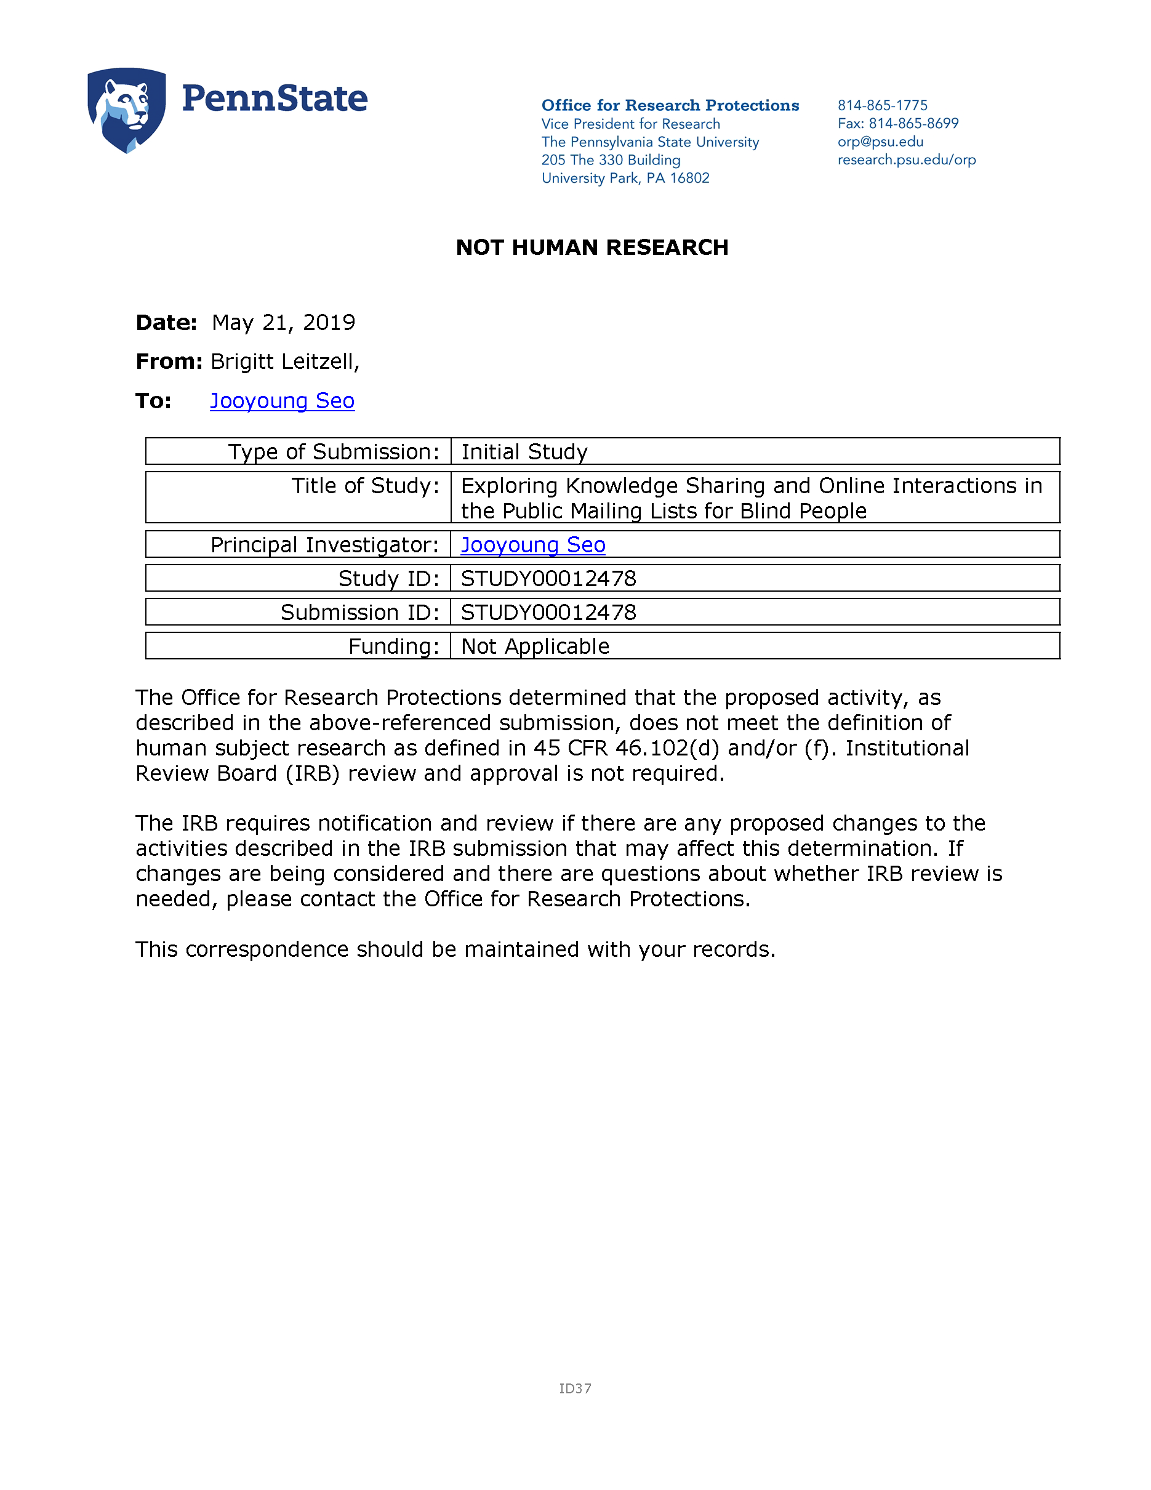

Figure 6.1: Exploring Knowledge Sharing and Online Interactions in the Public Mailing Lists for Blind People.

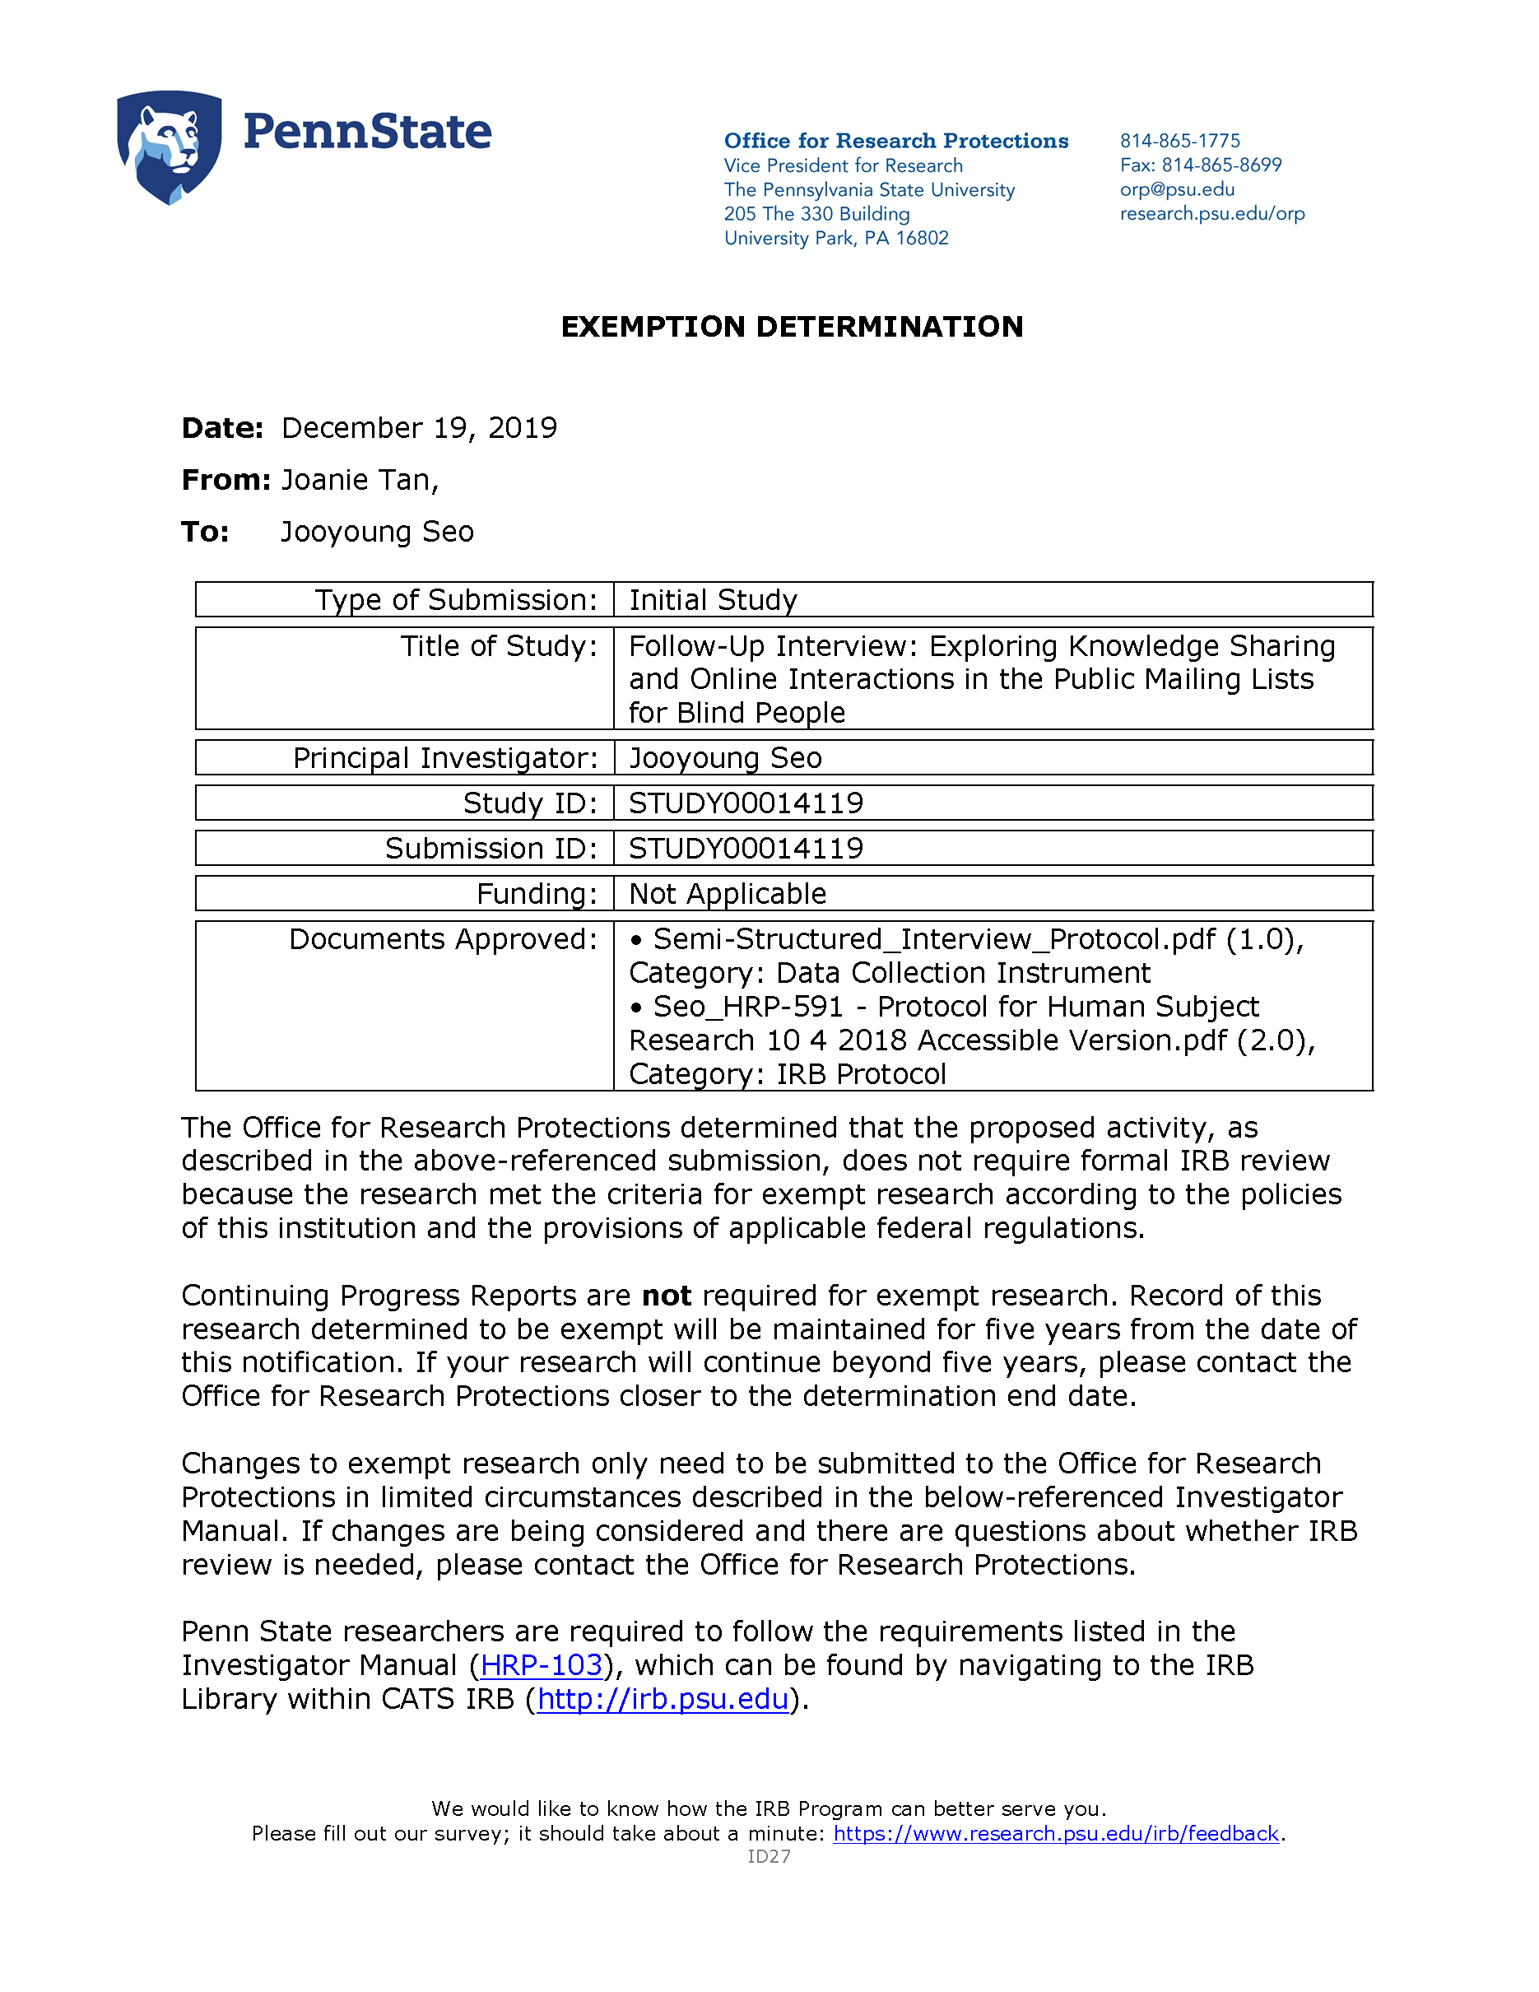

Figure 6.2: Follow-Up Interview: Exploring Knowledge Sharing and Online Interactions in the Public Mailing Lists for Blind People (page 1).



Figure 6.3: Follow-Up Interview: Exploring Knowledge Sharing and Online Interactions in the Public Mailing Lists for Blind People (page 2).

# 7 The National Federation of the Blind (NFB) Materials

The following includes email communications with the NFB gate keeper, official form submissions to the NFB Research Advisory Council, and the information stating that the proposed study has been approved by their committees.

## 7.1 Contact with a Gatekeeper of the NFB Community

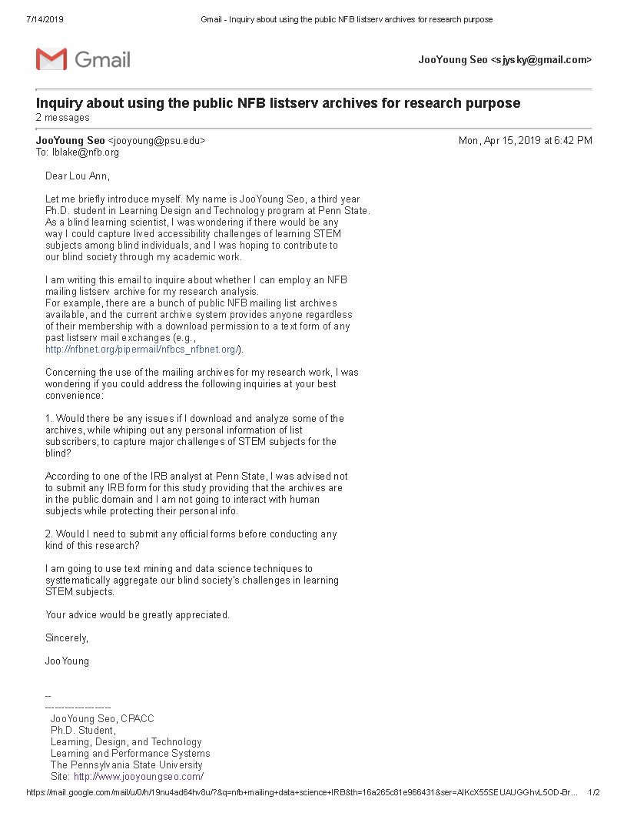

Figure 7.1: Email Exchange with the Community Gatekeeper (page 1).

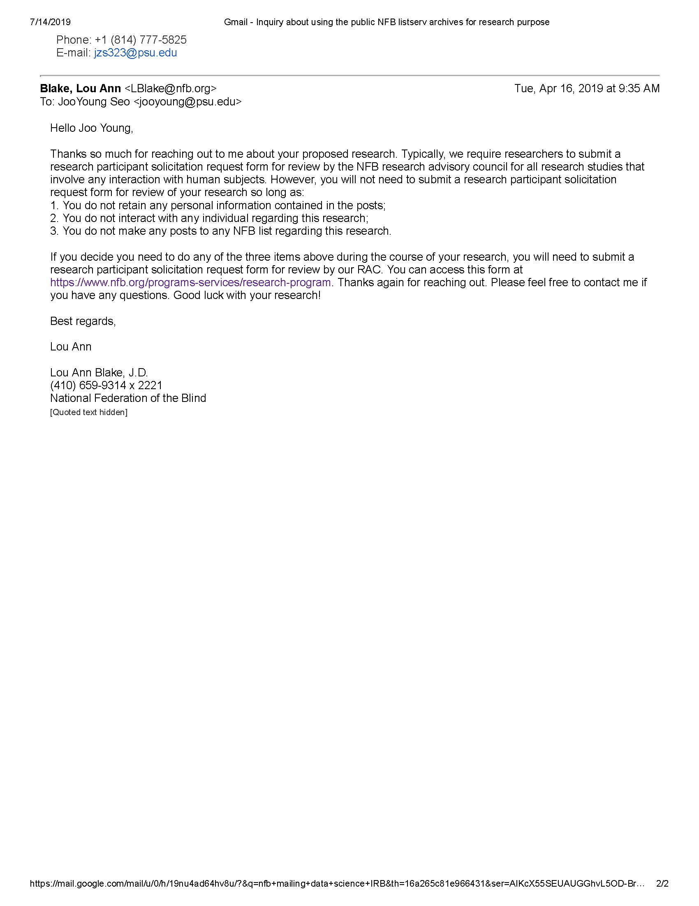

Figure 7.2: Email Exchange with the Community Gatekeeper (page 2).

## 7.2 Research Participant Solicitation Request Form

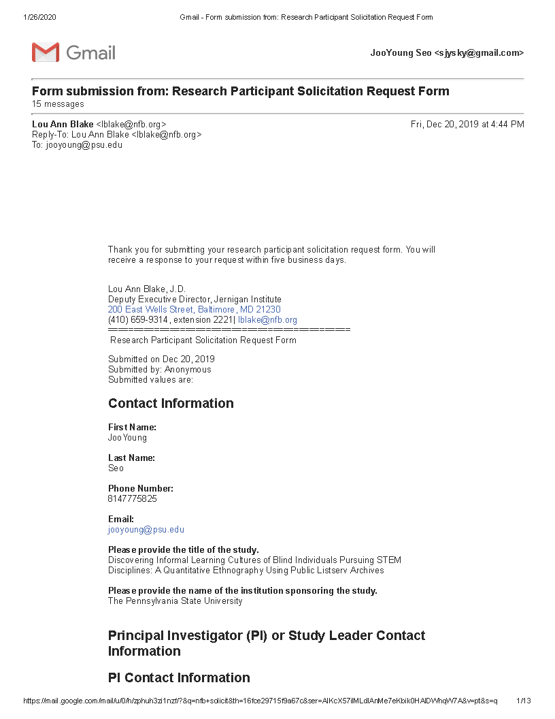

Figure 7.3: Confirmation of the Form submitted to the NFB Research Advisory Council (page 1).

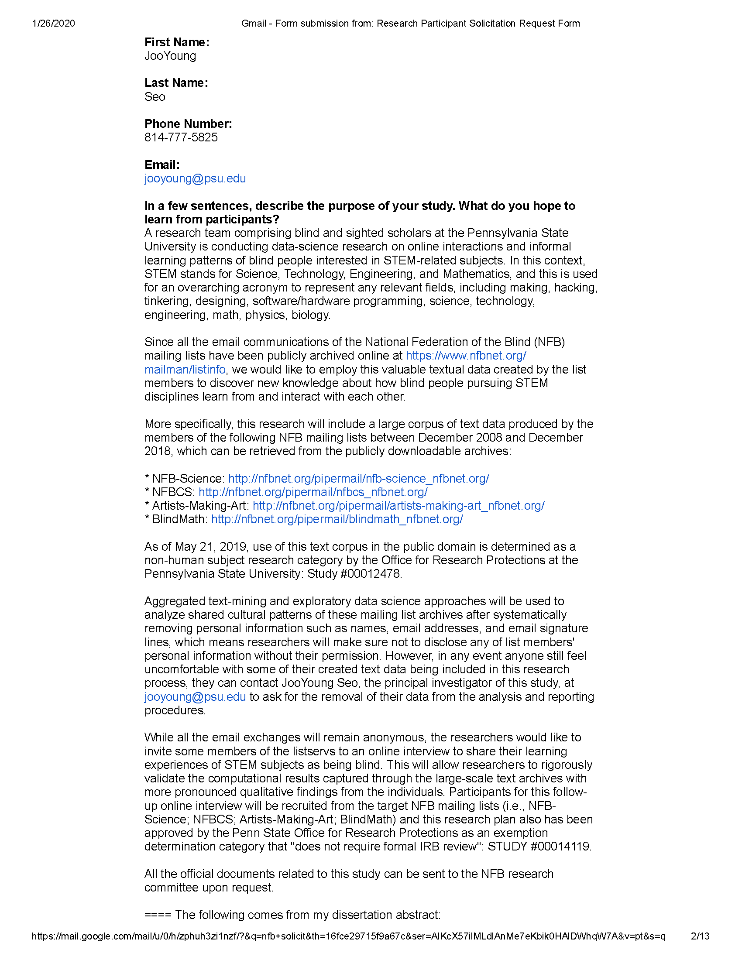

Figure 7.4: Confirmation of the Form submitted to the NFB Research Advisory Council (page 2).

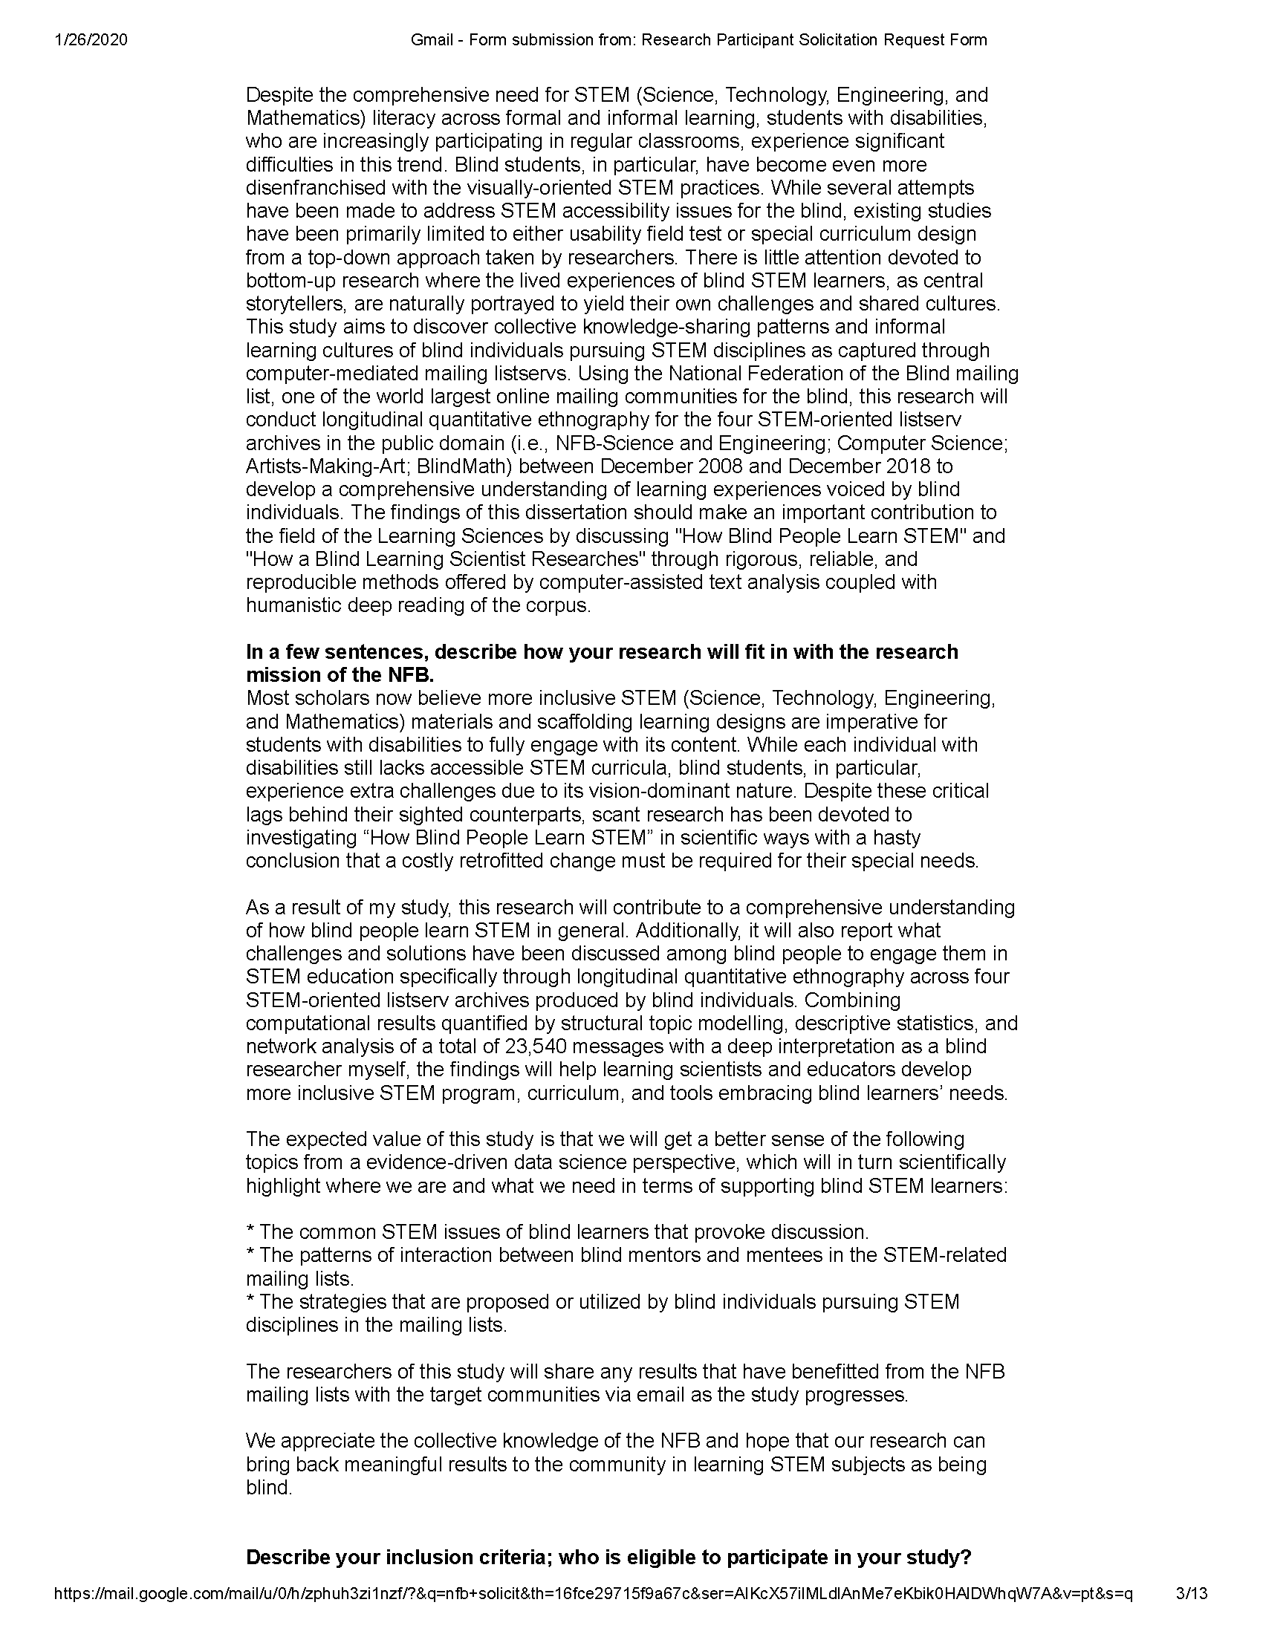

Figure 7.5: Confirmation of the Form submitted to the NFB Research Advisory Council (page 3).

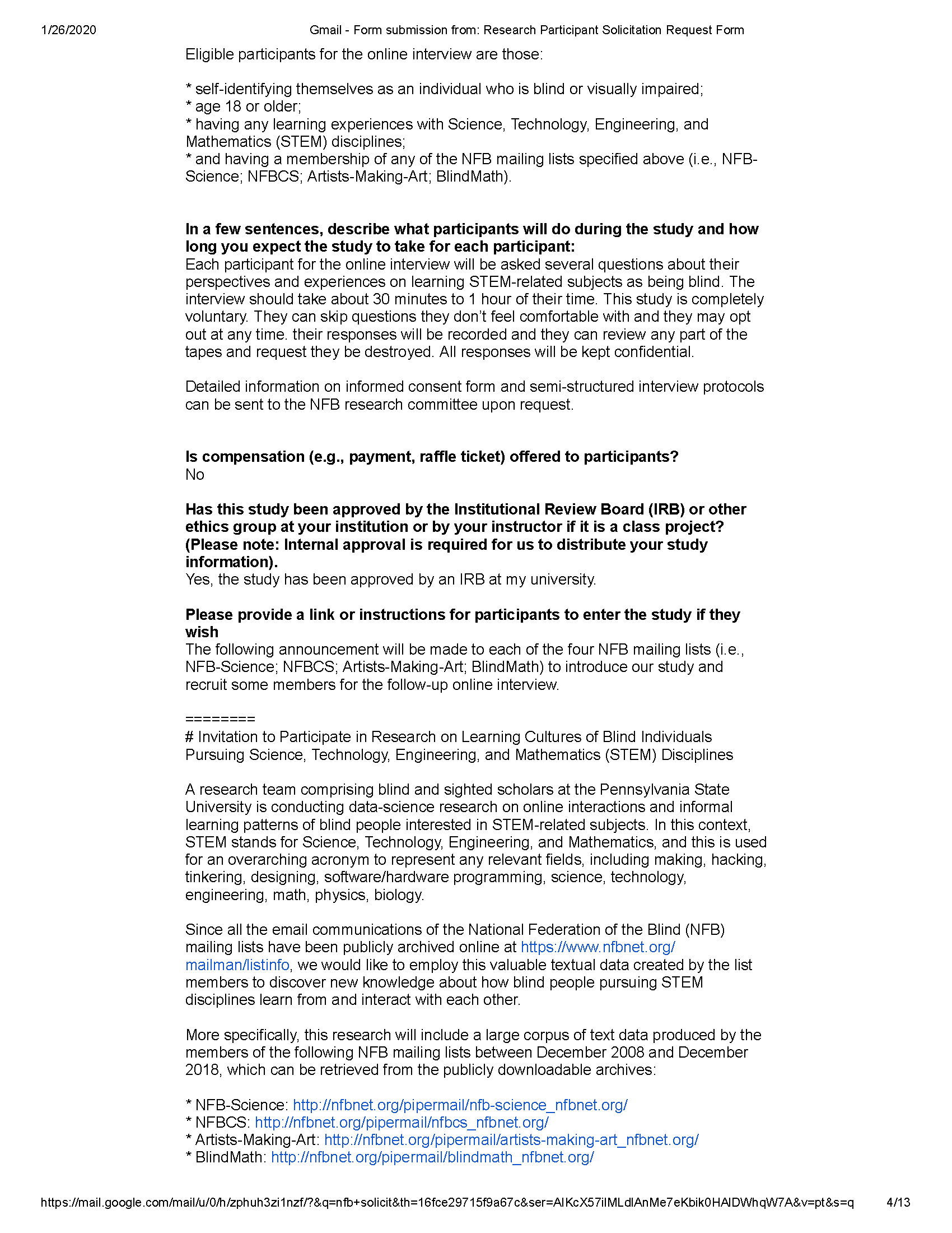

Figure 7.6: Confirmation of the Form submitted to the NFB Research Advisory Council (page 4).

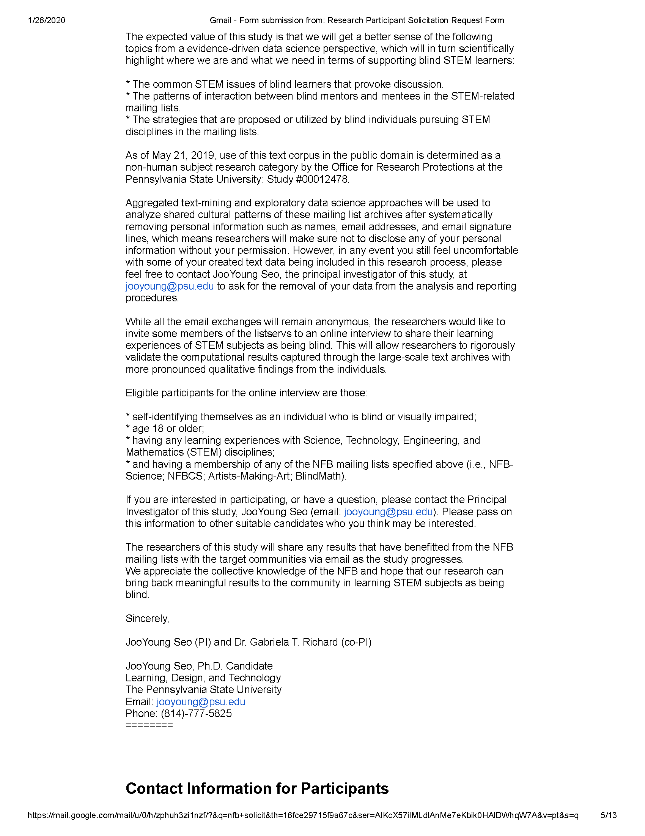

Figure 7.7: Confirmation of the Form submitted to the NFB Research Advisory Council (page 5).

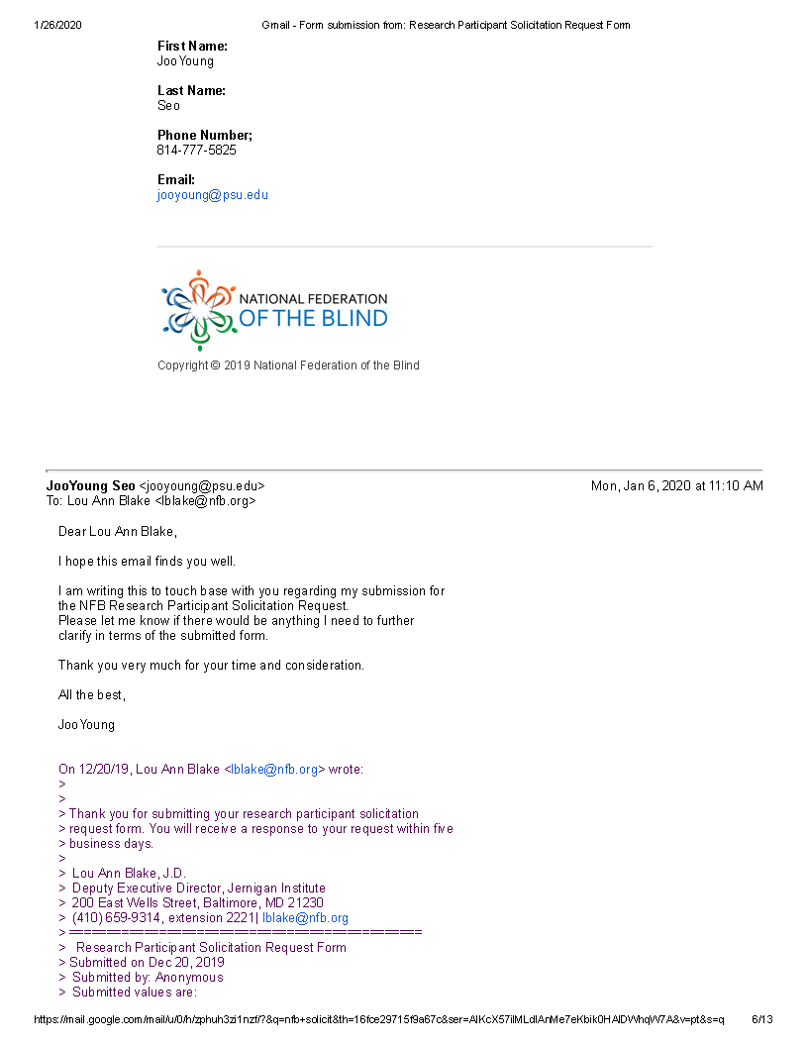

Figure 7.8: Confirmation of the Form submitted to the NFB Research Advisory Council (page 6).

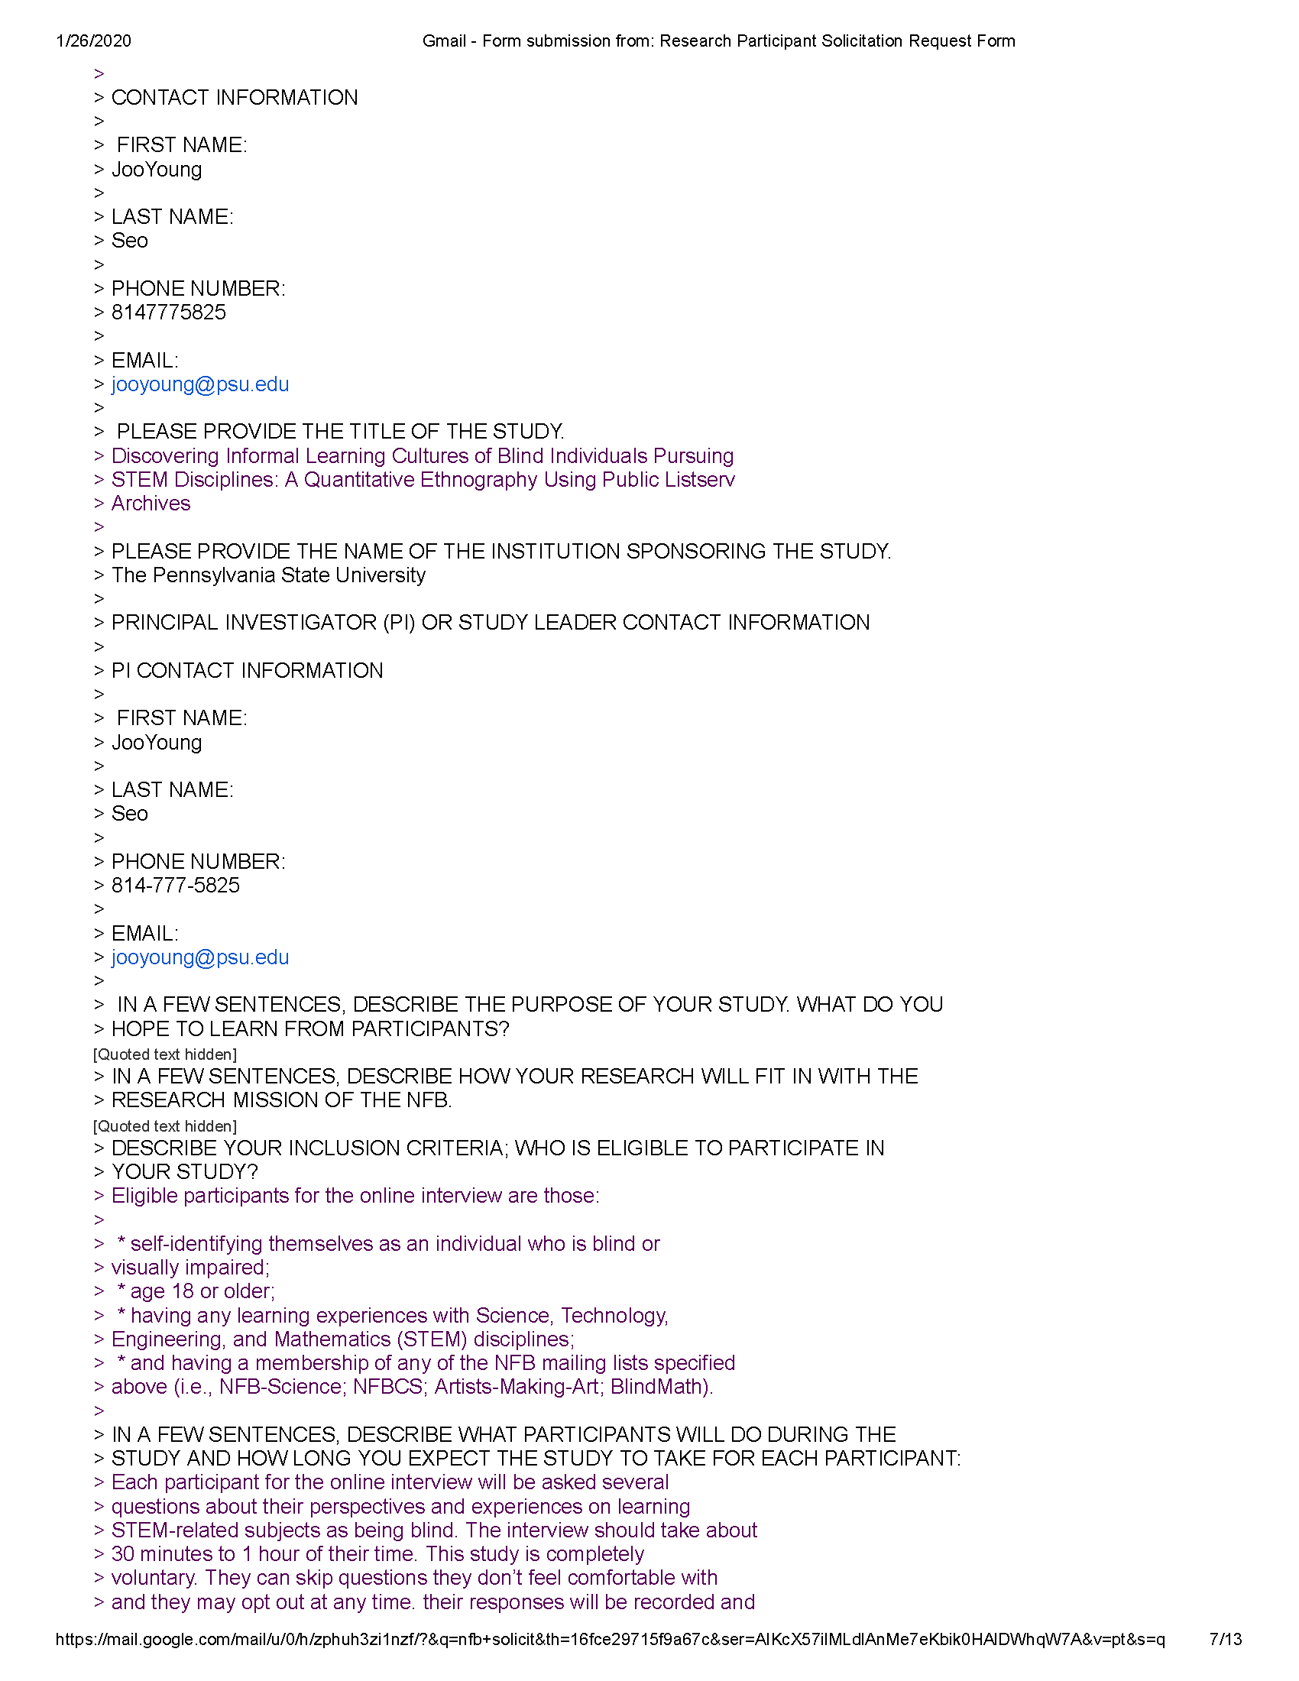

Figure 7.9: Confirmation of the Form submitted to the NFB Research Advisory Council (page 7).

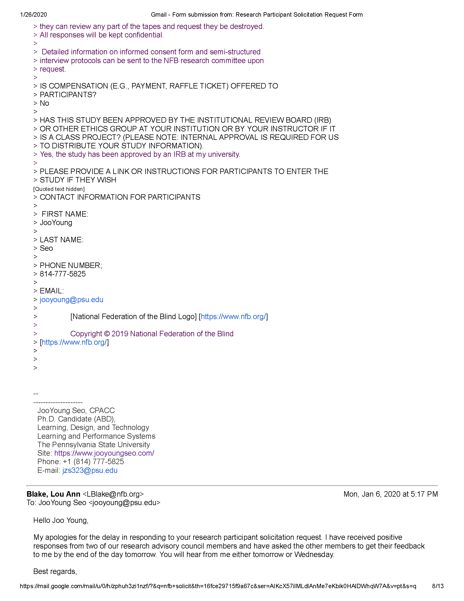

Figure 7.10: Confirmation of the Form submitted to the NFB Research Advisory Council (page 8).

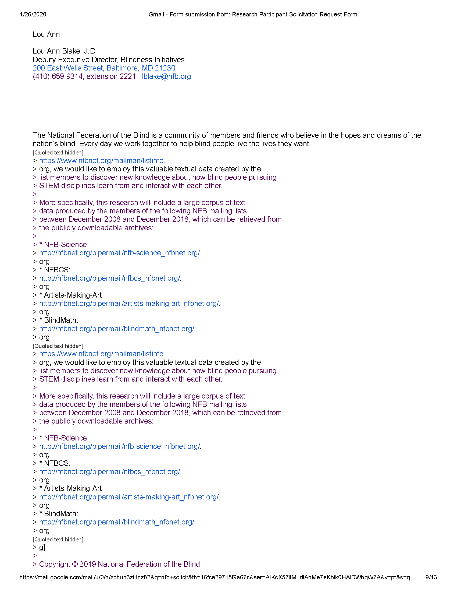

Figure 7.11: Confirmation of the Form submitted to the NFB Research Advisory Council (page 9).

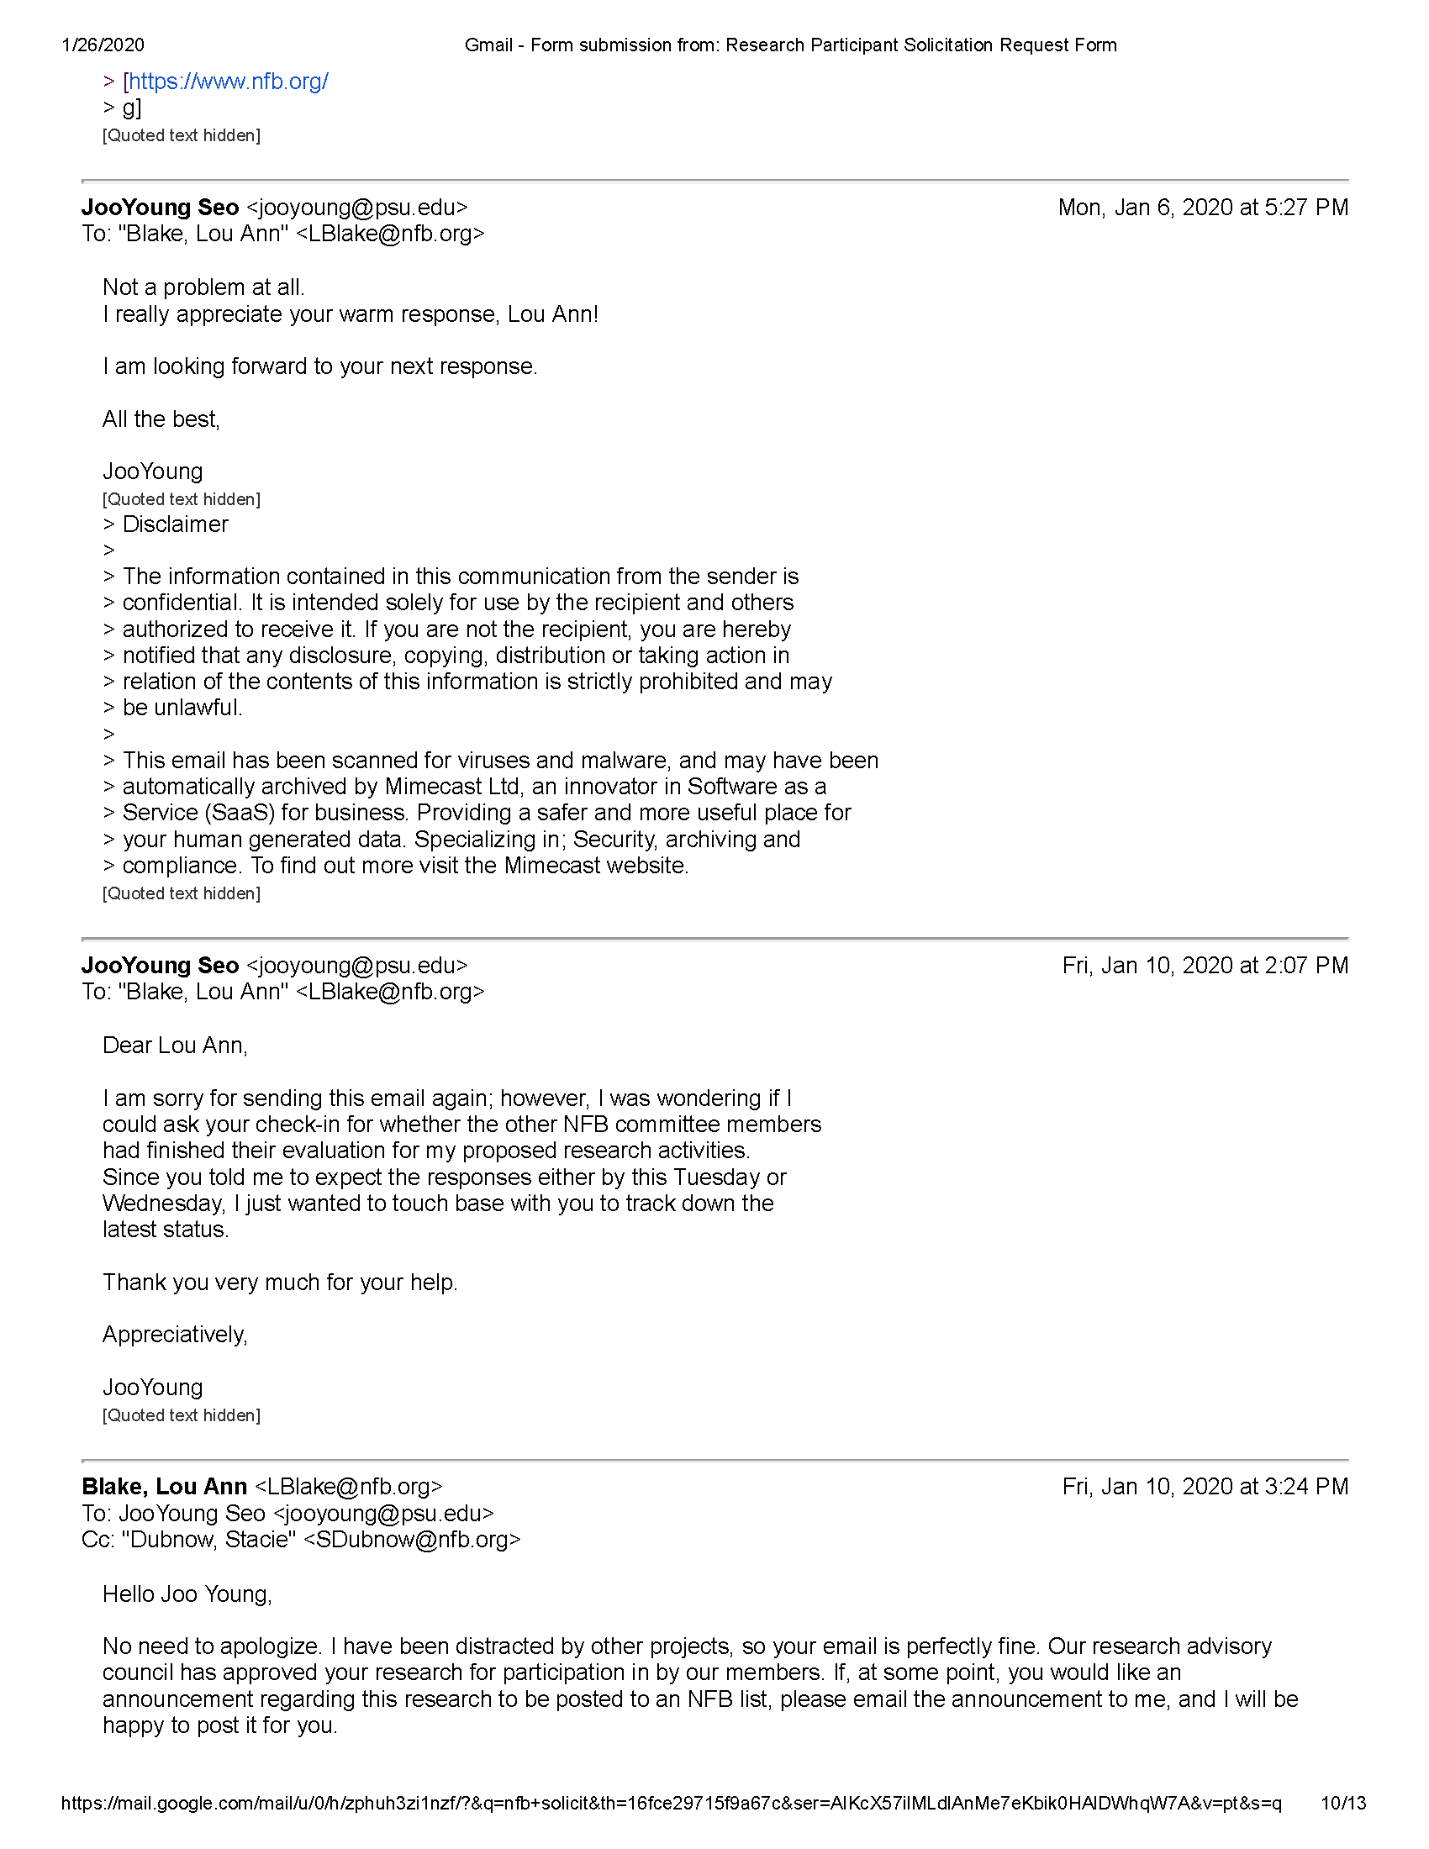

Figure 7.12: Confirmation of the Form submitted to the NFB Research Advisory Council (page 10).

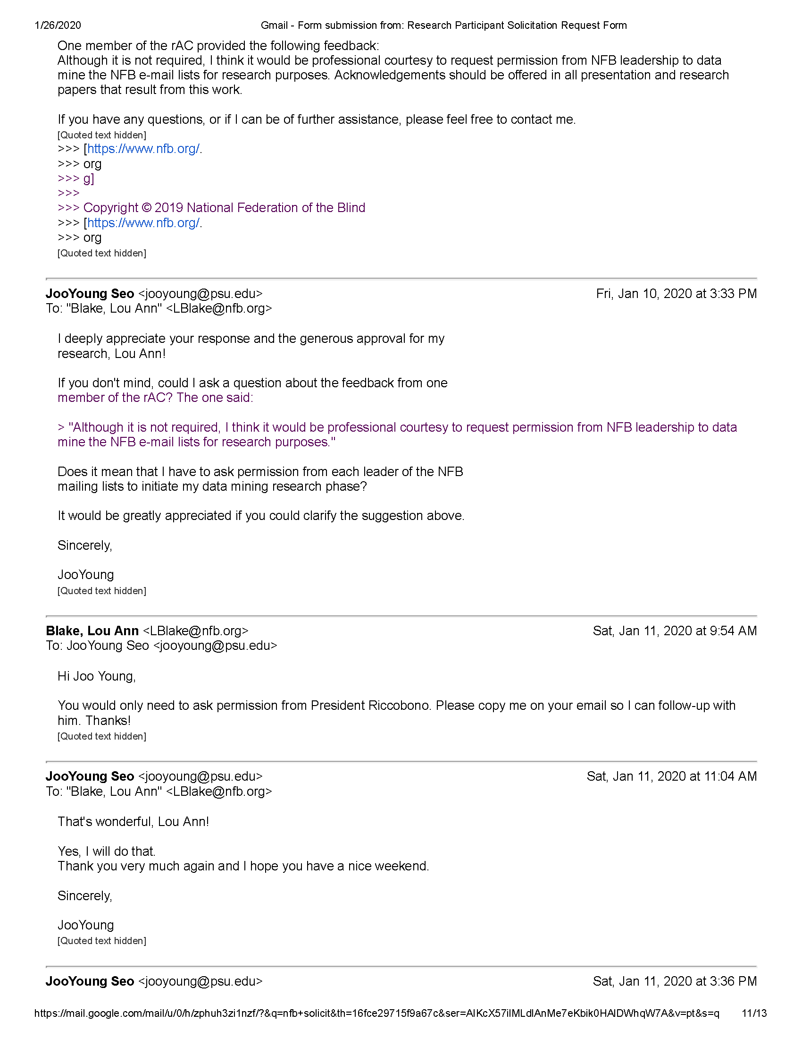

Figure 7.13: Confirmation of the Form submitted to the NFB Research Advisory Council (page 11).

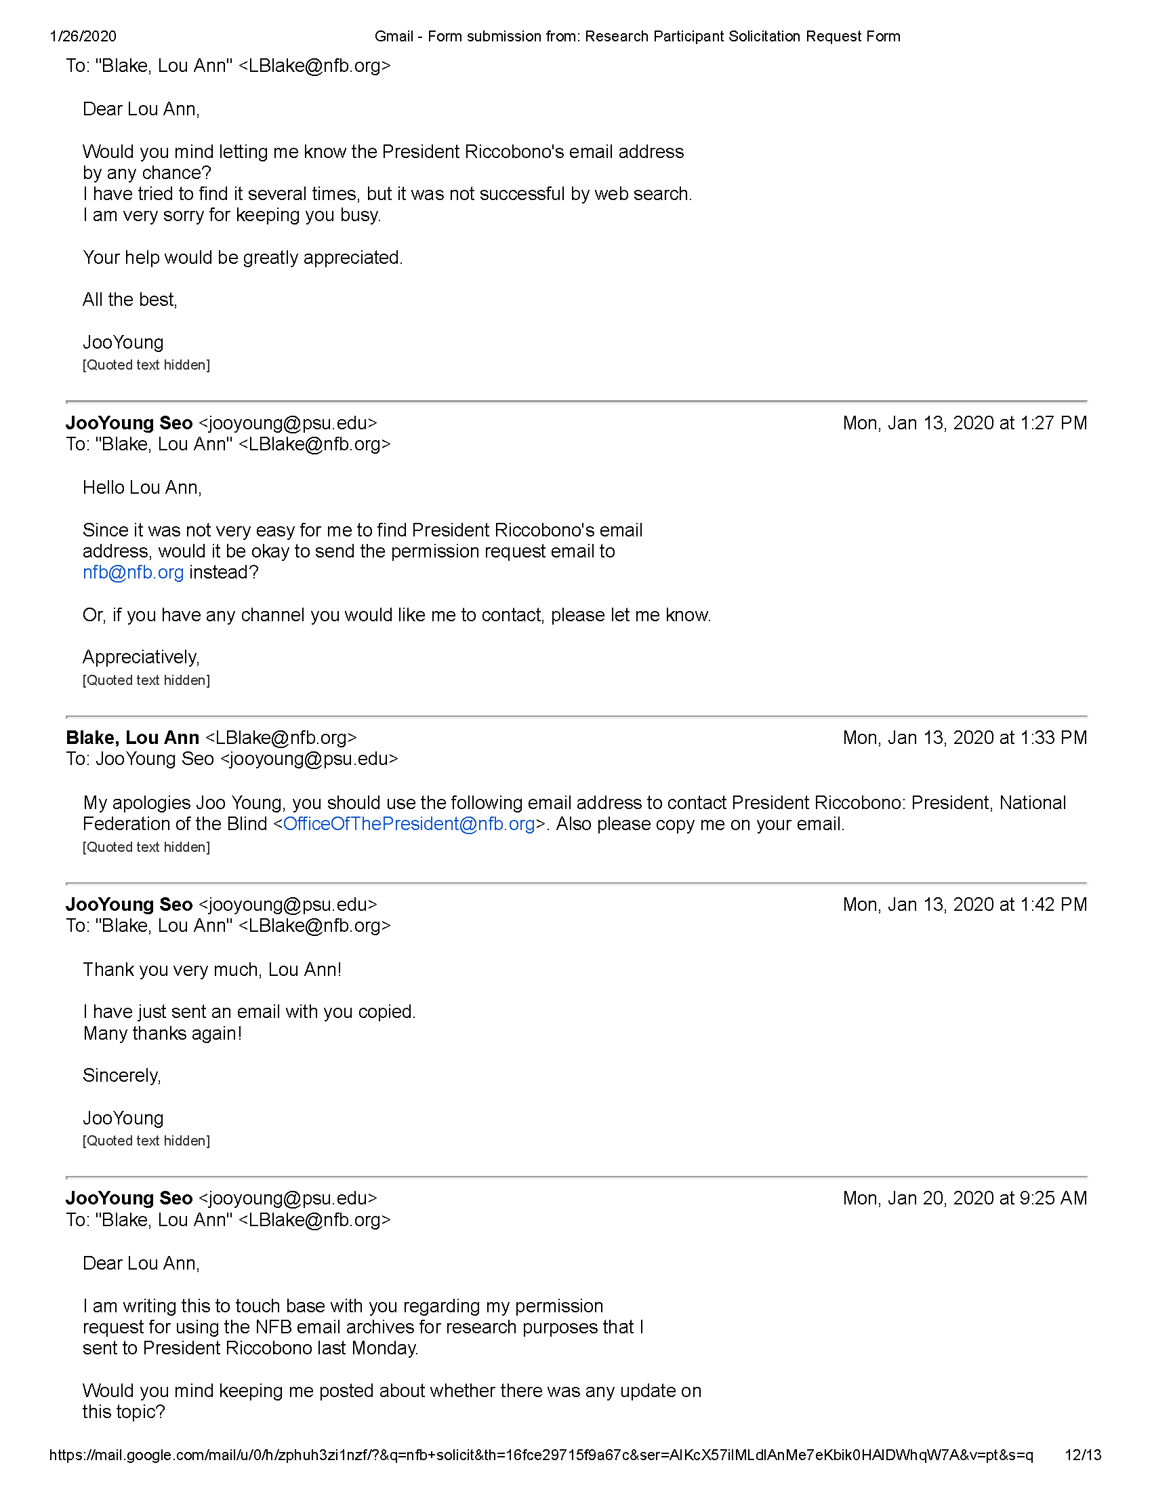

Figure 7.14: Confirmation of the Form submitted to the NFB Research Advisory Council (page 12).

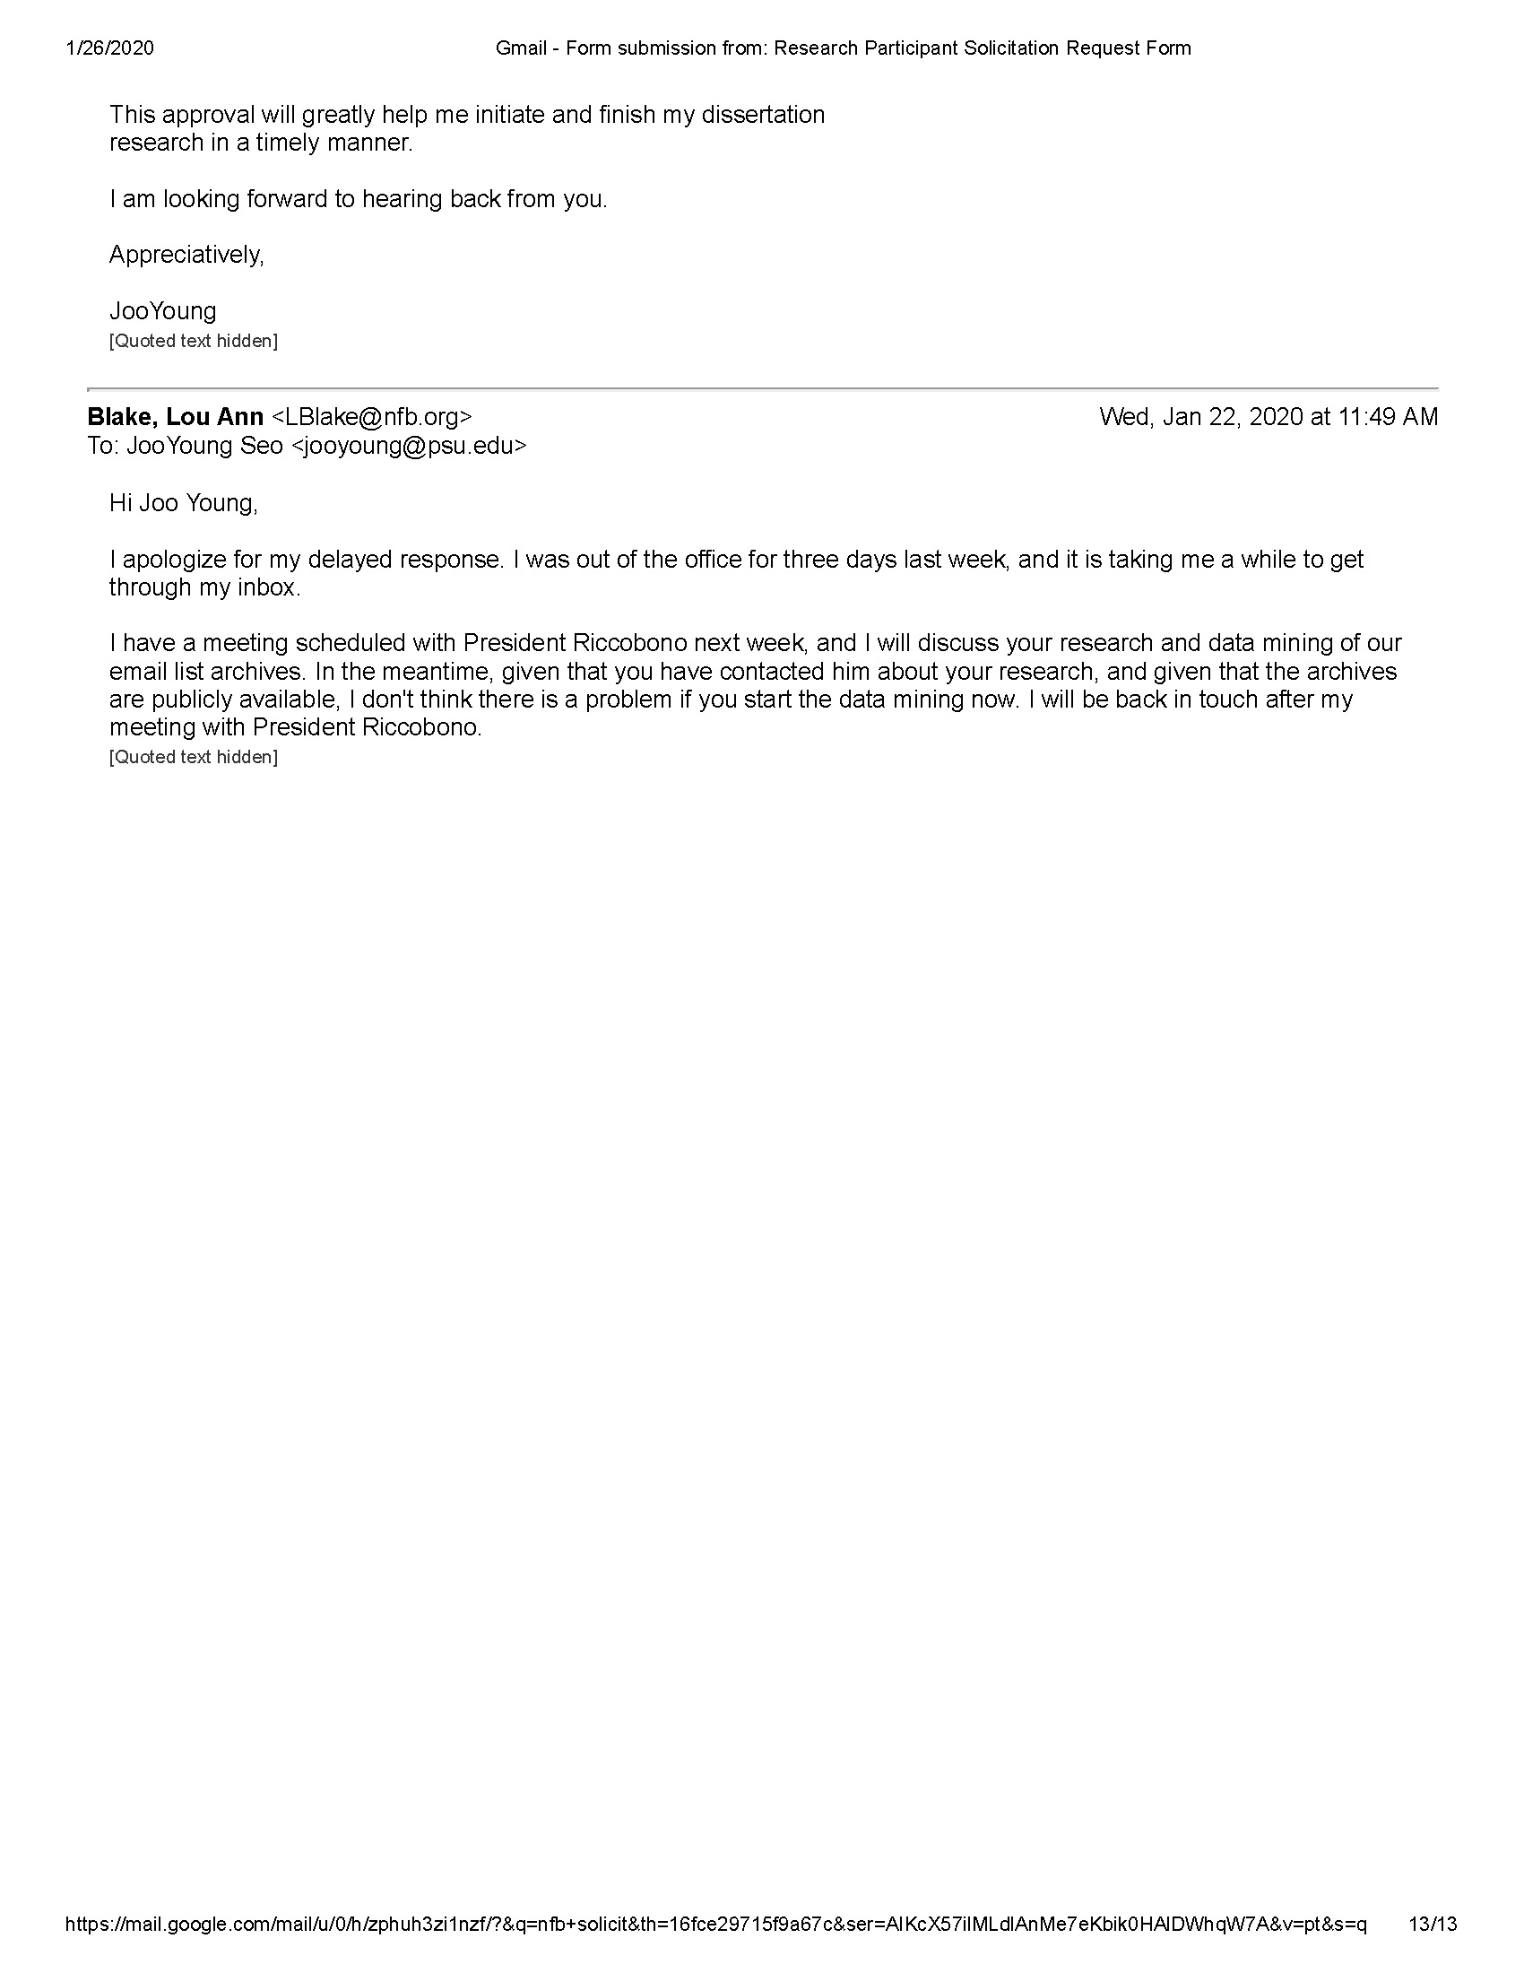

Figure 7.15: Confirmation of the Form submitted to the NFB Research Advisory Council (page 13).

## 7.3 Official Approvals from the NFB Research Advisory Council

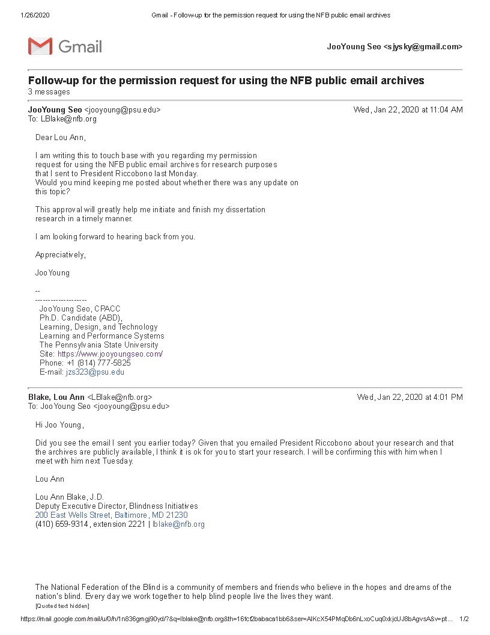

Figure 7.16: Official approvals from the NFB Research Advisory Council (page 1).

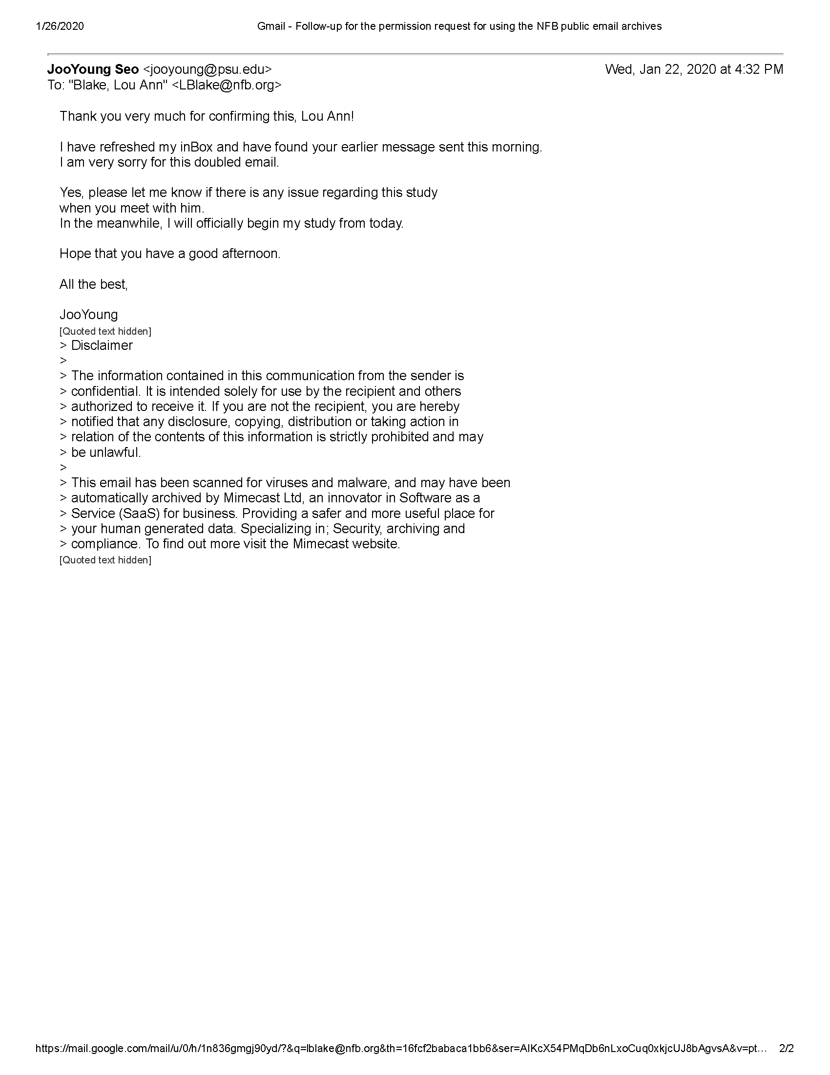

Figure 7.17: Official approvals from the NFB Research Advisory Council (page 2).

# 8 Interview Materials

The following includes some materials related to conducting follow-up interview with the NFB members.

## 8.1 Recruitment Materials

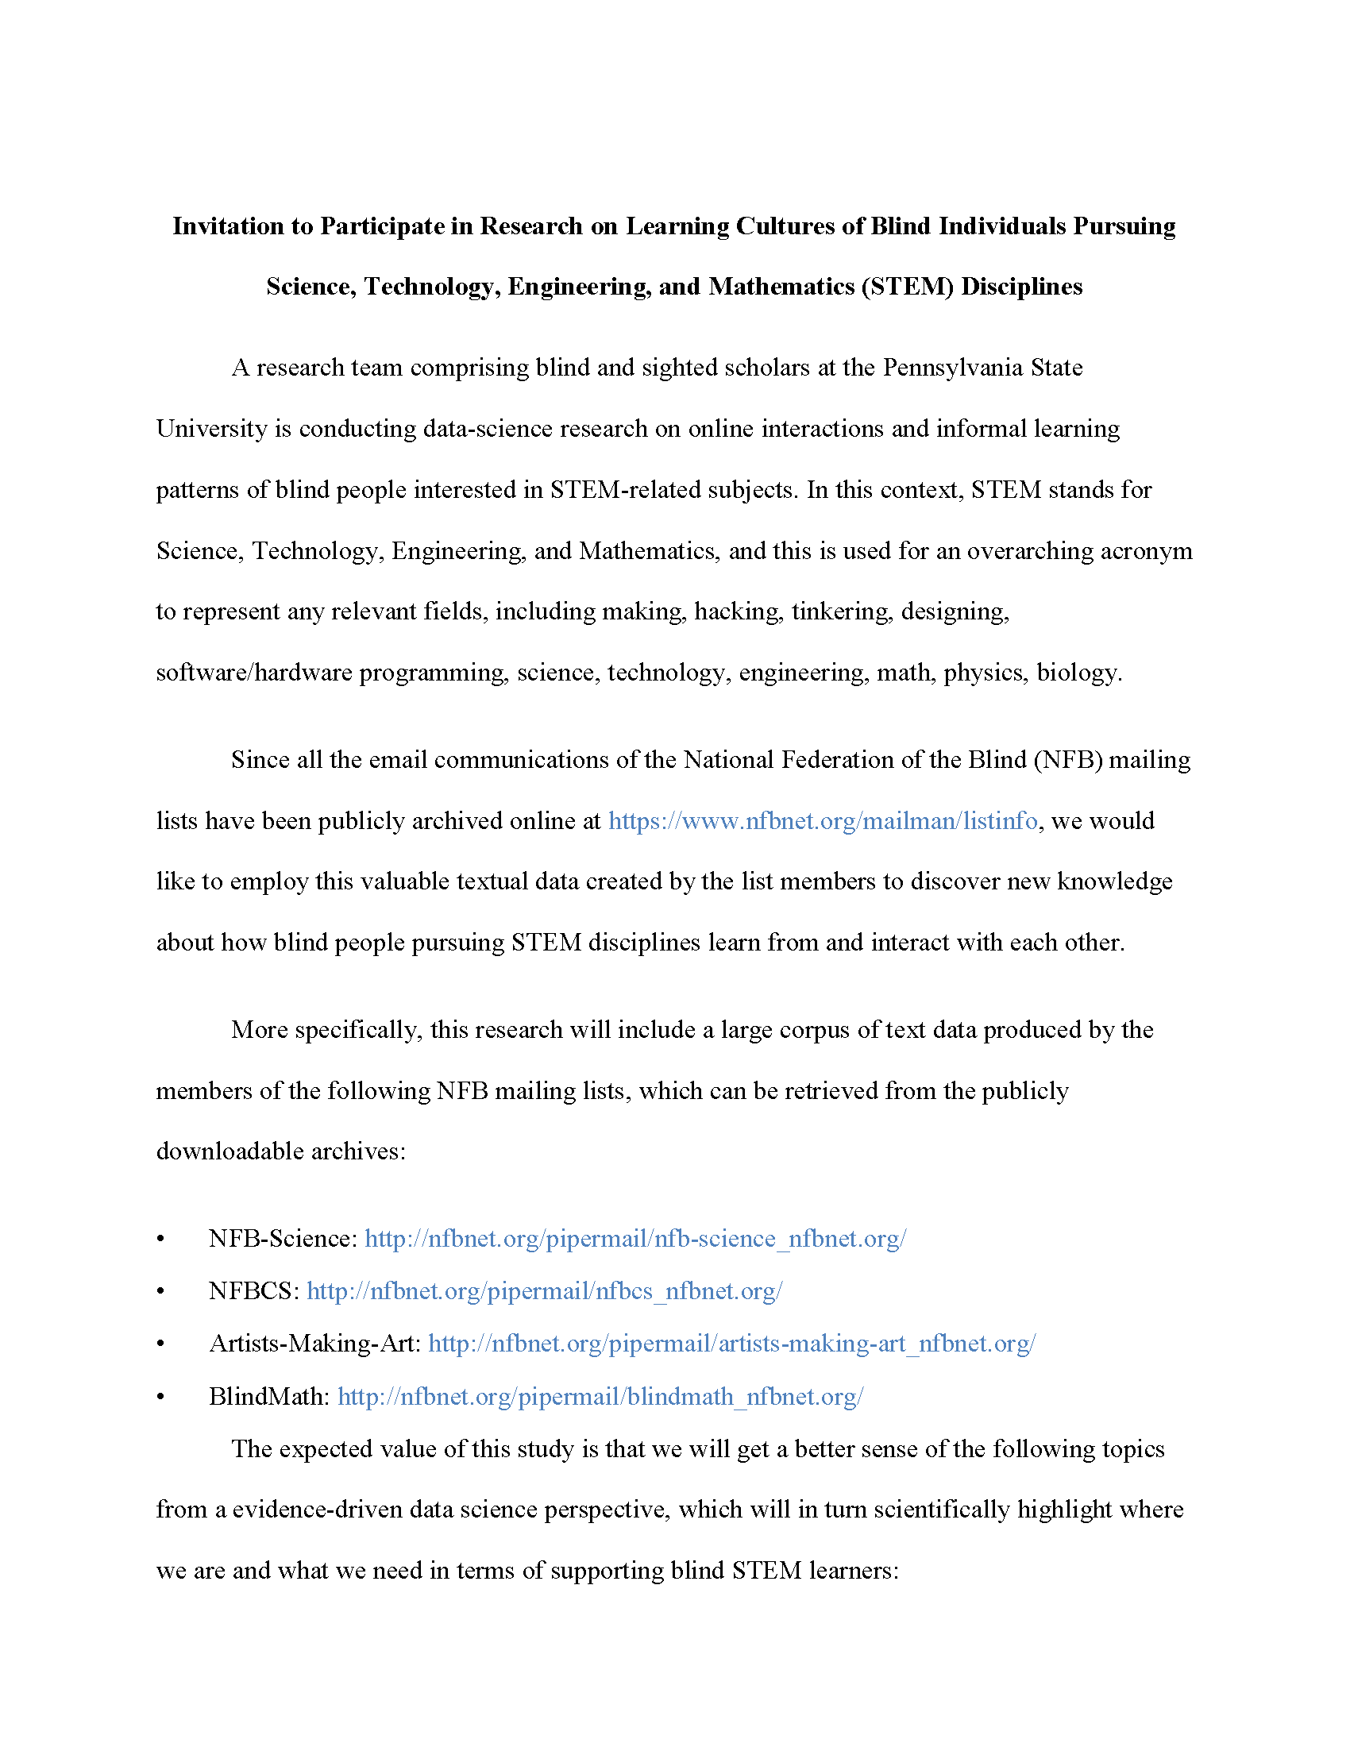

Figure 8.1: Study Invitation (page 1).

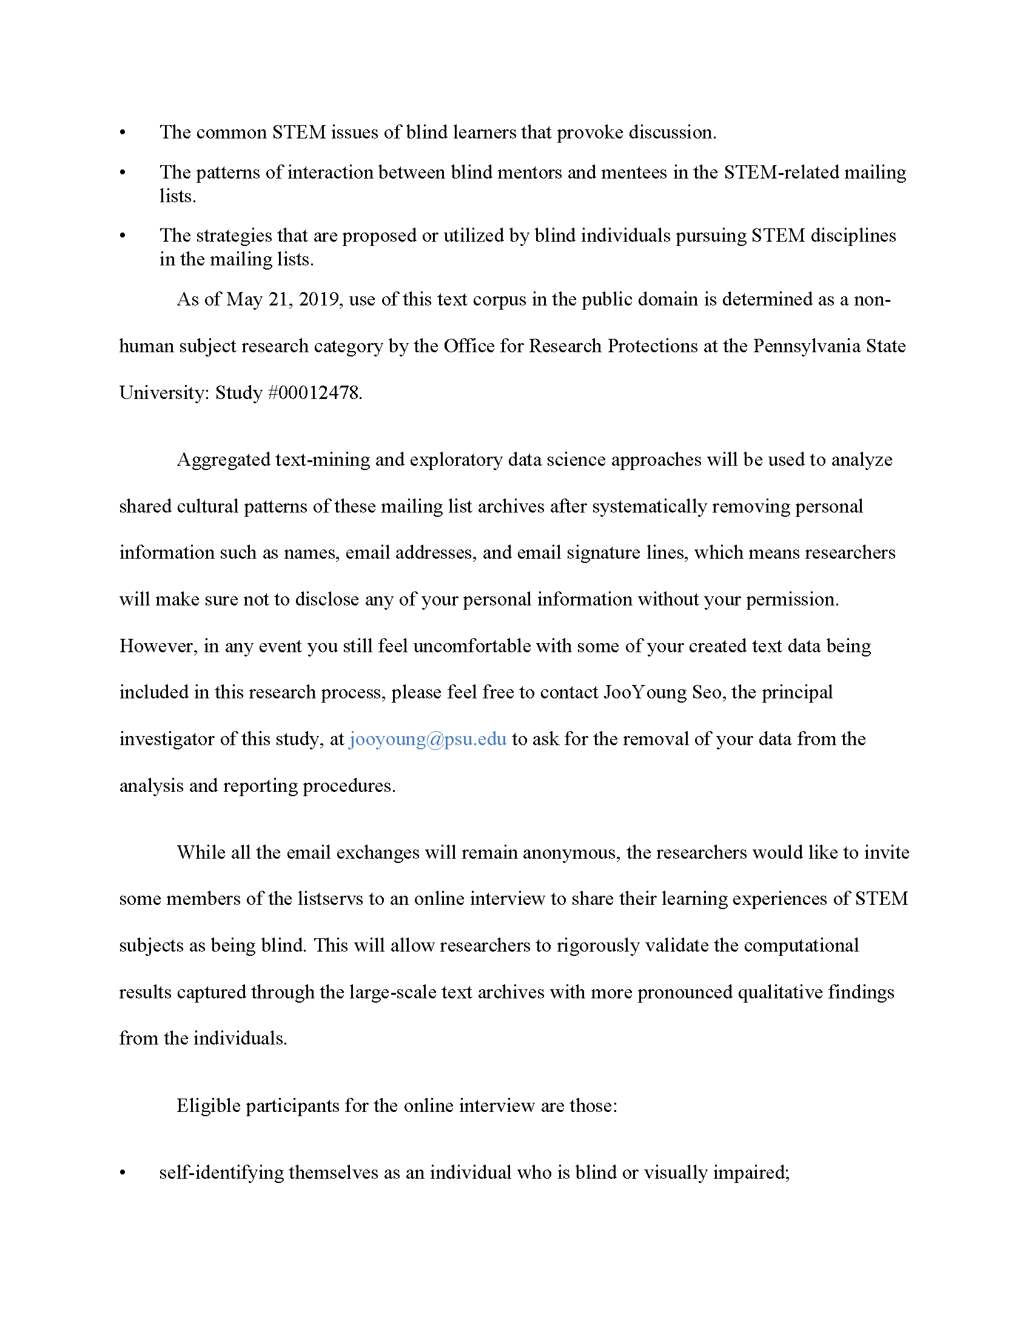

Figure 8.2: Study Invitation (page 2).

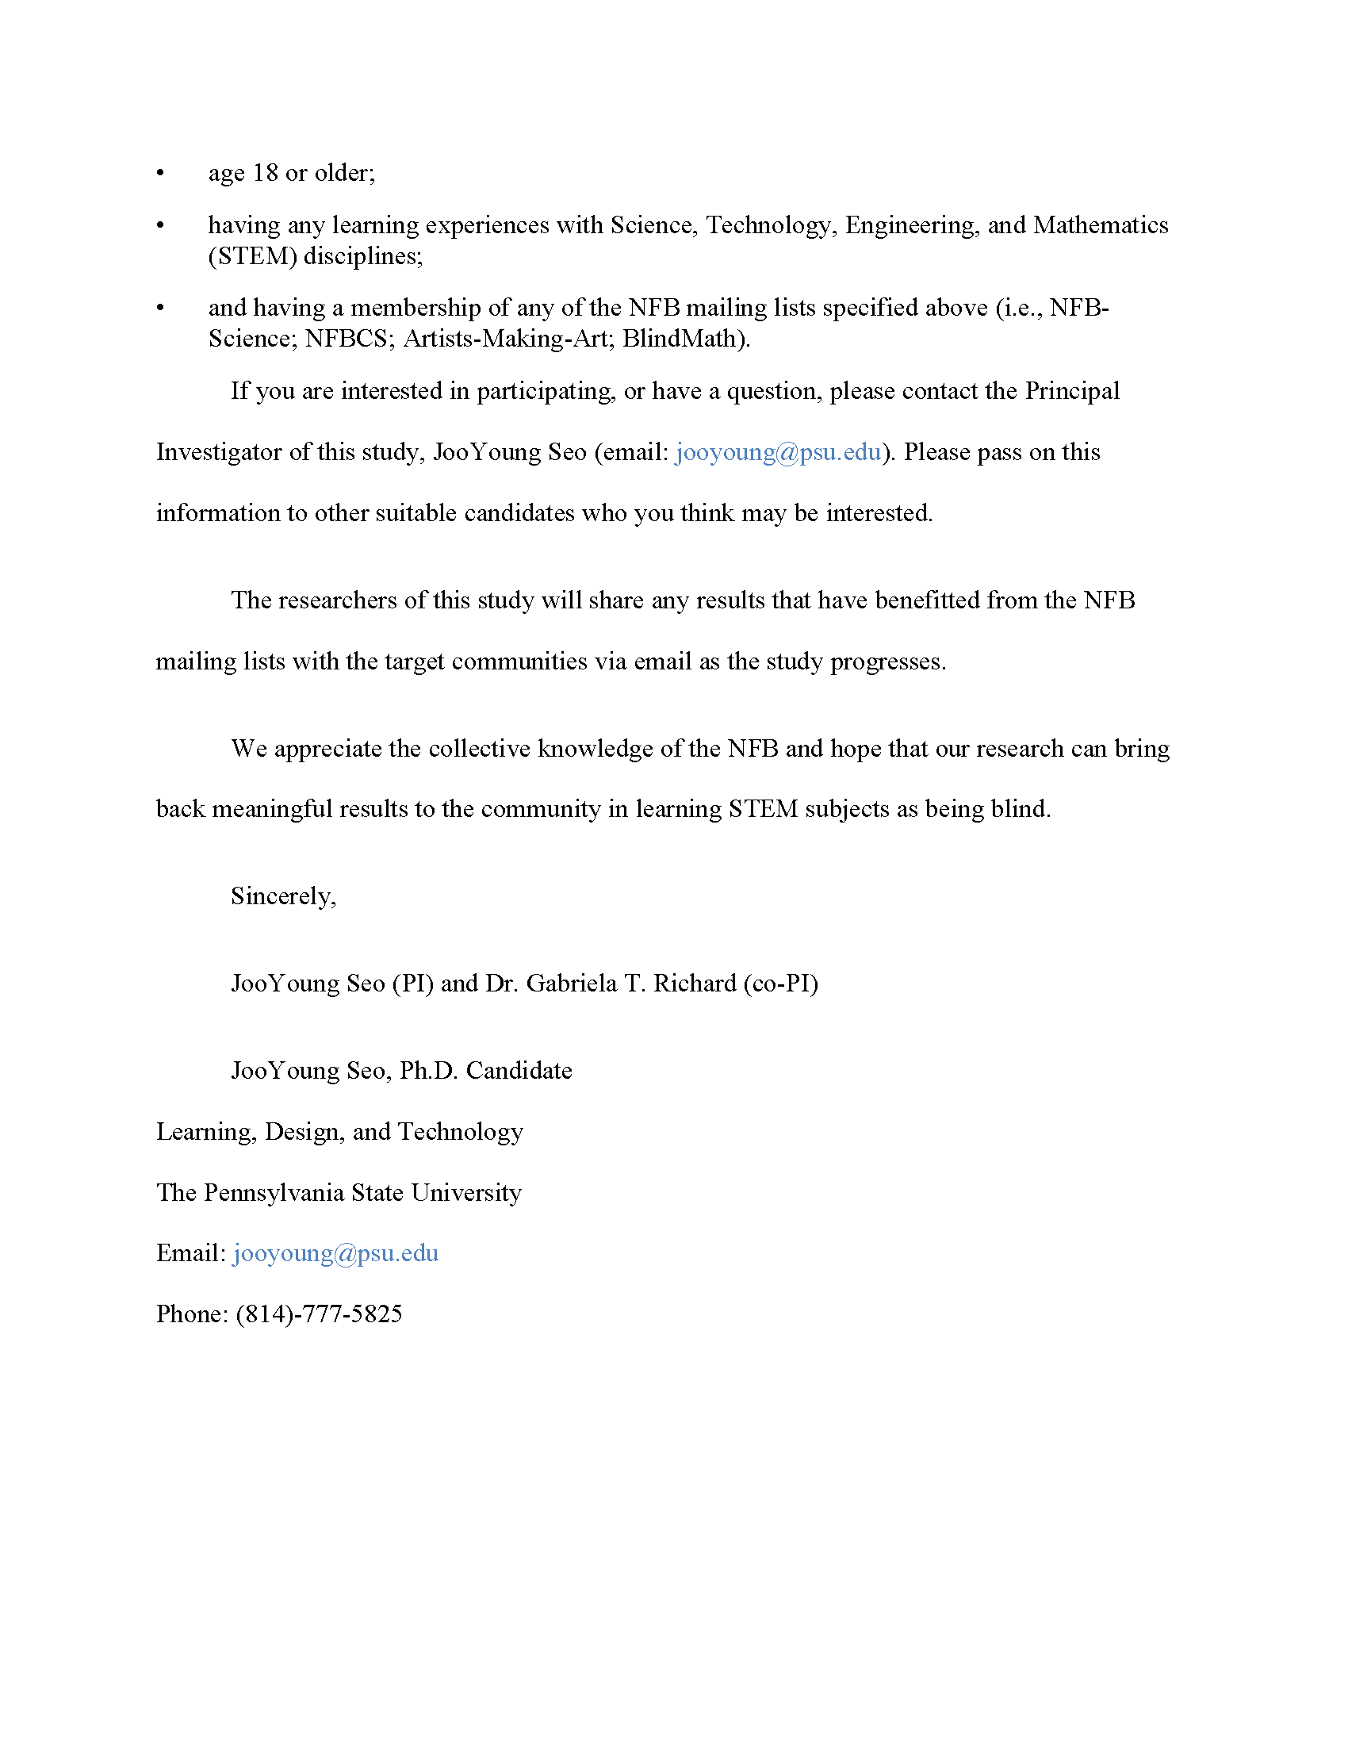

Figure 8.3: Study Invitation (page 3).

## 8.2 Interview Consent Form

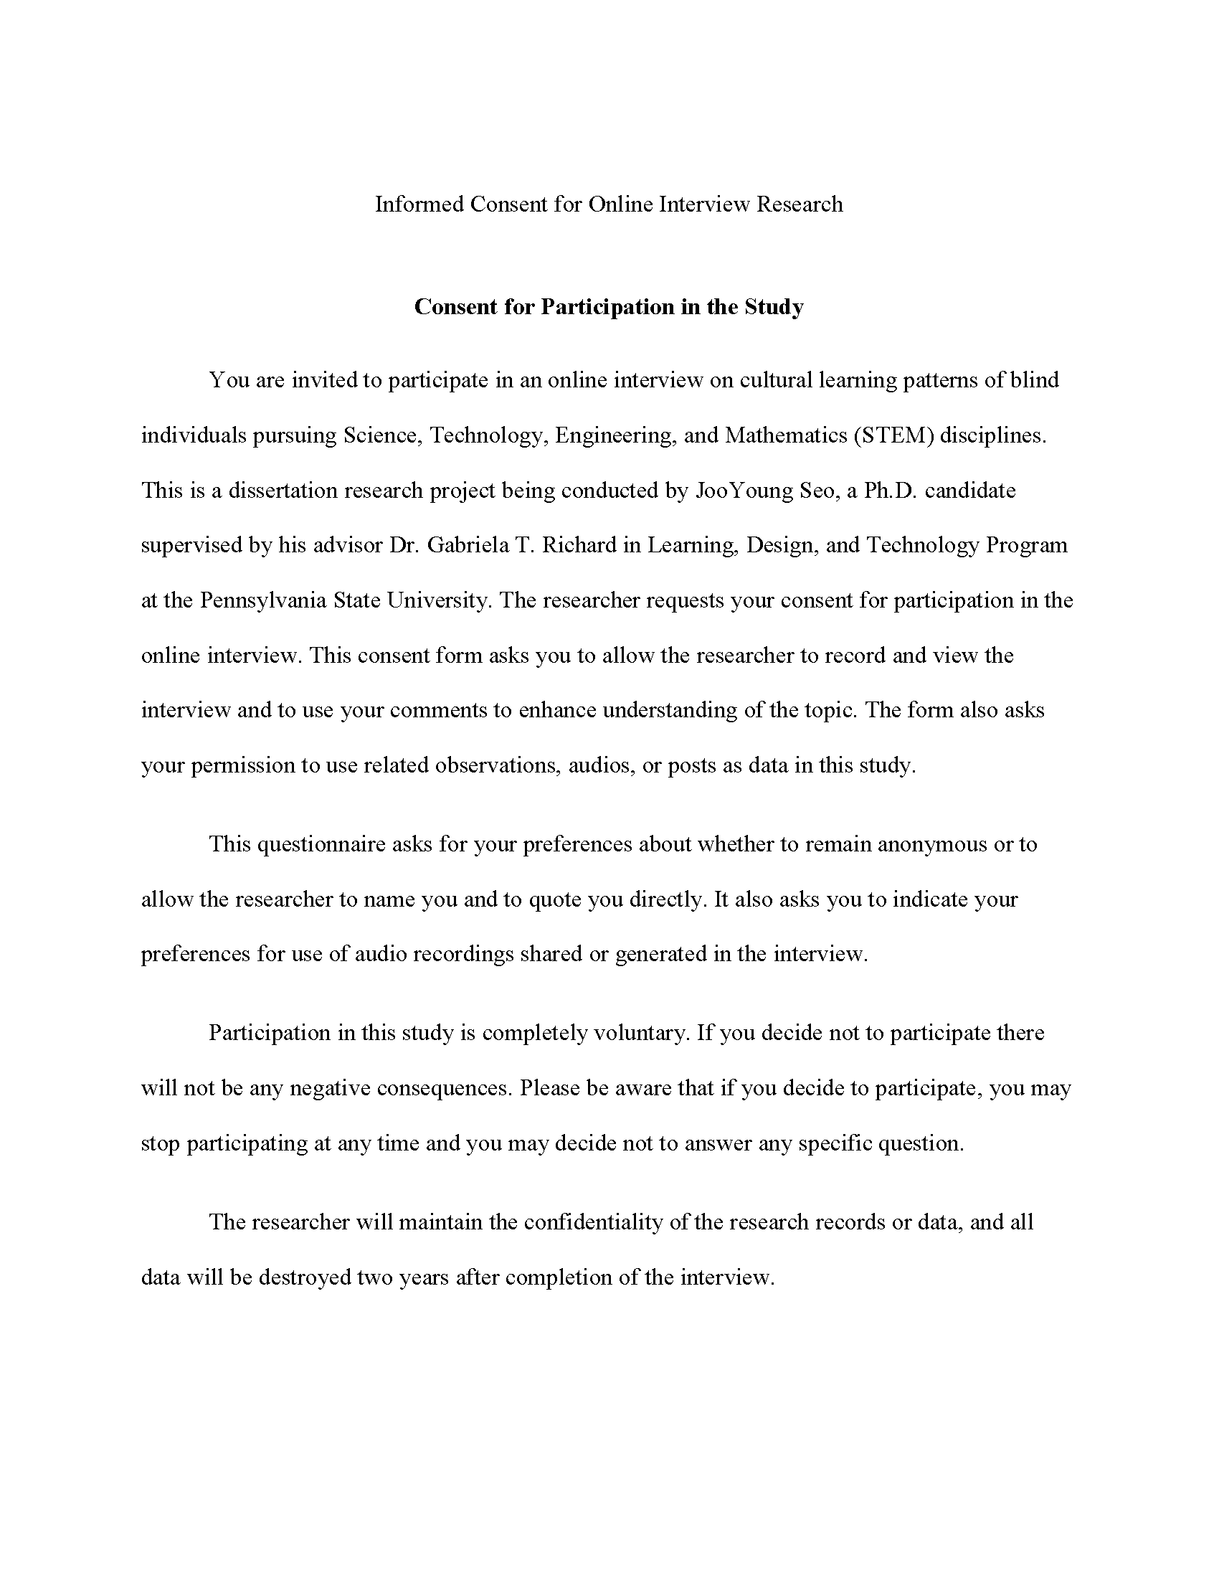

Figure 8.4: Interview Consent Form (page 1).

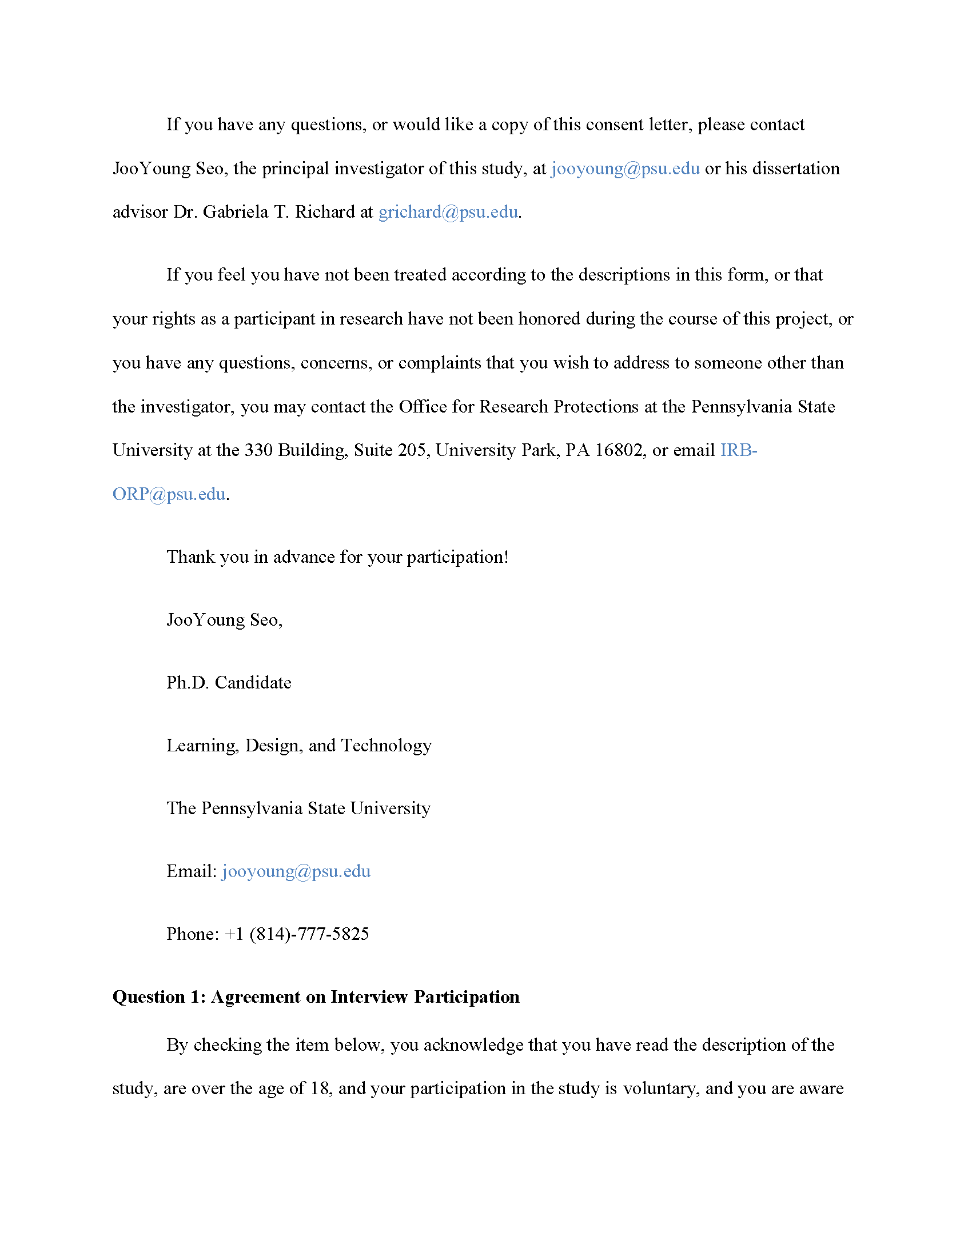

Figure 8.5: Interview Consent Form (page 2).

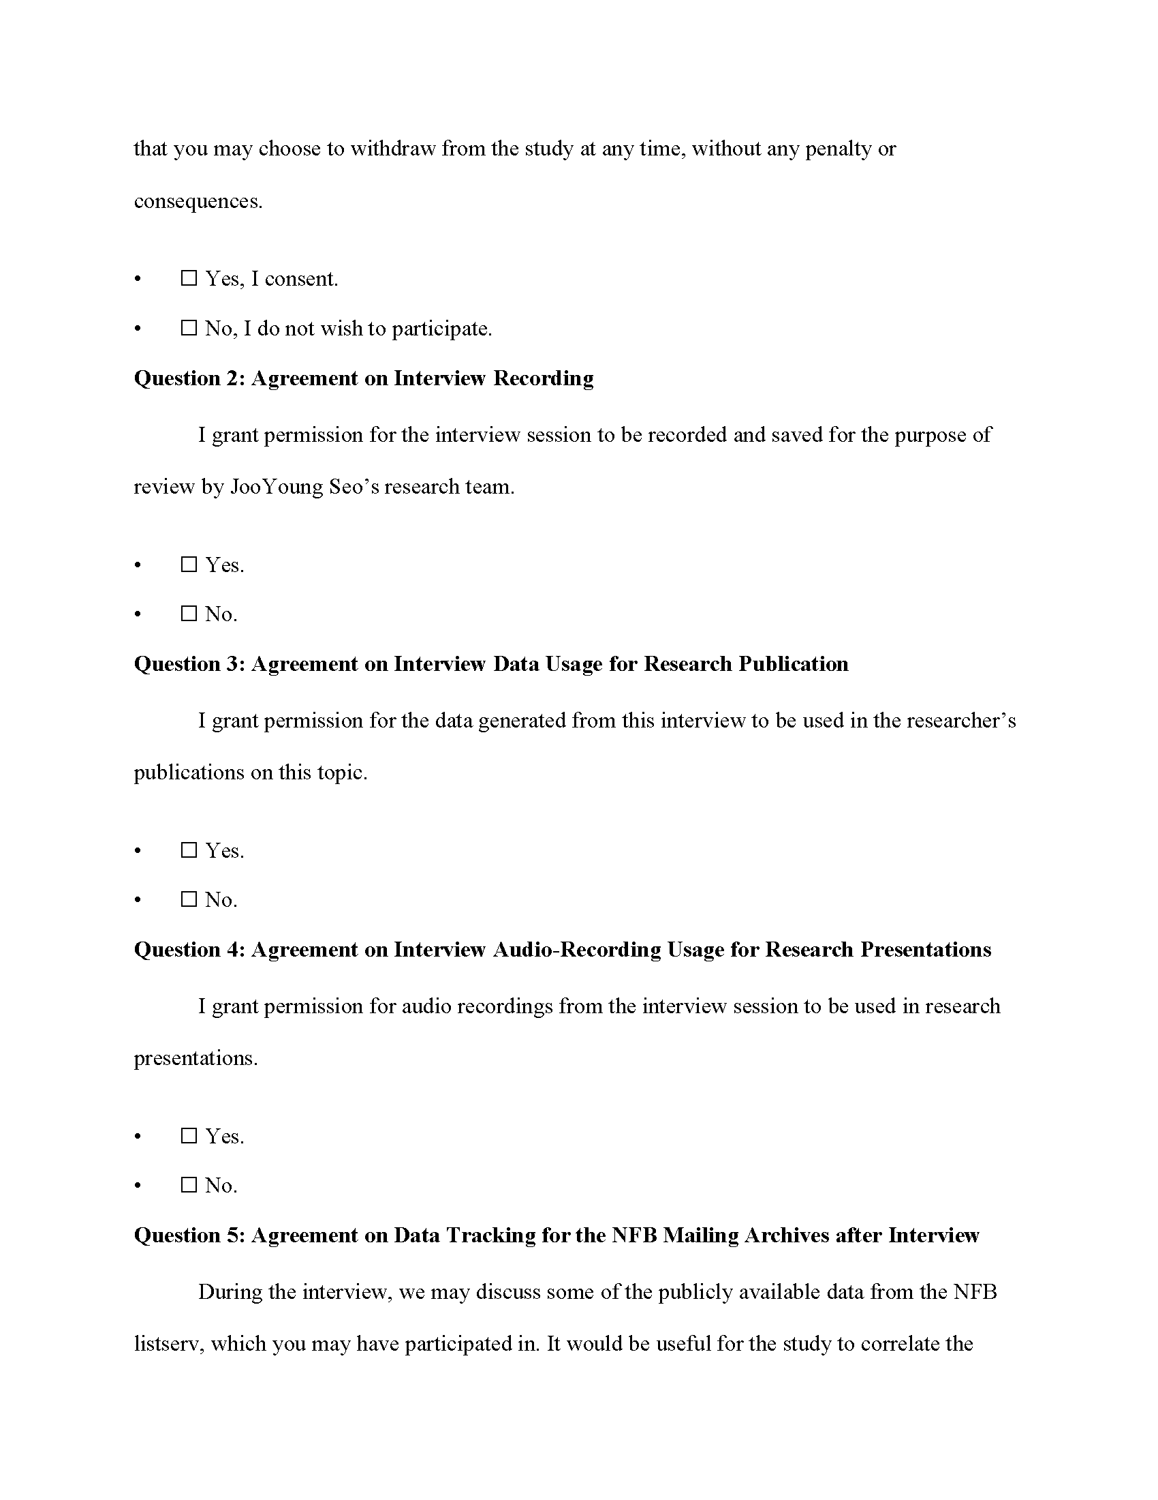

Figure 8.6: Interview Consent Form (page 3).

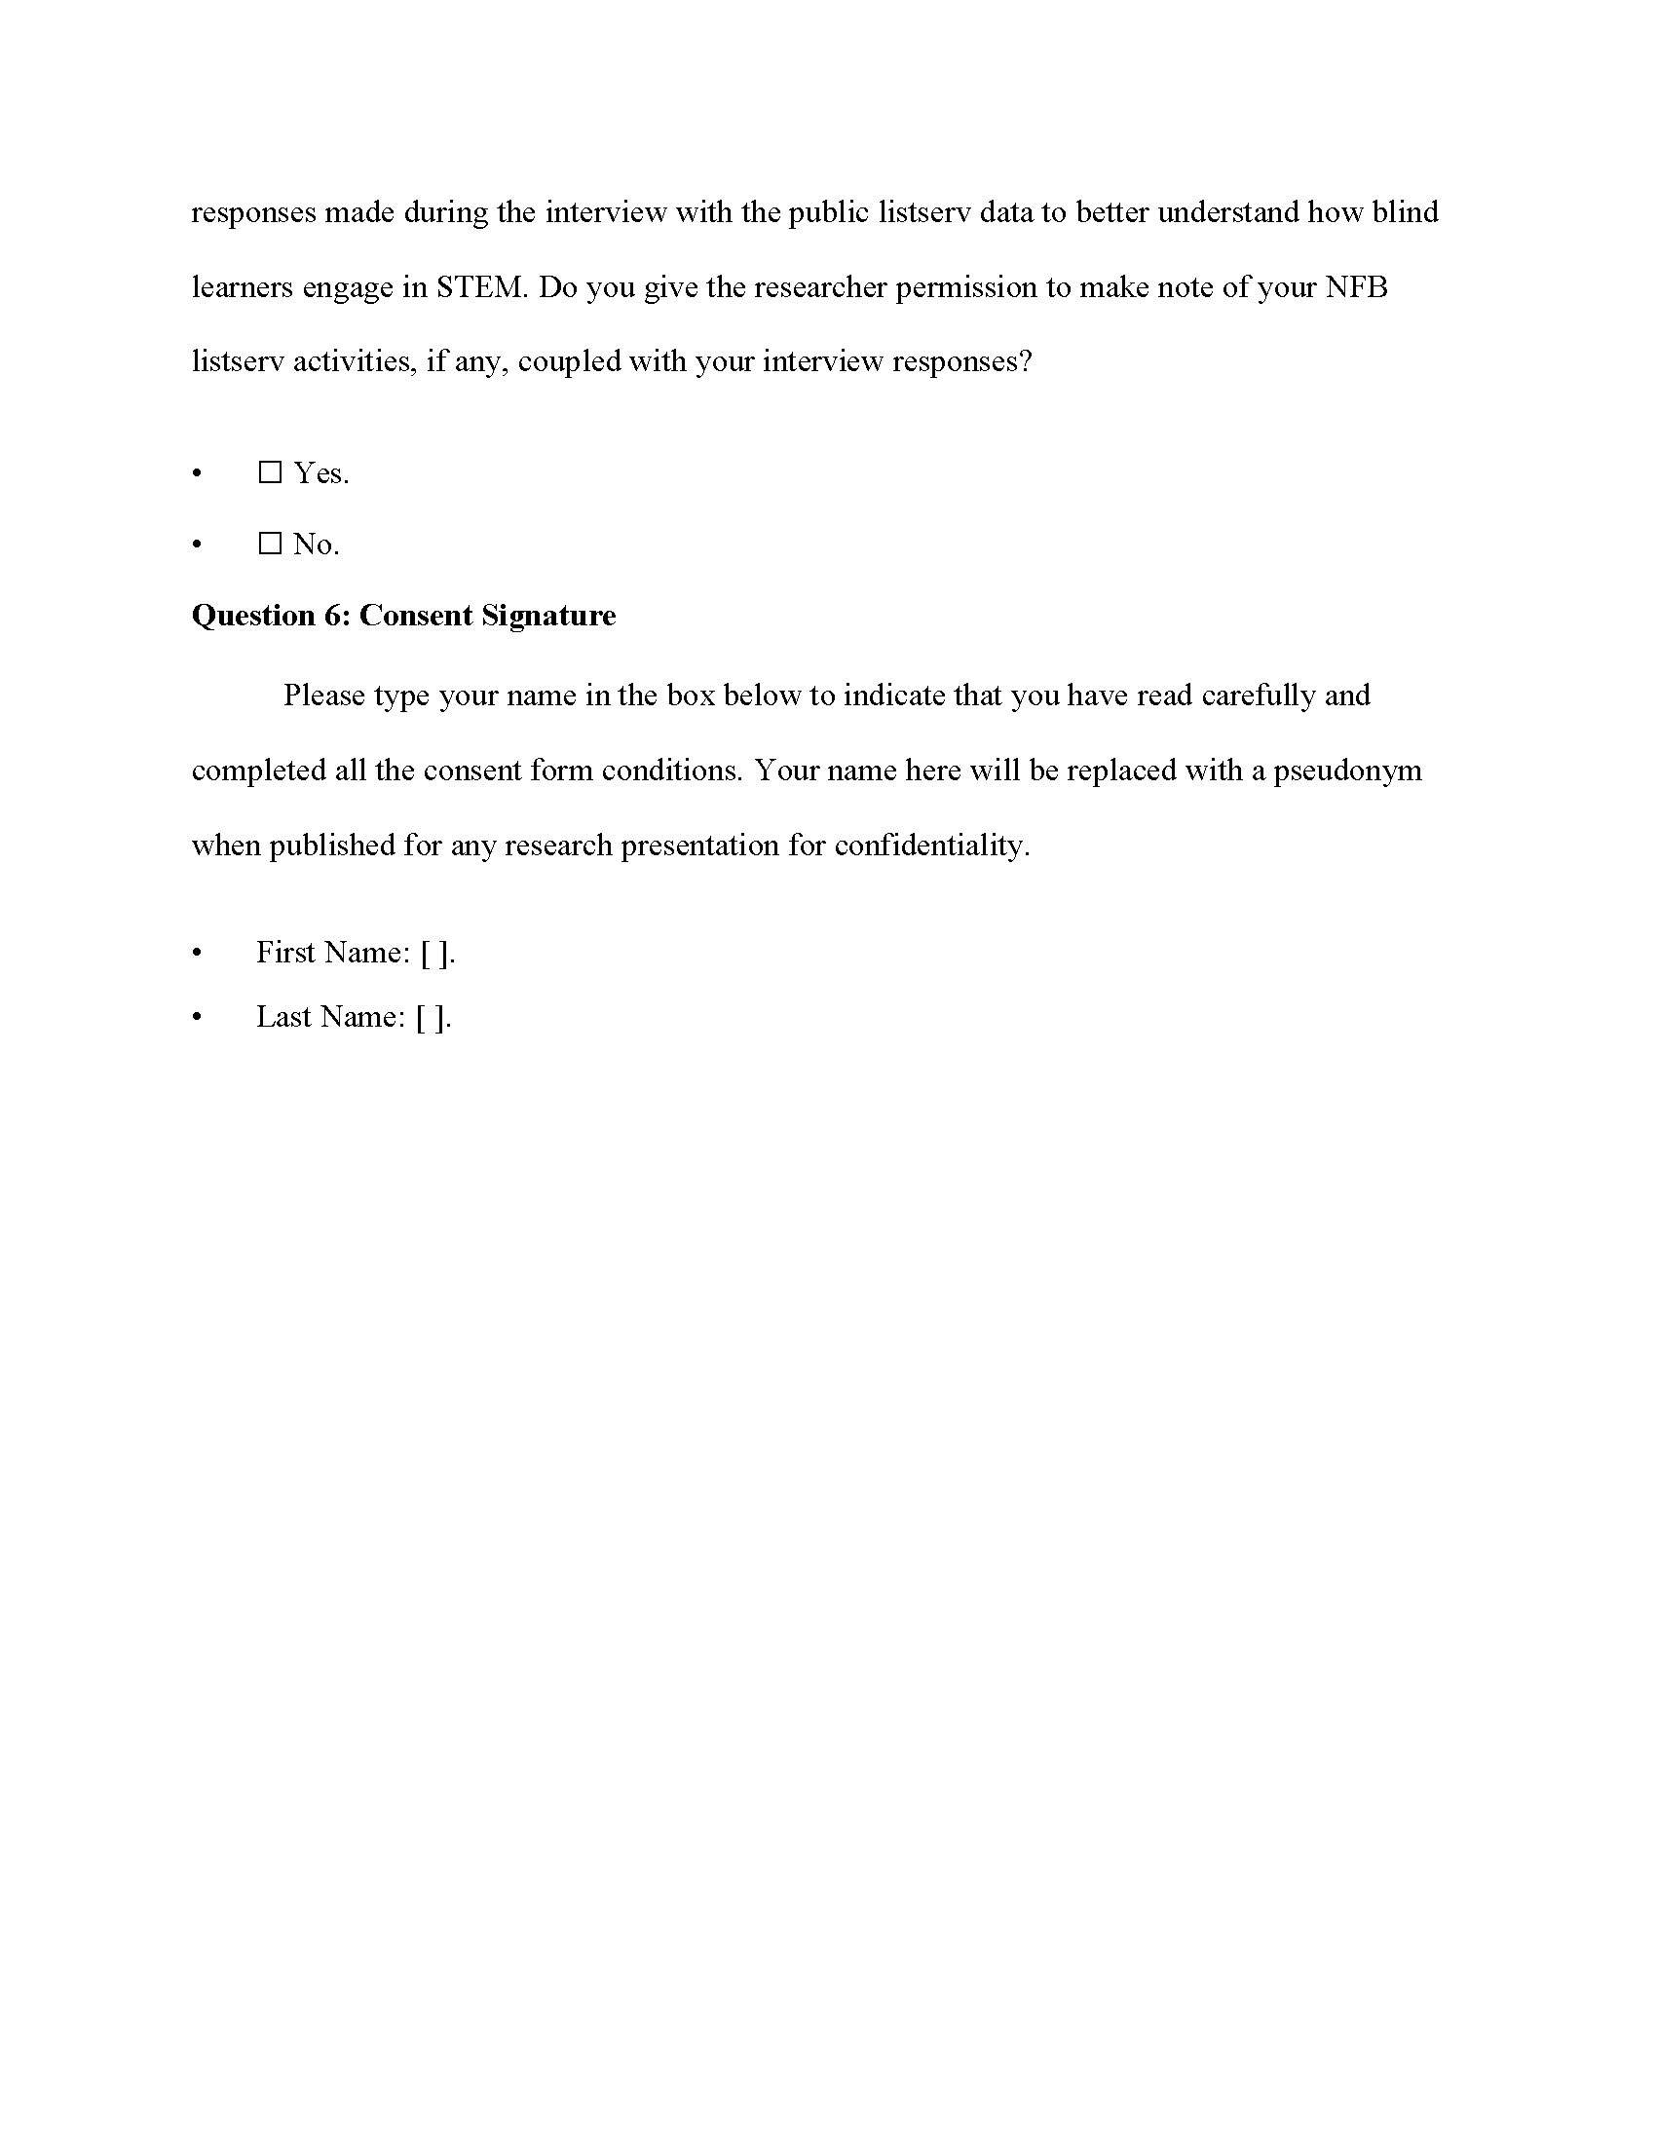

Figure 8.7: Interview Consent Form (page 4).

## 8.3 Semi-Structured Interview Protocol

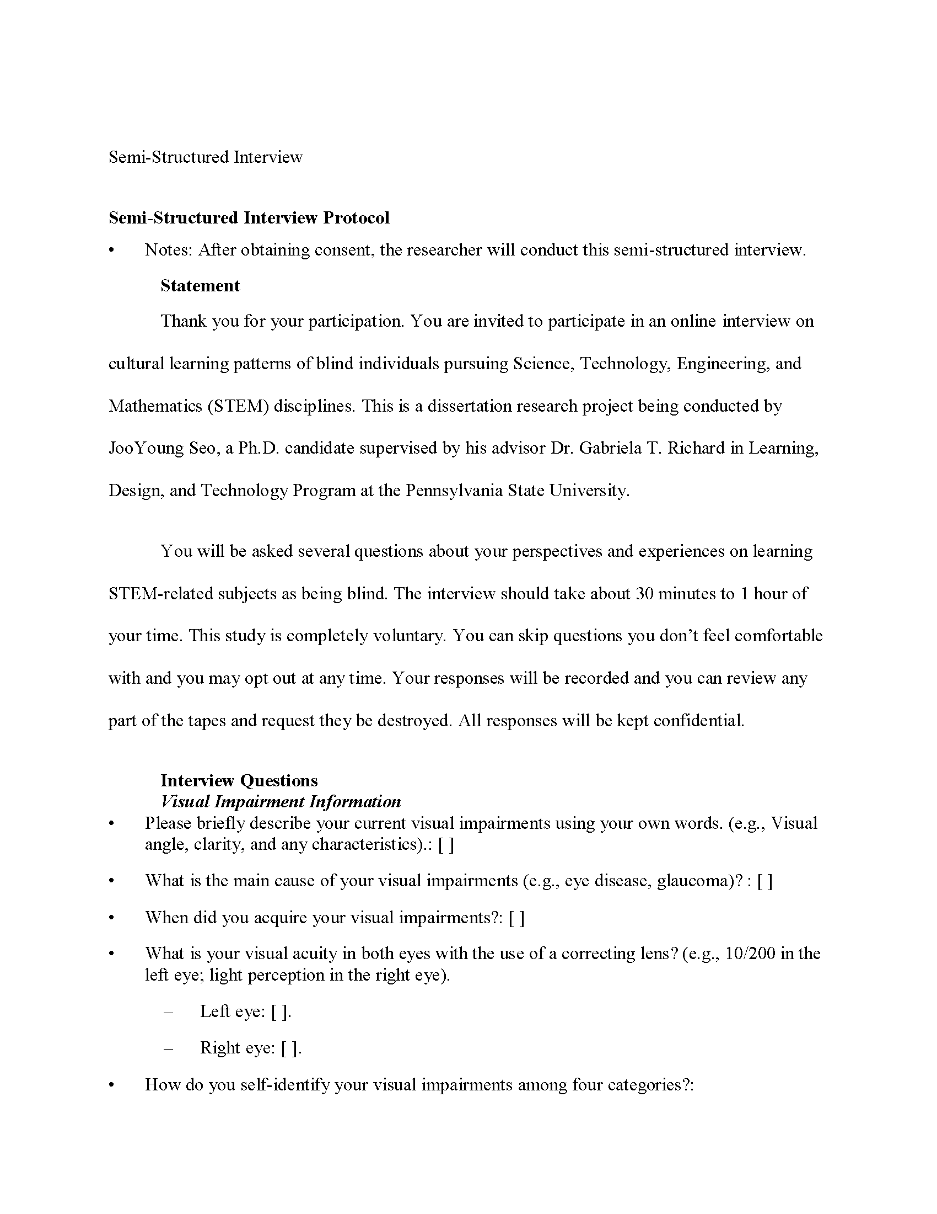

Figure 8.8: Semi-Structured Interview Protocol (page 1).

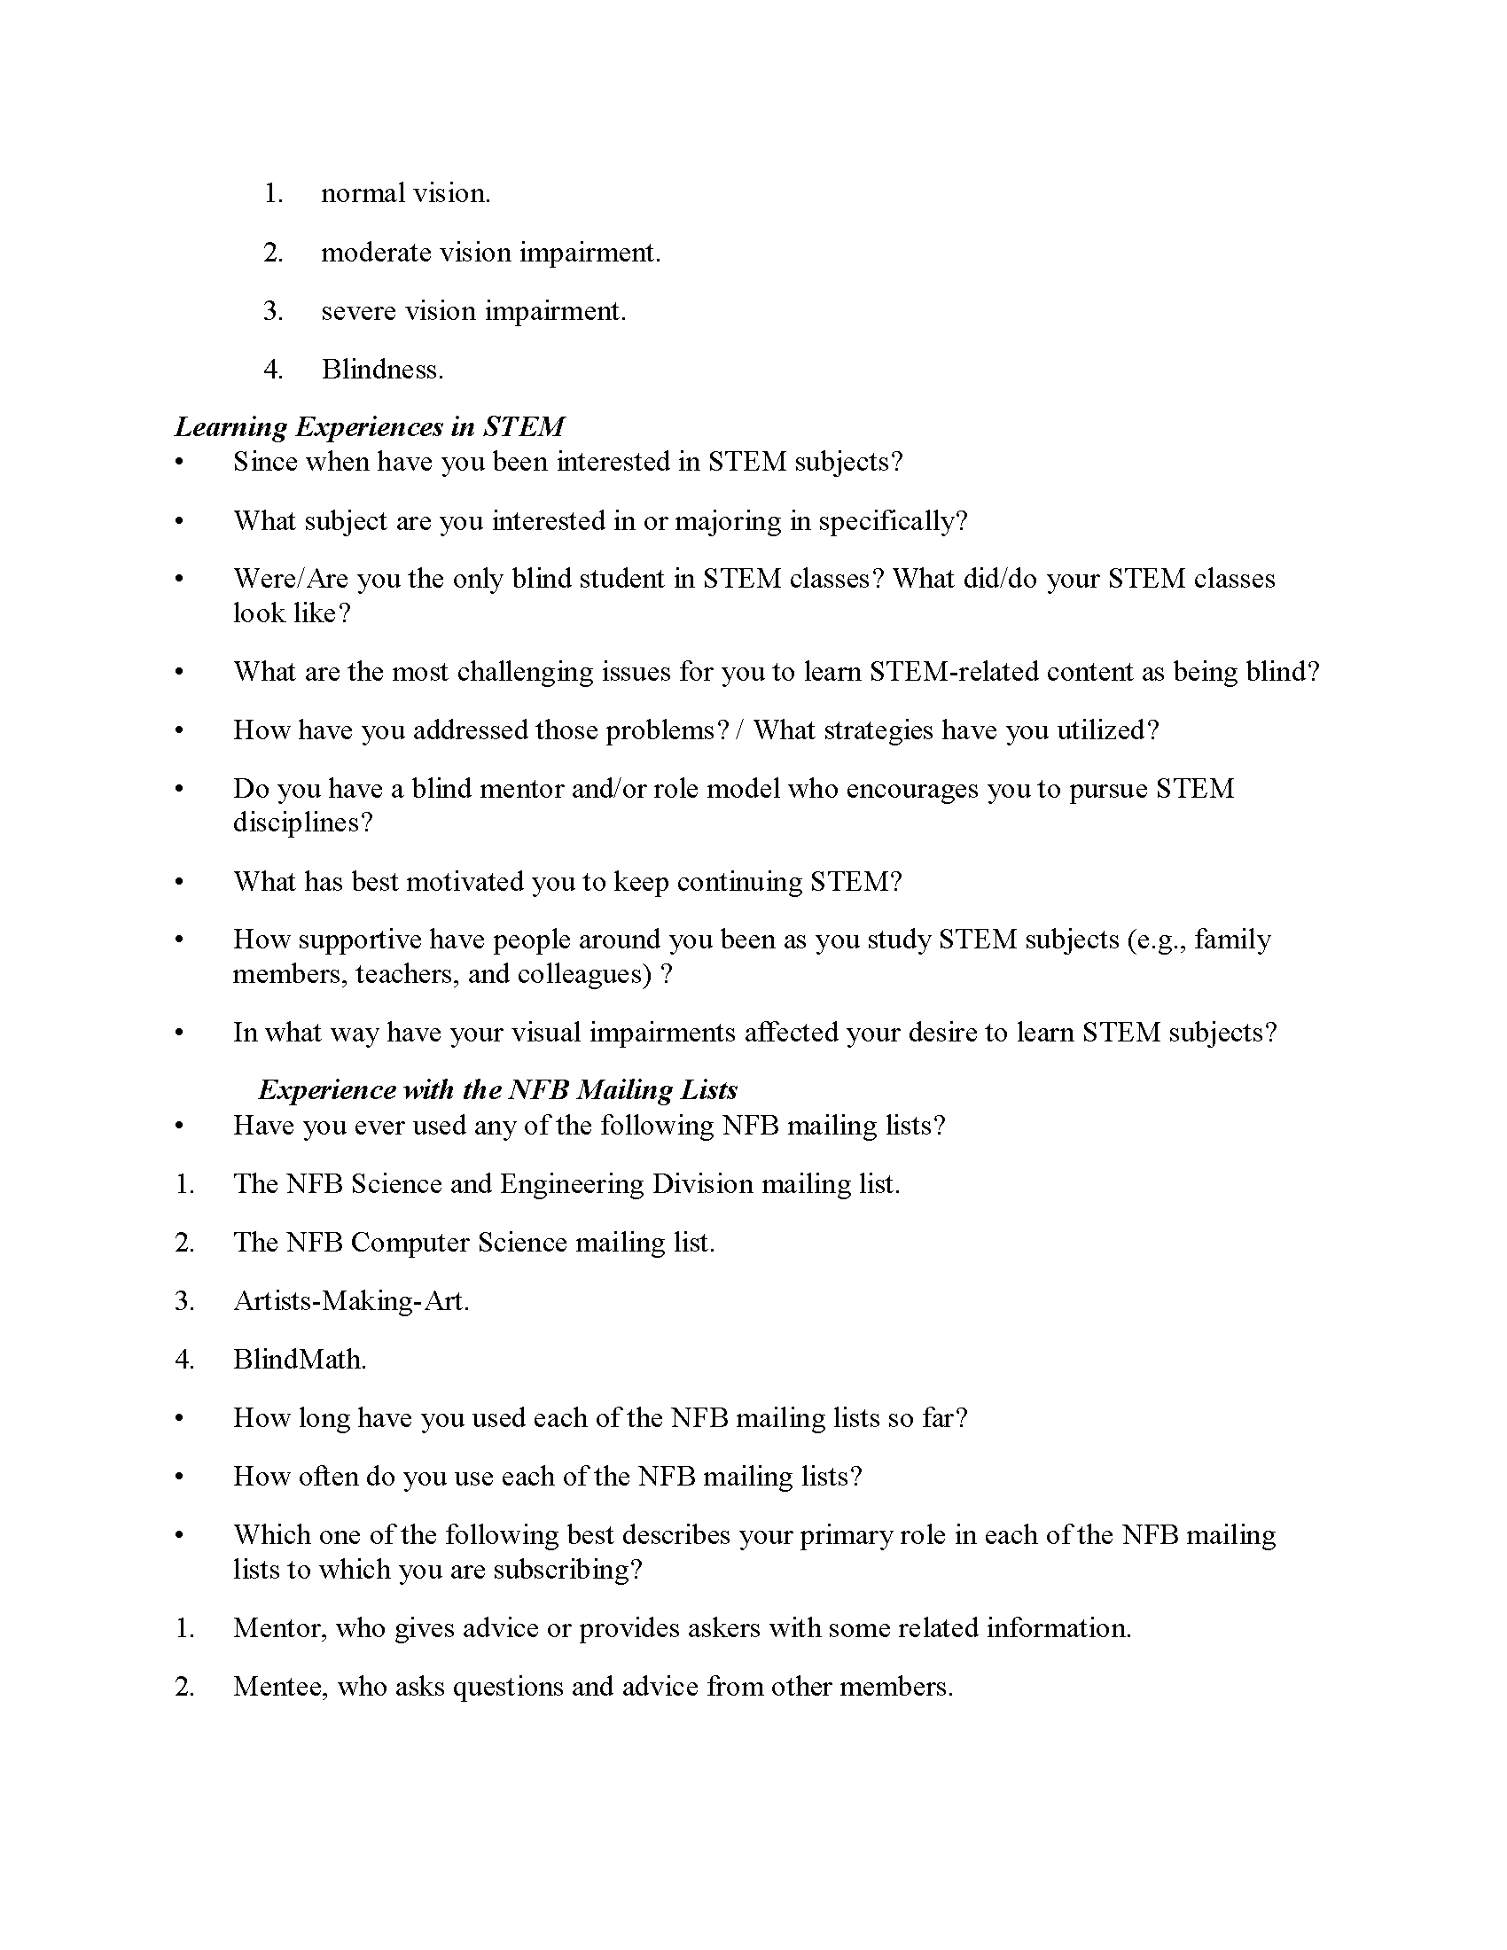

Figure 8.9: Semi-Structured Interview Protocol (page 2).

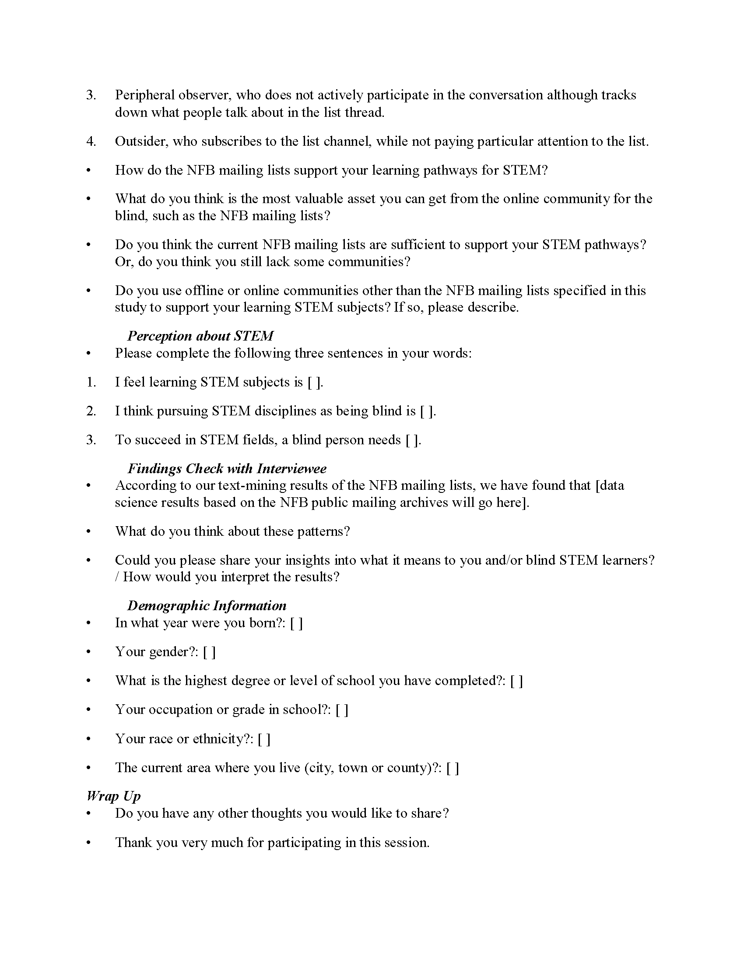

Figure 8.10: Semi-Structured Interview Protocol (page 3).

# 9 Interview Transcripts

* Note1: R indicates researcher; P# corresponds to participant number.
* Note2: The interview recordings of P1, P2, and P6 have been auto-transcribed using speech-recognition/machine learning technique, and these could contain some inaccurate text compared to other transcripts.

## 9.1 Participant 1

R: Hello. Is my microphone muted.

R: Okay, let’s see. Okay.

R: Your microphone is unmuted. That means there’s no issue with zoom right now.

R: Oh, now I hear you.

R: Yes. Okay, a little bit.

R: Can you please speak a little bit louder.

P1: Sure.

R: Yes. Okay.

P1: Is that a little better.

R: Yes.

P1: Okay, cool. Alright. Sorry about that.

R: Thank you so much for your valuable time

P1: Yeah, of course.

R: And I’m so glad that we’ve made virtually

R: Remotely and

R: Were there any difficult issue to get connected

P1: So first actually tried joining on my laptop, but

P1: Hi. Yeah. The reason I was having trouble. So I switched to my desktop so

R: Yeah. Yeah, I saw that you got a new laptop.

R: I’m sorry for any trouble technical trouble.

R: Oh,

P1: And it’s fun.

R: You know, technology.

P1: Yet it’s always hitting this

P1: Yeah, that’s okay. Yeah.

R: I’m for your information I’m recording this session. If you don’t mind, that’s fine. Yeah. Thank you so much. I briefly want to introduce myself before we start. Okay, as you saw in my

R: Dissertation studies introduction. I’m JooYoung Seo a PhD candidate in Learning Design and Technology Program at Penn State, and I’m currently doing my dissertation study on informal learning culture of blind individuals.

R: pursuing STEM, science, technology, engineering, mathematics, and you were invited because you connected and you are doing awesome jobs in STEM areas and I hope and I believe your insight to will add

R: So much to not only my study, but also to other blinds pathways to stem

R: Thank you so much. Can you please introduce yourself briefly.

P1: Okay, I’m P1

P1: currently applying to graduate schools for STEM fields.

P1: And yeah, in the process of doing that.

R: Great, great. Yeah, so

R: I’m going to read thumb some protocol interview protocol and I’m going to ask questions one by one. Okay. Okay. All right.

R: Thank you for your participation. You’re invited to participate in an online interview on cultural learning patterns.

R: Of blind individuals pursuing science, technology, engineering and mathematics STEM disciplines. This is

R: Um, this is a dissertation research project being conducted by Gian CEO of PhD candidate supervised by his advisor, Dr Gabriola Richard in Learning Design and Technology Program at Penn State University.

R: You will be asked several questions about your perspectives and experiences on learning stem related subjects as being blind.

R: The interview should take about 30 minutes to one hour of your time. This study is completely voluntary you can skip questions so you don’t feel comfortable with.

R: And you may opt out at any time. Your responses will be recorded and you can review any part of your tapes and request, they be destroyed.

R: All responses will be kept confidential. So I want to ask. Let me start our interview question I want to start with visual impairment impairment information.

R: So please briefly describe your current visual impairments using using your own words, for example, visual angle Cleary and any characteristics.

P1: Okay, so I have Retinitis Pigmentosa

P1: And it’s been kind of gradually onset so vision has been slowly deteriorating over time, but at this point I have pretty minimal functional vision remaining so I do primary everything primarily non visually. Mm hmm.

P1: Yeah, so anything using the puter it’s always text to speech stuff.

R: No, no.

P1: No use of vision early. Yeah. Mm hmm.

R: I see. Thank you. What is, what is the main cause of your visual impairments. So I think you already described, though your eye disease like yellow coma. But yeah, can you please repeat again.

P1: Retinitis Pigmentosa or r&b

R: I see. I’m in your both eyes. Right. Correct. Yes. When did you acquire your visual impairment

P1: When I was 12 ish is when I first started noticing it. And then, then it started like actually getting bad noticeably bad

R: And in

P1: High School, beginning of college.

R: I see. So it’s not congenital

P1: No.

R: I see. So you first identified your visual impairment in elementary school.

P1: Yeah.

R: I see, I see. What is your visual acuity acuity in both eyes with the use of correcting correcting lens for example 10 sludge 200 in the left I like perception in the right I SRI. So let me. Let’s start with left I

P1: So cutie.

P1: I don’t actually I assume it’s

P1: Worse than 2200. It’s been a long time since I’ve been able to read

R: Yeah, that’s a

P1: cutie thing. So yeah, it’s definitely worse than that. Yeah.

R: You can

R: You can just, you can just describe it in your words on what about left i is it like perception.

P1: Yeah. So I do have like perception. I do have some contrast perception.

P1: Know, seeing the difference between light and shadows and stuff, or if there’s something dark on

R: I see.

P1: Founder, or vice versa. A little bit of that.

R: I see. What about right i is the same.

P1: Is the same. Yeah.

R: I see.

P1: They’re both. Yeah, pretty much exactly this.

R: Hmm, I see, I see.

R: Thank you so much. Yeah.

R: How do you self identify your visual impairments among the following four categories. First, normal, normal vision second moderate vision impairment third CV or vision impairment

R: For blindness.

P1: I guess severe vision impairment

P1: Yeah, I mean, most people usually associate blindness total blindness, which isn’t

R: ISIS. Isis here.

R: Then a couple of questions I have, when you

R: Go outside. Do you walk with a cane. Oh yeah, I see, then, can you read some large print It.

P1: No.

R: Not functionally, I see.

R: Yeah. Oh, I see, then, do you use braille.

P1: So I only recently started learning Braille. So yes, I’m just now starting to use a little bit of rail. I don’t use it a lot though. Especially not for like studying

R: I see there’s not

P1: Not proficient enough in it.

P1: I see I can get by, I can read it slowly.

R: If I see, I see. So I guess your vision gradually decreased.

R: As time goes by. Yeah, then um

R: Did you felt so when did you learn first learn braille.

P1: Only recently really this the last the past summer is what

P1: I see adoring braille. I’m

P1: Not I mean my vision had gotten bad long before that.

R: I

P1: Was putting it off because I could do most everything getting around without needing to learn braille.

R: Ah, I see then that means you used your function of vision. Until then,

P1: No, I just figured out other ways to get things read other than braille.

P1: Ah puter

P1: Always found a way around generally having to read something on the page.

P1: Using an OCR app on my phone or

R: Yeah, I see. So you mostly used text to speech and screen readers for your study.

R: Yeah. Okay, that’s enough. Thank you so much. So

R: I’m going to ask questions about learning experiences in STEM.

R: Okay, since when have you been interested in STEM subjects.

P1: Since I was young.

P1: Yeah, actually pretty much always

P1: Yeah, so a little bit of background initially out of high school, I started studying engineering at Cal Poly. Um, but that was when my vision started really getting bad to

P1: Cal Poly after two years.

R: I see.

P1: I ended up transferring to business and getting my undergrad degree and that was

P1: A few years. Realizing it wasn’t what I wanted to

P1: Do. That’s what I decided to go back and do what I really had always wanted to do, which was

R: I see school for math.

P1: Or physics. So that’s, yeah.

R: I see you doing that now. Yeah. So, can I ask piggyback question.

R: So you said you you

R: You wanted to switch your major to business. That’s because of your visual impairment. Yeah.

P1: Exactly. I see how you did it. I mean I’d always wanted to do math or science. No, it was realistic.

P1: I see realizing how vision was getting

R: So it isn’t going to

P1: Just kind of fell into business. I didn’t really think it just kind of and

R: I see, I see.

R: I think many blind people they want to be realistic and they think, oh, business or humanity, it would be easier than stem splits that

P1: Yeah, exactly.

P1: That’s what happened, cuz I didn’t know what to do.

R: Yeah, oh yeah.

R: I’ll be business. Yep.

R: Okay, what subject. Are you interested in or majoring in specifically

P1: So physics.

R: Mathematics, but I see

P1: I’m pursuing a graduate degree in physics.

R: I see. I don’t know much about physics, but I guess there are many sub areas under physics. So why is it. Are you pursuing and you want to pursue

P1: So right now I’m really interested in doing quantum mechanics.

R: But it’s still

P1: Pretty early, but if I had to choose right now probably going to quantum mechanics.

R: I see. So when you talk about graduate school that’s master’s degree. Right.

P1: Correct. Yeah, so eventually a PhD, but definitely

R: Yes.

P1: true masters program.

R: I see her at this stage masters, but you ideally want to pursue a PhD at the end.

P1: Yeah. I see.

R: I see, I see.

R: I’m worried you all the only blind student in STEM classes.

P1: Yeah.

P1: I see definitely get

R: I see.

R: Then what did. What did your classes look like

R: If you were on the only blind student like

P1: In terms of

R: In terms of the class accommodations and the general accessibility of class.

R: Activities or subjects.

P1: Oh yes so

P1: Accessible is always it’s not great in STEM classes.

P1: In there just aren’t many find students

P1: Classes. So professors and other like students haven’t really ever had to deal with it.

P1: So surely not good. And so

P1: There’s a lot of work I have to do on my part to kind of accessibility.

P1: Work with professors what it was. What I generally do is worth like

P1: With my professors and we usually figure out ways to accomplish.

R: All I see to do but

P1: It takes a lot of work. It’s just some classes aren’t

P1: Best yeah but

P1: This isn’t really taking into consideration so

R: I see.

R: I see. So

R: It was born in accessible by nature.

P1: Yeah. Yeah, pretty much.

R: Yeah, so I’m sorry for asking the same question though you did your bachelor’s in physics, right.

P1: No, so it’s it’s in business.

R: It’s a business. So I so you want to transfer into another

R: I mean, which is physics from business for your master’s degree.

R: Exactly, yes. Yes. I see.

P1: It’s a hard. It’s a hard path to take.

P1: Yeah yeah

R: I know, but I really, really encourage you to do this, I

P1: Yeah, it’s, it’s gonna be a real big challenge, but it’s it’s gonna be fun. I’m actually making really good progress on it. So yeah.

R: Yeah, this is not in my interview protocol questions, but I wonder how you would

R: Prove your capability to enter

R: Graduate School and physics without having any bachelor’s degree.

P1: Yeah, so that’s sort of the biggest challenge right now I am taking physics classes at a local community college

P1: I so I’m taking. It’s a physics class, plus the lab.

P1: So,

P1: The last semester I took two classes. Yeah. So basically kind of just relying on

P1: Taking these classes and

P1: I see.

R: My professor

P1: Is really great and loves me because

P1: Really good in his classes.

P1: So I’m trying to get references that way.

R: I see from

P1: Professors and other people that have seen me work in the classroom and in the lab because the letters of recommendation or

R: Yeah, or

R: For me, absolutely.

P1: Um, I also took the, the general gra

R: Oh, yeah.

P1: rather well.

P1: So I think that’ll help. That’s kind of a, an objective.

R: I see.

P1: Piece of evidence for schools to look at, say, okay,

P1: Can still considering if I should take the physic Curie or not. A lot of the masters programs. I’m looking at don’t acquire it

R: Ah, really.

R: I see, yeah.

R: But, but, yes, speak.

R: Yeah, go ahead.

P1: So the one thing I think I’m lacking is real research experience.

R: Yes.

P1: What I’m trying to do right now. Really, really intensely is trying to get a research internship.

P1: Um, it’s been it’s been hard to find something

R: Yeah.

P1: There are a lot of opportunities for undergraduate students

R: Yeah.

P1: But since I have undergrad degree I don’t qualify for those

R: I see. Yeah, I understand.

P1: There are post back post baccalaureate internship opportunity.

R: Yeah, but

P1: If I go if I apply to those. I’ll be going up against people with physics undergrads.

R: Yeah.

P1: On paper, I’m not competitive, so it’s been it’s been a real struggle, actually. So it’s a good question, what you asked, because that’s where I’m at right now trying to prove myself and

P1: Trying to find the opportunities to do so. Yeah.

R: I will. I think there are many blind people who can assist you with this preparation and if needed. I will more than happy to find someone. And I can, if there’s anything anything I can help. I will do

R: Since we know each other.

R: Yeah. Yeah. So yeah, I’m with you.

R: Okay cool things.

P1: Are there any. Do you know any visually impaired people at your at Penn State.

R: I’m actually there were one guy.

R: His name is Terry swallow. Okay. He did his PhD in chemistry. He’s totally blind. Yeah.

R: Actually he graduated maybe five or six years ago.

R: So,

R: We didn’t go to school together, but I can connect put you through him after this interview and I have. So for this interview I recruited some participants for this interview right and there are. There’s another physicist. He’s totally blind. Okay, and he

R: Achieved his PhD degree in at Harvard.

R: Oh well, okay.

R: Actually, I can put you through him after this interview that would be really great community.

R: Yeah.

P1: Yep, that would be

R: incredibly helpful. Yeah, yeah, yeah, yeah.

P1: Cuz I’m, I’m actually struggling to find people that are blind in physics or math.

R: Yeah, hard to find. Yeah.

R: I’m so glad I’m doing

R: Conducting this kind of study because I can be a bridge between them.

P1: Yeah, exactly. Yeah, yeah.

R: Including. Yes. So let me keep asking

P1: Questions.

R: Yeah, I’m sorry, that was my question.

R: I mean aside, I’m apart from this interview. I have lots of questions personally that then we can have a personal chat later.

R: Okay, so what are the most challenging issues for you to learn stem related content as being blind.

P1: So,

P1: Right now, what’s really difficult is

P1: Math and diagrams.

P1: Getting math and any sort of diagram or model in an accessible format.

P1: And that’s been kind of the biggest hurdle in the classroom so far.

P1: In physics, there are a lot of a lot of things.

P1: Are taught you using visual aids diagrams and

P1: Models and stuff so I don’t

P1: Know have access to that.

R: So that’s been probably the

P1: biggest issue.

R: Yeah, as well.

P1: As getting math equations that are accessible.

R: Ton of equations. I still

P1: Don’t want to have to memorize them so

R: Nice to have a formula sheet.

R: I see, then, how have you addressed those problems and what strategies have you utilized

P1: So for the formulas I my professor hands out a formula at the beginning of the term. So I’ve made my own accessible version of

R: Oh, how do you do that.

P1: I just typed it up in word, it’s

P1: Very fancy or anything. It’s basically if anyone else were to read it in

R: Yeah, be confusing, but

P1: It works for me. So I just need a generally I have the formulas mostly memorize. Anyways, after hearing

P1: All so it’s it’s really just jogged my memory. Basically, when I can. So I am I am starting to learn latex.

P1: Just swing and actually do real

P1: Good looking math formulas

P1: But just for now I just read stuff in Word documents, that’s

R: WOW Incredible to

P1: Me. Yeah. So my own kind of like personal notes.

R: I see. So you just use plain text.

R: Yeah. Wow.

R: If the formula gets really, really complex more complex and complex, you will get more challenges.

R: Yes.

P1: Yes, definitely. Yeah.

P1: I see some of the formulas are yeah pretty lengthy

P1: But yeah, I’ll so my formula is going to a few lines there.

R: Yeah. So when you talk about STEM classes in this context, are you referring to the classes you are taking Community College.

P1: Yeah, so

P1: Yeah, so, electricity and magnetism.

R: Wow, the class and taking right now.

P1: Is like light, sound.

R: I see, yeah.

R: How long have you been in the community college while talking taking those classes.

P1: So this is only my second semester. So just

R: Yeah, how long do you have to be there.

P1: I’ve taken half after this semester, I will have taken

P1: All the physics classes they offer.

P1: Um, so

P1: Yeah.

R: When are you planning to apply for graduate school, then

P1: Fall 2021 next

R: Ah, I see. I see. So you are aiming at full 2021 as a student.

R: Or are you applying in

R: So you start applying this year. Right.

P1: So applications or do you early, mid to mid January, so I have just under a year. Yeah, to get ready and start submitting application.

R: I see, I see.

R: I see. All right. Um, do you have a blind mentor or blind role model who encourages you to pursue STEM disciplines.

P1: No, I really don’t.

P1: I really

P1: Don’t know anyone blind. That’s really in STEM.

R: And I see

R: So, but, but you really want to have one

R: It’d be nice.

P1: It’d be nice just to compare notes I have our just as sort of like practical questions.

P1: And how did they do this.

R: Yeah.

P1: I’m sure yeah if someone’s been in the same field for a number of years. They probably figured out some pretty clever tricks.

R: And we don’t

P1: Have to reinvent everything that so gnosis already come

R: Up. Yeah, yeah, that’s gonna be really, really great. Um, what has best motivated you to keep continuing stem

P1: It’s what I had always wanted to do and it’s just I love math and physics. So it’s just it’s just always interesting. So there’s no real lack of motivation ever. It’s just so interesting and exciting. Yeah.

R: I see. And you furthermore you found business. It was alternative but it didn’t catch your interest.

P1: No. Yeah. So actually when I switched to business. I ended up gravitating immediately towards

R: Economics and Finance, just because of

P1: Its, its map.

P1: But it was never something I really loved like I did with science so

R: I see.

P1: It was it was okay but I knew it wasn’t what I ultimately wanted to do.

R: I see so behind the reason you chose

R: Business as an alternative because he’d had math at the core, which you liked

R: Yeah, I see. But you more like science.

R: You rather than

R: Business. Okay.

P1: Yeah, it was sort of like economics and finance was

P1: Yeah, the best alternative within business, but it still is wasn’t what I wanted to do.

R: I see, I see.

R: Okay um how supportive have people around you, Ben, as you study STEM subjects, for example, family members, teachers and colleagues.

P1: Family and friends have always been really supportive

P1: And then teachers as well. My professor is really great at

R: The Community College.

P1: I end up so I don’t actually go through the Disability Resource department on

R: Oh really,

P1: Yeah, I mean, I’m registered with them or signed up with them.

R: But yeah, I find it.

P1: easier just to work directly with my professor and frogs.

R: Well, interesting. Yeah.

R: So you are really sort of reluctant to work with them, but you just prefer directly work with your professors

P1: Yeah, it just seems like we’re able to iterate and adapt so much quicker than having to go through

P1: I mean, if there’s something that we really just can’t figure it out. We’ll then we’ll reach out and go over there.

R: Oh, I see them.

P1: I said yeah so far, my experience finish just ease. If you have a good professor, like who’s willing to work on make things work. Yeah, it seems easier just to go work with them directly.

R: Well, I see. I think it’s interesting, but at the same time, I think you have a really great communication skills.

R: Very because what if possible direct communication with your professors is the best way because they day actually controls the

R: Class, and they understand deeply understand the content. Yeah. So yeah.

R: That’s great strategy, I think.

P1: Yeah, like for our labs and stuff. We work together to figure

R: Oh, we’re

P1: Going through the Disability Resource department would be difficult because they’re not. They don’t really know what the lab is

R: I see. And you have to rewrite and you have to explain everything from scratch.

R: Yeah yeah yeah I see.

R: In what way have your visual impairments affected your desire to learn STEM subjects.

P1: I mean, it did initially

P1: Like when I dropped out of Cal Poly and stuff. I kind of get. I don’t know if I gave up but started changing my goals, based on what I thought was more realistic.

P1: But then realized I could probably still use them anyways so

R: I said,

P1: Yeah, it definitely did

P1: Have an effect for for a while there but yeah

R: But now you’re just following your heart, regardless of your visual impairment. Yeah, I see. That’s really cool. P1

R: I’m, I’m going to ask about your experience with the NFB mailing list.

R: Okay. So have you ever used any of the following NFB mailing list. First, the NFP science and engineering. Second, the NFB computer science third artists making art and forth blind blind math.

P1: Yeah. So specifically, and a few science and engineering and math.

R: I see. Um, how long have you used each of the NFP mailing list. So you said science, engineering, let’s talk about science. How long have you used it.

P1: So it’s only been probably since November I didn’t actually I only I only found out about them.

P1: I see late October, early November.

R: So November 2019

P1: Team. Yeah.

R: I see. How did you get to know

P1: Um, I think so. It was one of my professors that actually

P1: Had heard about it once before something in

P1: Mentioned it and then I started looking online for it. And I found the whole mailing lists archive at the end.

R: That sounds cool.

P1: Then I found blind math and science and some other interesting sounding things

R: I see. So you have a great professor

P1: Yeah. Yeah. Actually, this is a different Professor than the one I have this is the other science professor at the college

R: I see ya. But he or she’s cited

P1: Yeah yeah us. Yeah. Yep.

R: Then are the same as blind math.

R: You were subscribing to it since November 2019 right yep

P1: The brewers the same time. Yeah.

P1: I signed up for both of them in the same day.

R: I see.

R: Did you did you go to regular school not special School for the Blind.

P1: Know, I always went to regular school. Yeah.

R: I see, then, how often do you use each of the NFB mailing list.

P1: I’m

P1: Sure, my mail pretty frequently every day.

R: I haven’t actually

P1: posted anything to

P1: post any questions. What I usually do is just monitor my inbox and if

P1: The thread that are a question that someone’s asking that sounds interesting or

P1: Not have the same question then. Oh.

R: I see. Oh.

P1: Cool dig into that and

P1: See what’s being said, Yeah.

P1: So, yeah.

R: Go ahead. Sorry.

P1: Oh actually it’s been quite a few things have come up in the that people have asked that I

P1: Yes, question. So

P1: Yes, that’s really helpful.

R: Yes.

P1: I’ve learned, actually a lot of good information from Yes.

R: So that real thats related to the next question, which of the following best describes your primary role in each of the mailing list.

R: To which you’re subscribing one

R: mentor who gives advice or provides Oscars with some related information to mentee who asked questions and advice from other Members three

R: Peripheral observer who does not actively participate in the conversation all the tracks down what people talk about in the list thread for outsider who subscribes to the list channel, while not paying particular attention to the list.

P1: Definitely the periphery.

R: I see, I see. The third peripheral observer. Yeah, okay.

R: I see how do the NFB mailing list support your learning pathways for STEM.

R: You can describe your yeah in your own words.

P1: Yeah, it’s been they’ve been cool because there’s a lot of practical

P1: advice or suggestions on some of the threads, which is really what I’m looking for. I’ll

P1: Always like run across some kind of specific problem and I just want sort of like the practical someone who’s already seen it in their how they dealt with it. So like I signed up for a MATLAB programming class.

P1: Ah, only to realize MATLAB the software isn’t really accessible.

P1: Haha. So I started seeing threads actually on the

P1: Thing is blind that specifically

P1: People that run into the same issue.

P1: There are some workarounds to it.

P1: So I’m kind of pursuing those workarounds

R: And then didn’t work.

P1: So it’s it’s it’s a little harder. So it requires some programming skills teaching myself Python right now.

R: Yeah.

P1: As well as seeing kind of learning MATLAB a little bit but

P1: I need to learn more program before I can actually

R: The workarounds that people see

R: I see, but at least the, you know, there exists some tips and the workarounds for

R: Blind people

P1: So MATLAB initially when I tried using it was like totally unusable.

P1: Yeah, so the fact that there is an Actual option is

R: Then walk on assistive technology do you use

P1: Screen Reader so NBA or jaws.

R: You use both.

P1: Yeah MBAs my primary sometimes I’ll use shows I see, yeah.

R: And you don’t use any magnifier.

P1: No.

P1: Not anymore. No.

R: I see. So school reading program is, though, the only one to use.

P1: Yeah, it was. It’s like a phone OCR after some time.

P1: In my laptop. Yeah.

R: I see. So speaking of fun. What kind of phone do you use

P1: I have an iPhone.

R: I see the reason why you choose iPhone over Android

P1: Oh,

P1: There’s no particular reason.

R: I see, I see it.

R: Because I’m asking this because many blind people prefer iPhone because it’s accessible more accessible. People say, Yeah, actually I have iPhone and I’ve never used Android, actually it has screen reader but

R: IPhones better in many ways.

R: In many ways, yeah.

P1: I don’t know, some of my some of my blind Android user friends actually swear by Android

P1: A lot of other people say it’s not as accessible. So I don’t know what to believe, actually. But yeah, iPhones. Good. So I don’t, I don’t see any need to switch. There’s nothing that

R: Yeah yeah I think Android is getting better. Okay. Yeah. Yep.

R: For your information, I’m from South Korea, the country of Samsung

R: But I, I like it. I like iPhone.

R: You better than enjoy

P1: This is secret. Yep.

R: Okay, what do you think is the most valuable asset you can gain you can get from the online community community for the blind, such as the blind and FB mailing lists.

P1: Really just sort of the practical advice that people you Know,

P1: There’s always some sort of some problem I’m running into and I just want that practical solution or working rounder so likely someone else has already encountered that issue. So what they did you do that.

P1: I mean, that’s the biggest thing.

R: I see practical

P1: Advice

R: Do you think the current NFP mailing lists are sufficient to support your stem pathways or do you think you still like some communities.

P1: One thing issue I have with the mailing list is

P1: Maybe I just haven’t looked hard enough, it’s, it’s

P1: Finding the archive of all the conversations

P1: I have you

P1: Have you look. Is there an archive of like old posts.

R: Yes, yes, that that’s what I’m going to use for my dissertation study, you know, I’m doing your

R: Data Science Research

R: So yeah, at the end of this interview our walk you through how to do search for the all old posts. Yeah.

P1: Okay.

R: That’s great question.

P1: Okay cool, because I yeah okay I guess I just didn’t look are enough, the other mailing list. I’m in. That’s not associated with NFP is on his

P1: IPhone for visually impaired.

R: I see. I don’t think it’s

P1: So I was actually before interview going through the

P1: The NFB mailing list again to see if Python is was on there. I’m not sure if it is or not. I don’t think is associated with NFP

R: It’s not associated. Yeah, it’s not okay.

P1: So that’s cool. I that that is really searchable in nice best whatever program. They’re using for

P1: That mailing list.

R: Ah, I see.

P1: Pretty well.

R: I see. So you think their archive function is better than NFB in terms of searchable function and Capability.

P1: I don’t know, I just maybe I just haven’t found the one maths or maybe it works fine. It was just me. Yeah.

R: Just compare after

R: You use that. Okay. Do you use offline or online communities, other than the NFP mailing lists specified in this study to support your learning STEM subjects. If so, please describe, I think you answered. You are subscribing to Python VI.

P1: VI.

R: VI s and

R: What else do you have for supporting your STEM subjects.

R: If any

P1: Pretty much it actually

R: I see.

R: Not a problem.

R: So,

R: I’m going to ask questions about your perception about STEM please complete the following three sentences in your words. I feel learning STEM subjects is blank.

R: I feel learning sub learning STEM subjects is blank.

R: Anything you want.

R: To put here.

P1: Fascinating rewarding but very difficult

R: I see. Cool. Cool. Yeah. Okay, second sense I think pursuing STEM disciplines as as being blind is blank one more time. I think pursuing STEM disciplines as being blind is blank.

P1: I think it’s great. I wish more people did it.

P1: But I understand why they don’t because how challenging it is

P1: That’s. Is that too long of a response. Sorry.

R: It totally depends on your feeling it doesn’t have any right or wrong answer. It’s just your own story. Okay.

R: The last sentence to complete

R: To succeed in STEM fields, a blind person needs blank to succeed in STEM fields, a blind person needs blank.

P1: I’d say support and opportunities.

R: From

P1: So,

P1: So I guess support from

P1: Friends, family and basically faculty

P1: I see wherever you’re going

R: Great. Great. All right. Um, so, P1. As you know, this study is associated with quantitative research by data science research.

R: Since we are pressed for time. And actually, I have to do more thing on my data science part, would you mind if I contact you again to collaboratively and collectively interpret our data science results later. Sure. Or I can send the report to you for your review.

R: I’m going to contact you again, if you don’t mind. Yeah, that sounds good. That’s cool. All right.

R: I think that I have last questions about your demographic information.

R: In what year were you born

R: 1988 okay

R: Your GENDER Male Okay, what is the highest degree or level of school, you have completed.

P1: Undergraduate

R: Mm hmm. Your occupation or grade in school.

P1: That’s tough.

R: In your words. It doesn’t matter.

P1: Pursuing in between graduate or in between undergraduate and graduate that

R: That’s great response to P1. I like that you are race or ethnicity.

P1: White. Mm hmm.

R: The current area where you live, city, town or county

P1: San Francisco Bay Area. Now, okay.

R: Okay, I think we covered everything we need. Do you have any other thoughts you’d like to share

P1: Though this was really interesting though.

R: Okay, thank you very much for participating in this session. I’m going to stop the recording and I’m going to give you some other resources that’s not related to our study. Okay, thank you.

## 9.2 Participant 2

R: Alright, so, um, I want to introduce myself briefly before we start.

R: Yeah, my name is JooYoung Seo a PhD candidate in learning design technology program at Penn State. I’m also blind person.

R: And I’m pursuing my degree in the learning sciences field which is interdisciplinary subject between computer science and education psychology. So I’m I’m kinda I’m conducting my dissertation research on how blind individuals pursue STEM disciplines and this is one of the

R: Qualitative parts and qualitative portions of my research.

R: So more detail will be followed soon in our interview.

R: So could you please introduce yourself briefly.

P2: Like so. I am currently receiving like

P2: The world.

P2: Masters like best Justin Masterson five years.

P2: Here.

P2: I will be joining like

R: I’m, I’m really sorry. Your voice is kind of on and off. So, would you mind yet.

P2: I Strike

R: Can you please. Say that again.

P2: Okay, yeah, so I

P2: Pursued

P2: A degree to which that is my master’s in applied mathematics from internship with technology.

P2: After joining me.

R: Okay. I think the audio connection is kind of the signal is kind of week so it’ll be really appreciate if you can speak a little bit louder.

P2: Okay, yeah.

R: I see. I see another Electronic sound for some reason.

P2: Yes. Yeah, the box.

P2: Let me try, let me try to invite in

R: All right. Um, I think we can tackle the issue, um,

R: So, um, let me start if you don’t mind, I’m going to read through my prompt

R: Thank you for your participation, you are invited to participate in online interview on cultural learning patterns of blind individuals.

R: Pursuing science, technology, engineering and mathematics STEM disciplines. This is a dissertation research project being conducted by Jiang co

R: A PhD candidate supervised by his advisor, Dr Gabriola teed Richard in Learning Design and Technology Program at the Pennsylvania State University.

R: You will be asked several questions about your perspectives and experiences on learning stem related subjects as being blind.

R: The interview should take about 30 minutes to one hour of your time. This study is completely voluntary you can skip questions so you don’t feel comfortable with.

R: And you may opt out at any quite any time your responses will be recorded and you can review any part of the tapes and request, they be destroyed all responses will be kept confidential.

R: So, um, I want to ask some questions about your visual impairment information first so

R: Could you please briefly describe your current visual impairments using your own words, for example, visual angle Cleary and any characteristics. Okay, so like

P2: I am prosperity by night person and I lost my visa like

P2: In my life tentatively

P2: Except Roman Martina I forget the exact name of 33 but it’s more like liquid inside dirty code try

P2: That much information later.

R: Hello.

R: Oh, I’m sorry. I think my internet signal was really bad.

R: Massively apologize.

R: Um, let’s see.

R: Do you hear me clearly

R: Yeah, yes. That’s great. Um,

R: Okay. Um, can I start with your

R: I know you described your you’re completely blind.

R: Yeah. Um, can I ask the following question.

R: Are you. Yeah, so yes.

R: So what’s the main cause of your visual impairment. Like I disease and where

P2: I forgot the, what is the actual biological likely mobile disease, but it’s like more feel like the liquid insider to try like

R: I say

P2: It’s like a regular job at a property name like what his actual

R: I see is a congenital disease or did you gradually

P2: Lose I lose ritually

R: I see that. When did you acquire your visual impairment

P2: Thank you. It’s from birth, but like a completely lost when I my tail to date when I like when my eyes when I come just completely

R: Ah, really. Yeah. So, like, like you were 18 years old.

P2: Like

R: 1616 okay that was you when you were 16 years. Okay.

P2: 15 plus years.

R: I see then until, until 15 PLUS YEARS OLD. You had some function of vision right

P2: And you’re like, it’s keep integration like Phil. Phil Center. I can do a lot of stuff like then I came in like when I completed in middle school. I can’t walk my like I need to take someone for even for walking like it’s kind of that.

P2: Play like something like

R: I see, I see. But you

R: haven’t lived as a sighted person.

P2: More like me to book like for the first eight or nine years just like quite good. Like I can read, I can read, I can play everything I can like ride a bicycle.

R: I see.

P2: Here. Yeah.

P2: It’s kind of a normal life. But I have to get up in our spirits. Mm hmm.

R: Thank you so much.

R: The next question like,

P2: I am

R: Yes, go ahead.

P2: Okay, like I know what are the objects like each of this look like for me, like, what are the main car.

R: Bus like what the long line.

P2: And like this helps me a lot. Like, even though

R: Mm hmm.

R: Okay, next question is, what’s your visual acuity in both eyes with the use of a correcting lens.

R: Like 10 200 in the left high and like perception in the right eye, etc. So

R: Are you completely blind in both eyes. Yeah.

P2: Yeah.

R: I see, I see.

R: Um, how do you, how do you self identify your visual impairments among the following four categories for its normal vision second moderate vision impairment third severe vision impairment fourth blind. This

R: Useful. Yeah. All right. All right, let’s move on to the next category, the questions about learn your learning experiences in STEM, STEM. So, since when have you been interested in STEM subjects.

P2: Okay, like since my childhood. I am very passionate about mathematics, like I used to. The like lot of calculation in my mind itself.

P2: So,

P2: So like after that I done with my high school, I took sciences like regarded long medical science where I took physics, chemistry, and mathematics.

P2: And then I took a data centers in India, which is like it, Jay.

P2: I took the sentence. And then I got into this Indian Institute of Technology.

R: Yeah, so

P2: Basically it’s from like the childhood I have deep interest in mathematics.

R: Great, great what subject. Are you interested in or majoring in specifically

P2: Alright, so it’s like it’s applied mathematics.

R: So you are

P2: Yeah.

P2: Yeah i doing what is it like we have to do a master dissertation.

R: Mm hmm.

P2: So, Dad, I’m doing in like deep learning

R: Um, I see. So for your undergrad major you also did

R: Applied Mathematics. Yeah.

P2: Yeah, like it’s a combined courses like you have to do your bachelor’s, master’s in five years.

R: Um, I see it’s combined between undergrad and masters.

R: Yeah, I see.

R: Okay.

R: Um,

R: Where do you and are you the only blind student in STEM classes.

P2: In my city, yes.

P2: Even if you took the mathematics in India. It doesn’t find anyone till now, like if there was someone is turning somewhere else. I’m not, but I couldn’t able to find new communities and all I Institute don’t care facilities, because they have not seen such a student before

R: I see. So yeah, that has to do with the next question, which is, what did your stem classes look like. So it’s asking about the accessibility of your stem classes, then

P2: Okay. Yeah. So yeah, as an issue group level my Institute is not that great, because they have not like they have not

P2: experienced this before and they are evil, not interested, like to spend so much time and like disorders like single student

P2: Was but like like to some like best law. Like, if I could, performing good in class or some of my professors who are interested, and they are like providing health like at their own level.

R: Name, if

P2: Someone gave me late IQ score of some research paper if I have to go about and if they have like if they can access our latest source code of some particular book they will provide me that and

P2: Like yeah, even like if they asked to leave if they are doing some like quizzes like class quizzes, so I can try to latex like Ray techs are like a math me so they can go, I can compile it and gave it to them.

R: I see but class your classes themselves are not accessible by nature.

R: Yeah, I see.

R: What are the most challenging issues for you to learn stem related content as being blind.

P2: Even like all the mathematician.

P2: Even if you cook any PDF like me such a little excessive.

P2: Your standard config nothing

P2: For first step, we have to convert them lightning successful and which is very challenging was able to contact someone or someone

P2: That will protect you.

P2: By the time like

P2: My class like have moved past that I can get up.

P2: To the main problem is accessible.

P2: Like even my class professor from table to write every notes analytics and provide me before that.

P2: It can help me out in class like defined data center particular person. Yeah.

P2: Like. Thank you, Professor plan to

R: Provide yeah

R: I see. I think you have already described, but how have you address those problems and what strategies have you utilized. Can you please detail, you’re on debated. Yeah, yeah. For

P2: Like writing like bringing my class.

P2: So if you’re ready producer like began percolated so fast. Mine was involved many other symbols. So

P2: I have to look like what short kind of

P2: Like if I have to write. It’s powered by just rewrite execute it.

P2: Like something like that. I like I have to say. Also, I can like, and then I bet. You write them like So they can be for for class. I’ll have some kind of like for veterans for 500

R: Audio Is

R: Now buzzing again. So I didn’t, I didn’t hear you very clearly the

R: But you use light tech for taking notes. And no

P2: Shortage of like if I have to like

R: I see.

R: I can ask

R: Via email later to clarify this.

R: Yeah yeah yeah thank. Do you have a blind mentor or blind role model who encourages you to pursue STEM disciplines.

P2: in the making.

P2: Right, so I know I just feel

P2: Like I’ve enjoyed it doesn’t it doesn’t

P2: So there are some like a shopkeeper Shapeways and Microsoft

P2: He’s also spread mean like we can work in a software engineer or a machine learning engineer.

P2: So these by one a little model and

P2: And like I didn’t bring someone reading, mathematics.

R: I see. So if I understand you correctly, you are saying that you found some computer scientist who are blind. Yum. In industry, you

R: You

P2: Angry thing, right.

R: Yes. You think they are role models, but you didn’t particularly find any blind mess mess mess.

P2: Even like after like to like after three or four year I will definitely go for a PSL next, I’m just exploring this like on a computer science field like four to three years to get a job or like to make some money.

P2: And I will do some electricity like

P2: Some states to like their accessibility and all the simplicity

R: So I said, Okay.

R: So when you’re talking about

R: The blind computer scientist in Microsoft is he also in India.

P2: No, he’s in UK

R: UK. I see. So are you referring to one who developed seeing AI.

R: Yeah, I see. Is he also Indian

P2: alone is not Indian

R: But I see. But you are just

R: Following his pathways.

P2: Yeah.

R: I see, I see. I understand.

R: Um, what has passed motivated you to keep continuing stem

P2: Oh yeah, as I tell your MTP like passionate in mathematics. And so when I read through the classes like most productive and in Algebra I have done 234 season and chapter

P2: And even like this come very handy when I complete our findings.

P2: And

P2: And like even like using data science and AI, we can create accessible, things like recap using computer vision like even I do have several projects. We have a retry to extract, they will try to convert them like simple mathematics to latex itself. So,

R: That

P2: Even I am interested in it. And it’s also benefit to this particular society. So does he play maturity.

R: I see, I see. So you find you find mathematics, interesting, you know, and motivating you to pursue them. Yeah, I see how supportive heavy how supported have people around you ban as you study STEM subjects, for example, arm, your family members, teachers and colleagues.

P2: Yeah, so like my family is like is no they don’t have some great roots in mathematics light. So, but they supported me, I always like if the they have day like David me throughout my senior second level.

P2: Who have they helped me like to prepare for at ITC exams and then direct them here in the first row, second semester, I find it difficult to convince people

P2: But like there was one or two Eastern well there’s exam. Next day, right, like I explained some of the concept to a few of my friends.

P2: And after that, things change a lot like now. Like they supported me like given like to to friends, I am here.

P2: Because there’s not so much support by the Institute, but like even my friends helped me some time to read out like if I don’t have time, because just before the exam. We don’t go to the older latex and they did quickly.

P2: So at the time they come Henley handy to just go to the old stuff quickly, something that day. So you had a pregnancy or and some of the professor very different

R: Oh, cool. So it seems like you have a supportive supportive environment and support.

R: People around. Yeah, yeah.

P2: In like every form note in the struggling. If they go out like LA area late for dinner or some party for like some they will every time asked me, and there is nothing, there is no stigma, which I find it was there is only in first year after Detrick Moscow.

R: I see among your family members, who do you think most

R: Helping you to study.

P2: Actually ma So,

P2: Like when my papers like I left my home like 60 or backs when they came here.

P2: So as a current support me in study

P2: But before actually my sister is also blind.

R: Oh really. Oh, I see. Yeah.

P2: So my page.

P2: Just like

P2: The

P2: Last day and he and my sisters always

P2: I also have done monsters. He has a built into the masters like two, three years back. And so like your day and the both of my teachers or sorry, the parents are very confident

R: I see, I see.

R: All right, I’m

R: In what way.

R: Have your visual impairment affected your desire to learn STEM subjects.

P2: Yeah, yeah. Okay. It says, like, like, like as soon as each coin has like two sides. So I also like think of that way. Like, like if I have to like sometimes when I called it accessible material.

P2: It’s like sometimes discouraged me like yeah

P2: But like when you understand a subject label you go to the subject like some abstract algebra, like some tea and analysis pitch in was like great visualization and which my friends web design, even at professors

P2: And it is very tough for them to visualize everything because they lose the ability to visualize on like they have maximum ability to draw on 2D or maximum we can use some software and they can see the 3D view, but beyond that they can imagine

P2: And and this helps me a lot like when we, when we have to visualize. I don’t have to pick up airline productivity.

P2: Linda and I can quickly like

P2: Visualize that particular thing.

P2: So that also encouraging me like, yeah, this is like kind of like some. This will help me. I like to go and visualizing everything so I can import those comes in pretty quickly.

P2: Yeah.

R: So you think you have sort of your on strategy special strategies to tackle those

R: Obstacles he front of you. Yeah, I see. Great. Next, I’m going to ask some questions about your experience with the NFB mailing list.

R: Have you ever used any of the following NFB mailing list. First, the NFB the NFP science and engineering.

R: Second, the NFB computer science third artists making art for blind blind math.

P2: Yeah, I have been using secondary fourth.

R: Okay, so

P2: As well and then them that

R: Okay, I see.

R: Um,

R: How long have you used each of the NSP mailing list so far, maybe

P2: Yeah yeah

R: Say that again.

R: It didn’t okay 18 months. Yeah. Okay, then.

R: How were you introduced to those mailing lists.

P2: Yeah, so like one of my friends are supplying is it at Stanford University.

P2: So like he just told me one day right yeah I introduced him bison like I introduce you randomly when I’m in my third year

R: So I talked to

P2: A man, I just asked him whether there’s some community.

P2: He told me about this.

R: I see, yeah.

R: Do Indian people also have this kind of online community for the blind.

P2: On low, but I am building, and building a one of them working for a startup kind of thing where we can build this community.

R: I see.

R: How often do you use each of the NFB mailing list. So you said you are subscribing to computer science and I

P2: Will tweet once daily life. It is a digest thing.

P2: You gotta digest each day. So I go through it once. And if I more like something which I can contribute

P2: To that and if I if like some time ever tested, we just

R: I see. Cool.

R: Which one of the following best describes your primary role in each of the NFB mailing lists to which you’re subscribing

R: First mentor who gives advice or

R: Provides Oscars with some related information that can mentee who asked questions and

R: Advise other Members.

R: Observer, who does not

R: actively participate in the conversation. Although tracks down and what people talked about in the

R: Outsider

R: who subscribes to the list channel.

R: While not paying attention to the

R: I’m sorry, I didn’t hear you know

R: A third one.

R: Okay.

R: I see. So, um, have you ever posted any questions or any any information.

R: To the mailing list so far. More

R: I see, I see. All right. How do the NFB mailing lists support your learning pathways for STEM.

P2: Connected before I even mentioned like

P2: I know like mathematics were just like, I will do, right, like a good day for me.

R: So I just Like Someone needs.

P2: Someone made me Think

R: So you think

R: You gain some insight.

R: Into how to tackle some accessible accessibility.

P2: For sure.

P2: Yeah yeah

R: Yeah. Yeah, that’s good. What do you think is the most valuable asset you can get you can get from the online community for the blind, such as the NFP mailing list.

P2: And

P2: Someone read some books like even like reading Books.

R: Can

P2: Be super when

P2: Someone wants to be like shipment boards like I am

P2: Better

P2: I mean, if you better get started.

R: I see.

R: Do you think the current NFB mailing lists are sufficient to support your stem pathways or do you think you still Lex lack some communities. Back something like

P2: I’m not sure exactly like yeah maybe someone like

P2: Welcome. Thank

P2: You for all the professor’s name.

P2: Working

P2: Well, what does he trusted like if I

P2: had already left no

P2: He was not

R: He

P2: Was

P2: A candidate. Thank you.

P2: For watching

R: I see.

R: Do you use offline or online communities, other than the NFP mailing lists specified in this study to support your learning STEM subjects. If so, please describe

P2: Number three, as I

P2: Said, It.

P2: Was personal stand

R: So you think you have some offline connections to your yeah your colleagues when you need any help, they yeah give their hands. Yeah.

R: All right.

R: Um, I’m going to ask some questions about your perception about STEM please complete the following three sentences in your words.

R: The first sentence sentence is I feel learning STEM subjects is playing

R: Sorry, there is buzzing sound so I didn’t hear. I feel learning salt STEM subjects is blank. What’s your answer.

P2: Yeah, just give me some time.

R: Now, okay, we’re good. Okay, I’m sorry.

P2: Of all for tonight really want to do with like say thank you very much and cookies and even for an understanding you can achieve to

P2: Achieve those of like we can make it accessible Ricard make these to resolve this conflict without engineering being productive who decides to do this kind of stuff to make things

P2: And

P2: And change which involved with him. It says your life like for me if anything is the correct mathematics their

R: Life nice see

R: We still have

R: Two more sentences that we need to complete the, the second one is, I think, pursuing STEM disciplines as being blind is blank. I think pursuing STEM disciplines as being blind is blank. Yeah, we

P2: Don’t flooding like of looking for the one because we don’t have some like gold or even like I’m starting at the top, and she could offer currently still, we don’t have like proper resources to accommodate the needs so

P2: Yeah, it’s challenging, and it’s very

P2: Very hard work and a deep attention to pursue STEM filling in

R: All right, that’s, that’s great. And the last sentence to complete is to succeed in STEM fields, a blind person needs blank to succeed in STEM fields of blind person needs blank.

P2: HTML.

P2: He has to. He has to put an extra effort.

R: Actually, you know, this dissertation research is combining quantitative data science and results with qualitative interview findings.

R: In the people

R: Like you

R: So,

R: Since we are pressed for time.

R: I don’t think we have enough time for interpreting data science results. Actually, I’m planning to distribute my data science results to

R: everyone participating this research to collaboratively interpret the results.

R: Would you mind. Would you mind if I read contact you.

R: in near future with the results of the data science.

P2: Yeah, I really love to just, I’m a little like

P2: Seven.

P2: Seven.

R: Yeah. So what I’m doing right now is I have developed my on R and Python package to data mine. Our NSP archives, you know, NSP they archive.

R: All previous

R: email exchanges as a zipped

R: Text to files.

R: So I

R: Transfer

R: The plain text on structured data into structured data and I use text mining and unsupervised machine learning techniques to

R: uncover some salient themes

R: Out of the large scale data so

R: That’s going to be seared soon.

R: This is the last category. I’m going to ask

R: demographic information.

P2: So,

R: What year were you born

R: In 1986 1986 right

R: Okay 1996 okay your .

R: Okay.

R: What is the highest degree or level of school, you have completed.

P2: My masters and this may continue.

R: I see. So you’re graduating this may

R: I see.

R: Your

R: Your occupation or grade. In school,

P2: So like my current ladies.

P2: Joining us

P2: And I have gone on to the next demo.

P2: A couple of

R: So you are joining Microsoft as a data scientist right here in India. Yeah.

R: I see.

R: That’s really awesome.

R: Is it. Do you know what project are you going to be involved, specifically

P2: Was probably I will be going live HD

P2: Microsoft

R: Ah, I see.

R: I see the new browser right yes okay your race or ethnicity.

R: You identify yourself Asian yeah yeah okay the current area where you live, city, town or county

P2: Status.

P2: In India,

R: Okay, I don’t, I don’t need too much information. I just need your current yeah country, etc. So I think India is enough.

R: Yeah. Um, I think we have covered everything with me.

R: Do you have any other thoughts that you would like to share

P2: Are you just trying to

P2: Be providing the dirt bike carriage.

P2: Return.

P2: You have thoughts on

P2: This and for some reason.

R: Yeah, I would like to thank you so much, because your experiences is really valuable and actually finding a blind person pursuing especially mathematics is really rare and you’re

R: professional experiences means a lot to not just to yourself, but to our blind society. So I really appreciate your heart effort, and I’m going to share any findings from this study honestly to you sometime soon.

R: And I want to keep in touch with you to collaboratively.

R: Have a conversation and interpret our results later.

R: Yeah, thank you so much.

R: Thank you very much for participating in this session arm. If you have any other questions work close concerns for this study, please email me and I would be more than happy to address.

R: I think we yeah we’re good to go.

P2: Yeah.

R: Thank you so much. Have a good night.

P2: Nice to meet you.

R: Nice to meet

R: You. Bye.

R: Bye.

## 9.3 Participant 3

R: All right, now I’m recording. Before everything else, I want to introduce my self briefly. My name is JooYoung Seo and I’m also totally blind person. I’m originally from South Korea and I’m pursuing my PhD Degree at the Pennsylvania State University majoring in learning sciences. Learning sciences is interdisciplinary study between computer science and educational psychology. I came to United States back in 2014 to pursue my masters and I have continued pursuing my PhD. Could you please introduce yourself briefly?

P3: Originally I’m from Pakistan. I lost my sight around the age of 16 and then I wasn’t able to continue my science studies in Pakistan. The education system didn’t support that back there, but I continued my studies anyway but it wasn’t in science subjects. Then I eventually got a business degree but I wanted to really study science and physics, so I came to the U.S. for my second undergrad. I went to Oregon State University for my undergrad education. I came to the U.S. in 2001, I graduated from Oregon State in 2004. Then I went to grad school for my PhD at Harvard which I finished in 2014. Then I did a postdoc for sometime until 2016, and right now I’m doing a postdoc at the University of Arizona which I started last year.

R: Fantastic. Actually P3, I read your amazing stories on the web. Is saw several web articles about you, so I have basic background information about you.

P3: That’d okay.

R: It’s really, really amazing.

P3: Thank you.

R: Thank you so much for your valuable time. Actually, so far I have interviewed two blind people and you’re the third one. I’m going to interview maybe seven more people in STEM discipline. Actually, my dissertation will use NFB mailing archives and I’m doing my data science research using that live data, so I use computational linguistics and some unsupervised machine learning to capture some emergent themes about what challenges we have and how we have tackled those issues.

P3: I see.

R: I have prepared some qualitative interview questions so let me walk you through each question one by one, okay?

P3: Mm-hmm (affirmative).

R: Please describe your current visual impairment using your own words for example visual angle, clearly, and any-

P3: Your voice is kind of cutting, can you start the question again?

R: Yes, yes. Please describe your current visual impairment using your own words for example visual angle. Yes, go ahead.

P3: Total, total blindness.

R: Yes, that’s it. All right.

P3: That makes it simple.

R: Yeah.

P3: You can do a long description.

R: I think you mentioned already, but I have to ask one more time, what’s the main cause of your visual impairment?

P3: Retina detachments. I had retina detachments in both eyes.

R: When did you acquire your visual impairments?

P3: At the age of 16.

R: What is your visual acuity in both eyes and you said you don’t have.

P3: I have zero vision.

R: Yeah, zero vision in both eye. How do you self identify your visual impairment along four categories. I think the first is normal visual, second is moderate vision, third is severe vision impairment and fourth is blindness.

P3: The fourth.

R: I’m asking this because some people-

P3: Some people have partial vision but in my case it is simple.

R: Exactly.

P3: There is no vision.

R: Yes. All right, I’m going to ask some questions about your learning experiences in STEM. Since when have you been interested in STEM subjects?

P3: I have been interested throughout like from very early childhood before I lost my sight. I was always interested in going into STEM.

R: I see. When you’re in Pakistan, right?

P3: Yeah.

R: I see. What subject are you interested in or majoring in specifically?

P3: Physics although there is a time I thought engineering but eventually it ended up being physics.

R: I see. When you’re in your country, did you have interest in physics specifically?

P3: In early childhood I was interested in. In childhood sometimes it isn’t that narrowly defined, so it’s engineering or physics. Eventually I decided that physics was really I wanted to be. It was all on early on, yeah.

R: Did you gradually lose your sight?

P3: No, it was sudden.

R: Oh, I see.

P3: I lost one eye at the age of 10, I lost the other at 16. Although when I lost my one eye it didn’t change anything because you can keep functioning totally with one eye. That doesn’t really count. The other eye it was sudden.

R: I see. Were you the only and are you the only blind student… I think you’re not student but where you the only blind student in STEM classes and if-

P3: Wherever I took my classes, yeah I was the only one student.

R: Oh, I see. What did your STEM classes look like in terms of accessibility and course materials?

P3: This is a very broad question, since I have gone through multiple degrees, so should I narrow down my answers or how do you like it?

R: Yeah, you will be appreciated if you can narrow down specifically to STEM related courses.

P3: But you want me to describe every school I have gone to where I’ve taken STEM course?

R: No, in general.

P3: In general. In Pakistan first of all I was 11th grade when I lost my sight, at that time they told me that I can not take STEM anymore, “Now that you’re blind you can not do physics et cetera.” That was the first thing. There wasn’t STEM class basically available to me and I then changed my subjects to humanities. Then I did a business degree so for a while there wasn’t a STEM class. In the middle of the business degree, my university only offered in degrees in business administration and computer science, they didn’t offer other engineering discipline but they did have a computer science degree as part of that, they offered calculus and they offered like the first year kind of physic course that typically universities they offered some physics courses like one or two.

P3: Then I asked them if I can take those courses and they said, “Fine, no problem.” I was able to take those courses there, but they didn’t have any accessibility needed support as such, so I would attend the class, but accessibility wise I was on my own. They would offer me somebody to volunteer for STEM, I would speak and they would write. But for reading and on the blackboard, I wouldn’t be able to follow it as much as I liked. What really worked for me was the fact that my mother had a master’s in maths and she would read stuff to me and I basically did math and physics with her. That was the university setting there before I came to the U.S.

P3: But the other thing is, and this wouldn’t be on my transcript, but at home after losing my sight, I decided that I wanted to continue doing math and physics. Even apart from that course that I mentioned that those couple of courses that I was able to take, I did continue to do some math and physics study on my own with my mother. But again, it was her, there wasn’t a form of class, but she would read to me and I would work it out and then we would do the problems together kind of she would like… Basically she was playing the role of the reader things like that. Before taking that calculus course formally, my first introduction to calculus was actually with her. That’s the first thing. I’d say the first thing was my mother even though it wasn’t a form of class.

P3: The second thing is the university setting where I did take courses and I got grades and all that. But again, my mother was a big part of the story there. When I came to the U.S., the situation changed, because the U.S. system has the Americans with Disabilities Act, they provided books to me. Well, before coming to the U.S. I found organization called Learning Ally. Maybe you are familiar with it.

R: Yeah.

P3: Back then they were called RFB&D. I did start getting some books from them towards the end of my time in Pakistan before I was coming here in the buildup to it. So I did some reading through those which were like audio books. When I lost my sight, I tried braille but I felt that it was too slow and I was used to speech. Braille was way too slow and nothing was available in braille anyway. My bias was always not to use braille so much because it was slow. When I came to the U.S. I went to Oregon State University, then the university provided me books electronically. Maybe this is getting a longer.

R: No, no, no. Yeah.

P3: The university provided books electronically in special format because Oregon State University had a professor or a John Gardner.

R: Yes. I know him.

P3: You know him? Okay.

R: I mean, superficially.

P3: He developed something called WinTriangle, it was a software with speech for reading and writing maths, because JAWS and standard screen readers don’t do math pretty well. The university provided me books in that WinTriangle format and that’s how I took my exams. The classrooms were a little funky because when teachers started writing on the board, it becomes hard to follow. The university used to provide note takers. Some students would be hired to take notes and give them to me, but following the lecture itself was always. I didn’t get too much out of the lectures. I didn’t get that much out of lectures, that was always a problem.

R: I understand.

P3: Even in grad school at times I felt like it was a waste of time to even go to a lecture, so I would stay at home and read. But although I did attend lectures, but in hindsight. If I could do it again, I’m not sure if I would attend the lectures as much or who knows maybe I would, but following lectures was difficult. Even now when I’m attending seminars, people start writing on the board the equations, that’s the part that’s bad, that’s difficult. I do my homework, the same kind of WinTriangle format. I did my undergrad in Oregon, when I went to grad school more or less that format continued, but then at some point I switched. When I got to research I switched to writing and working out my math in LayTeX directly, rather than using WinTriangle, for reading I still use WinTriangle.

R: I see. I think you have provided somewhat comprehensive answers across the following questions. So if you think you have already provided answers, you can just simply tell me. I’m going to skip this.

P3: Okay. Let me ask you this, I mentioned which format I used, was that more the question or was it more the environment in terms of how supportive people around me were and all that?

R: Actually it includes both. I have a piggyback question before I ask this. Does your country have any special school for the blind?

P3: In Pakistan?

R: Yeah.

P3: Some until tenth grade, I was in eleventh grade and they don’t teach them very well. Typically, blind people are just told that they can’t do STEM period, but I had done my tenth grade anyway, and I was lucky otherwise would have been tougher.

R: So you didn’t go to special school for the blind in Pakistan?

P3: No.

R: I went to a special school for the blind in Seoul after losing my sight, actually I have a glaucoma and I lost my vision at the age of 10. I just wonder. You mentioned LayTeX, that’s I want to ask more about. Do you use LayTeX extensively when you write code or do you use later when you read something like math?

P3: I use LayTeX when I write. When I read, I convert like I mentioned this WinTriangle thing, then I came to Harvard, somebody who was hired to provide books to me in this LayTeX format. He wrote a program that convert LayTeX into Triangle. The Triangle is basically, it’s more old after LayTeX, but LayTeX is very messy and cumbersome. Blind people and you might’ve heard this from others, some people do try to read LayTec directly, but it’s a big, messy format. Sighted people don’t read it, it’s has a lot flatter.

R: So you are relying on Triangle, the device name is Triangle, right?

P3: Yeah, it’s a software. Triangle is modeled after LayTeX, but it’s meant to be a simpler version of LayTeX without modes of formatting flatter. If you read LayTeX directly, it’s a big mess.

R: I’m going to research after the session, because I’ve never heard of Triangle up to now.

P3: It went out of fashion. It didn’t become as popular as it should have, because it was a very good solution from reading directly in LayTeX. At some point, Professor Gardner gave up on it and moved on to other thing. I don’t know how much you’ll find on the internet. You might not find a lot, but you can try it and if you have follow up questions, definitely we can have follow up from your station.

R: P3 as you know this days people are using MathML more and more. Do you use MathML?

P3: Before I get to MathML, one very quick thing about LayTeX and Triangle. You are familiar with LayTeX at some level, as I get?

R: Yes.

P3: LayTeX writes fractions in this form where they’ll write like is alpha or . A fraction is like and then you have braces and you have the numerator inside braces then you have another pair of braces in which you put the denominator. What Triangle does is instead of , it just puts a single alpha. You know you are reading speech with JAWS and word dimension if you see alpha it’s just a single character alpha, instead of all that it’s just single alpha. For fraction instead of that it gives you a single character fraction. It says fraction after that you write the numerator, then it says denominator, after that you write the denominator, then it says fraction.

P3: For square roots in LayTeX you’ll put and you will have an opening brace and then you put whatever is inside the square root. LayTeX will give you a single character instead of , then open, then you put whatever is inside the square root then a closing character. It really is the same idea, but it kind of simplified it. It allows the writing, like the Triangle software also allowed writing in this. I did my work. Currently what happened, now coming to MathML, I see now people have these other alternatives like MathML for reading, for writing, there still isn’t a good solution out there.

P3: The issue however with MathML is, and MathML can be used with like JAWS or NVDA for MathML, but the problem is that a lot of stuff isn’t directly available in MathML, like research papers and books. Books are not available in MathML. Research papers typically in my field, research papers are all available in LayTeX. In fact, the good thing with my system like I mentioned, that I was offered that converts LayTeX into Triangle, so because of that conversion software, I go online, I download the paper. I take the LayTeX version, I download it, I convert it to WinTriangle and I’m able to read it. Without declutter, I don’t have to deal with and all the formatting junk that LayTeX has, but simplifies it and makes it efficient.

P3: For MathML, I would need to convert LayTeX into MathML, because research papers are in LayTeX or if I have a book… sorry. If there’s a book or let’s say like I’m looking for some reading material, I find something in PDF online. It’s not accessible, it’s got equations in addition to text, they’re not accessible, but then there’s the software which will convert an image into LayTeX, called screen reader. It will convert an image if it’s a scanned image, or if it’s a PDF online into LayTeX and then again, I can use the rest of the process to get LayTeX into WinTriangle. For MathML I would need to convert the LayTeX into MathML or the other alternative is to convert LayTeX into Microsoft word.

P3: There’s something called MathType, which is similar to MathType and people use that too. The tricky part is I experimented with those and those are the standard things that people use these days, but the LayTeX to MathML… I haven’t actually had much success with the LayTeX to MathML conversion tool anyway, but I tried a couple of LayTeX to words, like MathType document. When you have a conversion, the conversion is not always perfect and in that conversion imperfection in the conversion means that it’s very messy. It gets messy again and you typically cannot get a good output that’s readable unless you actually go into the LayTeX document and do some work where you change the form of LayTeX, because LayTeX has many commands and not all types of commands will convert perfectly.

P3: That’s also an issue in my LayTeX to Triangle conversion thing, but in the experimentation that I did, I found that my LayTeX to Triangle things converts much better with MathML than the LayTeX to word MathType things I’ve tried. I tried to get it one or two, like I tried to experiment with LayTeX to MathML, I didn’t have much success with getting a thing to work anyway, but I also heard that it requires a lot of work so that you have to edit a lot. But that’s the thing. If I get the nice MathML version, then I can use JAWS and read it maybe, but that isn’t the problem.

P3: We can talk about some imperfections like I think the way the quality of reading the JAWS does with MathType or NVDA does with like MathType and MathML, I think there’s good features there. There’s also room for including some new additional features which aren’t there. Hopefully some point people will think better, but the more fundamental problem is how do you even get it to MathML?

R: P3, I think you have offered really detailed answer and that’s really instrumental. Actually from a more computer science perspective I think I can also share some tips from LayTeX to MathML because I have developed some.

P3: If you can tell me how we get it to work, I couldn’t even get it to work. That would be helpful.

R: Yeah, because that’s off topic.

P3: Hopefully, again, lets do this.

R: I want to keep in touch P3, I want to become your friend because I want to share many tips as a blind person pursuing in STEM. You know P3 it’s really hard to find someone who understand both the subject area and technical side because we as a blind person, we have to understand both deeply, right?

P3: Right.

R: If you were sighted for example, you can just simply focus on your subject but you have to-

P3: You don’t have to become an exceptional.

R: Yeah, exactly. But now you have to handle lots of things, actually that could be off topic, but you have to memorize everything and maybe I can help you out in some ways, if there is anything I can help out, I will send you some information later, okay.

P3: Yeah. There’s the way I tried to download some stuff for LayTeX MathML and I asked around and nobody gave me a good answers in terms of how to make it work, including on the Blind Math mailing list and then because people were saying that it still requires a lot of work and I had experimented with LayTeX to MathType and the confusion was. The thing is, there’s a cost if you have a system that works fairly well or somewhat well. There’s a cost if you’d switched to something else, that something that needs to work at least equally well or better. That has not been the case, but if there’s a way for you to tell me how they make LayTeX to MathML, work that would help out to experiment with it. I probably would come to the conclusion that this technology isn’t yet ready for me to use, but I should at least have that option.

R: Yeah.

P3: That’s off topic, we can get to it later.

R: Later, I want to ask something about your data analytics skills, and how do you approach data analysis. What kind of tools you are using and what’s your strategy, et cetera? Basic question, do you use any statistical packages or software?

P3: Oh, I don’t use a statistical package. My work has not involved working with large data sets. It just happened to be the kind of research I have been doing, it didn’t require that so much. As an undergrad, I had lab data and I worked with it using mostly Excel. In grad school, when I got into research, I was doing the type of research where more of the work was algebraic. But obviously within algebra there’re tools, like I use Maple all the time, other people use MATLAB. The Maple is similar to MATLAB or Mathematica. That’s what I use if I’m working with large matrices or if I’m doing whatever, but usually typically I don’t work with large data sets.

P3: But when I have I’ve generally it’s been at a level like in an undergrad lab, even for my undergrad thesis, it was at a level where I could mostly do it in Excel. I did some simulation in C++ where I was generating data sets based on simulation, but then eventually again, I would open it in Excel.

R: I see. I later I want to open another session topic regarding data analysis for the blind people because I’m really into data sciences and I’m using R. I have developed some packages for blind people, R packages and Python packages and actually I’m doing my intern at RStudio this summer, because that’s not accessible. I will be involved in some accessibility project later.

P3: Oh, that would be awesome if R and those things become accessible.

R: Actually-

P3: Are you connected with Dr. Jonathan Godfrey?

R: Oh yeah, I’m sort of close to him.

P3: Oh, okay.

R: I think that there are lots of things and we can talk about later, but I will walk it through another question. Do you have a blind mentor or a role model who encourages you to pursue STEM disciplines?

P3: I was motivated to do STEM myself and I was like, “I’m going to do it even if people think I can’t do it,” and I came to the U.S. for it. In that sense there was no mentor who encouraged me and told me to do it and resulted in me doing it. But then Dr. Gardner was really good mentor. I went to Oregon State University because he was there. I also applied to some other places and had admission offers, but I thought I’m better off going for my undergrad, I should go there. The tool that I mentioned, either his tools like WinTriangle and he also introduced me to The Tiger, which I used more when I was an undergrad in deed.

P3: He’s been a very important montor, just that I didn’t need someone to tell me that, “Oh, you can do science,” and encouraged me to meet that type of mentor. By the time I got to Oregon State University, he was actively involved in accessibility related work, so he was never my physics teacher, but he was a very good mentor. I think he’s made he’s made things possible for a lot of people, including myself. If I hadn’t gone to Oregon, it was one of the best things I did. One of the best decisions I made was to go there because he understood what needed to be done. I mean, I’d name him as the blind mentor for science.

R: Thank you so much. I’m going to ask some questions about your experience in the NFB mailing list. Have you ever used any of the following NFB mailing lists first, NFB Science, second, NFB Computer Science, third, Artist Making and aArts and fourth, Blind Math

P3: Blind math.

R: Only blind math?

P3: Yeah. I didn’t know the science one existed. I should get on it.

R: How long have you used a Blind Math?

P3: Blind Math has been around for a long time. I think I joined Blind Math maybe in 2002 or 2003, somewhere along, something like that is when I joined it.

R: How often do you think you use a Blind Math?

P3: I see emails, I’m not always that active on it and for a long time, I wasn’t very actively part of the thing. The thing is people have kind of like this WinTriangle thing, which some people will say this is being shamed and why are you using the old technology, even Dr. Gardner will say that. But people are using other tools they’re more MathML focused, or people will just be directly from LayTeX or they’re writing in LayTeX. A lot of the things people do is different from the way I do math. Then there are braille people and I hate braille, so a lot of times the questions that are asked are specific to those things. But even for those things from time to time, somebody will join the list or ask, "Oh, how do I do math? Usually there’s somebody who answers that, so I don’t have to. There are people who answer it. If nobody were answering those questions then I would answer too and I would tell them about the MathML and everything.

P3: I don’t have to actively participate that much. There’s so many people who are much more able to do it, occasionally I do chime in.

R: Then, which of the following do you think best describes your primary role in Blind Math, first, mentor who gives advice or provides askers with some related info, second, mentee who asks questions and advice from other members, third, peripheral observer, who does not actively participate in the conversation, although text down what people talk about in the list, fourth, outsider who subscribes to the list while not paying particular attention?

P3: I’d say I’m three, because I don’t that actively respond to be a mentor. Mentee, again, once or twice occasionally I may answer some questions, but generally not that much. Three, I think I’m definitely not an outsider. So yeah three would describe me best.

R: I see. What do you think the most value valuable asset you can get from the online community for the blind such as NFB mailing lists?

P3: Me personally or someone in general?

R: Personally.

P3: Personally. Because I went to Oregon state and Dr. Gardner was there as a resource, so I saw a lot of things I didn’t have to, like I haven’t had to ask too many questions on the list, but it’s very nice to know that there’s a community out there where you can ask questions and share experiences with people. I think just the knowledge that there are people out there as a resource you can ask them is comforting. The other thing I get out of it is that people talk about these various tools and when they ask questions, it helps me stay somewhat informed about what other people are doing, which would be harder if we didn’t have the list. Then there’s no real, like how do you keep track of it?

R: That’s good. So I’m going to ask some questions about your perception of our STEM. Please complete the following three sentences. In your words, I feel learning STEM subjects is?

P3: Possible, but requires determination.

R: The second question is, I think personally STEM disciplines as being blind is?

P3: Oh, I mean they are kind of the same. Did the first one you mean me or as a blind person?

R: Yeah. First, it doesn’t have any blind in the sentence, but second it has.

P3: It’s about blind. What I said for the first one is what I should have said for the second one. Possible but requires determination. It’s possible, but it is somewhat challenging, it requires determination.

R: I’ll take that for the second question then.

P3: For the first one, I don’t know what to say. I mean, as a scientist it’s interesting and exciting and something I was doing and want to do. So interesting and exciting is maybe the word.

R: Then the third sentence to complete is, to succeed in STEM fields a blind person needs?

P3: Hard work and determination and somewhat more than your other sighted peers.

R: That’s cool. Actually the next part is about the interpretation of data science results, but I’m going to share my data science results later. Actually, I’m going to share to everyone who’s participating in the session, at the same time so you will be asked later. Last part, I’m going to ask very briefly about your demographic information. You can skip if you don’t. In what year were you born?

P3: 1979.

R: Your gender?

P3: Male.

R: What is the highest degree or level of your school you have completed?

P3: PhD.

R: Your occupation or grade in school?

P3: Occupation wise?

R: I think your post-doc would fit in.

P3: Yeah, right now am a post-doc.

R: Your race or ethnicity?

P3: I’m originally from Pakistan, so I think this would be put as a category of Asian.

R: I can just say Pakistani.

P3: Yeah, that’s more specific if you want.

R: The current area where you live like city, town or county?

P3: Tucson, Arizona. T-U-C-S-O-N.

R: Yup. Thank you so much. I think we have covered everything we need. Do you have any other thoughts or you would like to share?

P3: Do you have any other what? Sorry.

R: Do you have any other thoughts or you would like to share something?

P3: It depends what kind of stuff you are looking for in your research. We talked about tools, there’s the sociology there the environment in which you’re interacting with people how supportive they were, stuff like that and sometimes people are supportive, want to be supportive, but they’re not used to working with blind people and the way the world works is that the world everything is designed for sighted people. That’s the other dimension of facts which we didn’t get to talk about. It depends on what your focus in research is. I think my answers were more focused on the tools, from what I got. If you want me to talk about that other dimension, that’s something I can share some thoughts on. It depends what you’re looking for.

R: I think I gained really great insights. I think today’s conversation I learned what tools you have used and utilized, that’s really cool. I haven’t heard of Triangle, I’m going to go research in depth and I think we can have any cool conversation, follow up conversation that doesn’t necessarily have to be related to this research though. As a mode of appreciation for you to participate in this research, I would like to send you 25 Amazon gift card, would you like to receive that?

P3: Yeah. That would be awesome.

R: Actually P3, this requires you need to type in your name and email address and today’s date, that just three information. If I send a doc document, can you please type in your name and email address?

P3: So you’re going to send me a document?

R: Yeah. I’m going to email you as an attachment, you can just reply to me after typing in that information, my administrator who will provide you with Amazon card.

P3: You can send it to me and I’ll get back to you either today or tomorrow.

R: Yes. Then you will get 25 Amazon gift card in a time limit.

P3: Okay. Thank you. That’s awesome.

R: P3, I’m really sorry for any technically issues you faced today.

P3: No, No worries. I mean, those things happen. I have a question for you though.

R: Yeah.

P3: What you are doing is you are interviewing and you said you’ve interviewed a couple of other people, one thing I’ve been curious about is, if there are these which have their pros and cons. They have some limitations of their own, like MathML we don’t have a good writing tool for example from blind people to do things. I don’t think WinTriangle is better than anything else people are doing. Although like for simple work, for research level work, I just write directly in LayTeX and I’m used to it, but that’s for advanced level. These are kind of pros and cons of tools, but then there’s the social environment like getting into the job market, getting people to accept you, all that and then the other thing is a lot of these tools are designed specifically for… it seems to be done with the idea that this is going to be used by students as opposed to a full threshold.

P3: Like if I wanted to give a physics presentation, if I want to teach, the tools are designed for that so much, it seems like the focus seems to be more on the students side. Those things and how open and willing the society is, creates a lot of limitations and barriers. I come across a lot of people who are studying STEM. I don’t know if that many people. Do know people who are not students and are actually working at STEM, not a grad student or an undergrad, post-doc is fine, that all include because that’s a job, because is not student. But somebody who might be teaching, who may be working as a teacher or who may be working in some STEM are other than computer science. In computer science, we do find some people who are working in programming in mainstream spaces, but for natural sciences, do you know if people who are actually doing it?

R: That’s really great question and you pinpointed really important aspects, because we’re just focusing on how to teach and how to learn STEM, but we now have to think about professional blind people in STEM disciplines, how actually they pursue after graduation. To answer your question, actually there’re many blind computer scientists, but it’s really rare to find other than computer scientists. But one of the interviews is doing computational bio chemistry. Actually she’s under Gardner, but I have a friend actually he has graduated Penn State. He has a PhD Degree in Chemistry? His name is Kelly Sparrow. Kelly Sparrow he taught chemistry at R1 University, but now he’s no longer teaching chemistry. He’s now in ETS. You know what ETS is?.

P3: Oh, the testing.

R: Yes, exactly. I know Kelly Sparrow and I know-

P3: In ETS, is he working on the chemistry yet?

R: No.

P3: Because there are people who eventually go into accessibility, even on Blind Math list, a lot of people are accessibility people.

R: But you are specifically looking for someone who is actually doing their subject area?

P3: They’re actually doing STEM not doing accessibility, because if you’re doing accessibility you’re helping other people do it, but not doing it yourself. I’m wondering where are the people who are actually doing STEM or who have done STEM?

R: P3, I think that’s another research topic that’s really critical and important area we need to deep dive into. You know Josh Mill?

P3: No.

R: He also has a physics PhD in UC Berkeley. Actually he served on Smith-Kettlewell in California. Actually that the organization is tailored for the blind people. He organized blind are doing a blog. But I have no idea about what he is doing right now, but as far as I know, he’s not doing his subject matter related research, but rather he’s pursuing accessibility advocate for other blind people. I think that’s sort of out of your radar.

P3: Yeah. The tricky thing is that there is all this accessibility help available for students, but then at some point it seems like it’s not clear that people are continuing on to do fine after studying science. We should see more people who if somebody does a degree in chemistry, that they did their bachelor’s in chemistry, now they working for company XYZ as a chemist or a physicist, or somebody did their PhD and now they’re working in whatever the field is in industry or academia, wherever. It seems like somewhere people eventually aren’t continuing on to do what they actually planned to do and hoped to do as students.

R: P3, when it comes to the computer science field for example, we see many blind people in accessibility computing, but there are many blind people who are not doing accessibility project.

P3: Yeah. Computer science, I’ve heard that there are people who are doing other things.

R: Yes. Do you know statistics like Jonathan Godfrey?

P3: Yeah. Jonathan is one, he’s teaching, he’s a professor at the university.

R: Yes. Another-

P3: I mean, apart from statistics, if we brought in it’s likely, like we say statistics or you could include economics or finance, which are quantitatively rigorous field even if they’re not probably science or STEM. Even if we brought in my question to that, even there, I’m curious if there are people.

R: Ah, and there is one professor. He’s biology professor, totally blind.

P3: Oh, okay.

R: Do you know him?

P3: No.

R: I can send his information. He’s actually doing his subject matter. I will send his information. I just came across his information on NFB website. I’m going to send that information to you.

P3: That would really be helpful. I just am curious about this. The other thing is, at some point I thought about maybe writing an article on the subject, but then do you think you don’t want to say that it cannot be done or it’s hard to do and in a way that other people read and to start discriminating. Also, want to highlight the fact that a lot of times people spend arguing, “Oh, it can be done, it can’t be done,” and you can do that as student. But then there is a problem somewhere, because all these people who are doing this as students, it means that they can do it, but somehow they are not. So there’s something wrong either with a work environment or something like that and being able to write on the subject in a way that doesn’t end up closing doors.

P3: Like if you write something that all people drop out and kind of identify as a problem and maybe kind of helps draw attention to maybe what needs to change in the world. These things need to be done in an intelligent and sensitive manner, because they can be misunderstood. I have been thinking about this, but I don’t fully know what’s the best way to approach the subject. Like I was asking you where are those people, since I don’t know if other people were doing STEM.

R: Another person I interviewed he’s doing applied mathematics masters but in India.

P3: But he’s doing a master’s, so he’s a student right now?

R: Graduating this May. He’s going to Microsoft, actually the best computer science field. Even though he majored in applied mathematics, he found the combination of mathematics and computer science.

P3: Yeah. Somebody told me there was a particle physicist too, not blind but he did two post-doc, he didn’t get a third one and he interviewed with Facebook. He’s doing programming and he’s working for Facebook and he’s pretty happy actually, Academia is also flattered in the job market, so some people who live in somewhere else ended up being pretty happy actually, because they get better salary.

R: P3, that’s why your role is really important and you’re going to game changer and you already.

P3: Well, but I don’t know how long. I’m still post-doc.

R: What’s your next plan after this?

P3: I did my PhD in particle physics, but I now switched to a different branch of physics related to quantum information, a bit connected to quantum computing. I’m hoping that this choice will work out and I make enough headway in my research and the field itself takes off enough. It a field that in a few years there’s going to be some place for me. It’s a big unknown. It’s a big unknown.

R: I’m going to share my pathway moving forward because as a blind researcher myself, even though our fields are different, but we face the same issue, like prejudice or social issues against the disabilities, so I think I gained really good friend and I’m going to share any resources or information with you moving forward.

P3: Yeah. That would really help and will definitely stay in touch. I’m glad to be help and like to be an interviewee for research, but it’s also nice to touch base with someone interesting. I’m really glad to meet you.

R: P3, do you mind if I put some other blind interviewees who are interested in physics through you?

P3: Sure.

R: Yeah. There are some blind people in physics, undergrad students, actually I haven’t shared your information, but I just wanted to ask.

P3: Yeah. Feel free, you got my email address.

R: Yeah. Thank you so much P3. It was really informative and instrumental conversation with you and I’m going to touch base with you or once I have other information or other questions and other than that, let’s keep in touch.

P3: Yeah, and good luck with your research.

R: Thank you so much.

P3: I’d curious to know when you’re done with your interview, what are your findings, what do you come up with. It’ll be interesting in general. It seems like tools, the worst of the social, like the overall environment and the learning environment, those are two very different aspects. It seem that at some point you’re going to have to define where your research is focused, do you want to focus on the tools or the learning environment. But I guess right now you’re exploring, so it could be that you might at some point want to do follow up interviews or whatever. But these are our researches.

R: Thank you so much, Dr. Adam, right?

P3: Thank you.

R: Yeah, Adam. All right. You have a good rest of the day and let’s stay tuned and keep in touch.

P3: Okay, and I’ll look forward to your email.

R: Yes. I’ll send you the Amazon gift card information. Bye.

P3: Bye.

## 9.4 Participant 4

R: All right. Thank you so much. Do you hear me?

P4: Yes. I can hear you.

R: I want to briefly introduce myself, my name is [inaudible 00:00:17] actually I originate from South Korea, back in 2014 for my master’s degree here at Penn State in Learning, Design and Technology program. It’s interdisciplinary study between computer science and educational psychology.

P4: That’s [inaudible 00:00:40].

R: Yeah. Thank you. After my master’s, I continued to my PhD and actually I’m a fourth year PhD student and I’m expecting to graduate next May, May 2021. And I’m also blind, I have a service dog and I’m doing this research as my dissertation study. I use two different kinds of data, one from the data archives from NFB mailing list, I’m using quantitative data analysis, it’s data science research. And I’m going to… Actually I’ve been doing this qualitative portion and your interview is one of them. I’m interviewing 10 to 20 blind people in STEM disciplines.

P4: Okay.

R: To better understand our informal learning cultures and learning strategies, et cetera. So yeah, that’s pretty much everything and brief introduction, would you mind introducing yourself?

P4: Sure. So as you know, my name’s P4 I’m actually originally from California and then my family moved to Texas in high school. I’m one of two sisters or actually one of triplets, we all have different disabilities. And so we moved to Texas to facilitate my other sister who has learning disabilities. There’s a school there that helps people with learning disabilities so we did that in high school. And then in college I actually started out at a small liberal arts school in Virginia and then I realized as I got more involved with my degree, I wasn’t originally a pre-med student. And then I realized I enjoyed chemistry and that there wasn’t a lot of computational chemistry opportunities.

P4: And a lot of people ask me, “Did you go into computational chemistry because you’re blind? Was it something you felt relegated to?” And I felt like I love computer science and I love writing code and so I was excited because computational chemistry was my two loves all in one thing. So I actually transferred to the University of Delaware after a summer research fellowship here and I’m still working in a computational biochemistry lab here. And I’m a third year undergrad student and I’m hoping eventually to get my PhD in chemistry, in computational chemistry and continue with drug design and things like that as a career. So yeah, that’s [crosstalk 00:03:39].

R: So awesome. So you’re at University of Delaware.

P4: Yeah. I’m at the University of Delaware.

R: Oh, cool. That’s really awesome. So I have many questions to ask.

P4: Okay. Sure.

R: I have some protocols, interview protocol so I’m going to read through my prompt first and you can answer one by one.

P4: Okay.

R: Thank you for your participation, you are invited to participate in an online interview on culture learning patterns of blind individuals pursuing science, technology, engineering and mathematics, STEM disciplines. This is a dissertation research project being conducted by [inaudible 00:04:26] a PhD candidate supervised by his advisor, Dr. Gabriela T. Richard in Learning, Design and Technology program at the Pennsylvania State University.

R: You will be asked several questions about your perspective and experiences on learning STEM related subjects as being blind. The interview should take about 30 minutes to one hour of your time. This study is completely voluntary, you can skip questions you don’t feel comfortable with and you may opt out at any time. Your responses will be recorded and you can review any part of the tapes and request they be destroyed. All responses will be kept confidential. So let me start with questions about your visual impairment.

P4: Okay.

R: Please briefly describe your current visual impairments using your own words, for example, visual, angle, clarity and any characteristics.

P4: Okay. So I would say that I’m pretty much as close to blind as you can get without being totally blind. I have some light and some color perception but the majority of my vision is just light perception. I have ambulatory vision so I can see where windows are and things like that. But I would say no functional vision in terms of print readability and things like that.

R: I see. Okay. Thank you so much. What is the main cause of your visual impairment? For example, eye disease like glaucoma.

P4: Retinopathy of prematurity.

R: Cool. When did you acquire your visual impairment?

P4: About three months of age.

R: Let’s see, did you gradually lose your sight?

P4: No. I’ve had pretty much the same degree of vision loss my whole life.

R: Mm-hmm (affirmative). I see. What is your visual acuity in both eyes with the use of a correcting lens. For example, 10/200 in the left eye, light perception in the right eye, et cetera. I think you already described but let’s go with left eye to right eye.

P4: Sure. So they’re pretty equal so I’d just say light perception in the left eye and light perception in the right eye.

R: Okay. How do you self identify your visual impairments among the following four categories? First normal vision, second moderate visual impairment, third severe vision impairment, fourth blindness.

P4: Severe vision impairment.

R: Okay. So do you use braille?

P4: Yes.

R: Okay. So you mostly use braille and screen reading software?

P4: Yes. That’s correct.

R: Okay. What kind of screen reader do you use?

P4: I primarily use JAWS, I also have NVDA on my computer. I’ve noticed there some mathematical formula that NVDA does better with than JAWS.

R: I see. So you don’t use any magnifier or CCTV stuff?

P4: No, just screen reading technology and a braille display.

R: Okay. All right. Let me ask you questions about your learning experiences in STEM. So since when have you been interested in STEM subjects?

P4: I would probably say since my late middle to early high school was when I really realized that it was possible for someone like me with a visual impairment to go into STEM. So that’s when I allowed myself to be interested in STEM at that age, before I wasn’t really sure how I would accomplish the things that you needed to accomplish as a STEM degree seeking student.

R: I see. Then before the time you got interested in STEM, what did you want to be? What did you want to become?

P4: I thought I wanted to be a teacher and then I was quickly disabused of that idea when I started tutoring. I realized that I didn’t really have the patience for it, so I rethought things. And that’s when I started to realize that STEM was an avenue of possibility.

R: So since you mentioned you were considering being a teacher, so what subject were you considering?

P4: I wasn’t really sure honestly. There were some people who said, “You should teach braille,” but I thought that would be, no offense to anyone that teaches braille, but I thought that would be something I didn’t want to do. So I was thinking more in general terms as far as teaching.

R: Okay. That’s good. What subject are you interested in or majoring in specifically?

P4: Specifically I’m majoring in biochemistry and I’m actually thinking about picking up a physics minor due to the computational aspects of the research I’m doing. I’m realizing physics is becoming more and more prevalent.

R: Okay. As far as I understand, the reason why you were seeking computational chemistry specifically is because of your blindness?

P4: Actually not necessarily, I just personally really enjoy computational chemistry and I’ve always really liked the theory behind chemistry more than I’ve liked being in the lab. So I wouldn’t say that it’s because of my blindness, I’d just say more of that’s what I enjoy most about chemistry.

R: Cool. I see. Were you and are you the only blind student in STEM classes?

P4: At my university?

R: Yeah.

P4: There’s one other blind student but she’s taking more cognitive science classes and that degree does require a few STEM classes but not to the degree that I’m in.

R: Okay. If we restrict this question to your major, you are the only blind student in your program?

P4: Yes. In my major.

R: Okay. What did and what do your STEM classes look like in terms of accessibility, the materials and professors teaching style, et cetera to you?

P4: I would say in general terms, they’re all pretty accessible. In the beginning of coordinating things, it does take a little bit of an effort because a lot of these professors in the STEM field are very much set in their ways and they want to teach how they’ve taught for years. And so it does take a little bit of explanation of… You need to be a little bit more descriptive things like that, but I think after we’ve had those conversations and things like that, it’s pretty accessible. And I get a lot of chemistry materials in braille because they’re very, especially organic chemistry, they’re very visual and so it’s easier to have that. So it’s just a matter of coordinating all those things.

R: I see. Then who do you think is the best partner in terms of this kind of coordination?

P4: I think in my case, it’s the professors who… If the professors aren’t willing to work with you, the disability office can really only do so much. And so having that relationship with the professor to say, “Okay, this is what I need.” And then maybe going out and using disability services as a means to provide those accommodations.

R: Do you tend to go to and ask disability office to provide you with some accessible materials? Or do you communicate directly with your professor first?

P4: It depends on the material so if it’s something that has a lot of mathematical formula, I’ve had some calculus professors who write all of their tests and things in LaTeX. So I knew how to read LaTeX and so they just gave me a digital copy of the test. But for other professors, for example for chemistry, where it is very image-based and does involve a lot of translation and transcription of something visual and something tactile. That’s definitely where I’d involve, disability services because it’s not the professor’s area of expertise.

R: Yeah. Okay. Let me ask this question, you mentioned you’re using LaTeX.

P4: Yes.

R: What other technology do you use specifically for your math and science classes like MathML or other?

P4: I do use MathML in a lot of cases, when I get textbooks, for example my physics textbook is in MathML. And so I use that in grids for the braille display so I can read equations for easily, it’s helpful to have the braille display as well as speech to make sure I’m not missing anything. So I’d say that’s primarily what I do, I tend to avoid hard copy braille whenever I can. And lately as you know [crosstalk 00:14:22].

R: Because of the bulky volume.

P4: Yeah. So bulky, yeah.

R: LaTeX is really complex when it gets longer.

P4: It is. Yes.

R: So do you primarily use LaTeX for a writing purpose or reading purpose?

P4: I would say primarily for reading purposes, I have a shorter hand notation that I use to work problems. But if the professor asks that to be translated into LaTeX I can. Typically what I will do is write, if the professor knows LaTeX, I’ll write my final answer in LaTeX and if they’re curious about my work, they can go back and look at the shorthand notation that… I typically just use Computer Braille when I’m writing out because I realized Nemeth is great and everything; but it takes up a little bit more room than Computer Braille does. So I’ve realized that because in Computer Braille you don’t have to have the number symbol at the front, you don’t have to have the equal sign takes up two cells instead of one. So that was just a decision I made based on efficiency.

R: Awesome. What’s your special strategy for the back translation between Braille Nemeth Code and sided print.

P4: So it depends, I would say since I do a lot of my stuff visually, it just depends on what the professor wants. Like I said, if the professor knows LaTeX then I just write out my answers in LaTeX and use MathType or some other add-on to convert that to a PDF and then either email it to a TA or whoever’s grading it. Or for example, if I’m taking a test in the disability office, they’ll typically put the test on a flash drive, I will take the test and then they’ll somehow either print it out; or get it to the professor that way or somehow find a way to get it to them digitally. And especially this semester, professors have been great about TAs or whoever’s grading has been great about getting me things back in a digital format. So that I can actually see, “Okay, here’s what I wrote,” potentially any comments or anything the professor made. So that I’m not having to rely on sighted assistance to read me back my graded papers, which is nice.

R: Cool. P4, did you go to special school for the blind?

P4: I did not. I was mainstreamed my whole life.

R: Then, how did you learn the math code and LaTeX and other blind skills for STEM.

P4: So in early life, I had a teacher of the visually impaired so it was from, I would say early childhood all the way up until eighth grade. And then in high school, I was actually in a private high school so I did not have a teacher of the visually impaired. So a lot of the STEM related skills that I learned other than, I learned Nemeth in early elementary school and things like that. But I really did teach myself a lot, I taught myself LaTeX so it was very much… My motivation was there and so I pretty much told myself, “Okay, here’s a solution to this problem, here’s how to…” Because it’s hard for someone to teach you a programming language [crosstalk 00:17:49] you have to teach yourself. So that’s how it ended up working out.

R: So amazing. So how did you find out those workarounds and resources?

P4: As I’m sure you imagine, a lot of it was from NFB math archives and things like that because NFB is, in terms of those mailing lists, they’re really the only ones who have that resource. But also I did go to a lot of the blindness conventions, I went to CSUN I went to the… Especially when we lived in California they have that big statewide convention. And so they always share a lot of fantastic resources and ideas. And so I was just very much interested in doing this thing and I was looking for every possible solution and trying things out, and what worked I kept doing and what didn’t work I tried something else.

R: I see. That’s great. What are the most challenging issues for you to learn STEM related content as being blind?

P4: I would say once all the accommodations and things are worked out in classes, you get into a rhythm and it’s fine. I would say the most challenging thing is breaking down those initial barriers. And especially because in a school that’s big like the University of Delaware, they’re different professors for each class. And so as you go to each STEM class and even each… Organic Chemistry I here is taught by a different professor than Organic Chemistry II and things like that. So it’s really just about reproving yourself I guess, is the only way I can really put it. A lot of these teachers have never seen a blind student in their STEM classes before. And so it’s a matter of saying, “Okay look, it is possible for me to do this, here’s how and if you could be descriptive and things like that, that would be helpful.” But I would say that’s probably the most challenging and the most stressful aspect of learning STEM because it’s really just an ongoing process semester to semester.

R: I think you pointed a very interesting point, people tend to highlight inaccessible technology as the most challenging part. But it seems like you are highlighting communication or social interaction when you are interacting with new people because you have to explain everything from scratch.

P4: Yeah. And honestly it’s a matter of these people’s initial perceptions and I think this problem will hopefully be fixed as more blind go into STEM. Because it’s just the fact it’s something these people haven’t seen before. And so it’s a novel thing and they’re not exactly sure how it works. For me there’s definitely the challenge of inaccessible technology but as you know, as someone who’s into computers half the fun is figuring that stuff out. So it doesn’t bother me as much as it might bother someone else.

R: Can you recall any interesting reaction that you got from any sighted people who never seen blind people?

P4: I’ve never seen someone be overtly shocked or anything like that. I think the most interesting reaction I had was actually a couple of weeks ago from my physics professor. I had to add the class late and because I realized I was taking the physics without calculus and I needed physics with calculus for my degree. And so I added this class about a half a week into the drop period so I’d missed the first day of class which I’d never done before. And this professor comes up to me before lecture and just very abruptly goes, “We should talk after class.” I was like, “All right, this is my first interaction with you calm down a little bit, we’re going to figure this out.” But people react in interesting ways and I think that was probably my most bluntly astonished reaction that I’ve ever gotten from a professor.

R: Do you think as time goes by, as you attend the class and as you do great job in class, do you think professors more understand blind people can deal with STEM?

P4: Definitely. I think it’s just a matter of… Which does put a lot on the blind student, especially if it’s the first student that a professor has seen. But it does over time, people can get used to a lot of things. And I think that once the professor sees, “Okay, I’m willing to work hard in this class and to do as much as I need to, to do well.” They feel less obliged to describe things in more like, “Okay, well this is actually doing a service to you.” And from what a lot of professors have said, it does a service to the rest of the class too. Because they’re getting much more detailed verbal descriptions of what’s going on, particularly in chemistry and mathematics classes. They’ve said that it’s been helpful to their students, so it’s actually changed their teaching cell for the longterm which is cool.

R: Great. So this is a piggyback question to your most challenging issues in STEM classes. How have you addressed those problems and what strategies have you utilized?

P4: My first strategy is always to just talk to the professor. I think having a good rapport with the professor is extremely helpful but I’ve been lucky with the disability services here. They’re very much willing to… If I step in and say, “Hey, this professor is not willing to work with me.” And so we can all sit down and have a meeting and in that instance it’s very helpful to work with them. But I think it’s always important to reach out to the professor first because you’re trying to perceive yourself as human and you’re part of student in their class just like any other student who just happens to need these things. So yeah, I would say that’s the order that I do things

R: Cool. Do you have a blind mentor or blind role model who encourages you to pursue STEM disciplines?

P4: I’ve definitely seen some pretty cool blind scientists in the past, Hoby Wedler is one of them. I actually went to his chemistry camp in California that he runs when I was in high school. And then there several other blind computational scientists out there who I’ve just seen their work. And I don’t really have… I have a lot of older blind friends who are doing well in their chosen careers but a lot of times it’s law or something psychology. It’s not really the hard sciences a lot of times so I would say probably one solid mentor if I’m thinking of Hoby [crosstalk 00:25:39].

R: Do you have a connection with him? Do you keep in touch with him these days?

P4: We keep in touch pretty regularly I would say, he’s a busy guy so I don’t talk to him as often, if I have a question it might be a while before I hear back. But I think that it’s really cool that a lot of those mentors are so willing to work with students who are also pursuing the same field. So I wouldn’t feel uncomfortable at all reaching out to him and asking him a question, but I would say we don’t keep in touch super regularly.

R: Cool. I think as far as I remember he graduated from UC Davis.

P4: Yeah. He got his PhD in chemistry a couple of years ago from UC Davis.

R: Yeah. What does he do?

P4: I think he works with, I think a winery company or he does something with the chemistry of wine. I can’t remember exactly what he does.

R: So interesting. So exciting. Wow. What has best motivated you to keep continuing STEM?

P4: Personally my love for the subject is first and foremost. But then second to that is, there really aren’t very many of us blind scientists and I hope that one day I’ll be able to mentor younger blind scientists; or be there to say, “Okay, well you need to take this class, here’s how I did it in the past, here’s what protocols I used.” So that people don’t have to reinvent the wheel like I had to sometimes.

R: Wow. So wonderful. So it seems like you have sort of ecological dream and you will be one of the movers and shakers in our society.

P4: I hope so. Yeah. That’s my goal.

R: How supportive have people around you been as you study STEM subjects, for example family members, teachers and colleagues?

P4: I would say, ironically teachers and colleagues have been the most supportive probably. I think my family members were always unsure of how I could do these things but I think it really comes down to… Scientists are pretty rational people and once they understand that, “Okay, this can be done,” they just move on and do the next thing. Which is really helpful in terms of you explain to a scientist, “Okay, this is usually the accommodations I need, this is how they work and this is why I need them.” And then they go, “Okay, we’ll make this work.” But with family members it’s like a constant barrage of, “I can’t believe you’re doing this,” it’s a reverse of what I perceived would be the case.

R: Do you regard their reactions as being negative or neutral or?

P4: I would say it’s hard to really categorize them because they start out negative and they’re positive and eventually when they see that, “Yes, I’m actually able to be successful.” But I would say they’re more skeptical than anything. I know you probably have to rate it on a scale, I would probably say neutral if you [inaudible 00:29:21].

R: Yeah. Great. In what way have your visual impairment affected your desire to learn STEM subjects?

P4: I think at first they were a hindrance because I wasn’t really around blind people who were also studying STEM, so I thought it really couldn’t be done. But then eventually they allowed me to be a part of this community that is very small, but is very supportive of each other. And I think that had I not had these visual impairments, I honestly don’t know if I would have studied science. Because it just came from a place of curiosity and then a desire to challenge myself that I might not have had had I not been visually impaired. So I think that they were really the limiting factor and the catalyst for me studying science, which is weird dichotomy but there it is.

R: I see. Let’s all sum this way, if you were not blind, if you were fully sighted, do you think you’re still majoring in this major subject?

P4: I don’t think so. I think I would’ve probably done something more visually oriented. I don’t know exactly what it would have been. I don’t know, probably something like, I don’t know, arts or something in more of the creative arts.

R: Oh, interesting.

P4: Yeah.

R: Not STEM?

P4: No, because I think what happened for me I think is, as someone who’s visually impaired, you have to solve problems all the time. And had I not been visually impaired I don’t think I would have realized that I love solving problems. So that solving problems and enjoying solving problems and making up new solutions for things was another aspect of science that I just really enjoyed; and something that I probably wouldn’t have figured out had I not been visually impaired.

R: Mm-hmm (affirmative). I see.

P4: Yeah.

R: Thank you. Let me ask a question about your experience with the NFB mailing list. Have you ever used any of the following NFB mailing list? First the NFB Science and Engineering, second the NFB Computer Science, third Artists-Making-Art, fourth BlindMath.

P4: I’ve used NFB-Science and BlindMath.

R: Okay. How long have you used each of the NFB mailing list so far?

P4: I’ve been on both NFB-Science and BlindMath since the beginning of the fall semester in 2018, so not long at all. Probably year and a half, almost two years now.

R: Oh, good. How did you get introduced to this mailing list?

P4: I was actually Googling, at the time I was at a very small university with not a lot of NFB chapters around me, otherwise I probably would have heard of it through there. But I realized that the NFB had these mailing lists through Google and decided to try them out.

R: So you are so self-directed learner. Cool. How often do you use each of the NFB mailing lists?

P4: I don’t use them personally very often in terms of sending messages. I do keep an eye out and see what people are talking about on a daily basis as emails come in.

R: I see. Which one of the following best describes your primary role in each of the NFB mailing lists to which you are subscribing? First, mentor who gives advice or provides askers with some related information. Second, mentee who asks questions and advice from other members, third peripheral observer, who does not actively participate in the conversation although tracks down what people talk about in the list thread. Fourth, outsider, who subscribed to the list channel while not paying particular attention to the list.

P4: I’d probably say peripheral observer at this time.

R: All right. So you said this time then you will become mentor someday.

P4: Who knows? I hope so, I might have a question in a week. I don’t know, we’ll see.

R: Okay. But have you ever posted any questions in the list?

P4: I think overall I’ve posted maybe two questions.

R: Do you remember what kind of questions you posted?

P4: It was to the NFB math mailing list and it was just at the time I was going into calculus and I was wondering what advice or tips people had. But I actually didn’t end up getting any answers to the question.

R: Oh, really?

P4: So I think that might’ve actually been the only time I posted. So then I just figured it out on my own through there.

R: I see. How do the NFB mailing lists support your learning pathways for STEM?

P4: There are definitely a lot… There’s one thing I did actually find through the NFB mailing list and that was through being more of an observer. It was the SAS graph, audio graphing sonification software. And I had not heard of that until then and so I was able to try it out and actually get in contact with developers through the list, off list. And he actually was able to walk me through how to set things up and use the software productively which actually in the research that I do these days, the software is extremely helpful. So the list itself has made a big impact on my career, I would say.

R: Amazing. Are you referring Ed Summer.

P4: Sorry.

R: Ed Summer is the accessibility team at SAS

P4: I think it is, yeah.

R: So do you produce your own graphic graphs using SAS Accelerator?

P4: I do, I use SAS for more of my own data analysis because I can sonify the graphs and do that. But if I’m actually looking to produce professional quality images, I use R because it’s so script-based that I can just produce a graph pretty easily.

R: So P4, you are so amazing. So how did you teach yourself fast syntax?

P4: I really just read documentation and just a lot of trial and error. I’ve realized over the years to not be afraid of trial and error and just same with [inaudible 00:37:00]. And eventually I’m sure you know, once you teach yourself one programming language it becomes more intuitive to teach yourself other languages. So yeah, over time it just got to be routine.

R: P4, see you said you gave up being teacher because you thought you were not patient enough; but I think you are so patient because we have to tackle many accessibility issues as a visually impaired person and you do such a great job. Wow.

P4: Thank you.

R: And for your information, I’m also R programmer, I use R a lot, I love R and I like Python. And this is off topic though, I want to talk about R strategies you have utilized. I was just wondering how other blind people were interacting with R, maybe they’re just using console command line with-

P4: In the biochem lab that I’m in, we use Linux pretty regularly, on a daily basis. And I’ve realized there’s so many programs that… Windows going through the GUI, I’ve used R in the Windows GUI before and it’s just a nightmare sometimes with the JAWS cursor and trying to just switch between them. So typically I write R scripts in Linux, in the Linux text editor and then just run them on the command line and pipe all of that to an output file, either a JPEG for a graph or some sort of a log file to read any sort of data analysis that I do. And that way it just really happens pretty instantaneously, there’s no fiddling around with GUIs or anything like that which is nice.

R: So now that you mentioned Linux, do you use Emacs?

P4: We did something with the Linux machine when I first got there that made Emacs not work super well. So right now I use vi the text editor, but I’m hoping I’m actually about to get a new Linux machine at my desk in the lab. So I’m going to probably try and re-install Emacspeak and see what I can do with that but in the meantime, I just use vi.

R: Okay. So when you use Linux, do you use remote control like telnet or SSH?

P4: So I actually have a Linux VM on my laptop and I go through there, but I can also SSH… In our lab we have just one primary machine right now because it’s pretty new lab. So we all SSH into that machine and do our work that way. So I can choose to either just use my VM version of Linux or SSH into the lab computer that way.

R: So fantastic. So when you do your Linux on your Windows machine on top of VMware, so do you use Vinux, is it?

P4: I just use Ubuntu.

R: Ubuntu?

P4: Yeah, I find it to work pretty well. I thought about installing Vinux but the professor wanted us all to use Ubuntu and I thought, “Okay, might as well try and just see if it’s accessible.” And it works really well.

R: Did you install manually Oracle.

P4: Oracle actually came pre-installed on my version of Ubuntu, so I didn’t have to worry about that. Which is nice, I didn’t want to compile Oracle on my system but-

R: So you just turn it on?

P4: Yeah.

R: I see. You have many interesting stories I want to hear more after this session. Actually I’m doing my intern at our studio this summer. I’m going to make our studio IDE accessible because our studio is the most widely used IDE for R programming but that’s not accessible yet. So if I have any update, I will keep you posted.

P4: That’d be great.

R: For SAS, I haven’t had any chance to teach myself how to use SAS. Maybe I can ask you later.

P4: Sure, yes. When I first started with SAS, I just use the Chrome add-on so I got familiar with it. And then as I got, I actually had to teach myself how to write the code eventually because my data set was 200,000 data points long. So it wouldn’t fit in the web version, so I was forced to teach myself.

R: What edition do you use on your machine?

P4: What edition of?

R: Of SAS.

P4: I would have to look it up, I’m not exactly sure.

R: Yeah. Anyhow it’s native version not the web application you’re using.

P4: Now I use the native version, when I first started out I used the web application.

R: So you are running your native version on Windows not on Linux, right?

P4: Yes.

R: Yeah. Oh, I see. Do you use command line when you invoke commands through SAS or you just interact it with the GUI?

P4: It depends, in terms of writing code for clots and such, I do use the command line or text editor and then run those scripts because it’s just easier. Sometimes the GUI is a little bit finicky with SAS.

R: Yeah. I remember I gave up the SAS installation, the University Edition because of the weird installation process because I had to use virtual-

P4: Yeah. You have to use, I think it’s a VMware or something like that.

R: Yeah. Which was not very accessible and [crosstalk 00:43:50].

P4: Yeah it’s really not.

R: Yeah. I can ask you later. That’s so amazing, P4. Wow. So what do you think is the most valuable asset you can get from the online community for the blind, such as the NFB mailing list?

P4: I think it’s just a matter of finding someone who’s doing something similar to you because now the world is a lot smaller in those terms. You can go and see, okay, someone else is doing data science and they’re blind or someone else’s doing computational science. And you can actually connect with them and ask them questions versus 20 years ago you really were having to reinvent the wheel quite a bit more. So I think that community aspect and sharing knowledge like that is just so valuable.

R: Good. Do you think the current NFB mailing lists are sufficient to support your STEM pathways? Or do you think you still lack some communities?

P4: I would love to see some sort of, not necessarily a mailing list, but some sort of a pen pal-esque program where they set up people like college students with high school students who are interested in STEM; or something to keep these kids motivated to pursue STEM. Because I think what happens is, sometimes the NFB mailing lists are very littered with the professional topics of like, “Okay, how do I do this very specific thing?” And it can be intimidating to the younger kids. So it’s just to have that more friendly environment. For me as someone who came into it pretty young in my science career, I think that would have been nice to see.

R: I see. So do you prefer any webinar style meeting or?

P4: I actually haven’t attended, I know that they exist and that they’re out there but they were usually when I had lab. So I don’t know, but I’m hoping to attend one in the future.

R: Okay. Why don’t we create one? In the near future.

P4: I think we should, that would be great.

R: Maybe we can run a session about data science and how to analyze data using RNS, SAS.

P4: Yeah, that’d be really cool. This is a little bit off topic but I think there are a lot of… The philosophy of a lot of blind people I’ve met who are interested in science is they say, “Okay, I want to do this thing but I want someone to walk me through step by step, how to do it.” And it’s like, “All right, well if you want to be a scientist that’s unrealistic. I think you have to learn how to solve your own problems.>”

R: That’s good point P4.

P4: But I think it’s because we have teachers of the visually impaired from kindergarten through 12th grade who really do teach you how to do all this stuff. And then they get into college and all of a sudden there’s nobody teaching them how to do it anymore. So I think a webinar situation would be really a nice bridge to say, “Okay, well we’ll teach you how to do the basics but if you’re curious, figure it out.”

R: Yeah. But P4, I completely agree with your point because in order to become a scientist, we must become a problem solver, self-directed problem solver.

P4: Whether you’re blind or not, it’s universal in science. You have to be a problem solver.

R: Exactly. That’s good point. Yeah. I think you are such a crazy and great scientist already. And great problem solver.

P4: Thank you.

R: Do you use offline or online communities other than the NFB mailing list, specified in the study to support your learning STEM subjects.

P4: I do have an offline network of blind friends who are in some sort of either higher education or specifically science education that have supported me in the past.

R: Is it NFB list award or just a friendship meeting?

P4: They’re just a network of friends, it doesn’t really have anything to do with the NFB.

R: I see. I want to ask questions about your perception about STEM. Please complete the following three sentences in your words. First sentence is, I feel learning STEM subjects is blind, not blind blank. Sorry. I feel learning STEM subjects is blank.

P4: I feel learning STEM subjects is challenging and rewarding.

R: Great. Second, I think pursuing STEM disciplines as being blind is blank.

P4: I think pursuing STEM disciplines as blind person is… There’s so much I want to say. I’m trying to… Okay, let’s see. I would say an adventure.

R: Wow, great. Third, to succeed in STEM fields a blind person needs blank.

P4: To succeed in STEM fields, a blind person needs to be a strong advocate and to be a problem solver.

R: Great. Beautiful. The next section is about my data science results. But I want to distribute these data science results a little bit later because I figured out it takes longer than I expected for this interview session. And for everyone I mean, for every interviewee-

P4: There is a lot to talk about.

R: I have lots of things to ask and everyone has a very interesting story. So I will distribute this later and if you don’t mind please, collaboratively interpret the results because I need your insight.

P4: Sure. Yeah. Just let me know what you need and I’ll do my best to-

R: Thank you so much. And this is the last section, your demographic information. In what year were you born?

P4: I was born in 1998.

R: Okay. Your gender?

P4: Female.

R: What’s the highest degree or level of school you have completed?

P4: Bachelor’s Degree in progress, so I guess high school would be the highest.

R: Cool. Your occupation or grade in school?

P4: A junior.

R: So third grade?

P4: Yeah. Third year.

R: So your race or ethnicity.

P4: White.

R: The current area where you live, like city.

P4: Newark, Delaware.

R: Okay.

P4: Yeah.

R: Great. This is everything I have prepared to ask. Do you have any other thoughts you would like to share?

P4: I can’t think of anything in terms of the interview but I think we should collaborate later, if you’re serious about the webinar thing I think that’d be cool.

R: Yeah. So because I need to stop this recording, I’m going to close this prompt. Thank you very much for participating in the session. And I need to ask this, as a modest appreciation I would like to provide you with $25 Amazon gift card. Would you like to receive it?

P4: Yes, please.

R: Yes. Then I need your digital signature. That’s not have to be any scanned signature, you can just type in your name and email address and date of the signature. So I will send you the word file, this time that will be accessible for sure. I’m really sorry, last time-

P4: No worries.

R: Actually, this is off topic though. I use Pandoc when creating any document, do you know Markdown?

P4: Yeah.

R: Yeah. I use Markdown and the output last time was generated by Pandoc about, the checkbox that was not accessible. I didn’t know that until you told me. I will send you the document and please reply back to me. And actually you have to reply back to my department administrator with my email copied. I will give you a detailed instruction via email after the session.

P4: Okay. Sounds good.

R: Yeah.

R: So thank you very much for the session. I’m going to stop the recording, okay.

## 9.5 Participant 5

R: Hello?

P5: Hey, good evening. How are you?

R: Yes, I can hear you.

P5: Excellent.

R: Oh, thank you so much. How are you, P5?

P5: I’m doing well. How are you?

R: Good. Very nice to meet you, and thank you so much for your valuable time.

P5: No problem.

R: Actually, okay. Sorry, I’m just setting up.

P5: Yeah, take your time.

R: Yeah. Do you mind if I record this session?

P5: That’s fine, go ahead.

R: Thank you so much. All right. So, yeah. I just saw, “Your attendee is waiting,” so I said, “Oh, P5 is fast,” so, sorry for being late.

P5: No, no. I mean, you’re early. We have another six minutes to go before we were set to start.

R: But I should have been here earlier. It’s 7:30 PM-ish there, right?

P5: Right.

R: Yup. Before we start, I want to briefly introduce myself. My name is JooYoung Seo, as you saw in the email. I’m also a blind person. I originally from South Korea, back in 2014 to pursue my master’s degree at Penn State and I’m continuing my PhD after my master’s. I’m majoring in learning design and technology, which is learning sciences and which is interdisciplinary study between computer science and psychology, anthropology, some social sciences, plus computer science. This is one of the studies more specifically for my dissertation research. I was wondering how other blind people had pursued their degree or their professional experiences in STEM disciplines, as a blind person. I wanted to employ our valuable NFB archives, but that’s not enough, because that’s just superficial data. That’s why I’m conducting this in-depth interview in a qualitative way.

R: I have prepared for some interview questions beforehand that I’m going to ask throughout this session. For your information, I was originally planning to distribute my quantitative data science research and results during this interview, but I figured out it took longer than I expected when I interviewed with other folks. I decided will distribute it later so that everyone can see my results at the same time.

P5: Okay. Yeah, that sounds good. I’m definitely interested in reading the results of your study on this topic.

R: Yeah. I’m employing R and Python systematically. I have developed my package that systematically transforms our textual data into structured data like Excel form. I’m counting how many participants are there and which topics have best caught our attention, et cetera. That’s going to be descriptive statistics, but sort of interesting area that we can explore collaboratively later. If you are ready, I’m going to read some prompts so that we can start.

P5: Okay.

R: Yep. Thank you for your participation. You are invited to participate in online interview on cultural learning patterns of blind individuals pursuing science, technology, engineering, and mathematics, STEM disciplines. This is a dissertation research project being conducted by JooYoung Seo, a PhD candidate supervised by his advisor Doctor Gabriel T. Richard, in learning design and technology program at the Pennsylvania State University. You will be asked several questions about your perspectives and experiences on learning STEM related subjects as being blind. The interview should take about 30 minutes to one hour of your time. This study is completely voluntary. You can skip questions you don’t feel comfortable with, and you may opt out at any time. Your responses will be recorded, and you can review any part of the tapes and request they be destroyed. All responses will be kept confidential, so that’s brief introduction.

R: I’m going to start with some questions about your visual impairment information. Please briefly describe your current visual impairment using your own words, like visual angle, clearly and any characteristics.

P5: That’s easy enough. I’m totally blind.

R: Okay. That’s in both eyes?

P5: Yes.

R: Yup. What is the main cause of your visual impairments, like eye disease like glaucoma?

P5: Retinopathy prematurity.

R: Thank you. When did you acquire your visual impairment?

P5: At birth.

R: All right. What is your visual… Okay, this is already answered. Left and right eyes. Completely blind. How do you self identify your visual impairment among the following four categories, because I have to ask this. Someone self identify as a low vision, et cetera. First category is normal vision, second, moderate vision impairment, third, severe vision impairment, fourth, blindness.

P5: Blindness.

R: I’m going to ask questions about your learning experiences in STEM. Since when have you been interested in STEM subjects?

P5: I guess since I was a child.

R: Can you please more specify, so like elementary age or would you say?

P5: I developed an interested in computers probably in early elementary school and I always knew that I would be involved with them in some form. I just wasn’t exactly sure of what form that would take. Then in college, I was able to specialize a little bit. But the interest has been there since probably age eight or 10.

R: Did you go to special school for the blind or a regular school?

P5: To regular public school.

R: Okay. From elementary to-

P5: Yeah.

R: Everything, okay. What subject are you interested in or majoring in specifically?

P5: I majored in business information systems with a minor in computer science, is what I ended up.

R: Yeah, for your college?

P5: For college, yeah.

R: Yeah. You have a bachelor’s degree?

P5: Yes.

R: Were you the only blind student in STEM classes, like your minor computer science classes?

P5: Yes. There were maybe five or six blind students at the same time, we were all in different majors and in different areas, but we at least knew of each other and some of us were friends, so we formed a peer group, but none of us were in the same major as another.

R: Oh, I see. So you guys didn’t take the same class?

P5: No. No, it just didn’t work out that way.

R: Oh, all right. Then what did your STEM classes look like, so for example, your materials and your instructor’s teaching style, et cetera, in terms of accessibility?

P5: This is a while ago. I haven’t thought of any of this in years. I tried to get access to as much electronically as possible. I found that electronic text turned out to result in the most accessible experience. This was before that was super readily available, so I would scan some textbooks. I think I was able to find PDF copies of a few, but I did a lot of scanning. Meeting with professors to go over material. I was able to get a lot of lecture notes in electronic form, these power points and PDF primarily. There was not a whole lot of blackboard or other learning management systems at that time, so I didn’t have that to worry about. It was relatively accessible.

R: Would you mind letting me know when you went to college?

P5: Oh, I graduated in 2004.

R: Oh, I see. At the time you went to college, you used screen reading software as well, right?

P5: Yes.

R: Do you use Windows operating system?

P5: Yes, I use Windows as a main operating system. Then for work, most of that code is written in Linux, just using secure CRT or PuTTY as terminal emulator, but accessibility wise, I use Windows.

R: I see. When you went to college, you also used Windows for your study?

P5: Yes. I tried using Linux for a while as a purely text operating system and ended up going back to Windows.

R: I see. Did you self teach yourself Linux or did you take any-

P5: Yes.

R: Oh, okay. You didn’t take any Linux related course?

P5: No, no.

R: What converter do you use on Windows and Linux?

P5: Back then?

R: Yeah, back then and for now, both.

P5: So back then, it would’ve been JAWS, whatever the current version was then, and SpeakUp for Linux, because Linux was all text so SpeakUp actually worked really well, given what I had to work with. Then now, primarily JAWS, secondarily, NVDA. All of the Linux stuff that I do now is either using Windows subsystems for Linux or using a virtual machines through Vagrant or things like that, so using it from the Windows screen.

R: Through SSH terminal.

P5: Yeah.

R: Great. Awesome. What are the most challenging issues for you to learn STEM related content as being blind? It doesn’t have to be your past experience, and you can include your current learning, informal learning experience.

P5: The most challenging is probably getting access to visual material. Like now the thing is to make a YouTube video, so getting access to the visual of that video is a challenge.

R: I see. So would you say for sighted people they have many visual tutorials on YouTube for example.

P5: Correct.

R: We blind people don’t have many accessible tutorials.

P5: Well, I mean it’s the same as a lot of other things. You have to kind of combine a piece of knowledge from here and a piece of knowledge from there and you get just the right combination until it finally clicks. So you might have to watch four or five different videos in order to finally get the person who makes the right comment while demonstrating the right screen so that you finally understand what all those four other videos were trying to convey.

R: Yeah. This is a really silly question, but can you please introduce yourself briefly? I forgot to ask this question in the beginning.

P5: Sure.

R: I was really stupid.

P5: Yeah. No, no, no. No, you’re good. My name is [P5 00:16:43]. I’m 39. I graduated in 2004. I spent nine years working as basically a data analyst and then the last five years I’ve worked in network security for state government. Now I do primarily network monitoring, work with a lot of databases for collecting and analyzing data and different APIs for getting our various systems to work with one another. It’s a lot of SQL and Pearl and Python and rest APIs and just different things from day to day.

R: Wow, amazing. So amazing, because I just realized I don’t have much background information about you, so I had to ask this. I should’ve asked this, but thank you so much. Do you work for government these days or for industry?

P5: For state government.

R: Oh, I see. I see. Are you the only blind person at your team?

P5: Yes.

R: Wow. So then would you say you have primarily self taught yourself for your work related techniques or do you think you gained knowledge from college? What would you say?

P5: I’d say probably 80% of the material that I’ve found to actually be useful has been self taught, and maybe 10 or 20% has come from college courses.

R: Wow, I see. You are so self directed learner.

P5: Yeah. College at least teaches you how to learn and how to find and absorb knowledge.

R: Yeah. You highlighted that some accessibility issues in learning STEM related, more specifically computer science, materials. How have you addressed those problems and what strategies have you utilized?

P5: I try to find more accessible source materials, so if I can find something in book form that’s mostly text, that tends to work well. If I can find a tutorial article and GitHub repository with some code that I can look at, something that boils down into a more textual form, that tends to work better. Or if I can find people to bounce questions off of, but I find that this is such a broad area of study that sometimes it’s hard to find other people who are knowledgeable in these specific things that you need help with.

R: Yeah. I need to ask this question as another blind person in computer science related field. How do you address diagrams for example? When you have to communicate with other sighted people, sometimes they use diagrams.

P5: I’ve been really lucky in the jobs that I’ve had where that really hasn’t been an issue. The teams that I have been on have been small enough and a lot of times I’ve been the primary person writing the code, so I haven’t really had to handle that. If I would try to maybe write pseudo code instead of the diagram, just try to convert it into a more textual form, maybe talk somebody else through how to create it, we just have to. But as far as like accessible UML diagrams or that sort of thing, I just haven’t had to deal with that, which has been good.

R: Then how do you code review and how do you compare your code with others when there’s any new comment and conflict?

P5: I use Git, so all the usual Git tools and diff and that sort of thing. So if I’m looking for differences between commits, I’ll run a diff and look at it in the normal text Unix diff output and look for pluses and minuses. I mean, the code bases that I’m working with are not super large. They’re in the small thousands of lines, so they’re not super, super expansive.

R: I see. So it’s sort of discernible and detectable for a blind person?

P5: Yeah.

R: Wow, that’s good. What IDE do you use?

P5: In Linux, I just use Vim and in Windows I tend to just use Notepad++. I have not found an IDE that I really like. They say Visual Studio Code is supposed to be making a lot of progress, but I have yet to see anybody who is blind who seems to be using that really well. The most I’ve seen is people and they’re like, “Well, I mean it works pretty well. It has some problems. If you just list out these four or five things, I mean it kind of works.” I don’t need a kind of works. I need a works.

R: I see. I’m asking this because I’m also interested in those kind of things and many blind people use old fashion style like Emacs and Emacspeak. On Linux, I also use Vim, but on Windows I use Notepad++ or plain Notepad. But I wanted to ask other blind programmers their strategies or their tips to navigate through codes. So for example, how do you navigate code trees like code hierarchy? So for example, Python has indentation and for other C or compiler language, they have braces, et cetera. Yeah, go ahead.

P5: So for braces, it’s really easy because you can do percent in Vim will jump between matching parenthesis or matching braces or whatever. It’s much easier to get a mental map in your head by being able to do that. I have not found something that’s quite as easy for Python. You can do like code folding where it collapses your code into… That’s probably what I would settle on. I haven’t really figured out a good solution for that.

R: Then do you usually count every spaces or tabs when you interact with Python code?

P5: If I’m writing it for myself, then I use tabs and I just make sure that the indentation is correct.

R: I see. I think-

P5: I’ve often wished that you could use braces with Python instead of requiring the indentation.

R: Yeah. EdSharp has option to convert Python style into brace style and vice versa.

P5: Yes. I’ve heard of it. I’ve not looked into it to see how robust it is.

R: I see. It was sort of off topic, but I was curious, wonder your strategy. Do you have a blind mentor or role model who encourages you to pursue STEM disciplines?

P5: No. At this point I’m probably more likely to be the role model than me the role model.

R: What about back then?

P5: No, I don’t think so. I had role models among my couple of professors, but I don’t think I had any. I was aware that there were other blind people in the STEM fields, but I didn’t really need a role model to tell me that it was possible. I knew that it was possible. It was just a matter of figuring out how, so the fact that I would do this was never really in question. It was just how to get there.

R: I see. Then let me put it this way. These days we see many blind, young students are entering computer science or STEM related fields, but what about back then when you decided to be majoring in computer science and although it was minor? Do you think back then you saw many blind people in computer science?

P5: Yeah. I would say so. There were intro or programming lists that were sort of the equivalent of like program-l or whatever back then and I remember there were other people who were trying to learn the same concept. So, yeah.

R: I see. What has best motivated you to keep continuing STEM?

P5: It lets me keep the lifestyle that I want to enjoy.

R: Oh, what kind of life lifestyle do you want?

P5: I enjoy living where I live and being able to do the things that I do and like it’s…

R: Would you say tinkering around, messing around, geeking around, those kinds of stuff?

P5: Well, no. I was thinking more like working in STEM allows me to make the amount of money that I need to make to be able to afford the type of life that I want to live and it’s also fun to have side projects and do things on the side as well.

R: I see. This is off topic question, but I think this is an important question as well. When you were seeking your job after your college graduation, was there any negative prejudice against a blind person, blind computers, scientist in terms of getting a job?

P5: Yes. I’m pretty sure there were a couple, so I did several interviews with different companies and then I got an offer from a state agency and ended working there. But I’m sure that there were a couple of companies who did not hire me just because I was blind.

R: What was your strategy and what is your strategy? Would you disclose your disability first or at the interview stage, what’s your strategy?

P5: That has changed a little over, so my strategy then was to disclose after… how did this go? It was to disclose after the interview had been scheduled but before the interview itself and then I thought, “Well, maybe it’s better just to wait for the interview itself.” But then I found that a lot of positions have tests that they want to give you during the interview to prove that you know what you’re finding out. A lot of those just don’t work without some sort of accommodation, either you need to bring your equipment and then you need the test in electronic form, so you can take it or you need to have to use their equipment. Then you have to figure out how to deal with a screen reader and I have interviewed other candidates, so I’d been on the interviewee side of the table and kind of watch the same process.

P5: What happens is, so as a candidate maybe you’re just talking to somebody in human resources and that person may not even know the interview details. So you might ask that person, “Hey, is there going to be any sort of special testing?” The HR person might say, “No,” because that’s what they think and then you get to the interview and suddenly there’s all this stuff that isn’t properly accommodated because you decided to wait until interview dates to disclose.

P5: It’s a very challenging question and I wished there was more discussion on this and everybody is just sort of left to fend for themselves and figure out whatever works and so much of it is dependent on the individual situation. I mean, what works for one employer might not work for another

R: Would you mind recalling one of the negative reactions you went through for the hiring process back then?

P5: I mean, there wasn’t anything super negative because no one’s going to come out and say.

R: Yeah, because that’s illegal.

P5: Yeah. But I guess then it was just when you would do an interview and you just wouldn’t hear anything back, because then you’re just sort of wondering or you contact them and you don’t hear anything, so just the uncertainty is probably the most negative.

R: I see. When you went through code test did you bring your laptop and you just typed in?

P5: Yes. I would always bring that just as a matter of course. I call it the show and tell dance where you’re like, “Look, I can use a screen reader,” I don’t go for that. But if they’re interviewing you and I don’t know, it just seems a little unnecessary. But I do bring a laptop or whatever, so I can do all that. So yeah, I would just write code and then turn the screen towards them and we’d talk about what was on screen.

R: I see. All right. Thank you so much for your answers. How supportive have people around you been as you study STEM subjects like your family members, teachers or colleagues? You can include your college experience as well as your professional experience as a blind person in computer science field. Are people supportive to you?

P5: In college I did not come across anyone who was actively unsupportive. People were either supportive or they were just neutral, I guess. I think a lot of people they weren’t sure of how this was going to go or they didn’t really know what was possible, so they just waited to find out I guess. My family was always supportive and like I said, I had a few notable professors who were particularly supportive, so I would draw support from those contacts.

P5: Then as far as professionally I have a lot of support from my colleagues. They don’t usually have a whole lot of suggestions just because the workarounds are so different and the issues are so different, but they are certainly supportive. If I say, “Hey, this particular thing really isn’t all that accessible, why don’t we trade that off to somebody else and I’ll take this harder portion that is accessible,” then, they’re fine with that.

R: I see. Cool. That’s really cool. In what way have your visual impairments affected your desire to learn STEM subject you think?

P5: I think the desire would have been there in any case whether there is visual impairment or not. I think that having a visual impairment has made it more difficult because it just adds some extra layers and a lot of extra complexity. But it hasn’t made it impossible, it’s just made it more challenging

R: Then let me put it this way, if you were sighted, fully sighted, do you think you would have been working the same job as now?

P5: Yeah, quite possibly. I liked the job for the challenge and I think security is an interesting field to be in. I’m at least as competent as my other sighted coworkers, so I don’t see the reasons that I couldn’t.

R: So regardless of your blindness, you would pursue computer science?

P5: Yeah. Probably.

R: That’s cool. So you are just doing what you want.

P5: Yeah.

R: Yeah. That’s awesome. Let’s go to the next question category which is your experience with the NFB mailing lists. Have you ever used any of the following NFB mailing list? First, the NFB Science and Engineering, second, the NFB Computer Science, third, Artist Making Art, fourth, Blind Myth.

P5: Only the NFB-CS list.

R: Do you have any specific reason that you didn’t subscribe to other lists and you just follow the CS one?

P5: I see the CS one it’s sort of like a secondary community source. It’s not the primary place that I would go to ask a question. But it occasionally has some useful information on it, so I kind of look on it to see whatever’s posted and if there’s something that I can answer them, sometimes I’ll chime in. I think the program-l list is the best place that I know of for actual blind programmers. Then there’s a Blind-sysadmins list…

R: Oh, really? I didn’t know that.

P5: … that’s probably a place for blind system administrators in actual enterprise environments not people at home. But I think the NFB is maybe a little out of touch in some ways like people on the NFB-CS list they’re not really discussing the latest technology. I don’t know. It’s just not where I go first.

R: I see.

P5: But I’ve been subscribed to it for a long time.

R: Would you say the reason why you consider it as a secondary is partially because there are many discussions off topic, CS off topic, but just general questions about assistive technology, like how to use this using JAWS or NVDA, et cetera?

P5: There’s a lot of that and I wish there was less of that. It’s not really a problem, I just delete the threads. I guess people have to ask those questions somewhere. I guess it’s valuable. I mean, people answer whatever they want to answer, like I don’t really want to answer how to use in NVDA in outlook, but if somebody else does, that’s cool.

R: That’s valuable information for somebody else.

P5: Yeah.

R: How long have you used NFB-CS so far?

P5: I have no idea. I’m sure you’ll figure that out through your data analysis.

R: Oh, yeah. I can do that of course.

P5: I have no idea of when I was subscribed.

R: Have you used the same email account?

P5: No. Well, no, I probably use two, two email addresses throughout the I think I switched email addresses about eight years ago.

R: I see. I’m asking this, some people use different accounts and I’m trying to… so I have two strategies to track down somebody’s unique ID. One, the easiest solution is email address, but that’s not the only way because just like you some people have more than two email accounts, so I need to combine both email address and their name.

P5: Yeah. If you had a particularly common name, you might get some, but that’ll probably work for this small.

R: Yeah. That’s right. It doesn’t have to be accurate, but do you think you have subscribed to the CS one more than 10 years?

P5: Yes. I think that’s true.

R: I will let you know if I find the right data results.

P5: Yeah. The good thing with me is my name is unique.

R: How often do you use the NFB-CS? Say a week or a month, you can use your own.

P5: I read the messages as they come in. I’m not usually more than a day or so out of date with the messages. I don’t post very often, just because there’s not a whole lot that’s a personal interest.

R: I see. Actually that has to do with the following question, which one of the following best describes your primary role in the NFB-CS, first, mentor who gives advice or provides askers with some related information, second, mentee who asks questions and advice from other members, third, peripheral observer who does not actively participate in the conversation, although tracks down what people talk about in the list thread, fourth, outsider who subscribes to the list channel while not paying particular attention to the list?

P5: Mostly a peripheral observer and occasionally a mentor.

R: That’s good. How did the NFB mailing list in your case, just one channel, how does the NFB-CS support your learning pathways for STEM? This is just general question I prepared., so you can just customize this question.

P5: That particular list doesn’t really, because there just aren’t a lot of NFB-

R: What about program-l?

P5: But some other lists do. People, they’ll mention tools or techniques or procedures that are particularly accessible, so that’s helpful. Maybe someone’s found a new editor that works well or some new new strategy. Sometimes it’s helpful to hear about people who have had the same experiences and see the methods that they use to.

R: I see. That’s good.

P5: Of course current issues.

R: Have you guys ever got together like meet up or a virtual webinar or a virtual meeting going beyond the textual communication?

P5: No. No, I don’t think that’s happened in the technical lists that I’ve subscribed on to any sort of frequency.

R: I see. What do you think is the valuable asset you can get from the online community for the blind such as NFB-CS in your case program-l list?

P5: You don’t have to recreate the wheel. I’m not saying that somebody on the list has always found the most accessible or the best way forward, but sometimes I found a way forward and maybe you’ll try that and it’ll work really well for you, or maybe you try it and it at least gives you something to branch off of to find a better path, but it at least gives you something to start with. Maybe somebody gives you the idea that the web-based administration panel for something is not very accessible, but maybe there’s an alternative PowerShell module that you can use. Maybe without seeing that you would have had no idea that that existed or maybe you wouldn’t have thought to go that separate route.

R: I see. This is off the topic question, but I was wondering if you could find and identify any tendency of our blind computer scientists or our blind IT guys? Like in this context, tendency indicates for example, blind people tend to become accessibility specialists, they tend to be involved in more like system administrator et cetera, that kind of stuff?

P5: From what I’ve seen say system administration, there’s a lot of Windows and Linux system in people. Some programming probably more backend programming work than in the front end. I would think that database and data analysis and database administration would be particularly good.

R: Oh, would say so?

P5: Because it was not a text. SQL and all that is textual and that works well. I haven’t seen too many people in the security field. I think that that can work well on the type of organization you’re working for and the type of group you’re on and the tools that you have to use, so some of them work well and some of them don’t.

R: I see. If you recommend someone who is blind looking for computer science major specific major or their job in the future, would you recommend back end rather than front-end for blind?

P5: Well, I would for two reasons. First I think that a lot of the front-end stuff is really influxed and has been for the last several years. Look at how many different JavaScript frameworks have come and gone and if you concentrate on React or do you do Vue. I mean, it has not settled, so I think there’s some uncertainty. There’s so much with front-end, so much of it is visual and you can get around some of that by looking at is it like column-based CSS or grid based CSS and that sort of thing. I think you’re all what you’re always going to be at something of a disadvantage. You’re always going to have somebody check your work or you’re always converting between user interface that doesn’t really work well for you.

P5: I don’t know. Whereas if you concentrate on back end, then the UI doesn’t really come into play and you can do logic as well as anybody else can do logic. It really lets you play to your strengths.

R: I see. I think this is a really important thing that we need to highlight and we can highlight. This is what I feel in the same way because I feel like front-end is less stable in terms of accessibility and it changes a lot. Back end is basically text-based, every programming language is text-based though but by nature. I vote for that idea.

P5: Back end is harder, front-end is easier, so there is more competition because they’re way more front-end people than back end. If you concentrate on the area that’s more difficult then you’ll make yourself more credible and getting a job is hard, so you want to really stand out.

R: That’s really important points. That’s really great.

P5: Because if you’re one of 20 front-end people and you’re realistically only going to get to like 85% good at front-end because of the accessibility issues and the fact that you’re trying to make a thing that’s made for sighted people and you can’t see it. Then the maximum you can get is 85% or you can do back end and you can get to 100%.

R: That’s really logical. As one of the professionals in the CS area, what language would you recommend other blind folks starting computer science? I know there’s no such thing as inaccessible programming languages, because every programming language is accessible, but what language particularly would you recommend?

P5: I would say to figure out what excites you about programming and then try to make the mainstream lessons in that area. So like if you’re really into games, then I think there is a quorum which is accessible. The one where the GUI toolkit and all the other stuff has been really worked on accessibility and it has things for doing graphics and sound and games and all that. Maybe it makes sense to focus on that or if if you’re really into something where Python shines, then maybe it makes sense to do Python. It’s a good intro level language that’s very powerful and you can take you as far as you want to go.

P5: I wouldn’t want to limit someone by saying here’s what you should pick because you’re blind, because in the end one of the most important skills that you’ll learn is how to take a bunch of semi accessible material and make something of it.

R: That’s good. Thanks so much. Do you think the current NFB mailing lists are sufficient to support your STEM pathways? This is just prepared question. In other words-

P5: No.

R: Do you think that you still lack some communities which and where you can share your interest?

P5: No. The communities, they could always have more people, they could always be more active. I don’t think there are that many people who are at the mid point in their career and who are really like doing this every day to bounce ideas off of. As you go further into this, the number of people drops. But I think that with the combination of communities that are out there, it’s fine. It could be better. I think that NFB in particular is sort of an insular community, I don’t see a whole, whole lot of new people come into it.

P5: I think it’s the same group of people who are all getting older and not really not keeping up with the times so much and they’re just not… I think they were very relevant way back then, because I don’t know if you saw all the stuff that’s been happening on that list, but I just realized that they’ve been around since like 1976. I suspect that in the 70s and the 80s and a lot of the 90s, they were really a lot more relevant, because you didn’t have such like instant email, wasn’t quite so prevalent. Maybe you really did need a list of people that you could actually call on the phone or whatever and talk to, but as email and lists and whatever became more prevalent, then suddenly you didn’t need that list of people in that way. Like when I’m trying to find somebody who is involved with something, I don’t reach for a consumer organization, I just do some Googling and find them.

R: That’s really great input. In what way do you think the current NFB-CS can be better?

P5: I think that there’s a lot of weird politics surrounding all of the U.S. consumer organizations, so my flippant answer is not being related to the NFB, but that would kind of take away the take away the point and their identity. I think if they focused on challenges that blind people were facing, so like there’s a big thing with accessibility of certification tests, that’s something that legally savvy organization like NFB should be able to have the resources to do something about and maybe they’ve considered it, and they’ve decided that legally it doesn’t make sense to do that. I don’t know what the landscape is. But that’s something where they might really be able to change.

R: Yeah, that’s a really good suggestion. Do you happen to hear about I IAAP?

P5: Is it an accessibility?

R: Yeah, International Association of Accessibility Professionals.

P5: Yeah. I’ve heard of them. I think they have an accessibility certification thing. I’m not in the accessibility field really, so I haven’t kept up with it, but I have heard of them.

R: I see. Yeah, because since you mentioned the accessibility certificate.

P5: I was really thinking of things like the Microsoft certifications or Cisco certifications or other higher level IT certification where the testing process is not accessible and then the inability to have an accessible test processes is keeping people from getting those certifications and that might be keeping them from getting an entry level job in this. That’s what I was really talking about.

R: Do you have any professional certification?

P5: I do not.

R: Okay, because I know there exists many certificates, like Linux Masters, et cetera, SSR data science certificate, but I have a big question about whether they’re accessible?

P5: What you’ll find is that a lot of these testing centers think that allowing you to use a sighted reader to complete your test is an accessible experience and I don’t think that’s true.

R: That’s really rudimentary.

P5: Yes it is.

R: Have you ever considered a Coursera certificate?

P5: I thought about it. I have not looked at the accessibility of Coursera or any of the similar things, so I don’t know how accessible it would be to go through the process. But if it is, I mean, I’m also at the point in my career where like, it might make sense to do that if I’m going to change jobs, if I’m going to keep doing what I’m doing now then, it doesn’t benefit me. I’m already at a stable job, I could continue doing what I’m doing now until I retire and I’m not sure that I want to do that, but I could and other coworkers do, and it would be a perfectly acceptable process to me.

R: I see. Once you use secure the initial job that can become your professional experience and that’s more than certificate later?

P5: If I’m going to stay in security, then my professional experiences is going to be worth at least as much as a certificate, because it’s things that I’m doing everyday and working with and I’ve proven myself by doing it. If I want to move to data science, which might be kind of interesting to do, then I can probably spin some of what I’ve done in security as similar to data science, but I might also need to get a certificate or something to prove that I have some of the foundations that I don’t otherwise have proof for.

R: Thank you so much, P5. I have a couple of simple questions. Those are simple questions. I have three sentences, please complete the following three sentences in your words. The first sentence is, I feel learning STEM subjects is?

P5: Challenging, but ultimately rewarding.

R: Second sentence. I think pursuing STEM disciplines as being blind is?

P5: A viable goal.

R: Great. Last sentence to succeed in STEM fields a blind person needs?

P5: I’m not sure of how to keep it to one sentence, but I think that the biggest thing is that they need to not have a fear of failure. What worked for one person might not work for them, you might need to try five different sources of information until you finally find one that clicks or maybe you need to try something multiple times before you find the way. There’s almost always a way as long as you can keep whatever drives you internally to continue moving forward, as long as you can keep that, then you can find a way.

R: That’s really awesome. This is a last question, can you give demographic information? You can skip whatever you want to answer. In what year were you born?

P5: 1980.

R: Your gender?

P5: Male.

R: What is the highest degree or level of your school you completed?

P5: Bachelor’s degree.

R: Your occupation?

P5: IT security specialist.

R: Your race or ethnicity?

P5: Caucasian.

R: The current area where you live?

P5: I’m in-

R: City or yeah, town, state.

P5: Arkansas.

R: That’s everything I prepared. I think we have covered everything. Do you have any other thoughts you would like to share in general?

P5: One of the things that I’ve noticed with watching all of these communities is that, when someone’s new to programming or whatever the subject is, they have a lot of questions, a lot of intro, novice type questions and as people become more seasoned with the community and they’ve been around longer than they seem to want to answer those new questions, less and less, just because you can only describe what a four loop is so many times. But I think that it’s important to have those communities or those areas or whatever where new people can get that support and can have a place where they can ask all their newbie questions.

P5: I don’t know what the best way is of making that happen, but I think that there needs to be an easier way for new members to discover the communities and there needs to be both what we have now, which is like, how can more advanced people get help with specific things, but there also needs to be a like how can new people get help with all the things. That’s about it.

R: That’s really insightful. So learning programming language, learning a new programming language for example, in any textbook starts with a chapter explaining how to install a new IDE on your system and how to use that and how to compile et cetera. But the thing is, most of them are not accessible or most of them require some tricks, advanced tricks for screen readers. One thing we can do later, we can make resources walking and sharing each other with each other and walking novice people through how to configure screen reader and what is the most accessible in this situation, et cetera. Actually, that’s really important, but we don’t have the kind of resources yet.

P5: No, I made this suggestion on program-l, I think it was last year sometime, there was… I forget his name, but he was like super Emacspeak guy and I was like, “Why don’t you make a YouTube video and just show yourself using Emacspeak really well. Show us how you might browse some code or write something, or whatever Emacspeak is really good at, show us how it’s done.” Just so we can see you using or Visual Studio Code. If somebody is really using Visual Studio Code and likes it, then they should show it off with a little 50 minute YouTube video.

R: How were their responses?

P5: There has been no Emacspeak YouTube video.

R: Yeah. I want to know-

P5: To be fair, it not like I’ve made one of them either.

R: I self-taught how to use Emacs and Emacspeak, but I gave up because yeah, I managed to use that on Mac and Linux system, but my primary operating system is Windows and although there is exists Windows coding Emacs, that’s not very working well in conjunction with JAWS and NVDA. Emacs is basically all the fashion and we need to figure out the best text editor word IDE on Windows system and VS Code, I have no idea. I have tried several times, but continuous failure.

P5: Yeah. I don’t know how anybody is using that. I actually suspect that the Full Visual Studio IDE is probably the most accessible. It’s either between that and Eclipse, but probably Full Visual Studios, it’s probably the most accessible Windows IDE. I just don’t concentrate on, most of what I’m writing now is either a Python or Pearl just because we have a bunch of old programs that works. I don’t know. But yes, you’re absolutely right, that having some good tutorials would be helpful.

R: Do you usually use your command line on Windows when you write Python or Pearl code, you just separately open a command line and interact with the script file?

P5: All the scripts are on Linux, so I’ll use secure CRT as a program emulator editor, so I use them and write the code and run it all on Linux.

R: I see. Thank you so much. I think we have done for this interview and last but not least, I want to let you know that you will be rewarded as mode of appreciation as I told you 25 Amazon gift card-

P5: Oh, thank you.

R: $25 will be provided. But I need your digital signature, but that doesn’t have to be any scan signature. You can simply type in your name and today or a date of the signature and your email address, then that will be sent to your email address. I will send you detailed instruction after this.

P5: Okay. Great. Then I’ll look for that and I’ll follow those instructions.

R: This is off topic, but I’m interning at Our Studio this summer. I don’t know whether you have experience with Our Studio or are?

P5: I’ve looked at it a little bit, I’ve not had a whole lot of experience with it, but I’ve heard that as long as you use it in command line mode, it works very well.

R: Exactly. It works very well in command line, but the most widely used IDE which is Our Studio has not been accessible. As one of our programmers who is blind, I wanted to make it accessible. This summer I’m going to be involved at kind of project making Our Studio ID accessible.

P5: Success.

R: Thank you. In any event I make significant progress, I will let you know so that you can try. Can you please help me?

P5: Yeah.

R: Thank you so much.

P5: Please do. Yeah. I’d be happy to take a look at what you come up with.

R: Thank you so much. Regardless of the study, I want to keep in touch with you as a blind person in computer science, because I think we can share with each other many things, many tricks.

P5: Yeah, you have my email and feel free to let me know what you’re up to, and we can definitely keep in touch.

R: Thank you so much. As I told you before, the data science results will be distributed later, so it will be really appreciative if you can share your insights.

P5: Yeah.

R: Yup. Thank you so much P5.

P5: Okay. No problem.

R: And you have a good night.

P5: You too, and good luck with the rest of your study.

R: Thank you so much. I will keep you posted.

P5: Okay.

R: Bye for now.

P5: Bye.

## 9.6 Participant 6

P6: Meeting. You are consenting to be recording this meeting and I continue please mute, continue, continue

P6: Thank you so much for your valuable.

R: Valuable info.

P6: Meeting information button. I’m sorry to see someone with them. Mm hmm.

R: I will, I will like to introduce myself briefly.

R: I’m JooYoung Seo

P6: Just for you.

R: Mm hmm. I’m a PhD candidate in learning design and technology. Technology per game at Penn State.

R: Awesome. I’m currently I’m fourth year PhD student and I’m working on my dissertation study on stem for The blind.

R: And I’m also blind.

R: And I use screen readers assistive technologies like braille display and I have a service dog.

R: And my major learning design and technology is also, also known as learning sciences, which is interdisciplinary study between computer science and educational psychology

R: I see. Um, and

R: Yeah, so I’m collecting quantitative and qualitative data.

R: Towards my research to better understand our

R: Patterns in formal patterns of blind people

R: In STEM disciplines.

R: So your help would be really, really appreciated.

R: Thank you. Yeah, yeah. This is a brief introduction

R: On my end. Would you mind introducing yourself.

P6: Of course, my name is P6 and I’m from Houston, Texas. I attend University of Houston. Clear Lake

P6: It’s basically a a public university here in Houston.

P6: I’m pursuing a degree in business management and doing a concentration in HR

P6: Awesome. Um, I am blind as as well. I have no

P6: You know, like perception or anything of that I read Braille I use a cane.

P6: I don’t have a service dog planning to do that one day.

P6: And I used I use like technology to help me throughout my day and also at work. I worked for apple. The apple store.

P6: Call. And basically, you know, again, I use it once you to assist me to get my tasks done each day and you know technology for me empowers me to do more each day.

P6: And you know, I use a Mac.

P6: To do my work, either at school or at my job and use my iPhone for everything else speaking on the phone texting emailing people

P6: And you know, I use my cane to travel.

P6: And you know, I use my surroundings to know what what’s up there, you know,

P6: I do use like technology to help me navigate as well. Um,

P6: And See what else

P6: I guess that’s about it.

R: Yeah, thank you so much. I want to ask more questions as interview proceeds. So let me

R: Give you an introduction prompt

R: That I prepared.

R: Um, thank you for your participation. You’re invited to participate in

R: An online interview on culture learning patterns of blind individuals pursuing science, technology, engineering and mathematics STEM disciplines.

R: This is a dissertation research project being conducted by Jiang CEO PhD candidate supervised by he’s advisor, Dr Gabriola T, Richard, you know, Learning Design and Technology Program at the Pennsylvania State University.

R: You will be asked several questions about your perspectives and experiences on learning stem related subjects as being blind.

R: The interview should take about 30 minutes to one hour of your time. This study is completely voluntary you can skip questions, you don’t feel comfortable with and you may opt out at any time.

R: Your responses will

R: be recorded and you can review any part of the tapes and request a be destroyed all responses will be kept confidential up. Alright, this is the

R: Introduction. Okay, and I would like to ask some questions about your visual impairment information first

R: So I think you have already addressed this question, but please describe please briefly describe your current visual impairments using your own words, for example, visual angle Cleary and any characteristics.

P6: So I’m, again, I’m totally blind and I depend on my other senses to basically

P6: Do everything else.

P6: You know, I use

P6: Tactical tactical reputation. I use

P6: You know, do that by touch. I use my hearing to know what’s around me.

P6: You know,

P6: So it’s, it’s basically relying on my other census, to be able to perform tasks that I need to do. So it’s all about alternative techniques.

P6: And learning those

P6: To be able to master those skills, basically.

R: Thank you so much for us. What’s the main cause of your visual impairment, for example.

P6: I did. Oh, basically, when I was a kid.

P6: At age nine, I became very ill and

P6: Got in a coma for a month and a half and

P6: I had the hemorrhage in my brain arm. It was caused by leukemia.

P6: So I was could cure it from the human, but at the same time it did cause my optic nerve.

P6: To get damaged.

R: I see. So you got any surgery.

P6: Um, there’s no

P6: Any treatment for that. Because it’s

P6: It’s basically you know my up north got busted and the only way they can repair it is by stem cells.

P6: And I don’t think that’s approved here in the US. Yeah.

R: All right. When did you acquire your visual impairment. I think you partially

P6: It was back in 2002 Yeah.

R: So,

P6: So it’s been a while.

P6: Yeah. However, I can tell you that I got adjusted to it. Hundred percent

P6: I just learned all the, you know, alternative techniques of doing things in

P6: You know, I do that on a daily basis.

P6: Yeah, I learned, you know, assistive technology and

P6: You know,

P6: orientation and mobility, I learned, you know,

R: That

R: Glad before before you acquired your visual impairment. You were you fully sighted.

P6: Correct, yes.

R: I see.

P6: So I got, I got to see how colors look like how things look like yeah I

P6: Do I do still have the

P6: That

P6: The aspect briefly.

R: Um, I see.

P6: Like I can, I can like visualize things in my brain as well.

R: Yeah, like internal model mental model.

P6: American housewife Wednesday. Right.

P6: I’m equally then

R: You gradually lose your side or

P6: Family viewing

R: All of a sudden your vision.

P6: Okay. Can you repeat that one more time.

R: Did you gradually lose your sight.

P6: Know, basically, once I got in the coma, a month and a half.

P6: Yeah, and suddenly I woke up, you know, the doctors said that I’m not going to survive, but I did.

P6: And

P6: After I woke up. It was basically we living. I was, again, I had to learn everything you know

P6: Over explain

P6: It was like a, you know, being a new born baby.

R: I see, I see. I think it was really big transition

R: It wasn’t like, yeah.

P6: Although I can tell you that during that time, I don’t really remember how things were because I guess I was on chemo and I was not very conscious of what was happening. Um,

P6: And that part of it. I don’t really recollect anymore.

R: I see, I see.

R: I’m watch your visual I need to ask this question, I’m sorry, what, what’s your visual acuity in your eyes in the use of correcting lens left and right i. So, you said you are completely blind in my eyes.

P6: Yes.

R: I know like perception. No. Okay.

R: So how do you self identify your visual impairments among the following four categories. First, no more visual than normal vision second moderate vision impairment third see your vision impairment fourth blindness.

R: All right, so let’s move to the next category which is learning experiences in STEM.

R: So, since when have you been interested in STEM subjects.

P6: I mean, again, I once I you know fully recovered and I basically was able to attend school again I

P6: You know I told myself that I need to continue my life and succeed.

P6: And I was very interested of like know, learning how to do things in a non visual way. So basically, like with, you know, learning math and so like algebra or geometry and all that. I did that, like, you know, using braille.

P6: Using hands on, you know, Minnesota.

P6: And, you know, 3D

P6: Drawings as well.

P6: And I did that by using you know wiki six using Braille and using my talking calculator.

R: Oh, so did you go to special School for the Blind.

P6: I did not. I was not display. I was this my level of

P6: How can I say my level of my knowledge was way more advanced for me to go over there.

P6: I did not qualify

R: I say so, how they identify, then how what what’s your perspective on special School for the Blind.

P6: So again, it’s, it’s a really amazing experience because I did also attend their summer programs and I felt as if those really enhanced my

P6: daily living skills and my ability to, you know, being able to do math and learn all about the skills that you need to do a need to like acquire to do the work. Yeah.

P6: Because you know they one. One time I went to the math program and they told me, like how to use different calculators that were accessible with like, you know, speech.

P6: They showed me how to do graphs using you know Braille and also they showed me a program back then, where it

P6: It taught you how to do like quadratic formulas and

P6: parabolas using the computer.

P6: And that was really awesome. Just because you know I was using the software and I was very, you know, I’m

P6: Interested to learn such a thing to have me in my classes or in my math classes I say

P6: That what really got me, you know, successful in completing those courses.

P6: Because, you know,

P6: Just knowing what you have to learn and applying those to your courses really helps me to

P6: You know, complete the course successfully. Mm hmm.

R: Awesome so

R: How old were you when you first learned braille.

P6: So I was in fifth grade. So I was 10

R: I see. Mm hmm. Um,

P6: And in the beginning, I honestly did not except for me to learn something, but I know did

P6: Realize I needed it for my feature. And that’s what really got me to

P6: You know, work towards learning Braille.

P6: First, I learned, you know, the first first grade Braille and then the second grade.

P6: Yeah, and I learned how to do never code as well. Yeah, and that’s what really got me, you know, really successful and fulfilling my in math courses, by, by using them as well. Yeah, especially in math classes. Yeah.

R: So you want to a regular school right

R: Right, so

P6: I was the only one there, that is fine.

R: Yeah. So how did you, how did you learn braille and who taught braille.

P6: So it was there was a Brill teacher that used to come like twice a week to my college. And basically he talked about, you know,

P6: Basically, like if I had p you know P my, you know,

P6: Like they call it physical education.

P6: Yeah, they take out like the missy. Take me out for that you know that whole time and basically worked on braille.

R: Hmm, that’s interesting because okay you got an opportunity to learn braille, but you also lost a chance to be involved in PE class.

P6: No, I get that. Yeah. I see.

R: So,

P6: And sometimes I felt as if I, you know, did not have the chance to do such a thing, you know, get your sound like

R: Yeah, because

P6: One time I did it also for my leadership.

P6: Laughs And

P6: I felt as if I was no

P6: No, I’m

P6: Like it did not apply for me to do to do something, you know, Just yeah

R: So you you told me that you’re only one blind.

R: Student

R: Right. Um,

R: Were there any bullying.

R: And how were other friends around you.

R: Towards your disability.

P6: Back in the day.

P6: It’s okay to say it.

P6: I basically

P6: Was able to focus on my own skills.

P6: Yeah, I felt as if I was a bit more apart from my classmates.

P6: Yeah, this because they were, you know, doing things differently.

P6: And that was what really caused me to not interact with them that much.

R: I see.

P6: Mm hmm.

R: So what would you say the major reason that you didn’t go to special School for the Blind.

P6: Again they tested me and they thought that I was more advanced than other you know blind students

P6: And that’s what really got me not not attend such a school

R: Yeah, that’s really interesting.

P6: Right, right.

R: Because it

P6: Implies what my parents are used to say as well.

R: Because it implies in in my understanding that statement implies that special School for the Blind some art somewhat performs blow. Right.

P6: Rather than that.

P6: As well.

R: Crap.

R: All right, all right. Um,

P6: Again, I remember in when I was a junior in high school. Yeah, I had some teachers coming from Austin from region 13 to basically evaluate

P6: The way I interact. Michael in my classes. And also, like how my teachers interact with me and they really thought that they doing, they were doing really good, but I in the same time I felt that wasn’t, you know, really.

P6: The case.

R: That’s really interesting.

R: Do you see the tendency of

R: The lore average

R: Of special scope for the blind in the United States nationwide.

P6: I mean, I know the the one in Austin. I’m not sure if they have it anywhere else, honestly. Okay.

P6: I know there’s maybe one in California, but I don’t know if they have it anywhere else.

R: Yeah, I see. So in special School for the Blind in Texas.

R: And least

R: It seems like there were many blind.

R: Children who had other disabilities like intellectual disabilities etc multiple disabilities. Right.

P6: Right, right.

R: Okay um what subjects are you interested in or majoring in specifically

P6: So again, I’m my degree is in business.

P6: Management

P6: And I’m hoping one day to open my own business.

R: Oh, cool.

P6: And employ bomb people as well.

P6: Awesome, because I feel as if, when people are under

P6: Estimated

P6: Yeah, and

P6: I do want to lower the level of bomb people that are not working.

P6: Yeah, there’s that number is basically high it’s 70% of our people are not working.

P6: Oh, I want to, you know, change that.

R: All right. Um, where are you, and are you the only blind student in current stem classes. And what did you and what do you class.

R: Stem classes look like

P6: Like right now, I mean, Yeah.

P6: So I know there’s all there’s two other been people in my college. However, we don’t really interact that much. We just see our with our we see you know each other like once in a while. What we just by walking, you know, Yeah.

P6: And I can tell you the disparity officer my college

P6: They do have the technology to

P6: You know, assist from people. However, I feel as if they don’t know how to work the technology which is very sad.

P6: You know, because they have jobs they have course while

P6: They have, you know, in bottles.

P6: And bottles.

P6: Yeah. Again, I don’t, I don’t see that it be beside me or my those two other people. They’re really benefit from eat from using those

R: I see, I see.

P6: And the people that work for that for that office. Don’t know how to use such a thing.

R: Um, can you please let me know what kind of stem

R: Related courses were you and are you taking

P6: So right now it’s basically all management courses.

P6: Mm hmm. I’m also taking a business finance.

P6: With that one. It’s basically online. So if I have any graph or anything of that I

P6: Utilize a service called IRA.

P6: And basically by using that they told me what like what the graph looks like. And that’s how basically I consume such a thing.

R: They pay for IRA service out of your pocket.

P6: I do, yes.

R: Oh, I see.

P6: So there’s offer I feel that it’s, you know,

P6: It should be free but

R: I because I think

R: There should be support.

P6: We should

P6: I know they they sent a email today saying if you’re a student, you can benefit from this program. So I did sign up. I’m just still waiting for the email.

R: Why not you tell disability office to support you.

P6: We think so.

R: Today done day sport you for our service.

R: No, see,

P6: I did ask them by the said, you know, they don’t do that.

P6: Okay, but maybe one time I can go talk to the dean and see if they can do anything.

R: Okay.

R: So, you told me that you are working at Apple store.

R: Right, which is really amazing. So what’s your role and how

R: Did you join there.

P6: Okay, so I’m a specialist. Yeah. Um, and it can tell you. That’s the only vision that I can have just because if you have an other positions, it’s more difficult. And it’s more inaccessible.

P6: The interface for us is not accessible for people

P6: I feel as if they should fix such a thing, but I’m not sure who to talk to update digital services available to help you 24

P6: Hours. Okay, now more than that. So your account online anytime i mean i did my mentors.

P6: You know it’s you never know what happens.

R: So what’s your exact duty. I mean exactly job title such and such at Apple store right now.

P6: It’s project tunes specialist

R: I see. So are you working on. So what’s your duties, they’ll

P6: Talk about the product.

P6: You know, show the features for the products.

P6: Talk about services like Apple, you know, Apple. Apple here, Apple Pay Apple Music

P6: And so like the customer, how to use such a thing.

P6: And let’s see what else

P6: Is basically like show the customers like you know how things can be done if they have any questions.

R: So, do you also sell any product.

P6: It said you had

R: I see. So do you demonstrate how to use Apple products to sighted people not only for blind people

P6: Correct. Yeah, but sometimes you get into that gray gray area where you do need somebody that excited to come and help which I really don’t like

R: I see. How did you join join that position.

P6: I applied online and I basically took my actual resume to a manager to the store.

P6: And from there, they just had a

P6: Hiring hiring.

P6: Event.

P6: I went to that and they just hired me on the, you know, on the spot.

R: Is a part time position or a full

P6: Time. Okay.

R: How many hours do you work.

P6: Week 24 okay

R: All right, that’s really awesome. And what are the most challenging issues for you to learn stem related content as being blind.

P6: And

P6: Again, like I have challenges, but in the same time I think about how I can resolve those without, you know,

P6: Basically, like a state like I don’t like I don’t try to ask other people to help me out. I just, just because I have a big or a plethora of knowledge of, you know, what’s out there. I just try to do my own research and figure out how to do the task itself.

P6: You go on things like

R: Ice. Yeah.

P6: And don’t

R: Um, so next question is really

R: Related to what you

R: Have just said, how have you addressed those problems.

P6: Again, it’s it’s by knowing what’s out there and basically being able to research and finding the solution online.

R: Okay. So I think you’re saying you need some sort of workarounds

R: Correct. If you

R: Came across any at any in accessible.

R: Right, yeah.

P6: And also, I don’t. I don’t.

P6: Like Awesome job i don’t i don’t like to show my my manager with I can’t do the job. I’m saying

R: I see.

R: So rather than disability, you want To

P6: Show them that there’s an alternative way to do that.

R: I see. Gotcha. Um, do you have a blind men poor and or blind role model who encourages you to pursue STEM disciplines.

P6: Um,

P6: I used to be part of the Learning Ally mentoring program.

P6: Oh, just last semester. However, my

R: As a mentee human. Correct. Okay.

P6: Over my mentor did graduate and I just did not

P6: Participate in this semester.

P6: But I can tell you that program really helped me to, you know, figure out what

P6: What what sources are are for Bob people

P6: And basically getting getting help from that mentor. To

P6: Overcome some challenges that I was facing throughout school and you know that made it very helpful for me to, you know, continue my education.

R: I see. So I’m, were any of your mentors in STEM fields.

P6: And yes, they did.

R: So what kind of subject words.

P6: So my mentor was pursuing a degree in chemistry.

R: And he also blind.

P6: Yes. And that during that time I was taking a chemistry class because that’s what I chose for my science course in college. And basically he really helped me to understand how things worked and how to utilize

P6: You know,

P6: Basically force our youth wise like you know materials that are accessible for such a you know a course.

R: Awesome. You know,

P6: He showed me how to use the period periodic table. He showed me how to basically do like the Venn diagrams, because we did that one time.

P6: 24 else

P6: Basically he taught me in Braille or how to look for certain elements or compounds.

P6: And, you know, he just made it for F made it possible for me to understand how the subject is

P6: How the subject works basically and you know I passed through the beast. So I was happy.

R: Awesome.

R: So when you were talking about Venn diagram. For example, did he walk you through how to create how to create a Venn diagram or how to interpret the Venn diagram.

P6: Right, both

R: Okay, both

P6: Did not because he did it in a non visual way.

R: The. How do you create a Venn diagram by yourself. How do you produce

P6: So I told him about a

P6: Sketch board. Yeah, I’m God’s

P6: Perfect condition with a new icons being announced this morning. See, basically, I forgot the name of it.

P6: It’s basically a board that if you put any paper on it so that there’s a board in the board has like

P6: Texture on it.

P6: So when you put a paper on it and you draw on it, it’s going to form those race lines.

P6: And basically, I was able to to sketch on it and make any kind of, you know, jumping on it. And from there I could label it with like, you know, anything like a

P6: You know, Bell labels or

P6: You can put like mom dots on it. So we were like very creative with doing such a thing.

R: Okay, that’s really awesome. Do you recall or later. Can you please recall the name of the product. Yes. Um,

P6: I will

R: Yeah, please, please let me know. So I wonder if that’s the thing I

R: Used because I remember I used

R: A sketch board for the blind that had a robber base and you put special film.

P6: Oh yeah, that too. Yeah, I didn’t use that like when I was in high school. Yes.

R: But what you’re referring is different from this

R: Correct. Okay.

R: So the robber thing unique to flip it around.

R: Correct, you create it. But the thing you have just mentioned is not. You don’t have to Philip, Philip

R: None

P6: Of it. Stop. Basically, it’s a board that has texture on it and once you put the paper on it and you draw it’s gonna make that that you know those rays lines.

R: Wow. Well, I want to

R: I want to research that technology.

R: Right, okay.

P6: I mean it’s, it’s, um, it’s just a low tech

R: Device. Yeah.

R: Yeah yeah

R: I understand, um, that’s really great resource. Thank you so much, Tim.

R: What has best motivated you keep continuing Stan

P6: I mean i guess i mean it’s it’s all about you know that technology out there and knowing that there’s such a resource out there that can help you out. That’s really what made me motivated about continuing college and you know being successful honestly

R: I see how supportive have people around you ban.

P6: Know you’re very supportive. Just because Yeah.

P6: The attitude, a positive attitude.

P6: Yeah, doing that people would approach you and help you out.

R: What about your family, family members and teachers.

P6: And your college thing, same thing.

P6: The way they receive me is you know as outgoing as

P6: And because of that, they

P6: do their best to help now.

R: You know I’m, you know, studying stem

R: By by yourself as a blind person is very challenging.

R: Because it’s really vision oriented.

R: So on the fence among your family members, who do you think

R: The best supportive

P6: The most time. My dad just because he knows he went through the courses and seeing me like right now in the knowing my needs.

R: All so he

P6: may incorporate what he knows what he knows about me and we just work together, you

R: Saw I see

R: So does he hold any degree in business.

P6: And he actually got a degree in computer science.

R: Or C,

R: Is it like graduate level.

P6: Where

R: I get to live. I see.

R: Also

P6: I can tell you that it’s he helped me like maybe 25%

P6: But the same time I thought, you know, the hundred percent

R: Two words learning. Yeah, yeah, I’m in what way have your visual impairment affected your desire to learn STEM subjects.

P6: In the beginning, I was a bit

P6: Uncertain

P6: Uh huh. And not knowing what you know what I should pursue

P6: Yeah, but going through my first degree.

P6: You know, I realized that there’s so much things I can pursue not having that visual aspect of it.

P6: Aha. And just like learning what you are interested in, you know, and that’s what really made me pursue my degree. Um,

R: Are you planning to pursue any advanced degree like graduate school after this bachelor’s

P6: I can tell you that it’s in my mind right now.

P6: And I might do it. Okay.

P6: Because I can tell you, like I wasn’t planning to go to college.

P6: Yeah, but I took my first step I finished my first degree then I. Not I did not know that I’m going to continue but I did. So essentially, second associate and then from there I finish working on my bachelor’s in every now I might do my

P6: Masters.

R: So after your graduation. When do you, when do you graduate.

P6: December of this year.

R: Okay, then what what degree, you will get

P6: This is a bachelor’s in business management.

P6: Also doing constipation HR

R: Awesome. Okay, I’ll let me ask some questions about your experience with the NF e mailing list.

R: If so, have you ever used any of the following and the mailing list.

R: First, the NFP science and engineering.

P6: I get the everyday. I love it.

R: Okay. Second, the NFB computer science.

P6: Yes.

R: No word. Okay. Third, artists, making art.

P6: Yes.

P6: Oh really, yes.

R: Fourth BlindMath.

P6: I can tell you why. Just because I’m very

P6: I have that mind of like doing or in a hands on experience.

P6: And that’s what really helped me to understand how to do tactical representation. Now visually.

R: Cool, so

P6: You can say like

R: Yeah, yeah, yeah. I see. So

P6: Like you know like using modeling clay. Or you yeah

P6: I’m trying to think.

P6: In some docs using

P6: USB sticks.

R: Yeah yeah

R: That that’s really interesting point because I think you are using

R: Arts as a vehicle.

R: Of better understanding

R: Your content.

P6: And so I can tell you that like learning. I like living with my parents. You just because they’re, they’re, have they have visions. Right.

P6: Yeah, I do that just because

P6: I can understand it and they can understand as well. You’re saying, yeah. Like for me, like by feeling the bite by feeling the tackles I can basically, that’s the way I visualize things, you know,

P6: And by my parents, seeing it. They it makes sense for them as well. So it’s a basically a this is a vehicle to make it accessible for everyone in the in the house.

R: Can you please give me any specific examples that you made between you and your parents.

P6: Um, let’s see. Yeah, I can. I’m

P6: Trying to think

P6: So one time I took an art class. So I picked just a a regular art class where you draw and do

P6: Pottery poetry.

P6: And one time I decided to do a

P6: Was trying to think

P6: So basically I made a map of the US and the way I did it is by buying a big cardboard and basically using

P6: This like big beats and using

P6: You know, but he sticks.

P6: Yeah, and basically like outlining you know the map and marketing of cities inside it.

R: Is

P6: A label of the cities in Braille as well so

P6: And I did color. It just to make it more appealing to side of people

R: All the courses. You’re referring right now is I’m in college or

R: Yes, in college. Yeah. Okay, go ahead, I’m sorry. I was in, and they looked at Pfaff yeah

P6: And basically I showed the teacher how things can be done not visually and she really got really excited about that.

R: Really is.

R: Yeah, insightful.

R: But how did you color.

R: So you said you colored

R: Some areas for a sighted people. So how did you

P6: Go with that I did.

P6: Basically, get some help from my peers.

P6: Yeah, they showed me like Jessica. I mean, I can like I can basically know what we’re each state of mind lined up with like the weakest takes

P6: A harsh colored inside each one

R: I see. So you said you directed your colleagues like

R: I want the green wicked steak for this.

P6: Right, right.

R: Blue for that.

R: Yeah, I see, I see.

P6: I see a collective action.

R: You’re so interesting person and really amazing.

P6: Thank you.

R: All right, because I think you have some mental memory.

P6: Exactly. That’s what really helped me to

P6: You know, like make things much easier to, you know,

P6: Visualize briefly.

R: I see that’s so when you calculate something

R: In your brains, for example, hey, I’m multiply 14 by three, for example.

R: Right, so do you visualize in your brain using print

R: Sign or any braille.

P6: I’m usually in print. I see.

R: I see.

P6: Right, cuz

R: I’m asking this because I’m I also lost my vision at age of say 10 because of because of Kuma Kuma

R: Right. And when I calculate do calculation in brain.

R: I do in print, rather than

P6: Yeah yeah

R: Yeah, yeah, yeah, yeah. And the way I like

P6: The way I sometimes when I wanna the fish was something my head. I do it with my finger and just, I just do it in print. I don’t. You don’t say you

P6: Know, think about this in Braille.

R: That that’s really insight insight for

R: Okay, that you can still okay what about this. Do you still dream.

P6: Yes, I do.

R: Oh really, yes.

R: Um, do you think you dream, clearly, or you’re getting losing the kind of visual aspects.

P6: So I so I dream in color. But sometimes, like I

P6: It would be in color. But basically, I forget like how things were you saying

P6: Are you saying that, let me see.

P6: Sorry.

P6: Let’s see. I saw I do dream in color. But the thing is I

P6: I don’t like realized what color is they were you can send

R: Yeah, yeah, yeah, I see, I see.

R: So maybe your dream, even though it’s visual someone visual that could be sort of different from what side that people would dream.

R: Correct. I see, I see. And I’m asking this because when you calculate on your head.

R: Is the printed

R: Calculation visually clear or you

R: And do you, do you also color any numbers. For example, blue four sevens something

P6: For that, no.

R: So is it all black and white.

P6: Correct.

R: I see, I see. Thank you so much.

P6: Yeah.

R: Um, how long have you used each of the NFB. So how do you use blind math as well.

P6: Yes, I do. Okay.

R: Then, how long have you used each of them NSP mailing lists.

P6: Um, since 2011

R: For everything

R: Yes. Okay.

R: Okay, then how did you get introduced

P6: With NSP so I went to a bonus Training Center in Austin crystal.

P6: Yeah. And I basically got interested to the NFP from there.

P6: Because they had a chapter in Austin and I attended one of their chapter meetings.

R: Yeah.

P6: And that’s where I really got involved with her work.

R: Awesome. So, you told me that you are subscribing to

R: All of the for all of the for mailing list serves

R: Correct. So

R: Do you think you joined all of them at the same time, or you chose

P6: It was we see the same time.

R: Oh, I see. Then

R: I think it implies you would or you have been subscribing to

R: Other list serves as well. Correct.

R: Do you subscribe to every NSP mailing list or

P6: No. So I have a student one I have the blind enter

P6: Yeah, and the math, enter. I mean, I’m I do the

P6: The computer science one

P6: I do the anything else.

P6: That art one

P6: Okay, um, there’s another technology. Wanna try and think

P6: Training is a trainers, I say, and there’s another one.

P6: Um,

R: I see, I see. So when you got introduced and you decide which one you are, you were interested in right. I see. So which. Which one of the following best describes your primary role in each of the NSP mailing list to which you’re subscribing

P6: Um, I mean, I just love to, you know, consume what content. The provide

R: Okay, so

P6: And I also like

P6: Provide What insight I have as well.

R: I see. So I have prepared for

R: Roles and you can choose one of them. Okay, so first mentor who gives advice or provides as curse with some related information.

R: Second mentee who asked questions and advice from other Members third perform observer.

R: Who does not actively participate in the conversation. Although tracks down what people talk about in the list thread fourth outsider who subscribes to the list channel, while not paying particular attention to the list.

P6: I should save. Second one.

R: Second mentee.

R: Right. OK.

R: I see how do the anatomy.

R: And the mailing lists support your learning pathways for STEM.

P6: I mean, again, it’s basically a an opening to

P6: Realize what resources I have out there to help me with my studies.

R: I see.

R: Do you think the current NFB mailing lists are sufficient to support your stem pathways.

R: Or do you think you still lack some communities.

P6: Um,

P6: So if I want to know something, and I don’t have the answer to, that’s when I decided to write to them and

P6: What questions as I get

R: Oh, you know. Yeah, yeah.

P6: It’s basically a way for me to interact with other members that are

P6: Sufficient with answering some Yeah.

R: I see. Um, do you use offline or online communities are other than the NFP mailing list specified in bed.

R: Yes. Yeah. What kind of

R: Please describe

P6: It. They use it for me read this email online see

P6: March 18 2020 20 books are too so

P6: Are you talking about vine lists or just regular ones.

R: Um, in terms of pursuing your stem

P6: Related so I use both.

P6: Lizards for volland and non point

P6: Once

P6: Yeah, I am very

P6: Like, you know, to know what’s out there for like technology for new policy.

P6: Now you see usually use that with

P6: You know, like I think CNET or

P6: Something else.

P6: Here’s a free TV movies and games you need plus seeds for your old school wireless myself, you know, brown. So, for if I went on like no no about technology that is out there right now. Yeah, that, you know,

P6: thirith like visual people

R: Yeah.

P6: I usually like goofy net or

P6: What’s the other one I think.

P6: Let me, let me look at my phone. Just a minute.

R: Sure, sure.

P6: It’s got open for your

P6: Face ADC one three Katie RK unread unread Uber credit card.

P6: Twitter doc page to afford a notification page or type on it. First of utility travel for you to trap tech folder 13 have an opening Twitter tech ed tech IDB tech install High Tech High Tech today called a nine to five toys so not too far off. Mark is one and then call tech tech or

P6: Apple insider. It’s another one to open for closing tag lines.

P6: I’m subscribed to

P6: Feed see trying to think

P6: Blind my smart is one

P6: They usually talk about assistive technology.

P6: Screen I’m see the one from freedom scientific development on not another one.

R: Did you say blind blind bargains.

R: Yes. Okay.

P6: That one is more 10 it’s more like for

P6: You can also like sell products on. Yeah.

P6: But I do, you know, learning about, you know,

P6: devices that are accessible to people.

P6: Yeah, um,

R: I recall, you mentioned CNET

P6: CNET yes

R: Yeah, what, what’s the URL.

P6: Um,

P6: It’s, it’s basically Sina com s and et com

P6: I think

R: Yeah. What makes it unique.

P6: I’m just learning about our new technology out there. It’s basically mainstream

R: Technology. Okay, I see.

R: Awesome.

R: Thank you so much for your response. And I’m going to ask some

R: Questions about your perspective and your perception about them. Oh, please, please complete the following three sentences in your own words first sentence is I feel learning STEM subjects is blank. And powerful

R: Cool.

P6: Maybe empowering.

R: Okay. Second, I think pursuing STEM disciplines as being blind is blank.

P6: Is

P6: Beat that one more time.

R: Sure. I think pursuing STEM disciplines as being blind is blank.

P6: I’m

P6: Trying to think

P6: Can go there.

R: Time. Yeah.

P6: I mean, it would be

P6: Can we can we go, come back to that.

R: Or

R: If I think. Yeah. So one more time. I think pursuing STEM disciplines as being blind is

P6: Powerful

R: All right.

P6: I had just a you know a brain fart.

R: Sure, um, the last sentence is to succeed in STEM fields, a blind person needs blank.

P6: Persevere

R: Oh, I see.

R: Okay, I’m findings.

R: Out of the quantitative

R: Analysis of an F, the mailing, this will be destroyed this distributed later.

R: For your interpreter interpretation is it okay for you.

R: Sure. All right, the last category question.

R: Is your demographic information in. What year were you born 1993 okay

R: Your gender.

P6: Me. Where’s

R: Your mail. Okay.

R: What is the highest degree or level of school, you have completed.

P6: And we’d be associate degree.

R: Okay that’s completed.

R: Right and bachelor is

P6: Is

P6: What I’m going to receive. Yeah.

R: Will be completed.

P6: Right, right. Yep.

R: Okay, um,

R: Your occupation or or a grade in school.

P6: I’m a senior. Okay.

R: Are you applying for your any job.

P6: I’m currently yes I am.

R: Have you applied already or are you planning to apply.

P6: I have applied already

P6: By me

P6: So, waiting for the manager to contact me.

R: Oh, I see you’re just waiting for

R: Their response.

P6: Correct. However, for that job. I have to move too often.

R: I see this is a tech companies.

P6: It’s apple. So it’s a internal job.

R: I see. So what about the

R: Job duties.

P6: For that one. I believe it’s going to be all accessible. I spoke to the

P6: To the accessibility mentor and basically I told him what I had trouble. And when I had my first one with my current job and the job I had before. And he said that they made sure for this job just because it’s you know it’s a job that would

P6: Allow me to work with other people that everything is accessible.

R: Is that full time job or part time job.

P6: Is full time.

R: Okay that’s I think it feels like its accessibility related job right.

R: Right, so like quality assurance, etc.

P6: Correct, yes. Okay.

R: I’m your race or ethnicity.

P6: And so I’m originally from the Middle East Palestine.

P6: Mm hmm. So you can see the Caucasian. Okay.

R: So,

R: When did you move to the United States.

P6: I wasn’t. Oh.

R: Wow.

R: I see.

R: Are you bilingual

P6: Yes. Am

R: I see what language. Arabic

R: And English

R: Correct. Both fluent.

P6: Yes. Okay.

R: The current area where you live.

P6: I’m in Houston, Texas. Okay.

R: All right, I think we have covered everything

R: Oh, awesome. Do you have any other thoughts you would like to share

P6: I mean, I can tell you that I really enjoyed this interview or this

P6: You know, just being part of answering these questions.

P6: Just because in my help other you know people to learn about how to do things differently.

R: That’s really, really insightful and you really helped me

R: And I’m going to share my findings and

R: I will touch base with you regarding my quantitative funding so that we can collaborate delete interpret that

P6: Awesome, thank you for that. Thank you.

R: And as I told you before, would you like to receive 25 amazon gift card as a modest up Appreciation.

P6: Oh, thank you so much for that.

R: Yeah. In order to do that I need you to sign on in type in your name and today’s date.

P6: Okay, it’s on.

R: Yeah, I’m going to share the document with you via email.

R: And close yeah please complete the form and send back to me.

R: Yeah, I’m going to give you a detailed instruction on the email.

P6: I awesome

R: All right, thank you very much for your

P6: Participation really enjoyed it.

R: Yeah. Have you, have a great day. Please stay healthy. In the middle of pandemic.

P6: Oh, I know I am. I mean, I’m hearing in my house. It’s been like three days, four days.

P6: Yep.

P6: Yep. Well, thank you so much.

R: Yeah, I will. I will talk to you soon.

P6: Okay, yeah.

R: All right, why

P6: Zoom is using image talking into full screen meeting top hostname

## 9.7 Participant 7

R: All right. My name is JooYoung Seo, and as you saw in my previous email, I’m a PhD candidate in learning, design and technology program at Penn State. I’m originally from South Korea, back in 2014 for my master’s degree. And in the same program for my PhD, and I’m at the final stage for my dissertation study. And this is part of my study. I’m doing my data science and computational linguistics using NFB public list of archives to identify some shared patterns of our collaborative knowledge. And I’m also blind, totally blind. I went to special school for the blind in Seoul, after losing my sight at age of 10. And I have a service dog and I’m enjoying programming. And this summer I’m doing my internship at our studio as a software engineer for accessibility aspect of our studio, IDE, hence our studio server and desktop Shiny, et cetera. And I’m so excited to hear about your background and your professional life as well. Would you mind introducing yourself?

P7: Sure. Yeah. I grew up in Michigan until from … I was born in 1975. I lost my vision due to a tumor on the optic nerve that pinched it and damaged. They detected it when I was six, because I couldn’t see out of my left eye at all during a kindergarten vision screening. And eventually, they found a tumor. And they tried to get rid of it. It was not cancerous, but it kept growing back because they couldn’t take it all out. So, eventually, it knocked out most of the vision in my right eye during my sophomore year in high school. So, that made me legally blind. And I’ve pretty much been at the same state ever since.

P7: After high school, I attended Michigan Technological University for two years, studying electrical engineering. And then my family moved from Michigan to Pennsylvania because my dad changed jobs to a better one out here. And so we moved and I transferred schools because Michigan Tech was way too far away. So then I changed and I struggled to find what major I wanted to be in because liked electrical engineering, but it wasn’t quite right for me. So I switched to mathematics. So I got a bachelor’s degree in mathematics and I’ve been working as a programmer for 21 years now at a company, it’s the company for which my dad came to Pennsylvania to work for, but he has since retired. But I’ve been working in the software engineering field. My dad was an electrical engineer. So he did really low level programming with PIC Microcontrollers and some of those kinds of things, but nothing really high level. And a lot of hardware design. But then I did the higher level software. We both worked for a company that makes self guided vehicles for factory automation, for hospitals and pharmaceutical manufacturing and all sorts of things.

P7: So I’ve been working there for about 21 years basically in the vehicle software department. Although, I also work … I’m the head of a project that creates our layout tool. Because our vehicles use a variety of different navigation methods to figure out where they are, they use laser scanners that shoot laser beams off of reflectors on the wall and they triangulate where they are. And other ones use, while following the distance measuring sensors to figure out how far walls are away, and they compare that to internal maps and they figure out where they are with respect to that. But then once they know where they are, they follow roads that we designed. So they have specific paths around the facilities where they can be allowed to go.

P7: So the host computer will interface with the hospital or the automotive manufacturing facility and say, “Hey, we need a vehicle to pick up certain product at a certain location.” So the vehicles are told to go to that location. So the vehicles follow the roads essentially until they get there then they pick something up. Our vehicles range from tiny little vehicles for the hospitals that basically are just one platform that moves up and down, so they’ll pull under a tray or a cart and then pick it up and go somewhere all the way to huge ones where general dynamics, airplane engines like engines for the 747s are built and tested on top of our vehicles. So some of our vehicles are just enormous and move tens of thousands of pounds of sheet rock, or sheet steel for the automotive plants, all sorts of things like that. The majority of what we sell there are basically automated forklifts, but ours don’t have people riding on them. They’re just basically forklifts that move the forks up and down themselves and then drive off, pick something up, drive off, drop it off somewhere else, that kind of thing.

R: Wow. Sounds really amazing. It sounds like it’s very close to self-driving car in some ways.

P7: Right. It is very close.

R: Yeah. Wow. Actually, I have prepared for some interview prompts. If you don’t mind, I want to walk you through some questions, but other than those questions, I have a lot of questions for you because I’m so interested in your professional life, especially. I’m going to skip over my introduction of this study because you have already read this. Yeah. So I want to ask some questions about your visual impairment again. Please briefly describe your current visual impairment using your own words, like visual angle, clarity and any characteristics.

P7: Okay. I cannot see out of my left eye at all, not even light. And in my right eye, I can see in the extreme peripheral area. In the upper left-hand corner of my right eye, I can see a little bit. So things that are very high contrast, I can see. I can see a computer screen if it’s magnified up like 20 times, but they have to be high contrast. So the rest of my visual field is all just a cloud because it’s optic nerve damage. I have no central vision, part of that, so the only what I can see is peripheral. So I have no central vision. So wherever I’m directly looking, it’s just a cloud.

R: Can you please repeat the main cause of your visual impairment?

P7: Sure. A benign optic nerve tumor. The technical term is a craniopharyngioma. I can spell it if you’re interested.

R: Yes, please.

P7: C-R-A-N-I-O-P-H-A-R-Y-N-G-I-O-M-A.

R: I see. I need to look it up after this interview. Yes. Thank you so much. And when did you acquire this visual impairment, you said?

P7: Sophomore year in high school. So it was probably 1991.

R: I see. So before then you were fully sighted, right?

P7: Well, I was probably like 20/30 vision. Because I couldn’t see out of my left eye as far as I’ve remembered. So I’ve had really bad depth perception and it wasn’t perfect vision at that point. So probably 20/25, 20/30 vision. But yeah, I was able to get a driver’s license for about a year before the vision went bad.

R: I see. Then you’re not legally blind at all.

P7: I was not legally blind until 1991. I guess it would have been 92. Yeah, spring of 1992.

R: Got you. So right now you said you have some vision in your right eye. So do you have any visual acuity with the use of a correcting lens?

P7: Nope. Corrective lenses don’t do anything.

R: Okay. So, how do you self identify your visual impairment in the following category, first, [dimmer 00:09:46] vision, second, moderate vision impairment, third, severe vision impairment, fourth, blindness?

P7: I would say blindness.

R: I see. Then in terms of assistive technology, do you rely on braille and screen reading software or do you sometimes use any magnifier?

P7: I primarily use JAWS. I don’t have any braille display, but sometimes I do use … Actually, I have a little braille display. So yeah, I use JAWS primarily. I also use ZoomText a little bit for things that JAWS doesn’t read. But it’s not a primary, it’s a far secondary. But yeah, and I do use braille, yes.

R: Then when did you first learn braille?

P7: Right after I lost my vision, so in 1992

R: And your age was?

P7: Let’s see. I would have been 17. 16, actually.

R: I see. Do you think you’re comfortable with reading braille and braille because the speed is really slow for those who learned braille after-

P7: Correct. I can read braille, but it’s slow. And in times that I use it a lot, I get faster, but then if I don’t use it for a while, it gets slow.

R: Yeah. I see.

P7: But I can read a significant amount of braille if I need to, like during the NFP National Conventions, I can read huge chunks of the agenda and all that without any problem.

R: Oh, I see. Do you use any other screen reading software like NVDA?

P7: Yes, I do use NVDA at times.

R: And I’m pretty sure you use Linux sometimes.

P7: No, I don’t actually use Linux at all.

R: Oh, really?

P7: No.

R: I see. Then you just use Windows probably.

P7: Right. Yeah. I use Mac a little it, but it’s only for fun stuff like … I double in iOS programming, so I need to have a Mac for that. But, I would say 99% of the time it’s Windows.

R: I see. When you work on some programming job at your company, so is it interface programing or embed per gaming or what kind of programming work do you do?

P7: It’s a wide variety. So, what I do with the layout tool is, let’s see, what would you call it? There are aspects of it that are user interface because I do design occasionally and modify or design new dialogs, new forms, to edit different amounts of data. But the majority of it is, is interfacing with a database and input and output files. So data manipulation, improving algorithms. My recent tasks have been making our field engineers job easier by putting more and more into our layout tool. So I pull more in from the database that they configure and then it’ll automatically find where all the different spots in the road system, a deadlock can occur, where two vehicles are trying to get the same resource and for some reason they’ve gotten stuck and they’re at an impasse.

P7: So, building more smarts into the data, but it’s not mostly primarily user interface. That’s for the one tool. In other stuff, I do low-level motion control. Like, our vehicles have motors and they have shaft and coders and they have other sensors. So taking all that data together. And then if we have to manipulate, say they’re not slowing down smoothly, then we look at that and we figure out how, oh, we need acceleration profile and then we need a speed profile and a position profile to merge those all together. So motion controls, that’s all in there too.

P7: And we also, our vehicles have an interpreter. We have our own scripted language for doing more complicated things when we have to interface with machinery where we pick up and drop stuff off. So, part of what I do is work with the internal interpreter and we also have a compiler for it and [inaudible 00:14:39] assembler. So I work with that stuff too. So it’s a wide breadth of different things.

R: I see. Then do you identify yourself as a back-end programmer rather than front-end side?

P7: I’d say two thirds back-end one third front-end.

R: I see. That’s really logical. Yeah. When you do any professional presentation, do you tend to memorize every script in your head or do you use braille?

P7: I use braille note cards or braille on a refreshable braille display. Yeah. Either index cards, depending on how much data it is. I’ll either use index cards with braille on them or a braille display.

R: I see. And I guess you are handling many data and sometimes you need to visualize the data, what’s your strategy to interact with the large number of data?

P7: Probably my first step would be to go and plot it in Excel. And then you screen magnifying stuff to review it.

R: I see. So when you explore the data like descriptive statistics like histogram or a bar chart, you use your functional vision.

P7: Yeah. Well, actually a lot of times I don’t even use that. I just read through the data and visualize it in my brain. I can’t remember the last time that I’ve said, “Oh, I need to make a chart so that I can understand these numbers better.” Typically, I work with Excel pretty much every day because we have huge log files that we need to look through. So I’d actually go through them and just basically look through the data and generally find the trends, which is by listening to the values.

R: One by one, cell by cell.

P7: Or if it’s a huge amount, what I do is either sample it or I use Excel with calculated columns to build averages, take the average of this chunk and that chunk and that chunk. And then I go through it and look at the averages or the mins and the maxs, that kind of thing. So, there’s other ways to do it rather than little value by value.

R: Is it in CSV format?

P7: Yes. We collect most of our data in CSV format.

R: I see. Thank you so much. I’m really interested in science data aspect. And I personally have been using R and Python, and I wondered how other blind people had interacted with data and their strategies.

P7: Yeah. I’ve never used R but I have used Python at times. And I have heard that if I really needed to, I think there’s a free software out there that does an audio graph. It can take a graph and you can sit through it and the audio patterns as the plot goes up and down. But I’ve never actually needed to use that. I’ve always figured out a way to do it without needing to do that.

R: Yeah. I see. Yeah. I was told that SAS Graphics Accelerator.

P7: Yeah. That might be [crosstalk 00:18:35].

R: They have that kind of thing. Okay. I want to ask some questions about your learning experiences in STEM. Since when have you been interested in STEM subjects?

P7: Probably all my life. As we grew up in a very rural area, and this was before the internet, but we had an encyclopedia set. So my brother and I would just read the encyclopedia and we were especially intrigued by physics and by scientific stuff. So we were always into science. We were even trying to make our own gunpowder as kids and all that stuff that we do with chemistry sets and all that kind of stuff. So probably much as far as I remember, I’ve always been interested in STEM.

R: I see. Do you think your father as an engineer impacted your motivation towards STEM as well?

P7: Yeah, I think so.

R: I see. So what subject are you interested in or majoring in specifically? So I think it’s computer science or software engineering, you might say.

P7: I don’t actually have a degree in that, but I am a self-directed learner. So I program in C++ and C-Sharp and a bunch of other things. And I basically taught myself all of that.

R: Yeah. This is really interesting point because according to your professional LinkedIn profile, I was so impressed. Because how did you self-taught yourself programming and what’s the strategies and how did you find the materials and resources that you need, how did you?

P7: Nowadays, it’s easy to learn any programming language just by surfing the internet. For C-Sharp, I basically just digested everything that Microsoft had about all the .NET framework classes. My main strategy was I’d find an example of something I want to do and then I’d go and research on MSDN, Microsoft Developer Network, all the different functions. So, I have on my computer, a folder that basically represents the .NET framework. Off of the main, there’ll be a system and then there’ll be data, IO, Windows, all that kind of stuff. And then inside the Windows, there’ll be the forms. And then inside that, there’s dozens and dozens of files and folders for all the different controls and the control sets and all that stuff. I would download or basically, excuse me, I would go to the MSDN page, copy that off, create a text file with all the information from there and then study that. And then refer back to that as I use it more and more so I just become familiar with it.

P7: Also, aside from the internet, Bookshare was extremely important for learning all sorts of things. I’ve downloaded probably thousands of books from Bookshare and have digested them like … I had a reason to look into Salesforce the other day because where my wife now works, they use Salesforce. So, my first thing was I went to Bookshare and downloaded three different books, one on the Salesforce for dummies, one on Salesforce for administrators and one Salesforce AJAX programming, just to get the different flavors of that. I would often download several books about the same topic from different people, different authors, and then I’d look through and make sure … I’d see which one’s writing sell the best and then I would go through and take that chunk by chunk and process it.

P7: So yeah, I basically go and find the information I need and then I study it long enough until I feel comfortable using it. And then if it doesn’t work right, then I go back to the documents and if I find an error in that document, I find in a different document. And I just pursue it. I don’t know, just that’s how I’ve always been.

R: Awesome. Awesome. So when you read Bookshare files, do you use FSReader or do you use another application?

P7: I do usually use FSReader for a while, but then eventually I realized that I want to take notes in the document. So I frequently copy all the texts from inside FSReader and save it into a text file. And then I use, my little tricks that I’ve come up with, is I use three hyphens in a row to indicate one section, three hyphens followed by three equal signs for a different kind of section break. And then I can quickly jump through the book and find different things that I want.

R: I see. So you made your own notation system for you.

P7: Yeah. Mm-hmm (affirmative).

R: I see. Cool, cool. And another interesting story is that you switched your pathway from electrical engineering to software engineering field. And how did that go and how was your first start of software engineer career?

P7: Well, I had been playing with software even in high school because we had early computers in our house because my dad is an electrical engineer. He put several computers together back from pieces and then would install the early versions of CP/M DOS and those kind of things on it before Microsoft DOS even came around. So we were programmed in playing with that. My older brother who’s a year and a half older than I am, he also became an electrical engineer. But I definitely took the twist of the software because I liked the software better. It was more what I liked. I like algorithms. I like that kind of stuff, putting pieces together to make something larger that is greater than the some of the parts.

P7: So I was programming in high school. And before I graduated from college, shortly after we moved out here where my dad works and where I currently work now, they needed a summer intern to do some programs. So I actually was working there before I graduated and then they offered me a job before I even graduated. So I didn’t really have to fight too hard to get a job. So it’s what they say, it’s who you know. There have been many, many layoffs and firings in the 21 years I’ve been there, and praise the Lord, I’ve been saved from all those. I don’t know, maybe it’s just because I’m the only person with a disability in the whole place, they don’t feel like they can fire me. I don’t know.

R: I think because you’re a very great programmer. You’re very skillful. So you said you started programming in high school. So did you have any assistive technology, like screen reader for DOS at the time?

P7: No, because back when I started programming, I hadn’t lost my vision yet. Actually, it was even in, I guess it would have been seventh through eighth grade, that kind of thing. I was still doing it because I remember going to the library as a kid and checking out books on basic programming. Once I lost my vision in high school, I started using … For a long time, I used a really strong magnifying, I think it was called the Beecher magnifier, that was like glasses, but it had a little viewing window and a really big magnifying lens. So that I actually tried to look at the screen through that magnifier and it gave me headaches, but at least I was able to do it. Because that’s the time even Ai Squared wasn’t really around yet. The MAGic and the ZoomText weren’t there yet.

P7: But shortly later on, within a couple of years, I received demo disks of MAGic and ZoomText, those products. And by the time I started my job at where I work now, they actually bought something for me. At that time, it wasn’t a software alone. It was actually a video card. So it was actually a whole like an ISA type plug in card, so actually had a desktop computer with that card plugged in. That’s what was actually doing the screen magnification. So I was using the screen magnification with that. And I think I was using JAWS at that time too. But, back then accessibility was way worse than it was today. So, JAWS only did so much. I think I got in at JAWS 2 or JAWS 3, was when I started with it. So JAWS and an actual hardware solution for doing the screen magnification, which is really tricky because it only worked with some computers, only some monitors and all that was hit or miss.

R: And you gradually lost your vision.

P7: It was pretty sudden. In high school, it just went away because of the tumor kept … It changed from a solid tumor to a cystic tumor. So, it would fill up and push on my optic nerve and then all my central vision would go away. But then they would shoot a needle, put a needle through my skull into the [inaudible 00:29:00] reservoir place and pull the liquid out through this tube. And then my vision would come back, but it never quite came back all the way. And so then they started putting medicines in the tumor through that tube to try to kill it. And eventually they did kill it by putting a little bit of a radioactive isotope of p32 at the Mayo clinic. They put that and that eventually killed it when I was like 21.

P7: But during high school, it was that trauma of that little tumor filling up pushing against the optic nerve and then being drained. And the pressure would go away that the optic nerve never recovered from that. So, it was over about an eight week period roughly that my vision went from the 20/25 to what now is, who knows, it’s like 2,400/2,700. It’s really hard to tell because without central vision, I can’t really tell what much except that if there’s something super high contrast, a person’s hand at five feet away is not much contrast at all.

R: Then when you walk, do you use any white cane or a service dog?

P7: I use a long white cane. Yep. I walk to and from work every day. Well, now I’m working from home right now temporarily due to the virus. But yeah, typically, I work … I bought a house that was less than a mile away from where I work. So I’ve been able to walk to work for the majority of the time I’ve been working there, which has really been a blessing.

R: I see. And you’re studying electrical engineering. Were you the only blind student in any classes back then?

P7: Yes. I think at Michigan Tech, when I was studying electrical engineering, they didn’t have any other blind students. No, not that I knew of. Not that I ever crossed paths with.

R: Then how did your STEM classes look like in terms of accessibility, how did you tackle some challenging accessibility issues?

P7: Yeah. The university was good about providing, for the labs, a sighted helper who would do what I told them to do and nothing else, like my eyes, essentially. Usually it was a teaching assistant who had extra time and was able to do that. I think they did pay them and all that, but it was usually somebody who knew what they were doing. They didn’t want me to be in danger and they didn’t want the person helping me to be in danger, so they chose somebody who had some semblance of knowledge of what they were doing. But yeah, so for chemistry labs, physics labs, there was somebody to interpret the visual data that I couldn’t see. Or not to interpret, to at least describe it. But then I did all the reports. I didn’t have anyone ever take notes for me. I did that all myself, that sort of thing.

R: How did you do any soldering jobs?

P7: I actually soldered projects together under a CCTV.

R: so you use CCTV?

P7: Yeah. Yeah. I do use that too.

R: Cool. All right. And I think you are a mentor these days, but back then, did you have any blind mentor or a role model who encouraged you to pursue STEM disciplines?

P7: No, not really. The only blind people that I really ever met until we moved out here and then even for few years after that were, was when I won one of the NFP national scholarships in 1994. So I went to an NSP convention. It was in Detroit so I didn’t actually get to travel all that far. It’s just a few hours south of where I was living. But, I did meet some math and some electrical people. I attended the computer science division meetings and the science and engineering divisions and those kinds of things. So those people were really cool, but I never … I was impressed and I met some people, but no one stayed in contact with me and I didn’t pursue that either. So, no, I didn’t really have any blind role models.

R: I see. Then, despite the fact that STEM is not low hanging fruit, what had best motivated you to keep continuing STEM?

P7: Well, I enjoyed it and I didn’t feel like my vision impairment or my blindness would keep me from doing anything that I wanted to do.

R: That’s-

P7: It just took convincing the teachers sometimes, but I never doubted it.

R: So you didn’t go to special school for the blind.

P7: Correct. I did not. No.

R: So you just remained in the regular school you went?

P7: Correct.

R: I see. And I guess there was a special teacher who taught you braille.

P7: Right. Yeah. I guess they call it an itinerant teacher of the blind, who covered my school district and a number of others. So, I think once a week, I guess like once a week maybe, she came through. But she gave me enough materials. And since I’m a self motivated learner, I learned braille very quickly.

R: Oh yeah, I guess.

P7: That kind of thing. I had one teacher that taught me braille and one teacher that taught me orientation and mobility. And that was about it as far as blindness training.

R: And you also learned the math code right?

P7: A little bit. I regret not pursuing that more, but I did learn it later, but I did not use the [inaudible 00:35:37] code during high school or college. I just used math books under the CCTV.

R: Oh, I see. And your GPA is so unbelievable, 4.1/4.1. So, how did you made it?

P7: I had no social life whatsoever. I was one of those dedicated students that was, looking back, I’m like, “Dummy, you could’ve had a little fun during college,” but no. It took me a long time of course to do all my work, but I wanted to do a good job. I come from a long line of perfectionist, so to not do my best on it is hard for me not to do. So I have to give it my all. And unfortunately it took all my time and all my energy, but I did well.

R: I see. I see. So in terms of programming and software engineering, blind people have a difficult time when identifying hierarchy. Sighted people can quickly grasp the code structure through indentation and indent visually. Even though C, C++, C-Sharp, they use braces, what’s your own strategy for code review to quickly understand, or not quickly, but to understand the code structure?

P7: Like if I’m trying to understand an existing project-

R: Yeah. Yeah. Exactly.

P7: I usually go through and first identify all the classes or all the major chunks and then once I have an idea for how they work together by either reading through the code, especially looking for comments, or if that fails, looking through any documentation that might exist, basically get a high level view. And then I dive deeper and deeper as needed into the different classes or modules to figure out what they’re doing under the hood and the different spots. I use a lot of searches more than just going line by line through the code. I do use line by line at times, but typically what I’ll do … I use Visual Studio all the time. So, I love the feature find in files. So I’ll find a class that I want to look for and then I’ll do find in files by the class name. And then I’ll look through all the 24 results or something and see which files they’re using. And then I’ll go one through one, one by one each through all the different results to figure out how that class is being used in its different contexts.

R: I see. So do you use Visual Studio for your primary IDE?

P7: Correct.

R: I see. So you also self-taught yourself how to use Visual Studio-

P7: Correct.

R: … with JAWS. Because many blind people, they have a hard time finding a right programming IDE.

P7: Yeah, I understand that.

R: And many people still recommend Emacspeak.

P7: Yeah. I see that a lot on the list, but I’ve never tried Emacspeak. Whenever I read about it, they’re like, “Oh, it’s a whole different set of keystrokes and looking through the keystrokes,” I’m like, “Yeah, that would be all a lot of strange stuff to learn.” I’ve gotten very comfortable with the Visual Studio. And even though every time that Microsoft comes out with a new line of it, there’s some new things to learn. It’s still the one I’m most comfortable with. Although, I have used Eclipse and I’ve used a bunch of other editors and things like that, but Visual Studio I think is the most successful now. If you’re part of the programming-L list like Dante from Microsoft is there now, they’re actually paying good attention to the accessibility of Visual Studio, which is really, really cool.

R: Have you ever used Visual Studio code?

P7: I have. I’ve tried it a few times and it was not as intuitive as they were making it sound. I tried to follow the steps for configuring it, but part of it is I don’t really have anything I need to do in Visual Studio code right now. So there’s nothing that forces me to try it. So I only tried it to the point where I got frustrated and then I gave up on it. But if I get to the point where I need to, I might look into it further. I think Visual Studio code was helping people who didn’t want to learn the full Visual Studio environment. So I just stuck with what I knew. If I need to, I’ll try to pursue it again. I did play with it and realized that it does have more of a web browser feel to it, but there were certain things that I didn’t quite like or at least I didn’t understand why they were there. So, that turned me off to it somewhat.

R: I see. Do you also employ auto completion in Visual Studio or you-

P7: Yeah. Mm-hmm (affirmative). I use that.

R: I see. Don’t you think Visual Studio is slow and heavy?

P7: It’s better than it used to be. At times it can be, but I think if you take that with a grain of salt that it does a lot and it does a lot for you, then I think it’s not too heavy of a burden. I used the Eclipse for a while. I actually played with a version of Minecraft. I was trying to get it more accessible. I actually got it so that if you hit different keystrokes, whatever block you were pointing to, it would say the description of it and things like that. So I was playing with the Eclipse for a while and I found that more hokey than Visual Studio. More clunky.

R: Yeah. Yeah. So then do you have your personalized JAWS script or any special personalization scheme?

P7: I’ve never really gotten into the scripting. Although, at times I ask myself why I haven’t because certain people are making money off of it and they make certain programs much more useful. So at times I do wish I would do more into that, but again, I haven’t really run across any barrier that scripting would have gotten me anywhere with it. So I really haven’t embraced it. I haven’t needed to yet. But really, the only thing that I really customize, I customize color schemes in Visual Studio. I do a lot with the dictionary, the JAWS dictionary, because I don’t use braille as the primary coding technique. I do it all by ear. So a lot of, especially the C functions, where they’re all lowercase. They’re [inaudible 00:43:18] JAWS.

P7: So, I have dictionary files like the JAWS dictionary file, the JDF extension, where I just usually copy and paste out what I want to into other parts. So I have things like strlen(). I create a dictionary entry for that that actually says str space len, so when JAWS reads it, it actually reads it in sensical terms, not just nonsensical. So I’ve done that for a ton of functions and different things that I’d like to hear more clearly. So I use the JAWS dictionary as my primary mode of customization.

R: I see. Then you don’t use any sonification technique for your coding?

P7: No.

R: I see. That’s great. Okay. I’m going to ask some questions about your NFB mailing list. I know you were previous president in Pennsylvania. Have you ever used any of the following NFB mailing list, first, the NFB science and engineering?

P7: Yep, mm-hmm (affirmative).

R: Second, the NFB computer science?

P7: Yep.

R: Third, artists making art?

P7: I was on that for a while. Yeah, I think I’m still on that.

R: I see. Fourth-

P7: Because I did that because of the graphics, the accessible graphic stuff that they’re doing.

R: I see. Fourth, blind math.

P7: I was for a while. I’m not currently on that.

R: I see. Oh, this is just piggyback question. Did you extensively use LaTeX when you studied math?

P7: No. No, I didn’t.

R: Interesting.

P7: I looked into it and I think I used it for a couple of things, but when I was going to college, I was using WordPerfect, if you remember that at all. And they had a really good math editor. You could actually do math in line and it would actually create the correct graphic side of it. When they actually did away with WordPerfect as it was, I think Corel bought it and then they really ruined it. But then when I had to switch over to Microsoft Word, that was one of the worst things about it, that math just became horribly inaccessible at that point. But yeah, during college I used WordPerfect and I could create the math very easy without having to go to a lot of tech for that.

R: That’s interesting. How long have you used each of the NFB mailing lists so far? Let’s say the NFB science and engineering, what do you think?

P7: Probably 20 years.

R: Wow.

P7: Yeah, I think it was around then. Pretty sure it was around back then.

R: Yeah. I think you have subscribed to the other NFB lists for quite a while. Maybe more than 10 years of course.

P7: Yeah. More than 10 years for most of them except … Yeah.

R: Yeah. Which one of the following best describes your primary role in each of the NFB mailing lists? First, mentor who gives advice or provides askers with some related information. Second, mentee, who asks questions and advice from other members. Third, peripheral observer, who does not actively participate in the conversation, although tracks down what people talk about in the list thread. Fourth, outsider, who subscribes to the list channel while not paying particular attention to the list.

P7: I would say the mentor, especially for the NFB computer science and the science ones and that kind of thing.

R: Yeah. And how did the NFB mailing list support your … I think it’s not because you have already passed your learning pathways, but what do you think about the role of NFB mailing list, especially the STEM related mailing list?

P7: Is there choices or open-ended question?

R: No, it’s open-ended. Yeah.

P7: I think probably what happens is a lot of people will post the same questions to all the lists. If people are desperate for an answer, they just post it to everybody. And a lot of times there’s the same question was asked a few months ago by somebody else. So, they’re a little tedious from that regard, but occasionally there’s somebody who’s really trying to learn, either they’re trying to learn as a primary career goal or as a secondary career goal. And they’re really struggling with something. Like they’re working through a book or a lesson and they’re like, “I really don’t get what’s happening here.” And those are the people that I like to help because they’re really actually trying to learn and they’re not just fishing for answers because they’re in risking not getting an A on their homework or something.

R: Yeah. Actually, I’m in the middle of the data science project and at the end I’m going to calculate the response rate of the listserv.

P7: Oh, interesting. Cool. Looking at each listserv individually, or just certain ones or them as a whole?

R: Each individual list. But the four mailing list.

P7: Okay. The ones you listed before.

R: Yeah. But I can easily calculate other because I can expand my project to other listserv as well. But that would be really interesting calculation at the end. And I’m also calculating how many people are participating in a certain topic because when we cc people, we can have the number of people involved in a certain subject. So, that can be also calculated. I’m going to share the results later with you and I’m going to ask your insightful, collaborative interpretation. That will be really appreciated.

P7: Sure.

R: Because you’re a mentor side. And do you use any other communities other than the NFB mailing list?

P7: Yeah. I use the program -L. I forgot where that’s hosted by or if that’s … I think it’s just a general blind programming list.

R: Yeah. Free list.

P7: Free list, yeah. It’s a free list. And also I’m on the JAWS beta and the Fusion beta testers list. So a lot of questions about … There are several programmers on there. So we talk about Visual Studio stuff once in a while, or a lot of Office products, a lot of things related to generally how the screen readers are working with Microsoft updates and that kind of stuff. So those lists, I’m involved with, but those are the primary ones. The NFB in computer science, the blind programming and the JAWS and Fusion beta list. Those are my primary ones. I do read the other ones occasionally, but not as much.

R: I see. I see. Because I’ve been interviewing other blind programmers and they also mentioned program -L and I think that’s really resourceful.

P7: Yeah. That’s a very active list.

R: Yeah. I was actually attempting to collect data out of their archive, but it was encrypted and I wasn’t able to.

P7: Oh, really?

R: Yeah.

P7: You couldn’t data mine it.

R: Actually the archive itself has a password. So I sent an email to the administrator of the list, but he has never responded to my email.

P7: Well, hopefully, eventually.

R: Yeah. Eventually. Okay. I’m going to ask your perception about your STEM. We’re almost done. Please complete the following three sentences in your words. First sentence, I feel learning STEM subjects is, blank.

P7: A wise career path for blind students.

R: Cool. Second sentence. I think pursuing STEM disciplines as being blind is, blank.

P7: Challenging but not impossible.

R: Wow. And third sentence, to succeed in STEM fields, a blind person needs, blank.

P7: Motivation and perseverance.

R: Cool. And the data science findings will be shared later. And the last category is your demographic information. You can skip any questions you don’t want. In what year were you born?

P7: 1975.

R: Your gender?

P7: Male.

R: What is the highest degree level you have completed?

P7: Bachelor’s degree.

R: Okay. Your occupation?

P7: Software engineer or senior software engineer.

R: Okay. Your race or ethnicity?

P7: White.

R: Okay. The current area where you live.

P7: Pennsylvania.

R: All right. That’s all the questions I have prepared. Do you have any other thoughts you would like to share?

P7: No, but I really find that you’re studying this, I find that fascinating because it wouldn’t be really cool to understand more about if the lists are being productive, how we could use them better, if more guidance is needed on behalf of the moderators of directors to do more with them, if every once in a while something has to be … Like a question should be put out there for people to discuss. Yeah, there’s so many different aspects to look into how the lists can be used for STEM advancement. That’s really cool.

R: Thank you so much.

P7: What do you want to do after you finish your PhD, what are you going to do?

R: Thank you so much for asking. I’m considering either a faculty position or software engineer position. But I might need to keep bogging you moving forward because I want to explore data science career, not only the accessibility aspect. Because many blind computer scientists are involved in accessibility projects. That’s good and that’s what we need of course, but other than accessibility field, I don’t see many people. Maybe that’s because of my narrow social network, but I want to see more blind people doing their career. Not just because they’re blind, I don’t want them to pursue accessibility aspect does because they’re blind. So your case is really exceptional to me. Yeah, this is going to be my final question as well. And what would you recommend other people, including me, other blind junior computer scientists or junior blind students in terms of their career path? Because some people recommend, “Do accessibility career path first because that’s going to be what our fit very easily.” Yeah.

P7: I would say, if you haven’t already, is to learn the different database structures and database models out there that people are using to hold all the large data. Because right now we use SQL server and we’re just barely able to use it for what we need it to. We’re almost have enough data that we need to use like a whole different mentality because of the data that we want. We want to collect more data because we’re running into situations that we don’t have enough data to figure out what actually happened. To tweak more performance out of it, we need more data.

P7: So, our job or my employer, we really need somebody who knows how to analyze data. We recently hired one PhD guy in math, but he’s not really doing a great job. He’s not self-motivated. So he’s just waiting for people to hand him stuff to do. It frustrates me a little bit. We’re big data hits. The real world is that it has to go into a database, maybe manipulate it before it goes in to, reduce it to streamline it a little bit. And then it has to be able to come out of a database and go into more logic to turn it into information that can then be used for other software to complete the loop, complete the circle to go back to the source of the data and make things happen differently so that the data that we’re collecting tunes the system, essentially. So if you haven’t already studied databases, that would be really important because if you just go ahead with a philosophical picture of data and not know how it’s stored and how it’s manipulated, then you wouldn’t have as many cards to deal.

R: Yeah. Yeah. That’s really insightful input and great advice. I think data database and data size is something that blind people can handle. And for this NFB study and for this dissertation study, I have developed R and Python package that transforms our on structured plain text NFB archives into structured data format.

P7: Cool.

R: So it has 11 variables. So, in an Excel form is 11 columns. So sender’s name, sender’s email, subject content, date, and how many people are involved, and the weekday, et cetera, et cetera. So, those data manipulation and data transformation was really, really fun project for me. And I found my capability while conducting this geeky stuff, and I thought, “Wow, this another area of software engineering that blind people can do. And I will keep exploring this possibility.” And during this summer at our studio, I want to find more possibilities as a data scientist. Actually SAS, Ed Summers, who developed the SAS Graphics Accelerator, he is also blind data scientist. And I guess someday I can become a blind data scientist. That’s my ultimate goal.

P7: Cool. Awesome. That’s a really good goal.

R: Thank you so much. And I would like to keep in touch with you and I want you to become my mentor moving forward, and I think I can share many aspects with you and I can learn a lot from your insightful advice.

P7: Anything I can do to help. Yeah. You have my email and you have my phone number.

R: Yeah. Thank you so much. I really appreciate that. And as I told you before, I’m going to provide you with 25 Amazon gift card as a modest appreciation.

P7: That’s very nice of you. Thank you. You don’t have to, but that’s very nice of you.

R: Yeah. Yeah. Because I secured my dissertation initiation of grant.

P7: Okay, cool.

R: But if you don’t mind, could you please fill out the form I sent to you and send it back to me because they are … The administrator at my department requires that information from my participants.

P7: The one with the check boxes or is there a different one?

R: That document that I’m going to send you-

P7: Oh, that you’re going to send me. Okay.

R: … will include three fields, not fields, that is just plain Word document. Then you can type in your name and current date. Yeah, very simple form. I’m going to share it with you.

P7: Of course. Sure. That’s fine.

R: Thank you so much, P7. And I’m going to speak with you once I get my quantitative results. I’m going to keep you posted.

P7: I look forward to it. Cool.

R: Thank you so much. You have a good night.

P7: You too, and bye-bye.

R: Thank you. Bye for now.

## 9.8 Participant 8

R: Okay. Oh, thank you very much. I will talk to you more after this official interview. Let me read the prompt first. Thank you for your participation. You are invited to participate in an online interview on cultural learning patterns of blind individuals pursuing science, technology, engineering and mathematics, STEM disciplines. This is a dissertation research project being conducted by JooYoung Seo, A PhD candidate supervised by his advisor, Dr. Gabriela T. Richard, in learning design and technology program at the Pennsylvania State University.

R: You will be asked several questions about your perspectives and experiences on learning STEM-related subjects as a blind person. The interview should take about 30 minutes to one hour of your time.

R: This study is completely voluntary. You can skip questions that you don’t feel comfortable with, and you may opt out at any time. Your responses will be recorded, and you can review any part of the tapes, files, and request they be destroyed. All responses will be kept confidential.

R: Okay. Thank you so much again. I want to start with visual impairment question, if you don’t mind.

P8: Okay.

R: Yes. Please briefly describe your current visual impairment using your own words, for example, visual angle, clearly, and any characteristics.

P8: Okay. So, I have a very small visual field. I’m not exactly sure of the angle of coverage, but it’s mostly on the edges of my eye. I don’t have any central vision. Very low acuity. I can’t read normal-sized or even large print. It has to be very large, like 20, 30 points. Let’s see, I am a primary screen reader user for results. I sometimes can use my vision to look at a graph if it’s zoomed in, but only for a short amount of time because I have visual fatigue as well.

R: Thank you. I have some followup questions here. What is the main cause of your visual impairment? For example, eye disease like glaucoma, et cetera.

P8: It’s Leber’s congenital amaurosis, which is a retinal deterioration.

R: I see. When did you acquire your visual impairment? You said it’s congenital.

P8: Yeah. It’s from birth.

R: Yeah. What is your visual acuity in both eyes with use of a correcting lens? It’s asking the same question, but if you have any accurate number, like 10/200 in the left eye, light perception in the right eye. So, I’m asking your left and right eye condition.

P8: I don’t know the exact numbers. I know it’s worse than 20/200, because I am definitely legally classified as legally blind.

R: Yes.

P8: And my right eye is worse than my left eye, but that’s all I can tell you.

R: Yeah. Thank you. Doesn’t matter. How do you self-identify your visual impairment among four categories below? First, normal vision. Second, moderate vision impairment. Third, severe vision impairment. Fourth, blindness.

P8: Severe visual impairment is probably the most accurate.

R: Okay. Thank you. And now, I’m going to turn into your learning experiences in STEM. So, since when have you been interested in STEM subjects?

P8: It was pretty early. I’d probably say maybe fourth grade is when I got interested. I didn’t know I was going to pursue a career in STEM at that point, but I was definitely enjoying my science classes.

R: So, what subject are you interested in or majoring in specifically?

P8: Biology. I guess to be more specific, genetics and the computational side of that. But I still consider myself a geneticist.

R: I see. So, did you go to regular school?

P8: I did for high school. For K-8, I went to the Governor Morehead School for the Blind in Raleigh, North Carolina. I did high school was at a public high school.

R: Then in the regular school, were you the only blind student in STEM classes?

P8: I believe so. There was one other blind student, but he was a bit younger and we didn’t overlap. So, I was the only blind student in my STEM classes.

R: Including your K-12 and through your doctorate, what did your STEM classes look like in general, in terms of in general and accessibility?

P8: Okay. So, I guess, starting back at the Governor Morehead School for the Blind, there weren’t really any accessibility issues.

R: Yeah.

P8: But once in high school, a lot of the classes, there’d be a lecture portion where teacher would show slides, and then we would do some hands-on experiments. And sometimes we would also do reading, like read the textbook and take notes or something.

P8: So, I would typically get all of my textbooks in braille in high school. And generally, I would take notes on the slides that the teacher was presenting without always having them. Sometimes it would happen, but not always. And the labs were usually not hands-on for me. There were more other people doing them and I’d write down my notes.

P8: And that continued through college, really, the lab experience. And so, I got into the computational side of things, and then [inaudible 00:07:19] programming, and then I could do that.

R: Gotcha.

P8: In college, though, I did not have braille textbooks. I would have either audiobooks from [RFBD 00:07:33] or [fanned 00:07:35] books that the disability services would prepare. Pretty much the only time I wouldn’t get braille would be for a test or quiz.

P8: And everything pretty much kind of transitioned into either audio format or a digital in college.

R: So, was the translation process quick enough?

P8: In college for reading the textbooks and things?

R: Yeah.

P8: No, not usually. And this was even starting a couple of months ahead of time, and-

R: I see. Then were your instructors or professors supportive?

P8: They generally were. My problem was I kind of wouldn’t complain enough. I wasn’t getting the materials in time, or if the materials… This also happened a lot where I might have the materials, but they weren’t prepared very well.

P8: For example, if they were scanned in and someone went through and converted the scientific notation stuff into text, then they wouldn’t always do it right. They would often be student workers who didn’t know things.

P8: One time, they would actually just write out the word “squared” instead of the caret-2 symbol.

R: Yeah.

P8: Yeah. I had a whole physics textbook where all the symbols are written out in words. So, in those cases, I would struggle through it and not do as well as I should have, and then I would just tell all my teachers, “I’m fine. I have all the accessible [crosstalk 00:09:23].”

P8: It’s not smart thinking back on it, but at the time, I was just like, “I’ll get through these classes making B’s or B-’s or sometimes C’s, and then not have to retake the class.” Or for example-

R: Yeah, yeah, yeah. So, you had your own threshold.

P8: Yeah. I guess a good example was say when I took organic chemistry. It was all audiobook. I don’t know if you’ve taken a chemistry class in the higher levels, but when you’re trying to look at the molecules, and someone’s just describing them to you, and you don’t have the tactile stuff, it’s very, very hard to follow it. And it takes a long time to go through an organic chemistry chapter. So, I’d spend a ton of time and still not get through the material. And once I got through the material, I wouldn’t really have any time to go back and practice.

P8: So yeah, I would kind of be okay. I would accept the somewhat mediocre results I would get in those intro classes, as long as I just got through them.

R: I see. I see. I have many followup questions, but I have to follow this script first. Then I will ask. Thank you so much, P8. What are the most challenging issues for you to learn STEM-related content as a blind person? For example, for your major, in your case.

P8: It was always access to graphics and to math content.

R: Ah, I see. So, would you say all-

P8: And for the chemistry stuff, it was the diagrams, but I guess that’s graphics.

R: I see. Then, how have you addressed those problems? What strategies have you utilized?

P8: So, I learned LaTeX for the math part of it, which was very helpful. Especially once you get into the classes where a professor uses LaTeX for their slides already, but that’s helpful, and so that can actually make something directly that they can read, too. I can just compile the LaTeX and then give it to them. The graphs is tricky.

P8: So, these days, a lot of what I read are journal articles, and I do the best… I read a lot of the figure legends, and I try to figure out what graphics are showing.

R: Yeah.

P8: But outside of the classroom, you can always ask someone to help, which I guess a lot of the issues with accessibility come when you’re being tested on something, right? When you’re in the research environment, it’s a bit easier to get help, and you’re not in a vacuum in that test room.

P8: And I’ll say that was a lot of the issues. If I went back to school today, I don’t necessarily have the best answers to fix the accessibility issues that they had for the graphics and things, but what I tried to do was get the disability services office to write a description of the graph, or to get the instructor or to include a text description of the graph.

P8: And occasionally, I could actually get an instructor to [inaudible 00:13:00] the drawing kits, like the Draftsman, the tactile drawing kits?

R: Yes, I know.

P8: Sometimes they would draw some graphs that way, but that wasn’t always possible.

R: Because sometimes you need to interact with 3D model instead of 2D.

P8: Yeah. And sometimes the professor just wouldn’t do it.

R: Yeah. I see.

P8: Occasionally there was also the graphics, with the braille embosser graphs.

R: And did you use Swell touch paper?

P8: The disability services did for a bit for some of my classes.

R: I see. So, you mentioned that you used LaTeX to communicate with your professors.

P8: Right.

R: So, that’s for math equations. Then what about graphing? How did you create graphs on your end?

P8: So, I would use Draftsman for actually turning in graphs on tests as well, because you can see them as well.

R: I see. Yeah.

P8: So, I would draw the graphics that way.

R: I see. So, for other professional activities, like manuscript submission or making PowerPoint, et cetera, et cetera, how did you tackle making graphs or charts, visualization, on your end?

P8: So, I started out trying to use Excel, which is what a lot of classmates would use in college, but then I didn’t find that particularly accessible. So, I moved on to R for making graphs, and I found that pretty accessible.

P8: And I could typically tell if a graph worked by zooming in on it and looking at it. There were some issues, if you’re making a PowerPoint and you’re inserting a graph into the PowerPoint, getting it to fit.

R: Yeah, yeah.

P8: And these days, a lot of the times, I’ll send it to my PI or someone else and be like, “Can you make sure all the stuff fits?” But I’ve talked to you as well, that I’m working on Markdown as well. So, I’m hoping that it will get easier.

R: I see. I see.

P8: And you’ve asked about manuscripts as well. So at that end, typically, we prepare all the graphs, and someone will typically go in and make them look pretty in Adobe Illustrator. Or we might send not the best-looking… They might need to be touched up a little bit in Illustrator, [crosstalk 00:16:10] journal will do that.

R: Yeah.

P8: They have the graphic artists at the journals that [crosstalk 00:16:14].

R: Ah, I see. I see. I see.

P8: Yeah.

R: Great. Okay. I want to ask about the LaTeX again. So, LaTeX is basically for math equation. Then, did you try to translate math equation from LaTeX to Math ML?

P8: I probably tried at some point, but it wasn’t something that I used much.

R: Then you just interacted with the raw LaTeX when you had to interpret any math equation?

P8: Primarily.

R: I see.

P8: I also use… Have you heard of [ChateMT 00:17:12]?

R: I see.

P8: As a equation editor.

R: I see. I see. Do you use the math braille?

P8: I know it. Yeah. I used it in high school.

R: But not in college or in PhD.

P8: Not in college, most of the time. I think I may have used it in some of my early college calculus classes, but at that, I would still have to find some way of getting it into a way that the teacher could read it. And, I don’t really use braille at all in my PhD work anymore.

R: Ah, really.

P8: It’s just making notes for a presentation.

R: Then do you use Braille Notetaker?

P8: No, not anymore. I used to use that in early college and high school.

R: I see.

P8: Like a PAC Mate.

R: I see. So, you are prominently using your laptop and screen reader for your study.

P8: Right.

R: I see. Do you have a blind mentor or role model who encourages you to pursue STEM disciplines?

P8: I would probably say, there’s a couple of people who have inspired me. Ed Summers over at SAS is one. And I also met Hoby Wedler. Have you heard of him?

R: No. Who is that?

P8: He’s a chemist. He’s a blind chemist who, the last time I talked to him, he was in California working at, I think UCSD or UCLA, one of the two. And he has a PhD in chemistry, and he actually does web app work. He definitely uses assistance to do that. But I would say those two are probably… Ed Summers is probably the primary one.

R: I see. Then, have you had a long mentorship or relationship with Ed Summers?

P8: I’ve definitely known him for a very long time, probably close to eight years.

R: Wow.

P8: But we don’t interact super often. I’ve done an internship with him, and I occasionally send emails, but I wouldn’t say it’s a constant active mentorship.

R: I see. I see. What has best motivated you to keep continuing STEM?

P8: That’s a good question. I think part of it is to show that I can do it, and I like the overcoming the challenge of it.

R: Yeah.

P8: I like science in general. I want to make a difference in helping to identify new treatments or target genes that can be disease treatments for [inaudible 00:20:31].

R: I see. So, do you think you achieved the goal?

P8: I guess I never feel that way.

R: Good answer. Yeah.

P8: It still feels unreal that I graduated.

R: I see. How supportive have people around you been as you study STEM subjects? For example, your family members, teachers and colleagues?

P8: Most of them have been very encouraging and supportive throughout the process.

R: So, you didn’t hear any negative reaction against your decision to pursue STEM major?

P8: There were a handful, out of several that were supportive. Overall, though, most people were supportive. I had like one guy during one of my grad school interviews who said he didn’t think it would work out, but nobody else in my university was that way.

R: I see. Interesting. That’s really good for you. And good for us. In what-

P8: It’s the one bad ones, though, can have an impact though, right? You run across 1,000 people who are supportive and one who’s not, and then that one’s probably more impactful.

R: Yeah.

P8: I was very fortunate that my family was supportive. I think if I didn’t have a supportive family, it might’ve been a lot harder.

R: I see. So, how did your family, for example, help you pursue STEM?

P8: I would say there’s definitely a lot of emotional support, just saying they had that confidence in me. A lot of my family is not in STEM, so they couldn’t give the technical support of tutoring me in science, but [inaudible 00:23:00] always tell me I could do it and supported me in college, whether… They would come over and help me with anything I was having issues with.

R: I see, I see. That’s good. In what way have your visual impairments affected your desire to learn STEM subjects?

P8: So, when I first started, I wanted to be in the wet lab. I actually wanted to be a chemist working at the bench. And I certainly could have done that with a sighted assistant handling all the dangerous chemicals, but I didn’t like that when I tried it in my college labs.

P8: So, I think that’s definitely something that, being blind, drove me away from chemistry into-

R: Biology?

P8: Yeah. And even with biology, if I weren’t blind, I would work at the bench more. But, I don’t work at the bench at all. And it definitely drove me to computational work. I didn’t like computers before. Junior year of college, I was like, “I’ll never be a programmer,” but then [crosstalk 00:24:12].

R: Oh, really.

P8: It was like, “Oh, this is cool. I can actually do everything myself.” And I’d say that’s probably the main thing that it’s done. It’s also made me more into the statistics and numbers of something, like learning how to explore data using statistics and programming rather than always relying on graphs.

R: I see. I see. So, would you say the reason why you picked up computational biology is because it’s more accessible?

P8: Yeah. Definitely.

R: I see. And do you like computer now?

P8: I do, but I don’t like sitting at the computer all day. If I had the choice to get up and move around at the same time, do the experiments, I would like that much more. And I would want computers to be part of it, but it would be nice to move around more.

R: I see. And let me tweak this question a little bit around, if you were sighted, then do you think you would still major in the computational biology, or do you think you would choose another major?

P8: I probably would have been in molecular biology or chemistry.

R: I see. Now, I’m going to ask your experience with the NFB mailing list.

R: Okay. Have you ever used any of the following NFB mailing lists? First, the NFB science and engineering?

P8: Yes.

R: Okay. Second, the NFB computer science?

P8: Yes.

R: Okay. Third, artists making art?

P8: No.

R: Okay. Fourth, blind math?

P8: Yes.

R: All right. Then, how have you used each of the NFB mailing lists so far? So, for science engineering, approximately how long have you used this mailing list?

P8: I think I subscribed from college. So, probably I think somewhere between seven or eight years. I think I’m unsubscribed from all of them now, though.

R: Okay.

P8: I don’t remember when I unsubscribed from each one. But it was probably at least more than five years I was on all of them.

R: All right. All right. Then, how often do you use each of the NFB mailing lists?

P8: So, I didn’t end up using any of them very often. I would occasionally respond to questions that people asked about programming or how to do something with math. I would use the computer science one when I was in my early programming classes. I think once or twice, I got help on a programming assignment and using the Eclipse IDE. But not a ton. For blind math, I used to read a lot about how to make Math Player work and LaTeX, and that was useful early on. But I generally unsubscribed from all of them there because the traffic was way too high, and the topics weren’t relevant to me, pretty much.

R: Then would you say the topics are very rudimentary?

P8: Yes.

R: So it’s a good for entry-level blind students, but not for advanced level.

P8: Yes.

R: I see. Then do you get good response? What about response rate when you ask a question?

P8: For a lot of the basic questions, there would usually be good response. For anything somewhat complicated, sometimes I just wouldn’t get any response.

R: Yeah, I see. That’s interesting. Okay. So which of the following best describes your primary role in each of the NSB mailing lists to which you are subscribing? First, mentor who gives advice or provides askers with some related information. Second, mentee who asks questions and advice from other members. Third, peripheral observer who does not actively participate in the conversation, although tracks down what people talk about in the list thread. Fourth, outsider who’s subscribed to the list channel while not paying particular attention to the list.

P8: So, most of the time I was probably number three. I would have read all of the messages, but not comments. Occasionally I was a mentor, and even less often I was a mentee.

R: Good. I see. How did the NFB mailing list support your learning pathways for STEM?

P8: So, they were helpful in learning basic things with programming and acceptable IT issues for working with IDEs, or which editors to use. And for learning how to convert LaTeX, for the blind math, into Math Player readable. But yeah, that’s probably what I would say for that.

R: I see. I see. Thank you. What do you think is the most valuable asset you can get from the online community for the blind? Such as the NFB mailing list. And do you think the current NFB mailing lists are sufficient to support your STEM pathways? Or do you think you still lack some communities? I’m sorry. I combined two questions.

P8: Okay. Okay. So, the first one was… Could you repeat the first part again?

R: Yes. The most valuable asset you can get from the online community for the blind, such as the NFB mailing list.

P8: Okay. So, are you asking if the mailing lists are the most or what part of the mailing list is the most useful?

R: Yeah. What part of the mailing list is the most useful? Valuable?

P8: I would probably say connecting people to those basic, accessible tips for how to program or how to use math electronically, and basic troubleshooting of that.

R: I see. And the second question was about, do you think you have sufficient support from the NFB mailing list? Or do you think you still lack some communities?

P8: So, I think there’s some lack in the organization of the listserv. I think things like a wiki page could be more useful where people don’t have to ask the same questions as a year ago.

R: Yeah, yeah.

P8: It’s impractical to go search through all of the lists.

R: I see.

P8: So, I think organizing it into some kind of like website would be better for… And also having some kind of way of doing a little bit more complicated things.

R: I see.

P8: It’s harder because there’s not that many high-level scientists in each of the fields. Right? [crosstalk 00:33:23].

R: That’s really good insight. Yes. Then, do you use offline or online communities other than the NFP mailing list?

P8: Yeah. I used Access STEM and Access computing from the University of Washington.

R: Great. What about programming? Blind programmers?

P8: I do not know that one.

R: Okay. I see. Then, let me ask some questions about your perception about STEM. Please complete the following three sentences in your words. The first sentence is, I feel learning STEM subjects is: blank.

P8: Hard.

R: Okay. Hard. Okay. The second sentence is, I think pursuing STEM disciplines as being blind is: blank.

P8: Worth it.

R: Okay. Worth it. Last sentence is, to succeed in STEM fields, a blind person needs: blank.

P8: Tenacity.

R: Wow. That’s good. Okay. Next question. Category is about my computational analysis of NFB, but I will distribute this analysis later on to all of the interviewees, so that we can collaboratively interpret them. Actually, I have made some SAS graphic audio charts out of the data. Maybe you could give me some great input and insight.

P8: That sounds cool.

R: And then I also found the issue of the NFB which is, it talks about how to use windows, how to use voiceover, very basic usage of computer, and how to interact with math and LaTeX, definitely. That was the most recommended solution, but not for advanced topics.

P8: Right.

R: So, maybe we can point that out later. And, okay. This is last category of why prepared question. Your demographic information. In what year were you born? You can skip any question you don’t feel comfortable with.

P8: 1992.

R: Okay. Your gender?

P8: Male.

R: What is the highest degree or level of school you have completed?

P8: PhD.

R: Cool. Your occupation or a grade in school?

P8: Research associate.

R: Okay. Your race or ethnicity?

P8: White. Caucasian, I guess.

R: Okay. The current area where you live? Just city, town or county.

P8: North Carolina.

R: Great. Do you have any other thoughts you would like to share about learning STEM as a blind person?

P8: Not that we haven’t covered, I don’t think.

R: Okay. Thank you very much for participating in the session. Thank you so much. I’m going to stop this recording.

P8: Okay.

# 10 Unix Shell Commands for Data Extraction

The following commands will be used for data extraction step of this study (Chapter 3.8.1). Any Unix-like operating systems can be used as long as wget and gzip commands are installed. In Windows OS, [*Cygwin*](https://www.cygwin.com/) can emulate the Unix Bash shell.

# Step 1: Downloading Each of the Four Public Mailing Archives  
## 1. Nfb-science:  
wget -r --no-parent -w 1 -l 1 --restrict-file-names=nocontrol http://nfbnet.org/pipermail/nfb-science_nfbnet.org/  
  
## 2. The nfbcs Archives:  
wget -r --no-parent -w 1 -l 1 --restrict-file-names=nocontrol http://nfbnet.org/pipermail/nfbcs_nfbnet.org/  
  
## 3. Artists-Making-Art Archives:  
wget -r --no-parent -w 1 -l 1 --restrict-file-names=nocontrol http://nfbnet.org/pipermail/artists-making-art_nfbnet.org/  
  
## 4. BlindMath:  
wget -r --no-parent -w 1 -l 1 --restrict-file-names=nocontrol http://nfbnet.org/pipermail/blindmath_nfbnet.org/  
  
# Step 2: Unzipping Each Downloaded Archive as an Mbox Format  
## Issue the following commands in each of the downloaded archive root directories:  
gzip -d *.gz # Unzipping *.gz files into *.txt.  
mv *.txt *.mbox # Changing file extension from *.txt to *.mbox for mail data manipulation later.  
mkdir mbox # Creating a new directory, called "mbox."  
mv *.mbox mbox/ # Moving all *.mbox files inside the newly created "mbox" directory.

# 11 R Script Used for Text Mining

The following R scripts are transparently provided for study reproducibility performed in Chapter 3.8.3.

# Selecting a CRAN Mirror:  
chooseCRANmirror(ind = 1)  
  
# Installing Required Package:  
install.packages("stm")  
  
# Loading the Installed Packages within current R session:  
library(stm)  
  
# The following scripts are employed in Step 1 (Pattern Detection)  
## 1.1: Searching the number of desired topics:  
K <- c(5, 10, 15)  
temp <- textProcessor(documents = gadarian$open.ended.response, metadata = gadarian)  
out <- prepDocuments(temp$documents, temp$vocab, temp$meta)  
documents <- out$documents  
vocab <- out$vocab  
meta <- out$meta  
set.seed(02138)  
K <- c(5, 10, 15)  
kresult <- searchK(documents, vocab, K, prevalence = ~ treatment + s(pid_rep), data = meta)  
  
plot(kresult)  
  
## 1.2: Visualizing estimated Structural Topic Models in four ways:  
# Examples with the Gadarian Data  
plot(gadarianFit)  
plot(gadarianFit, type = "labels")  
plot(gadarianFit, type = "perspectives", topics = c(1, 2))  
plot(gadarianFit, type = "hist")  
  
# The following scripts are employed in Step 2 (Pattern Refinement)  
## Use the wordcloud package to plot a wordcloud for a particular topic  
cloud(gadarianFit, 1)  
  
## Outputs most representative documents for a particular topic. Use this in order to get a better sense of the content of actual documents with a high topical content.  
# We can plot findThoughts objects using plot() or plotQuote  
thought <- findThoughts(gadarianFit, texts = gadarian$open.ended.response, topics = 1, n = 3)  
  
# plotQuote takes a set of sentences  
# plotQuote(thought$docs[[1]])  
  
# we can use the generic plot as a shorthand which will make one plot per topic  
plot(thought)  
  
# The following scripts are employed in Step 3 (Pattern Confirmation)  
## Plots semantic coherence and exclusivity for high likelihood models.  
temp <- textProcessor(documents = gadarian$open.ended.response, metadata = gadarian)  
meta <- temp$meta  
vocab <- temp$vocab  
docs <- temp$documents  
out <- prepDocuments(docs, vocab, meta)  
docs <- out$documents  
vocab <- out$vocab  
meta <- out$meta  
set.seed(02138)  
mod.out <- selectModel(docs, vocab,  
 K = 3, prevalence = ~ treatment + s(pid_rep),  
 data = meta, runs = 5  
)  
plotModels(mod.out)  
  
## Plots a loess line of the topic proportions on a covariate inputted by the user.  
plotTopicLoess(gadarianFit, topics = 1, covariate = gadarian$pid_rep)  
  
## Uses a topic correlation graph estimated by topicCorr and the igraph package to plot a network where nodes are topics and edges indicate a positive correlation.  
## This function becomes more useful with larger numbers of topics.  
## it is demonstrated here with a small model simply to show how the syntax works.  
cormat <- topicCorr(gadarianFit)  
plot(cormat)

# 12 R Script Used for Data Cleaning and Transformation

For the data cleaning and transformation, two open-source languages, R and Python, are required on your system. Download and install R from [The R-project for statistical computing](https://cran.r-project.org/bin/windows/base/); Python from [Anaconda Distribution](https://www.anaconda.com/distribution/).

# Selecting a CRAN Mirror:  
chooseCRANmirror(ind = 1)  
  
# Installing Required Packages:  
install.packages(c("mboxr", "tidyverse"))  
  
# Loading the Installed Packages within current R session:  
library(mboxr)  
library(tidyverse)  
  
# Resaving Plain-Text Mbox Files into One Structured R Data:  
data <- merge_mbox_all(path = "[path/to/mbox_directory]", file = "[output_file_name.rds]") # Do this command for each of the four mailing archives.  
  
# Making Sure Whether the Data Has Been Structured:  
glimpse(data)  
  
# "From" Escaping Issue in Target Archives  
## The following mbox files have non-escaped "From " issue that means a new line starting with the word "From " in the mail body is mistakenly treated by a Python mbox parser as a breaking point between each message "From" line.  
## To resolve this issue, I have to replace "From " with ">From " for every occurrence found in mail body to escape.  
  
### Five files have this issue in NFB-CS archive:  
#### * 2013-April.mbox  
#### * 2013-November.mbox  
#### * 2016-July.mbox  
#### * 2017-February.mbox  
#### * 2017-May.mbox  
  
### No file has escaping issue in both Science and Arts archives.  
  
### Eight files have the escaping issue in BlindMath archive:  
#### * 2012-May.mbox  
#### * 2013-November.mbox  
#### * 2014-August.mbox  
#### * 2015-January.mbox  
#### * 2016-March.mbox  
#### * 2017-February.mbox  
#### * 2018-May.mbox  
#### * 2019-March.mbox

# 13 Supplementary Tables

## 13.1 Table for Term Frequency-Inverse Document Frequency

Table 13.1: The top-10 most salient words in each of the four NFB mailing lists.

|  |  |  |  |  |  |
| --- | --- | --- | --- | --- | --- |
| list | word | n | tf | idf | tf_idf |
| arts | pottery | 40 | 0.0030 | 0.6931 | 0.0021 |
| arts | craftyfrugalmom | 19 | 0.0014 | 1.3863 | 0.0020 |
| arts | fiber | 18 | 0.0014 | 1.3863 | 0.0019 |
| arts | blindworrell | 15 | 0.0011 | 1.3863 | 0.0016 |
| arts | kiln | 15 | 0.0011 | 1.3863 | 0.0016 |
| arts | nfbc | 30 | 0.0023 | 0.6931 | 0.0016 |
| arts | etsy | 14 | 0.0011 | 1.3863 | 0.0015 |
| arts | lyndalambert | 14 | 0.0011 | 1.3863 | 0.0015 |
| arts | exhibition | 63 | 0.0047 | 0.2877 | 0.0014 |
| arts | soundcloud | 12 | 0.0009 | 1.3863 | 0.0012 |
| cs | linux | 1073 | 0.0027 | 0.2877 | 0.0008 |
| cs | microsoft | 1073 | 0.0027 | 0.2877 | 0.0008 |
| cs | key | 1065 | 0.0027 | 0.2877 | 0.0008 |
| cs | nvda | 893 | 0.0022 | 0.2877 | 0.0006 |
| cs | cobol | 171 | 0.0004 | 1.3863 | 0.0006 |
| cs | command | 699 | 0.0018 | 0.2877 | 0.0005 |
| cs | java | 657 | 0.0017 | 0.2877 | 0.0005 |
| cs | script | 635 | 0.0016 | 0.2877 | 0.0005 |
| cs | library | 614 | 0.0015 | 0.2877 | 0.0004 |
| cs | menu | 608 | 0.0015 | 0.2877 | 0.0004 |
| math | latex | 2653 | 0.0075 | 0.2877 | 0.0022 |
| math | equation | 1512 | 0.0043 | 0.2877 | 0.0012 |
| math | mathml | 1165 | 0.0033 | 0.2877 | 0.0009 |
| math | calculator | 966 | 0.0027 | 0.2877 | 0.0008 |
| math | mathtype | 935 | 0.0026 | 0.2877 | 0.0008 |
| math | mathplayer | 817 | 0.0023 | 0.2877 | 0.0007 |
| math | convert | 800 | 0.0023 | 0.2877 | 0.0007 |
| math | mathematics | 743 | 0.0021 | 0.2877 | 0.0006 |
| math | inftyreader | 144 | 0.0004 | 1.3863 | 0.0006 |
| math | nvda | 693 | 0.0020 | 0.2877 | 0.0006 |
| science | eyesonsuccess | 568 | 0.0059 | 0.2877 | 0.0017 |
| science | episode | 280 | 0.0029 | 0.2877 | 0.0008 |
| science | lab | 233 | 0.0024 | 0.2877 | 0.0007 |
| science | podcast | 192 | 0.0020 | 0.2877 | 0.0006 |
| science | committee | 138 | 0.0014 | 0.2877 | 0.0004 |
| science | independence | 131 | 0.0014 | 0.2877 | 0.0004 |
| science | keyboard | 114 | 0.0012 | 0.2877 | 0.0003 |
| science | equation | 113 | 0.0012 | 0.2877 | 0.0003 |
| science | latex | 110 | 0.0011 | 0.2877 | 0.0003 |
| science | newsline | 110 | 0.0011 | 0.2877 | 0.0003 |

## 13.2 Tables for Co-Occurrence Network Analysis

Table 13.2: The top-40 most co-occurring word pairs across the four NFB listservs.

|  |  |  |
| --- | --- | --- |
| item1 | item2 | n |
| reader | screen | 1811 |
| screen | reader | 1811 |
| read | time | 1048 |
| time | read | 1048 |
| read | reader | 878 |
| reader | read | 878 |
| read | screen | 836 |
| screen | read | 836 |
| read | jaws | 820 |
| jaws | read | 820 |
| learn | time | 790 |
| time | learn | 790 |
| screen | jaws | 777 |
| jaws | screen | 777 |
| accessibility | accessible | 745 |
| accessible | accessibility | 745 |
| student | time | 744 |
| time | student | 744 |
| learn | read | 716 |
| read | learn | 716 |
| reader | time | 714 |
| time | reader | 714 |
| student | learn | 712 |
| learn | student | 712 |
| read | write | 711 |
| write | read | 711 |
| read | accessible | 707 |
| program | time | 707 |
| time | program | 707 |
| accessible | read | 707 |
| screen | time | 696 |
| time | screen | 696 |
| time | accessible | 685 |
| accessible | time | 685 |
| reader | accessible | 680 |
| accessible | reader | 680 |
| screen | accessible | 673 |
| accessible | screen | 673 |
| student | read | 671 |
| read | student | 671 |

Table 13.3: The top-20 most co-occurring word pairs in the NFB CS list.

|  |  |  |  |
| --- | --- | --- | --- |
| list | item1 | item2 | n |
| cs | reader | screen | 993 |
| cs | screen | reader | 993 |
| cs | screen | jaws | 528 |
| cs | jaws | screen | 528 |
| cs | jaws | time | 448 |
| cs | time | jaws | 448 |
| cs | read | time | 435 |
| cs | time | read | 435 |
| cs | read | jaws | 429 |
| cs | jaws | read | 429 |
| cs | screen | time | 419 |
| cs | time | screen | 419 |
| cs | program | time | 407 |
| cs | time | program | 407 |
| cs | read | screen | 392 |
| cs | screen | read | 392 |
| cs | reader | jaws | 383 |
| cs | jaws | reader | 383 |
| cs | accessibility | accessible | 380 |
| cs | accessible | accessibility | 380 |

Table 13.4: The top-20 most co-occurring word pairs in the NFB math list.

|  |  |  |  |
| --- | --- | --- | --- |
| list | item1 | item2 | n |
| math | reader | screen | 698 |
| math | screen | reader | 698 |
| math | student | read | 491 |
| math | read | student | 491 |
| math | time | read | 485 |
| math | read | time | 485 |
| math | read | reader | 469 |
| math | reader | read | 469 |
| math | student | learn | 469 |
| math | learn | student | 469 |
| math | time | student | 461 |
| math | student | time | 461 |
| math | write | read | 443 |
| math | read | write | 443 |
| math | latex | read | 425 |
| math | read | latex | 425 |
| math | learn | read | 418 |
| math | read | learn | 418 |
| math | student | university | 394 |
| math | university | student | 394 |

Table 13.5: The top-20 most co-occurring word pairs in the NFB science list.

|  |  |  |  |
| --- | --- | --- | --- |
| list | item1 | item2 | n |
| science | eyesonsuccess | net | 250 |
| science | net | eyesonsuccess | 250 |
| science | note | audio | 214 |
| science | audio | note | 214 |
| science | host | net | 212 |
| science | net | host | 212 |
| science | eyesonsuccess | host | 209 |
| science | host | eyesonsuccess | 209 |
| science | host | audio | 206 |
| science | audio | host | 206 |
| science | note | host | 204 |
| science | host | note | 204 |
| science | note | net | 200 |
| science | net | note | 200 |
| science | audio | net | 198 |
| science | net | audio | 198 |
| science | eyesonsuccess | audio | 197 |
| science | audio | eyesonsuccess | 197 |
| science | eyesonsuccess | note | 195 |
| science | note | eyesonsuccess | 195 |

Table 13.6: The top-20 most co-occurring word pairs in the NFB arts list.

|  |  |  |  |
| --- | --- | --- | --- |
| list | item1 | item2 | n |
| arts | idea | experience | 20 |
| arts | experience | idea | 20 |
| arts | gallery | exhibition | 20 |
| arts | exhibition | gallery | 20 |
| arts | artist | love | 19 |
| arts | create | time | 19 |
| arts | love | artist | 19 |
| arts | experience | share | 19 |
| arts | idea | share | 19 |
| arts | time | create | 19 |
| arts | share | experience | 19 |
| arts | share | idea | 19 |
| arts | artist | time | 18 |
| arts | time | artist | 18 |
| arts | idea | accessible | 18 |
| arts | story | share | 18 |
| arts | accessible | idea | 18 |
| arts | share | story | 18 |
| arts | idea | meet | 17 |
| arts | read | time | 17 |

## 13.3 Tables for Correlation Network Analysis

Table 13.7: The top-20 most correlated word pairs in the NFB CS list.

|  |  |  |  |
| --- | --- | --- | --- |
| list | item1 | item2 | correlation |
| cs | reader | screen | 0.7065 |
| cs | screen | reader | 0.7065 |
| cs | eye | window | 0.5824 |
| cs | window | eye | 0.5824 |
| cs | mathplayer | mathtype | 0.5099 |
| cs | mathtype | mathplayer | 0.5099 |
| cs | engineer | national | 0.4304 |
| cs | national | engineer | 0.4304 |
| cs | engineer | library | 0.4289 |
| cs | library | engineer | 0.4289 |
| cs | operate | system | 0.4167 |
| cs | system | operate | 0.4167 |
| cs | opinion | library | 0.4118 |
| cs | library | opinion | 0.4118 |
| cs | national | library | 0.4099 |
| cs | library | national | 0.4099 |
| cs | braille | display | 0.4096 |
| cs | display | braille | 0.4096 |
| cs | answer | question | 0.3709 |
| cs | question | answer | 0.3709 |

Table 13.8: The top-20 most correlated word pairs in the NFB math list.

|  |  |  |  |
| --- | --- | --- | --- |
| list | item1 | item2 | correlation |
| math | reader | screen | 0.7148 |
| math | screen | reader | 0.7148 |
| math | service | disability | 0.4841 |
| math | disability | service | 0.4841 |
| math | eyesonsuccess | host | 0.4336 |
| math | host | eyesonsuccess | 0.4336 |
| math | equation | mathtype | 0.4171 |
| math | mathtype | equation | 0.4171 |
| math | network | security | 0.4150 |
| math | security | network | 0.4150 |
| math | mathplayer | mathtype | 0.4127 |
| math | mathtype | mathplayer | 0.4127 |
| math | graphic | tactile | 0.4061 |
| math | tactile | graphic | 0.4061 |
| math | eye | window | 0.4053 |
| math | window | eye | 0.4053 |
| math | answer | question | 0.3581 |
| math | question | answer | 0.3581 |
| math | mathtype | editor | 0.3476 |
| math | editor | mathtype | 0.3476 |

Table 13.9: The top-20 most correlated word pairs in the NFB science list.

|  |  |  |  |
| --- | --- | --- | --- |
| list | item1 | item2 | correlation |
| science | eyesonsuccess | net | 0.9019 |
| science | net | eyesonsuccess | 0.9019 |
| science | eyesonsuccess | host | 0.8464 |
| science | host | eyesonsuccess | 0.8464 |
| science | host | audio | 0.7980 |
| science | audio | host | 0.7980 |
| science | host | net | 0.7774 |
| science | net | host | 0.7774 |
| science | success | eye | 0.7543 |
| science | eye | success | 0.7543 |
| science | note | host | 0.7297 |
| science | host | note | 0.7297 |
| science | eyesonsuccess | audio | 0.7193 |
| science | audio | eyesonsuccess | 0.7193 |
| science | note | audio | 0.7018 |
| science | audio | note | 0.7018 |
| science | eyesonsuccess | note | 0.6543 |
| science | note | eyesonsuccess | 0.6543 |
| science | audio | net | 0.6475 |
| science | net | audio | 0.6475 |

Table 13.10: The top-20 most correlated word pairs in the NFB arts list.

|  |  |  |  |
| --- | --- | --- | --- |
| list | item1 | item2 | correlation |
| arts | current | concern | 0.8651 |
| arts | concern | current | 0.8651 |
| arts | current | discuss | 0.8114 |
| arts | discuss | current | 0.8114 |
| arts | concern | discuss | 0.7687 |
| arts | concern | matter | 0.7687 |
| arts | discuss | concern | 0.7687 |
| arts | matter | concern | 0.7687 |
| arts | current | matter | 0.7332 |
| arts | matter | current | 0.7332 |
| arts | browser | click | 0.7198 |
| arts | click | browser | 0.7198 |
| arts | statistic | control | 0.7059 |
| arts | task | control | 0.7059 |
| arts | company | machine | 0.7059 |
| arts | machine | company | 0.7059 |
| arts | fix | jaws | 0.7059 |
| arts | jaws | fix | 0.7059 |
| arts | method | worth | 0.7059 |
| arts | worth | method | 0.7059 |

## 13.4 Tables for Bigram Network Analysis

Table 13.11: The top-20 most common bigrams in the NFB CS list.

|  |  |  |
| --- | --- | --- |
| word1 | word2 | n |
| screen | reader | 1716 |
| window | eye | 366 |
| operate | system | 305 |
| web | site | 301 |
| braille | display | 285 |
| library | congress | 260 |
| web | page | 245 |
| freedom | scientific | 203 |
| visual | studio | 202 |
| assistive | technology | 194 |
| command | line | 185 |
| physically | handicap | 139 |
| national | library | 138 |
| hard | drive | 134 |
| cell | phone | 131 |
| handicap | library | 131 |
| press | enter | 128 |
| program | language | 127 |
| jaws | cursor | 124 |
| congress | nls | 121 |

Table 13.12: The top-20 most common bigrams in the NFB math list.

|  |  |  |
| --- | --- | --- |
| word1 | word2 | n |
| screen | reader | 985 |
| braille | display | 285 |
| graph | calculator | 244 |
| tactile | graphic | 235 |
| command | line | 184 |
| equation | editor | 168 |
| latex | source | 163 |
| assistive | technology | 161 |
| community | college | 156 |
| disability | service | 152 |
| pdf | file | 146 |
| text | editor | 124 |
| web | page | 122 |
| national | association | 115 |
| learn | latex | 107 |
| web | site | 106 |
| maker | mathtype | 105 |
| mathflow | mathplayer | 105 |
| mathtype | mathflow | 104 |
| mathplayer | mathdaisy | 101 |

Table 13.13: The top-20 most common bigrams in the NFB science list.

|  |  |  |
| --- | --- | --- |
| word1 | word2 | n |
| eyesonsuccess | net | 469 |
| screen | reader | 146 |
| national | association | 107 |
| net | eyesonsuccess | 107 |
| engineer | division | 88 |
| vision | loss | 82 |
| subscribe | googlegroups | 71 |
| half | hour | 64 |
| tactile | graphic | 62 |
| week’s | episode | 62 |
| weekly | half | 62 |
| cell | phone | 61 |
| audio | program | 60 |
| hour | audio | 60 |
| guide | dog | 59 |
| braille | display | 58 |
| eyesonsuccess | subscribe | 55 |
| graduate | student | 52 |
| web | site | 51 |
| messenger | access | 50 |

Table 13.14: The top-20 most common bigrams in the NFB arts list.

|  |  |  |
| --- | --- | --- |
| word1 | word2 | n |
| nfbc | san | 20 |
| san | chapter | 20 |
| track | click | 17 |
| river | road | 15 |
| mix | medium | 12 |
| puff | paint | 12 |
| rag | rug | 12 |
| vision | revision | 12 |
| san | lighthouse | 11 |
| accessible | bart | 10 |
| affiliate | goings | 10 |
| avenue | san | 10 |
| california | nfbc | 10 |
| civic | station | 10 |
| concern | share | 10 |
| current | organizational | 10 |
| discuss | matter | 10 |
| energy | idea | 10 |
| friendly | invitation | 10 |
| goings | ons | 10 |

## 13.5 Tables for Structural Topic Models

Table 13.15: Regression table with “topic” as a response and “year” as a predictor. Only p.value < .05 results are included.

|  |  |  |  |  |  |  |
| --- | --- | --- | --- | --- | --- | --- |
| topic | term | estimate | std.error | statistic | p.value | word |
| 1 | (Intercept) | 0.0325 | 0.0014 | 23.003 | 0.0000 | article, news, visit, excellent, book, publication |
| 1 | s(year)4 | -0.0231 | 0.0095 | -2.434 | 0.0149 | article, news, visit, excellent, book, publication |
| 1 | s(year)5 | -0.0187 | 0.0054 | -3.490 | 0.0005 | article, news, visit, excellent, book, publication |
| 1 | s(year)6 | -0.0243 | 0.0042 | -5.799 | 0.0000 | article, news, visit, excellent, book, publication |
| 1 | s(year)7 | -0.0124 | 0.0039 | -3.167 | 0.0015 | article, news, visit, excellent, book, publication |
| 1 | s(year)8 | -0.0296 | 0.0059 | -5.025 | 0.0000 | article, news, visit, excellent, book, publication |
| 1 | s(year)9 | -0.0152 | 0.0061 | -2.484 | 0.0130 | article, news, visit, excellent, book, publication |
| 1 | s(year)10 | -0.0201 | 0.0020 | -10.000 | 0.0000 | article, news, visit, excellent, book, publication |
| 2 | (Intercept) | 0.0189 | 0.0011 | 16.747 | 0.0000 | test, stuff, start, break, suppose, week |
| 2 | s(year)5 | 0.0174 | 0.0058 | 2.990 | 0.0028 | test, stuff, start, break, suppose, week |
| 2 | s(year)8 | 0.0124 | 0.0062 | 2.015 | 0.0439 | test, stuff, start, break, suppose, week |
| 3 | (Intercept) | 0.0112 | 0.0013 | 8.810 | 0.0000 | register, missouri, registration, wednesday, convention, contest |
| 3 | s(year)6 | -0.0084 | 0.0040 | -2.109 | 0.0350 | register, missouri, registration, wednesday, convention, contest |
| 4 | (Intercept) | 0.0353 | 0.0027 | 13.098 | 0.0000 | engineer, student, meet, research, stem, national |
| 4 | s(year)1 | -1.4647 | 0.5973 | -2.452 | 0.0142 | engineer, student, meet, research, stem, national |
| 4 | s(year)2 | 0.7017 | 0.2767 | 2.536 | 0.0112 | engineer, student, meet, research, stem, national |
| 4 | s(year)3 | -0.2059 | 0.0740 | -2.784 | 0.0054 | engineer, student, meet, research, stem, national |
| 4 | s(year)4 | 0.0455 | 0.0191 | 2.376 | 0.0175 | engineer, student, meet, research, stem, national |
| 4 | s(year)5 | -0.0470 | 0.0117 | -4.004 | 0.0001 | engineer, student, meet, research, stem, national |
| 4 | s(year)6 | 0.0186 | 0.0079 | 2.343 | 0.0191 | engineer, student, meet, research, stem, national |
| 4 | s(year)7 | -0.0140 | 0.0070 | -2.002 | 0.0453 | engineer, student, meet, research, stem, national |
| 4 | s(year)8 | 0.0295 | 0.0114 | 2.583 | 0.0098 | engineer, student, meet, research, stem, national |
| 4 | s(year)10 | 0.0103 | 0.0042 | 2.457 | 0.0140 | engineer, student, meet, research, stem, national |
| 5 | (Intercept) | 0.0099 | 0.0018 | 5.618 | 0.0000 | aph, draw, paper, tactile, board, model |
| 5 | s(year)4 | 0.0382 | 0.0174 | 2.193 | 0.0283 | aph, draw, paper, tactile, board, model |
| 5 | s(year)7 | 0.0132 | 0.0059 | 2.243 | 0.0249 | aph, draw, paper, tactile, board, model |
| 5 | s(year)9 | 0.0447 | 0.0103 | 4.326 | 0.0000 | aph, draw, paper, tactile, board, model |
| 5 | s(year)10 | 0.0140 | 0.0029 | 4.877 | 0.0000 | aph, draw, paper, tactile, board, model |
| 6 | (Intercept) | 0.0651 | 0.0021 | 30.363 | 0.0000 | file, download, copy, save, xp, message |
| 6 | s(year)5 | -0.0444 | 0.0099 | -4.479 | 0.0000 | file, download, copy, save, xp, message |
| 6 | s(year)6 | -0.0361 | 0.0065 | -5.524 | 0.0000 | file, download, copy, save, xp, message |
| 6 | s(year)7 | -0.0423 | 0.0066 | -6.441 | 0.0000 | file, download, copy, save, xp, message |
| 6 | s(year)8 | -0.0421 | 0.0092 | -4.598 | 0.0000 | file, download, copy, save, xp, message |
| 6 | s(year)9 | -0.0488 | 0.0105 | -4.628 | 0.0000 | file, download, copy, save, xp, message |
| 6 | s(year)10 | -0.0443 | 0.0031 | -14.075 | 0.0000 | file, download, copy, save, xp, message |
| 7 | (Intercept) | 0.0189 | 0.0016 | 11.979 | 0.0000 | error, receive, intend, information, immediately, attachment |
| 7 | s(year)10 | -0.0056 | 0.0025 | -2.264 | 0.0236 | error, receive, intend, information, immediately, attachment |
| 8 | (Intercept) | 0.0267 | 0.0008 | 34.793 | 0.0000 | accessible, accessibility, web, site, link, free |
| 8 | s(year)10 | 0.0051 | 0.0013 | 4.098 | 0.0000 | accessible, accessibility, web, site, link, free |
| 9 | (Intercept) | 0.0232 | 0.0017 | 13.305 | 0.0000 | student, college, class, school, university, learn |
| 9 | s(year)4 | 0.0373 | 0.0168 | 2.219 | 0.0265 | student, college, class, school, university, learn |
| 9 | s(year)6 | 0.0337 | 0.0071 | 4.766 | 0.0000 | student, college, class, school, university, learn |
| 9 | s(year)7 | 0.0138 | 0.0064 | 2.143 | 0.0321 | student, college, class, school, university, learn |
| 9 | s(year)8 | 0.0437 | 0.0112 | 3.886 | 0.0001 | student, college, class, school, university, learn |
| 9 | s(year)10 | 0.0094 | 0.0027 | 3.537 | 0.0004 | student, college, class, school, university, learn |
| 10 | (Intercept) | 0.0272 | 0.0009 | 31.796 | 0.0000 | question, experience, answer, understand, issue, specific |
| 10 | s(year)6 | 0.0076 | 0.0029 | 2.633 | 0.0085 | question, experience, answer, understand, issue, specific |
| 10 | s(year)8 | 0.0165 | 0.0045 | 3.618 | 0.0003 | question, experience, answer, understand, issue, specific |
| 10 | s(year)10 | 0.0051 | 0.0013 | 3.819 | 0.0001 | question, experience, answer, understand, issue, specific |
| 11 | (Intercept) | 0.0393 | 0.0016 | 24.245 | 0.0000 | product, company, feature, freedom, software, scientific |
| 11 | s(year)6 | -0.0159 | 0.0048 | -3.292 | 0.0010 | product, company, feature, freedom, software, scientific |
| 11 | s(year)7 | -0.0210 | 0.0044 | -4.723 | 0.0000 | product, company, feature, freedom, software, scientific |
| 11 | s(year)8 | -0.0321 | 0.0067 | -4.778 | 0.0000 | product, company, feature, freedom, software, scientific |
| 11 | s(year)10 | -0.0176 | 0.0023 | -7.706 | 0.0000 | product, company, feature, freedom, software, scientific |
| 12 | (Intercept) | 0.0237 | 0.0006 | 38.183 | 0.0000 | hear, send, hope, call, post, day |
| 12 | s(year)7 | -0.0079 | 0.0018 | -4.297 | 0.0000 | hear, send, hope, call, post, day |
| 13 | (Intercept) | 0.0081 | 0.0015 | 5.468 | 0.0000 | library, opinion, engineer, national, nls, physically |
| 13 | s(year)8 | 0.0288 | 0.0094 | 3.070 | 0.0021 | library, opinion, engineer, national, nls, physically |
| 13 | s(year)10 | 0.0081 | 0.0025 | 3.288 | 0.0010 | library, opinion, engineer, national, nls, physically |
| 14 | (Intercept) | 0.0102 | 0.0015 | 6.624 | 0.0000 | pay, address, talk, complaint, personal, doubt |
| 14 | s(year)7 | 0.0110 | 0.0054 | 2.052 | 0.0402 | pay, address, talk, complaint, personal, doubt |
| 14 | s(year)8 | 0.0192 | 0.0080 | 2.412 | 0.0159 | pay, address, talk, complaint, personal, doubt |
| 14 | s(year)9 | -0.0214 | 0.0090 | -2.388 | 0.0169 | pay, address, talk, complaint, personal, doubt |
| 14 | s(year)10 | 0.0179 | 0.0029 | 6.121 | 0.0000 | pay, address, talk, complaint, personal, doubt |
| 15 | (Intercept) | 0.0273 | 0.0020 | 13.773 | 0.0000 | phone, service, twitter, technology, fax, facebook |
| 15 | s(year)1 | 1.1174 | 0.5185 | 2.155 | 0.0312 | phone, service, twitter, technology, fax, facebook |
| 15 | s(year)2 | -0.5102 | 0.2410 | -2.117 | 0.0343 | phone, service, twitter, technology, fax, facebook |
| 15 | s(year)3 | 0.1258 | 0.0636 | 1.978 | 0.0480 | phone, service, twitter, technology, fax, facebook |
| 15 | s(year)7 | -0.0196 | 0.0053 | -3.667 | 0.0002 | phone, service, twitter, technology, fax, facebook |
| 16 | (Intercept) | 0.0219 | 0.0019 | 11.556 | 0.0000 | excel, datum, software, command, statistic, spss |
| 16 | s(year)10 | -0.0088 | 0.0029 | -3.000 | 0.0027 | excel, datum, software, command, statistic, spss |
| 17 | (Intercept) | 0.0237 | 0.0016 | 14.602 | 0.0000 | braille, book, print, display, code, text |
| 17 | s(year)7 | 0.0197 | 0.0053 | 3.693 | 0.0002 | braille, book, print, display, code, text |
| 17 | s(year)9 | 0.0261 | 0.0100 | 2.617 | 0.0089 | braille, book, print, display, code, text |
| 18 | (Intercept) | 0.0275 | 0.0013 | 20.895 | 0.0000 | microsoft, fix, issue, update, happen, office |
| 18 | s(year)10 | 0.0160 | 0.0023 | 6.802 | 0.0000 | microsoft, fix, issue, update, happen, office |
| 19 | (Intercept) | 0.0491 | 0.0026 | 19.206 | 0.0000 | latex, document, format, convert, file, pdf |
| 19 | s(year)5 | -0.0244 | 0.0113 | -2.154 | 0.0312 | latex, document, format, convert, file, pdf |
| 19 | s(year)6 | -0.0180 | 0.0077 | -2.340 | 0.0193 | latex, document, format, convert, file, pdf |
| 19 | s(year)10 | -0.0172 | 0.0039 | -4.429 | 0.0000 | latex, document, format, convert, file, pdf |
| 20 | (Intercept) | 0.0264 | 0.0023 | 11.480 | 0.0000 | linux, run, install, system, machine, server |
| 20 | s(year)6 | 0.0301 | 0.0081 | 3.715 | 0.0002 | linux, run, install, system, machine, server |
| 20 | s(year)8 | 0.0720 | 0.0133 | 5.415 | 0.0000 | linux, run, install, system, machine, server |
| 20 | s(year)9 | -0.0645 | 0.0144 | -4.474 | 0.0000 | linux, run, install, system, machine, server |
| 20 | s(year)10 | 0.0152 | 0.0039 | 3.871 | 0.0001 | linux, run, install, system, machine, server |
| 21 | (Intercept) | 0.0209 | 0.0021 | 10.117 | 0.0000 | program, code, language, write, java, learn |
| 21 | s(year)6 | 0.0275 | 0.0080 | 3.438 | 0.0006 | program, code, language, write, java, learn |
| 21 | s(year)7 | 0.0251 | 0.0072 | 3.505 | 0.0005 | program, code, language, write, java, learn |
| 21 | s(year)8 | 0.0345 | 0.0112 | 3.072 | 0.0021 | program, code, language, write, java, learn |
| 21 | s(year)9 | 0.0328 | 0.0126 | 2.609 | 0.0091 | program, code, language, write, java, learn |
| 21 | s(year)10 | 0.0232 | 0.0033 | 6.924 | 0.0000 | program, code, language, write, java, learn |
| 22 | (Intercept) | 0.0125 | 0.0015 | 8.246 | 0.0000 | field, benefit, career, skill, time, favor |
| 22 | s(year)8 | 0.0271 | 0.0080 | 3.385 | 0.0007 | field, benefit, career, skill, time, favor |
| 22 | s(year)10 | 0.0134 | 0.0026 | 5.104 | 0.0000 | field, benefit, career, skill, time, favor |
| 23 | (Intercept) | 0.0209 | 0.0019 | 10.742 | 0.0000 | mathplayer, mathml, mathtype, equation, en, support |
| 23 | s(year)6 | -0.0154 | 0.0063 | -2.441 | 0.0146 | mathplayer, mathml, mathtype, equation, en, support |
| 23 | s(year)7 | 0.0239 | 0.0065 | 3.675 | 0.0002 | mathplayer, mathml, mathtype, equation, en, support |
| 24 | (Intercept) | 0.0146 | 0.0016 | 8.884 | 0.0000 | svg, file, program, tutorial, draw, java |
| 24 | s(year)10 | -0.0097 | 0.0025 | -3.947 | 0.0001 | svg, file, program, tutorial, draw, java |
| 25 | (Intercept) | 0.0156 | 0.0020 | 7.942 | 0.0000 | net, audio, host, note, success, eyesonsuccess |
| 25 | s(year)5 | -0.0312 | 0.0111 | -2.800 | 0.0051 | net, audio, host, note, success, eyesonsuccess |
| 25 | s(year)6 | 0.0477 | 0.0076 | 6.298 | 0.0000 | net, audio, host, note, success, eyesonsuccess |
| 25 | s(year)8 | 0.0438 | 0.0105 | 4.183 | 0.0000 | net, audio, host, note, success, eyesonsuccess |
| 25 | s(year)10 | 0.0345 | 0.0036 | 9.583 | 0.0000 | net, audio, host, note, success, eyesonsuccess |
| 26 | (Intercept) | 0.0582 | 0.0025 | 22.864 | 0.0000 | key, control, enter, press, type, button |
| 26 | s(year)3 | -0.1905 | 0.0887 | -2.147 | 0.0318 | key, control, enter, press, type, button |
| 26 | s(year)5 | -0.0296 | 0.0133 | -2.234 | 0.0255 | key, control, enter, press, type, button |
| 27 | (Intercept) | 0.0347 | 0.0012 | 28.356 | 0.0000 | jaws, screen, reader, read, software, nvda |
| 27 | s(year)10 | 0.0053 | 0.0019 | 2.735 | 0.0062 | jaws, screen, reader, read, software, nvda |
| 28 | (Intercept) | 0.0224 | 0.0007 | 31.027 | 0.0000 | easy, reason, remember, sort, wrong, correct |
| 28 | s(year)5 | 0.0071 | 0.0034 | 2.080 | 0.0376 | easy, reason, remember, sort, wrong, correct |
| 28 | s(year)8 | -0.0080 | 0.0035 | -2.268 | 0.0233 | easy, reason, remember, sort, wrong, correct |
| 28 | s(year)10 | -0.0024 | 0.0011 | -2.123 | 0.0337 | easy, reason, remember, sort, wrong, correct |
| 29 | (Intercept) | 0.0191 | 0.0021 | 9.287 | 0.0000 | love, life, story, idea, artist, time |
| 29 | s(year)1 | 3.1925 | 0.5303 | 6.020 | 0.0000 | love, life, story, idea, artist, time |
| 29 | s(year)2 | -1.4961 | 0.2465 | -6.070 | 0.0000 | love, life, story, idea, artist, time |
| 29 | s(year)3 | 0.4232 | 0.0660 | 6.409 | 0.0000 | love, life, story, idea, artist, time |
| 29 | s(year)4 | -0.1106 | 0.0173 | -6.393 | 0.0000 | love, life, story, idea, artist, time |
| 29 | s(year)5 | 0.0544 | 0.0099 | 5.484 | 0.0000 | love, life, story, idea, artist, time |
| 29 | s(year)8 | -0.0223 | 0.0086 | -2.596 | 0.0094 | love, life, story, idea, artist, time |
| 29 | s(year)9 | 0.0245 | 0.0102 | 2.396 | 0.0166 | love, life, story, idea, artist, time |
| 29 | s(year)10 | -0.0083 | 0.0032 | -2.628 | 0.0086 | love, life, story, idea, artist, time |
| 30 | (Intercept) | 0.0114 | 0.0013 | 9.003 | 0.0000 | id, aim, radio, spanish, zone, english |
| 30 | s(year)7 | -0.0142 | 0.0040 | -3.590 | 0.0003 | id, aim, radio, spanish, zone, english |
| 31 | (Intercept) | 0.0480 | 0.0024 | 20.379 | 0.0000 | public, organization, national, agency, contact, job |
| 31 | s(year)5 | -0.0251 | 0.0095 | -2.650 | 0.0081 | public, organization, national, agency, contact, job |
| 31 | s(year)6 | -0.0308 | 0.0067 | -4.609 | 0.0000 | public, organization, national, agency, contact, job |
| 31 | s(year)7 | -0.0200 | 0.0061 | -3.265 | 0.0011 | public, organization, national, agency, contact, job |
| 31 | s(year)8 | -0.0428 | 0.0091 | -4.697 | 0.0000 | public, organization, national, agency, contact, job |
| 31 | s(year)10 | -0.0265 | 0.0034 | -7.814 | 0.0000 | public, organization, national, agency, contact, job |
| 32 | (Intercept) | 0.0208 | 0.0021 | 10.001 | 0.0000 | job, agree, company, world, accessibility, hard |
| 32 | s(year)5 | 0.0819 | 0.0116 | 7.077 | 0.0000 | job, agree, company, world, accessibility, hard |
| 32 | s(year)7 | 0.0505 | 0.0071 | 7.068 | 0.0000 | job, agree, company, world, accessibility, hard |
| 32 | s(year)10 | 0.0148 | 0.0034 | 4.364 | 0.0000 | job, agree, company, world, accessibility, hard |
| 33 | (Intercept) | 0.0136 | 0.0005 | 29.158 | 0.0000 | support, process, standard, add, exist, involve |
| 34 | (Intercept) | 0.0198 | 0.0022 | 8.826 | 0.0000 | symbol, write, line, table, dot, formula |
| 34 | s(year)3 | 0.1827 | 0.0800 | 2.283 | 0.0224 | symbol, write, line, table, dot, formula |
| 34 | s(year)5 | 0.0330 | 0.0116 | 2.835 | 0.0046 | symbol, write, line, table, dot, formula |
| 34 | s(year)9 | 0.0501 | 0.0138 | 3.615 | 0.0003 | symbol, write, line, table, dot, formula |
| 35 | (Intercept) | 0.0169 | 0.0012 | 13.742 | 0.0000 | coin, child, literacy, percent, independence, vehicle |
| 35 | s(year)4 | -0.0157 | 0.0075 | -2.101 | 0.0356 | coin, child, literacy, percent, independence, vehicle |
| 35 | s(year)5 | -0.0107 | 0.0043 | -2.501 | 0.0124 | coin, child, literacy, percent, independence, vehicle |
| 35 | s(year)6 | -0.0158 | 0.0029 | -5.515 | 0.0000 | coin, child, literacy, percent, independence, vehicle |
| 35 | s(year)7 | -0.0132 | 0.0027 | -4.971 | 0.0000 | coin, child, literacy, percent, independence, vehicle |
| 35 | s(year)8 | -0.0166 | 0.0040 | -4.124 | 0.0000 | coin, child, literacy, percent, independence, vehicle |
| 35 | s(year)9 | -0.0114 | 0.0046 | -2.491 | 0.0128 | coin, child, literacy, percent, independence, vehicle |
| 35 | s(year)10 | -0.0154 | 0.0016 | -9.700 | 0.0000 | coin, child, literacy, percent, independence, vehicle |
| 36 | (Intercept) | 0.0394 | 0.0023 | 17.072 | 0.0000 | drive, laptop, machine, usb, pc, system |
| 36 | s(year)10 | -0.0148 | 0.0036 | -4.124 | 0.0000 | drive, laptop, machine, usb, pc, system |
| 37 | (Intercept) | 0.0261 | 0.0019 | 13.746 | 0.0000 | graphic, image, tactile, diagram, embosser, produce |
| 38 | (Intercept) | 0.0214 | 0.0019 | 11.135 | 0.0000 | graph, calculator, teacher, sight, understand, concept |
| 38 | s(year)6 | 0.0266 | 0.0069 | 3.872 | 0.0001 | graph, calculator, teacher, sight, understand, concept |
| 38 | s(year)8 | -0.0230 | 0.0089 | -2.583 | 0.0098 | graph, calculator, teacher, sight, understand, concept |
| 38 | s(year)9 | 0.0436 | 0.0100 | 4.367 | 0.0000 | graph, calculator, teacher, sight, understand, concept |
| 39 | (Intercept) | 0.0290 | 0.0018 | 15.717 | 0.0000 | device, app, display, iphone, phone, buy |
| 39 | s(year)6 | -0.0213 | 0.0057 | -3.731 | 0.0002 | device, app, display, iphone, phone, buy |
| 39 | s(year)7 | 0.0109 | 0.0054 | 2.016 | 0.0438 | device, app, display, iphone, phone, buy |
| 40 | (Intercept) | 0.0087 | 0.0002 | 50.660 | 0.0000 | time, idea, solution, sound, mind, share |
| 40 | s(year)10 | 0.0008 | 0.0003 | 2.494 | 0.0126 | time, idea, solution, sound, mind, share |

Table 13.16: Regression table with “topic” as a response and “list” as a predictor. Only p.value < .05 results are included.

|  |  |  |  |  |  |  |
| --- | --- | --- | --- | --- | --- | --- |
| topic | term | estimate | std.error | statistic | p.value | word |
| 1 | (Intercept) | 0.0151 | 0.0035 | 4.355 | 0.0000 | article, news, visit, excellent, book, publication |
| 2 | (Intercept) | 0.0269 | 0.0033 | 8.034 | 0.0000 | test, stuff, start, break, suppose, week |
| 2 | listmath | -0.0071 | 0.0034 | -2.093 | 0.0364 | test, stuff, start, break, suppose, week |
| 2 | listscience | -0.0156 | 0.0035 | -4.493 | 0.0000 | test, stuff, start, break, suppose, week |
| 3 | (Intercept) | 0.0199 | 0.0043 | 4.631 | 0.0000 | register, missouri, registration, wednesday, convention, contest |
| 3 | listcs | -0.0087 | 0.0043 | -2.005 | 0.0450 | register, missouri, registration, wednesday, convention, contest |
| 3 | listmath | -0.0168 | 0.0043 | -3.876 | 0.0001 | register, missouri, registration, wednesday, convention, contest |
| 4 | (Intercept) | 0.0275 | 0.0065 | 4.255 | 0.0000 | engineer, student, meet, research, stem, national |
| 4 | listscience | 0.0794 | 0.0076 | 10.502 | 0.0000 | engineer, student, meet, research, stem, national |
| 5 | (Intercept) | 0.0653 | 0.0056 | 11.729 | 0.0000 | aph, draw, paper, tactile, board, model |
| 5 | listcs | -0.0595 | 0.0056 | -10.606 | 0.0000 | aph, draw, paper, tactile, board, model |
| 5 | listmath | -0.0350 | 0.0057 | -6.180 | 0.0000 | aph, draw, paper, tactile, board, model |
| 6 | listcs | 0.0476 | 0.0047 | 10.121 | 0.0000 | file, download, copy, save, xp, message |
| 7 | (Intercept) | 0.0091 | 0.0038 | 2.377 | 0.0174 | error, receive, intend, information, immediately, attachment |
| 7 | listcs | 0.0095 | 0.0039 | 2.407 | 0.0161 | error, receive, intend, information, immediately, attachment |
| 8 | (Intercept) | 0.0259 | 0.0026 | 9.825 | 0.0000 | accessible, accessibility, web, site, link, free |
| 8 | listcs | 0.0060 | 0.0027 | 2.225 | 0.0261 | accessible, accessibility, web, site, link, free |
| 9 | (Intercept) | 0.0247 | 0.0047 | 5.265 | 0.0000 | student, college, class, school, university, learn |
| 9 | listmath | 0.0344 | 0.0048 | 7.109 | 0.0000 | student, college, class, school, university, learn |
| 9 | listscience | 0.0306 | 0.0053 | 5.754 | 0.0000 | student, college, class, school, university, learn |
| 10 | (Intercept) | 0.0167 | 0.0022 | 7.424 | 0.0000 | question, experience, answer, understand, issue, specific |
| 10 | listcs | 0.0118 | 0.0023 | 5.212 | 0.0000 | question, experience, answer, understand, issue, specific |
| 10 | listmath | 0.0190 | 0.0023 | 8.414 | 0.0000 | question, experience, answer, understand, issue, specific |
| 10 | listscience | 0.0148 | 0.0024 | 6.129 | 0.0000 | question, experience, answer, understand, issue, specific |
| 11 | listcs | 0.0255 | 0.0034 | 7.450 | 0.0000 | product, company, feature, freedom, software, scientific |
| 11 | listmath | 0.0109 | 0.0034 | 3.169 | 0.0015 | product, company, feature, freedom, software, scientific |
| 11 | listscience | 0.0226 | 0.0037 | 6.135 | 0.0000 | product, company, feature, freedom, software, scientific |
| 12 | (Intercept) | 0.0316 | 0.0025 | 12.863 | 0.0000 | hear, send, hope, call, post, day |
| 12 | listcs | -0.0079 | 0.0025 | -3.172 | 0.0015 | hear, send, hope, call, post, day |
| 12 | listmath | -0.0091 | 0.0025 | -3.665 | 0.0002 | hear, send, hope, call, post, day |
| 12 | listscience | -0.0112 | 0.0025 | -4.434 | 0.0000 | hear, send, hope, call, post, day |
| 13 | listcs | 0.0135 | 0.0037 | 3.607 | 0.0003 | library, opinion, engineer, national, nls, physically |
| 13 | listmath | 0.0085 | 0.0038 | 2.250 | 0.0245 | library, opinion, engineer, national, nls, physically |
| 13 | listscience | 0.0153 | 0.0041 | 3.731 | 0.0002 | library, opinion, engineer, national, nls, physically |
| 14 | listcs | 0.0162 | 0.0036 | 4.479 | 0.0000 | pay, address, talk, complaint, personal, doubt |
| 14 | listmath | 0.0116 | 0.0037 | 3.117 | 0.0018 | pay, address, talk, complaint, personal, doubt |
| 15 | (Intercept) | 0.0145 | 0.0047 | 3.082 | 0.0021 | phone, service, twitter, technology, fax, facebook |
| 15 | listcs | 0.0159 | 0.0049 | 3.257 | 0.0011 | phone, service, twitter, technology, fax, facebook |
| 16 | listmath | 0.0360 | 0.0042 | 8.527 | 0.0000 | excel, datum, software, command, statistic, spss |
| 16 | listscience | 0.0206 | 0.0047 | 4.371 | 0.0000 | excel, datum, software, command, statistic, spss |
| 17 | (Intercept) | 0.0136 | 0.0042 | 3.220 | 0.0013 | braille, book, print, display, code, text |
| 17 | listmath | 0.0381 | 0.0042 | 8.991 | 0.0000 | braille, book, print, display, code, text |
| 17 | listscience | 0.0096 | 0.0047 | 2.046 | 0.0407 | braille, book, print, display, code, text |
| 18 | listcs | 0.0439 | 0.0032 | 13.651 | 0.0000 | microsoft, fix, issue, update, happen, office |
| 18 | listmath | 0.0066 | 0.0032 | 2.064 | 0.0390 | microsoft, fix, issue, update, happen, office |
| 19 | listcs | 0.0136 | 0.0054 | 2.528 | 0.0115 | latex, document, format, convert, file, pdf |
| 19 | listmath | 0.0782 | 0.0054 | 14.362 | 0.0000 | latex, document, format, convert, file, pdf |
| 19 | listscience | 0.0194 | 0.0058 | 3.322 | 0.0009 | latex, document, format, convert, file, pdf |
| 20 | listcs | 0.0547 | 0.0055 | 9.933 | 0.0000 | linux, run, install, system, machine, server |
| 20 | listmath | 0.0133 | 0.0055 | 2.405 | 0.0162 | linux, run, install, system, machine, server |
| 21 | listcs | 0.0522 | 0.0051 | 10.233 | 0.0000 | program, code, language, write, java, learn |
| 21 | listmath | 0.0205 | 0.0051 | 4.024 | 0.0001 | program, code, language, write, java, learn |
| 21 | listscience | 0.0141 | 0.0054 | 2.595 | 0.0095 | program, code, language, write, java, learn |
| 22 | (Intercept) | 0.0094 | 0.0042 | 2.261 | 0.0237 | field, benefit, career, skill, time, favor |
| 22 | listscience | 0.0294 | 0.0049 | 5.963 | 0.0000 | field, benefit, career, skill, time, favor |
| 23 | listmath | 0.0480 | 0.0049 | 9.895 | 0.0000 | mathplayer, mathml, mathtype, equation, en, support |
| 23 | listscience | 0.0132 | 0.0050 | 2.628 | 0.0086 | mathplayer, mathml, mathtype, equation, en, support |
| 24 | listmath | 0.0340 | 0.0043 | 7.868 | 0.0000 | svg, file, program, tutorial, draw, java |
| 24 | listscience | 0.0142 | 0.0048 | 2.996 | 0.0027 | svg, file, program, tutorial, draw, java |
| 25 | (Intercept) | 0.0286 | 0.0058 | 4.910 | 0.0000 | net, audio, host, note, success, eyesonsuccess |
| 25 | listcs | -0.0119 | 0.0059 | -2.025 | 0.0429 | net, audio, host, note, success, eyesonsuccess |
| 25 | listmath | -0.0160 | 0.0058 | -2.751 | 0.0059 | net, audio, host, note, success, eyesonsuccess |
| 25 | listscience | 0.0892 | 0.0068 | 13.092 | 0.0000 | net, audio, host, note, success, eyesonsuccess |
| 26 | listcs | 0.0705 | 0.0064 | 11.067 | 0.0000 | key, control, enter, press, type, button |
| 26 | listmath | 0.0166 | 0.0063 | 2.628 | 0.0086 | key, control, enter, press, type, button |
| 27 | listcs | 0.0427 | 0.0026 | 16.620 | 0.0000 | jaws, screen, reader, read, software, nvda |
| 27 | listmath | 0.0237 | 0.0026 | 9.193 | 0.0000 | jaws, screen, reader, read, software, nvda |
| 27 | listscience | 0.0197 | 0.0028 | 7.038 | 0.0000 | jaws, screen, reader, read, software, nvda |
| 28 | (Intercept) | 0.0177 | 0.0020 | 8.788 | 0.0000 | easy, reason, remember, sort, wrong, correct |
| 28 | listcs | 0.0070 | 0.0020 | 3.398 | 0.0007 | easy, reason, remember, sort, wrong, correct |
| 28 | listscience | -0.0063 | 0.0021 | -2.918 | 0.0035 | easy, reason, remember, sort, wrong, correct |
| 29 | (Intercept) | 0.4513 | 0.0131 | 34.429 | 0.0000 | love, life, story, idea, artist, time |
| 29 | listcs | -0.4402 | 0.0131 | -33.658 | 0.0000 | love, life, story, idea, artist, time |
| 29 | listmath | -0.4416 | 0.0131 | -33.806 | 0.0000 | love, life, story, idea, artist, time |
| 29 | listscience | -0.4139 | 0.0138 | -30.066 | 0.0000 | love, life, story, idea, artist, time |
| 30 | listcs | 0.0098 | 0.0031 | 3.146 | 0.0017 | id, aim, radio, spanish, zone, english |
| 30 | listscience | 0.0132 | 0.0034 | 3.898 | 0.0001 | id, aim, radio, spanish, zone, english |
| 31 | (Intercept) | 0.0163 | 0.0053 | 3.083 | 0.0021 | public, organization, national, agency, contact, job |
| 31 | listcs | 0.0124 | 0.0053 | 2.337 | 0.0194 | public, organization, national, agency, contact, job |
| 31 | listscience | 0.0175 | 0.0058 | 2.991 | 0.0028 | public, organization, national, agency, contact, job |
| 32 | (Intercept) | 0.0160 | 0.0054 | 2.988 | 0.0028 | job, agree, company, world, accessibility, hard |
| 32 | listcs | 0.0380 | 0.0055 | 6.944 | 0.0000 | job, agree, company, world, accessibility, hard |
| 32 | listmath | 0.0129 | 0.0055 | 2.356 | 0.0185 | job, agree, company, world, accessibility, hard |
| 33 | (Intercept) | 0.0068 | 0.0011 | 6.369 | 0.0000 | support, process, standard, add, exist, involve |
| 33 | listcs | 0.0066 | 0.0011 | 5.940 | 0.0000 | support, process, standard, add, exist, involve |
| 33 | listmath | 0.0083 | 0.0011 | 7.518 | 0.0000 | support, process, standard, add, exist, involve |
| 33 | listscience | 0.0039 | 0.0012 | 3.296 | 0.0010 | support, process, standard, add, exist, involve |
| 34 | listmath | 0.0574 | 0.0059 | 9.699 | 0.0000 | symbol, write, line, table, dot, formula |
| 34 | listscience | 0.0129 | 0.0060 | 2.153 | 0.0313 | symbol, write, line, table, dot, formula |
| 35 | listscience | 0.0119 | 0.0024 | 4.967 | 0.0000 | coin, child, literacy, percent, independence, vehicle |
| 36 | listcs | 0.0528 | 0.0054 | 9.790 | 0.0000 | drive, laptop, machine, usb, pc, system |
| 37 | (Intercept) | 0.0324 | 0.0056 | 5.774 | 0.0000 | graphic, image, tactile, diagram, embosser, produce |
| 37 | listcs | -0.0148 | 0.0056 | -2.618 | 0.0088 | graphic, image, tactile, diagram, embosser, produce |
| 38 | (Intercept) | 0.0147 | 0.0044 | 3.319 | 0.0009 | graph, calculator, teacher, sight, understand, concept |
| 38 | listcs | -0.0103 | 0.0045 | -2.302 | 0.0213 | graph, calculator, teacher, sight, understand, concept |
| 38 | listmath | 0.0437 | 0.0045 | 9.643 | 0.0000 | graph, calculator, teacher, sight, understand, concept |
| 39 | (Intercept) | 0.0529 | 0.0055 | 9.627 | 0.0000 | device, app, display, iphone, phone, buy |
| 39 | listcs | -0.0118 | 0.0056 | -2.113 | 0.0346 | device, app, display, iphone, phone, buy |
| 39 | listmath | -0.0383 | 0.0056 | -6.872 | 0.0000 | device, app, display, iphone, phone, buy |
| 39 | listscience | -0.0341 | 0.0057 | -5.946 | 0.0000 | device, app, display, iphone, phone, buy |
| 40 | (Intercept) | 0.0071 | 0.0006 | 12.822 | 0.0000 | time, idea, solution, sound, mind, share |
| 40 | listcs | 0.0026 | 0.0006 | 4.703 | 0.0000 | time, idea, solution, sound, mind, share |
| 40 | listmath | 0.0012 | 0.0006 | 2.121 | 0.0339 | time, idea, solution, sound, mind, share |

Table 13.17: Document-topic prevalence by list.

|  |  |  |  |
| --- | --- | --- | --- |
| list | topic | theta | term |
| arts | Topic 29 | 0.5511 | love, life, story, idea, artist, time |
| arts | Topic 5 | 0.0515 | aph, draw, paper, tactile, board, model |
| arts | Topic 39 | 0.0489 | device, app, display, iphone, phone, buy |
| arts | Topic 12 | 0.0373 | hear, send, hope, call, post, day |
| arts | Topic 8 | 0.0273 | accessible, accessibility, web, site, link, free |
| arts | Topic 37 | 0.0250 | graphic, image, tactile, diagram, embosser, produce |
| arts | Topic 4 | 0.0246 | engineer, student, meet, research, stem, national |
| arts | Topic 2 | 0.0243 | test, stuff, start, break, suppose, week |
| arts | Topic 9 | 0.0205 | student, college, class, school, university, learn |
| arts | Topic 25 | 0.0199 | net, audio, host, note, success, eyesonsuccess |
| arts | Topic 28 | 0.0177 | easy, reason, remember, sort, wrong, correct |
| arts | Topic 10 | 0.0176 | question, experience, answer, understand, issue, specific |
| arts | Topic 32 | 0.0120 | job, agree, company, world, accessibility, hard |
| arts | Topic 3 | 0.0118 | register, missouri, registration, wednesday, convention, contest |
| arts | Topic 38 | 0.0109 | graph, calculator, teacher, sight, understand, concept |
| arts | Topic 31 | 0.0108 | public, organization, national, agency, contact, job |
| arts | Topic 17 | 0.0100 | braille, book, print, display, code, text |
| arts | Topic 1 | 0.0098 | article, news, visit, excellent, book, publication |
| arts | Topic 15 | 0.0092 | phone, service, twitter, technology, fax, facebook |
| arts | Topic 40 | 0.0085 | time, idea, solution, sound, mind, share |
| arts | Topic 26 | 0.0070 | key, control, enter, press, type, button |
| arts | Topic 33 | 0.0066 | support, process, standard, add, exist, involve |
| arts | Topic 22 | 0.0058 | field, benefit, career, skill, time, favor |
| arts | Topic 18 | 0.0050 | microsoft, fix, issue, update, happen, office |
| arts | Topic 34 | 0.0046 | symbol, write, line, table, dot, formula |
| arts | Topic 7 | 0.0043 | error, receive, intend, information, immediately, attachment |
| arts | Topic 36 | 0.0034 | drive, laptop, machine, usb, pc, system |
| arts | Topic 11 | 0.0030 | product, company, feature, freedom, software, scientific |
| arts | Topic 6 | 0.0028 | file, download, copy, save, xp, message |
| arts | Topic 16 | 0.0023 | excel, datum, software, command, statistic, spss |
| arts | Topic 14 | 0.0015 | pay, address, talk, complaint, personal, doubt |
| arts | Topic 13 | 0.0015 | library, opinion, engineer, national, nls, physically |
| arts | Topic 27 | 0.0013 | jaws, screen, reader, read, software, nvda |
| arts | Topic 19 | 0.0007 | latex, document, format, convert, file, pdf |
| arts | Topic 20 | 0.0005 | linux, run, install, system, machine, server |
| arts | Topic 21 | 0.0004 | program, code, language, write, java, learn |
| arts | Topic 30 | 0.0004 | id, aim, radio, spanish, zone, english |
| arts | Topic 35 | 0.0003 | coin, child, literacy, percent, independence, vehicle |
| arts | Topic 23 | 0.0001 | mathplayer, mathml, mathtype, equation, en, support |
| arts | Topic 24 | 0.0001 | svg, file, program, tutorial, draw, java |
| cs | Topic 26 | 0.0882 | key, control, enter, press, type, button |
| cs | Topic 18 | 0.0593 | microsoft, fix, issue, update, happen, office |
| cs | Topic 32 | 0.0587 | job, agree, company, world, accessibility, hard |
| cs | Topic 36 | 0.0568 | drive, laptop, machine, usb, pc, system |
| cs | Topic 27 | 0.0567 | jaws, screen, reader, read, software, nvda |
| cs | Topic 6 | 0.0524 | file, download, copy, save, xp, message |
| cs | Topic 21 | 0.0522 | program, code, language, write, java, learn |
| cs | Topic 20 | 0.0515 | linux, run, install, system, machine, server |
| cs | Topic 8 | 0.0432 | accessible, accessibility, web, site, link, free |
| cs | Topic 39 | 0.0406 | device, app, display, iphone, phone, buy |
| cs | Topic 10 | 0.0385 | question, experience, answer, understand, issue, specific |
| cs | Topic 12 | 0.0336 | hear, send, hope, call, post, day |
| cs | Topic 28 | 0.0317 | easy, reason, remember, sort, wrong, correct |
| cs | Topic 11 | 0.0293 | product, company, feature, freedom, software, scientific |
| cs | Topic 2 | 0.0268 | test, stuff, start, break, suppose, week |
| cs | Topic 15 | 0.0259 | phone, service, twitter, technology, fax, facebook |
| cs | Topic 31 | 0.0235 | public, organization, national, agency, contact, job |
| cs | Topic 4 | 0.0211 | engineer, student, meet, research, stem, national |
| cs | Topic 9 | 0.0171 | student, college, class, school, university, learn |
| cs | Topic 33 | 0.0169 | support, process, standard, add, exist, involve |
| cs | Topic 37 | 0.0148 | graphic, image, tactile, diagram, embosser, produce |
| cs | Topic 40 | 0.0144 | time, idea, solution, sound, mind, share |
| cs | Topic 14 | 0.0140 | pay, address, talk, complaint, personal, doubt |
| cs | Topic 17 | 0.0137 | braille, book, print, display, code, text |
| cs | Topic 1 | 0.0134 | article, news, visit, excellent, book, publication |
| cs | Topic 7 | 0.0133 | error, receive, intend, information, immediately, attachment |
| cs | Topic 19 | 0.0131 | latex, document, format, convert, file, pdf |
| cs | Topic 13 | 0.0123 | library, opinion, engineer, national, nls, physically |
| cs | Topic 22 | 0.0116 | field, benefit, career, skill, time, favor |
| cs | Topic 25 | 0.0113 | net, audio, host, note, success, eyesonsuccess |
| cs | Topic 34 | 0.0077 | symbol, write, line, table, dot, formula |
| cs | Topic 29 | 0.0073 | love, life, story, idea, artist, time |
| cs | Topic 30 | 0.0059 | id, aim, radio, spanish, zone, english |
| cs | Topic 3 | 0.0055 | register, missouri, registration, wednesday, convention, contest |
| cs | Topic 16 | 0.0041 | excel, datum, software, command, statistic, spss |
| cs | Topic 38 | 0.0034 | graph, calculator, teacher, sight, understand, concept |
| cs | Topic 5 | 0.0034 | aph, draw, paper, tactile, board, model |
| cs | Topic 24 | 0.0026 | svg, file, program, tutorial, draw, java |
| cs | Topic 23 | 0.0025 | mathplayer, mathml, mathtype, equation, en, support |
| cs | Topic 35 | 0.0017 | coin, child, literacy, percent, independence, vehicle |
| math | Topic 19 | 0.0868 | latex, document, format, convert, file, pdf |
| math | Topic 9 | 0.0705 | student, college, class, school, university, learn |
| math | Topic 34 | 0.0629 | symbol, write, line, table, dot, formula |
| math | Topic 38 | 0.0605 | graph, calculator, teacher, sight, understand, concept |
| math | Topic 17 | 0.0560 | braille, book, print, display, code, text |
| math | Topic 10 | 0.0499 | question, experience, answer, understand, issue, specific |
| math | Topic 23 | 0.0412 | mathplayer, mathml, mathtype, equation, en, support |
| math | Topic 37 | 0.0401 | graphic, image, tactile, diagram, embosser, produce |
| math | Topic 8 | 0.0355 | accessible, accessibility, web, site, link, free |
| math | Topic 16 | 0.0347 | excel, datum, software, command, statistic, spss |
| math | Topic 12 | 0.0317 | hear, send, hope, call, post, day |
| math | Topic 27 | 0.0317 | jaws, screen, reader, read, software, nvda |
| math | Topic 32 | 0.0292 | job, agree, company, world, accessibility, hard |
| math | Topic 4 | 0.0285 | engineer, student, meet, research, stem, national |
| math | Topic 28 | 0.0279 | easy, reason, remember, sort, wrong, correct |
| math | Topic 26 | 0.0268 | key, control, enter, press, type, button |
| math | Topic 24 | 0.0262 | svg, file, program, tutorial, draw, java |
| math | Topic 5 | 0.0255 | aph, draw, paper, tactile, board, model |
| math | Topic 2 | 0.0204 | test, stuff, start, break, suppose, week |
| math | Topic 21 | 0.0199 | program, code, language, write, java, learn |
| math | Topic 33 | 0.0195 | support, process, standard, add, exist, involve |
| math | Topic 11 | 0.0137 | product, company, feature, freedom, software, scientific |
| math | Topic 18 | 0.0132 | microsoft, fix, issue, update, happen, office |
| math | Topic 39 | 0.0129 | device, app, display, iphone, phone, buy |
| math | Topic 22 | 0.0125 | field, benefit, career, skill, time, favor |
| math | Topic 40 | 0.0124 | time, idea, solution, sound, mind, share |
| math | Topic 7 | 0.0118 | error, receive, intend, information, immediately, attachment |
| math | Topic 31 | 0.0116 | public, organization, national, agency, contact, job |
| math | Topic 20 | 0.0114 | linux, run, install, system, machine, server |
| math | Topic 1 | 0.0106 | article, news, visit, excellent, book, publication |
| math | Topic 14 | 0.0105 | pay, address, talk, complaint, personal, doubt |
| math | Topic 15 | 0.0102 | phone, service, twitter, technology, fax, facebook |
| math | Topic 6 | 0.0092 | file, download, copy, save, xp, message |
| math | Topic 25 | 0.0090 | net, audio, host, note, success, eyesonsuccess |
| math | Topic 13 | 0.0077 | library, opinion, engineer, national, nls, physically |
| math | Topic 29 | 0.0064 | love, life, story, idea, artist, time |
| math | Topic 36 | 0.0052 | drive, laptop, machine, usb, pc, system |
| math | Topic 30 | 0.0033 | id, aim, radio, spanish, zone, english |
| math | Topic 35 | 0.0017 | coin, child, literacy, percent, independence, vehicle |
| math | Topic 3 | 0.0014 | register, missouri, registration, wednesday, convention, contest |
| science | Topic 25 | 0.1297 | net, audio, host, note, success, eyesonsuccess |
| science | Topic 4 | 0.1142 | engineer, student, meet, research, stem, national |
| science | Topic 9 | 0.0659 | student, college, class, school, university, learn |
| science | Topic 5 | 0.0615 | aph, draw, paper, tactile, board, model |
| science | Topic 10 | 0.0436 | question, experience, answer, understand, issue, specific |
| science | Topic 22 | 0.0343 | field, benefit, career, skill, time, favor |
| science | Topic 29 | 0.0318 | love, life, story, idea, artist, time |
| science | Topic 31 | 0.0315 | public, organization, national, agency, contact, job |
| science | Topic 8 | 0.0302 | accessible, accessibility, web, site, link, free |
| science | Topic 37 | 0.0299 | graphic, image, tactile, diagram, embosser, produce |
| science | Topic 12 | 0.0290 | hear, send, hope, call, post, day |
| science | Topic 11 | 0.0271 | product, company, feature, freedom, software, scientific |
| science | Topic 27 | 0.0255 | jaws, screen, reader, read, software, nvda |
| science | Topic 17 | 0.0234 | braille, book, print, display, code, text |
| science | Topic 38 | 0.0232 | graph, calculator, teacher, sight, understand, concept |
| science | Topic 16 | 0.0208 | excel, datum, software, command, statistic, spss |
| science | Topic 19 | 0.0196 | latex, document, format, convert, file, pdf |
| science | Topic 1 | 0.0185 | article, news, visit, excellent, book, publication |
| science | Topic 34 | 0.0181 | symbol, write, line, table, dot, formula |
| science | Topic 39 | 0.0175 | device, app, display, iphone, phone, buy |
| science | Topic 26 | 0.0154 | key, control, enter, press, type, button |
| science | Topic 32 | 0.0153 | job, agree, company, world, accessibility, hard |
| science | Topic 28 | 0.0144 | easy, reason, remember, sort, wrong, correct |
| science | Topic 33 | 0.0136 | support, process, standard, add, exist, involve |
| science | Topic 21 | 0.0136 | program, code, language, write, java, learn |
| science | Topic 13 | 0.0124 | library, opinion, engineer, national, nls, physically |
| science | Topic 2 | 0.0117 | test, stuff, start, break, suppose, week |
| science | Topic 3 | 0.0108 | register, missouri, registration, wednesday, convention, contest |
| science | Topic 15 | 0.0104 | phone, service, twitter, technology, fax, facebook |
| science | Topic 40 | 0.0104 | time, idea, solution, sound, mind, share |
| science | Topic 23 | 0.0103 | mathplayer, mathml, mathtype, equation, en, support |
| science | Topic 24 | 0.0100 | svg, file, program, tutorial, draw, java |
| science | Topic 30 | 0.0100 | id, aim, radio, spanish, zone, english |
| science | Topic 35 | 0.0085 | coin, child, literacy, percent, independence, vehicle |
| science | Topic 36 | 0.0078 | drive, laptop, machine, usb, pc, system |
| science | Topic 18 | 0.0074 | microsoft, fix, issue, update, happen, office |
| science | Topic 6 | 0.0066 | file, download, copy, save, xp, message |
| science | Topic 20 | 0.0065 | linux, run, install, system, machine, server |
| science | Topic 14 | 0.0050 | pay, address, talk, complaint, personal, doubt |
| science | Topic 7 | 0.0046 | error, receive, intend, information, immediately, attachment |

Table 13.18: Regression table with “topic” as a response and “list” as well as “year” as predictors. Only p.value < .05 results are included.

|  |  |  |  |  |  |  |
| --- | --- | --- | --- | --- | --- | --- |
| topic | term | estimate | std.error | statistic | p.value | word |
| 1 | (Intercept) | 0.0337 | 0.0036 | 9.268 | 0.0000 | article, news, visit, excellent, book, publication |
| 1 | s(year)4 | -0.0259 | 0.0094 | -2.749 | 0.0060 | article, news, visit, excellent, book, publication |
| 1 | s(year)5 | -0.0176 | 0.0054 | -3.283 | 0.0010 | article, news, visit, excellent, book, publication |
| 1 | s(year)6 | -0.0250 | 0.0040 | -6.186 | 0.0000 | article, news, visit, excellent, book, publication |
| 1 | s(year)7 | -0.0121 | 0.0036 | -3.348 | 0.0008 | article, news, visit, excellent, book, publication |
| 1 | s(year)8 | -0.0307 | 0.0062 | -4.992 | 0.0000 | article, news, visit, excellent, book, publication |
| 1 | s(year)9 | -0.0138 | 0.0067 | -2.060 | 0.0394 | article, news, visit, excellent, book, publication |
| 1 | s(year)10 | -0.0209 | 0.0020 | -10.619 | 0.0000 | article, news, visit, excellent, book, publication |
| 2 | (Intercept) | 0.0214 | 0.0039 | 5.564 | 0.0000 | test, stuff, start, break, suppose, week |
| 2 | listscience | -0.0131 | 0.0038 | -3.428 | 0.0006 | test, stuff, start, break, suppose, week |
| 2 | s(year)5 | 0.0143 | 0.0054 | 2.656 | 0.0079 | test, stuff, start, break, suppose, week |
| 2 | s(year)8 | 0.0132 | 0.0052 | 2.526 | 0.0116 | test, stuff, start, break, suppose, week |
| 3 | (Intercept) | 0.0237 | 0.0056 | 4.257 | 0.0000 | register, missouri, registration, wednesday, convention, contest |
| 3 | listmath | -0.0185 | 0.0054 | -3.393 | 0.0007 | register, missouri, registration, wednesday, convention, contest |
| 3 | s(year)6 | -0.0084 | 0.0037 | -2.272 | 0.0231 | register, missouri, registration, wednesday, convention, contest |
| 4 | (Intercept) | 0.0390 | 0.0073 | 5.301 | 0.0000 | engineer, student, meet, research, stem, national |
| 4 | listscience | 0.0668 | 0.0081 | 8.243 | 0.0000 | engineer, student, meet, research, stem, national |
| 4 | s(year)3 | -0.1653 | 0.0796 | -2.076 | 0.0379 | engineer, student, meet, research, stem, national |
| 4 | s(year)5 | -0.0352 | 0.0119 | -2.972 | 0.0030 | engineer, student, meet, research, stem, national |
| 4 | s(year)8 | 0.0259 | 0.0119 | 2.184 | 0.0290 | engineer, student, meet, research, stem, national |
| 5 | (Intercept) | 0.0559 | 0.0066 | 8.493 | 0.0000 | aph, draw, paper, tactile, board, model |
| 5 | listcs | -0.0590 | 0.0064 | -9.208 | 0.0000 | aph, draw, paper, tactile, board, model |
| 5 | listmath | -0.0338 | 0.0066 | -5.156 | 0.0000 | aph, draw, paper, tactile, board, model |
| 5 | s(year)5 | 0.0236 | 0.0086 | 2.748 | 0.0060 | aph, draw, paper, tactile, board, model |
| 5 | s(year)7 | 0.0183 | 0.0054 | 3.403 | 0.0007 | aph, draw, paper, tactile, board, model |
| 5 | s(year)8 | -0.0256 | 0.0085 | -2.995 | 0.0027 | aph, draw, paper, tactile, board, model |
| 5 | s(year)9 | 0.0455 | 0.0099 | 4.604 | 0.0000 | aph, draw, paper, tactile, board, model |
| 5 | s(year)10 | 0.0121 | 0.0031 | 3.854 | 0.0001 | aph, draw, paper, tactile, board, model |
| 6 | (Intercept) | 0.0370 | 0.0052 | 7.078 | 0.0000 | file, download, copy, save, xp, message |
| 6 | listcs | 0.0462 | 0.0047 | 9.878 | 0.0000 | file, download, copy, save, xp, message |
| 6 | s(year)5 | -0.0520 | 0.0090 | -5.778 | 0.0000 | file, download, copy, save, xp, message |
| 6 | s(year)6 | -0.0299 | 0.0062 | -4.816 | 0.0000 | file, download, copy, save, xp, message |
| 6 | s(year)7 | -0.0472 | 0.0063 | -7.466 | 0.0000 | file, download, copy, save, xp, message |
| 6 | s(year)8 | -0.0364 | 0.0099 | -3.672 | 0.0002 | file, download, copy, save, xp, message |
| 6 | s(year)9 | -0.0486 | 0.0107 | -4.521 | 0.0000 | file, download, copy, save, xp, message |
| 6 | s(year)10 | -0.0451 | 0.0032 | -14.051 | 0.0000 | file, download, copy, save, xp, message |
| 7 | (Intercept) | 0.0108 | 0.0043 | 2.522 | 0.0117 | error, receive, intend, information, immediately, attachment |
| 7 | listcs | 0.0096 | 0.0042 | 2.307 | 0.0211 | error, receive, intend, information, immediately, attachment |
| 8 | (Intercept) | 0.0234 | 0.0026 | 8.938 | 0.0000 | accessible, accessibility, web, site, link, free |
| 8 | listcs | 0.0062 | 0.0026 | 2.350 | 0.0188 | accessible, accessibility, web, site, link, free |
| 8 | s(year)10 | 0.0049 | 0.0013 | 3.802 | 0.0001 | accessible, accessibility, web, site, link, free |
| 9 | (Intercept) | 0.0181 | 0.0049 | 3.694 | 0.0002 | student, college, class, school, university, learn |
| 9 | listcs | -0.0127 | 0.0047 | -2.702 | 0.0069 | student, college, class, school, university, learn |
| 9 | listmath | 0.0316 | 0.0047 | 6.753 | 0.0000 | student, college, class, school, university, learn |
| 9 | listscience | 0.0260 | 0.0051 | 5.127 | 0.0000 | student, college, class, school, university, learn |
| 9 | s(year)6 | 0.0269 | 0.0067 | 4.040 | 0.0001 | student, college, class, school, university, learn |
| 9 | s(year)7 | 0.0171 | 0.0058 | 2.960 | 0.0031 | student, college, class, school, university, learn |
| 9 | s(year)8 | 0.0377 | 0.0096 | 3.907 | 0.0001 | student, college, class, school, university, learn |
| 9 | s(year)10 | 0.0101 | 0.0026 | 3.931 | 0.0001 | student, college, class, school, university, learn |
| 10 | (Intercept) | 0.0133 | 0.0024 | 5.465 | 0.0000 | question, experience, answer, understand, issue, specific |
| 10 | listcs | 0.0112 | 0.0023 | 4.947 | 0.0000 | question, experience, answer, understand, issue, specific |
| 10 | listmath | 0.0187 | 0.0023 | 8.235 | 0.0000 | question, experience, answer, understand, issue, specific |
| 10 | listscience | 0.0144 | 0.0025 | 5.761 | 0.0000 | question, experience, answer, understand, issue, specific |
| 10 | s(year)6 | 0.0063 | 0.0028 | 2.280 | 0.0226 | question, experience, answer, understand, issue, specific |
| 10 | s(year)8 | 0.0150 | 0.0037 | 4.093 | 0.0000 | question, experience, answer, understand, issue, specific |
| 10 | s(year)10 | 0.0055 | 0.0014 | 4.067 | 0.0000 | question, experience, answer, understand, issue, specific |
| 11 | (Intercept) | 0.0187 | 0.0040 | 4.735 | 0.0000 | product, company, feature, freedom, software, scientific |
| 11 | listcs | 0.0265 | 0.0035 | 7.629 | 0.0000 | product, company, feature, freedom, software, scientific |
| 11 | listmath | 0.0116 | 0.0035 | 3.344 | 0.0008 | product, company, feature, freedom, software, scientific |
| 11 | listscience | 0.0237 | 0.0038 | 6.179 | 0.0000 | product, company, feature, freedom, software, scientific |
| 11 | s(year)6 | -0.0163 | 0.0051 | -3.175 | 0.0015 | product, company, feature, freedom, software, scientific |
| 11 | s(year)7 | -0.0213 | 0.0042 | -5.022 | 0.0000 | product, company, feature, freedom, software, scientific |
| 11 | s(year)8 | -0.0324 | 0.0069 | -4.715 | 0.0000 | product, company, feature, freedom, software, scientific |
| 11 | s(year)10 | -0.0194 | 0.0027 | -7.328 | 0.0000 | product, company, feature, freedom, software, scientific |
| 12 | (Intercept) | 0.0313 | 0.0023 | 13.428 | 0.0000 | hear, send, hope, call, post, day |
| 12 | listcs | -0.0067 | 0.0023 | -2.935 | 0.0033 | hear, send, hope, call, post, day |
| 12 | listmath | -0.0085 | 0.0023 | -3.701 | 0.0002 | hear, send, hope, call, post, day |
| 12 | listscience | -0.0105 | 0.0025 | -4.270 | 0.0000 | hear, send, hope, call, post, day |
| 12 | s(year)7 | -0.0081 | 0.0018 | -4.617 | 0.0000 | hear, send, hope, call, post, day |
| 13 | listcs | 0.0127 | 0.0038 | 3.321 | 0.0009 | library, opinion, engineer, national, nls, physically |
| 13 | listmath | 0.0077 | 0.0038 | 2.009 | 0.0446 | library, opinion, engineer, national, nls, physically |
| 13 | listscience | 0.0142 | 0.0042 | 3.373 | 0.0007 | library, opinion, engineer, national, nls, physically |
| 13 | s(year)8 | 0.0271 | 0.0088 | 3.094 | 0.0020 | library, opinion, engineer, national, nls, physically |
| 13 | s(year)10 | 0.0076 | 0.0026 | 2.968 | 0.0030 | library, opinion, engineer, national, nls, physically |
| 14 | listcs | 0.0160 | 0.0037 | 4.310 | 0.0000 | pay, address, talk, complaint, personal, doubt |
| 14 | listmath | 0.0116 | 0.0037 | 3.166 | 0.0015 | pay, address, talk, complaint, personal, doubt |
| 14 | s(year)8 | 0.0218 | 0.0081 | 2.683 | 0.0073 | pay, address, talk, complaint, personal, doubt |
| 14 | s(year)9 | -0.0227 | 0.0091 | -2.490 | 0.0128 | pay, address, talk, complaint, personal, doubt |
| 14 | s(year)10 | 0.0179 | 0.0024 | 7.497 | 0.0000 | pay, address, talk, complaint, personal, doubt |
| 15 | (Intercept) | 0.0156 | 0.0055 | 2.826 | 0.0047 | phone, service, twitter, technology, fax, facebook |
| 15 | listcs | 0.0194 | 0.0050 | 3.875 | 0.0001 | phone, service, twitter, technology, fax, facebook |
| 15 | s(year)1 | 1.0524 | 0.5064 | 2.078 | 0.0377 | phone, service, twitter, technology, fax, facebook |
| 15 | s(year)2 | -0.4798 | 0.2348 | -2.044 | 0.0410 | phone, service, twitter, technology, fax, facebook |
| 15 | s(year)3 | 0.1236 | 0.0627 | 1.971 | 0.0487 | phone, service, twitter, technology, fax, facebook |
| 15 | s(year)7 | -0.0207 | 0.0055 | -3.765 | 0.0002 | phone, service, twitter, technology, fax, facebook |
| 15 | s(year)10 | -0.0068 | 0.0032 | -2.088 | 0.0368 | phone, service, twitter, technology, fax, facebook |
| 16 | (Intercept) | 0.0096 | 0.0044 | 2.184 | 0.0290 | excel, datum, software, command, statistic, spss |
| 16 | listmath | 0.0332 | 0.0043 | 7.796 | 0.0000 | excel, datum, software, command, statistic, spss |
| 16 | listscience | 0.0169 | 0.0046 | 3.710 | 0.0002 | excel, datum, software, command, statistic, spss |
| 16 | s(year)6 | -0.0140 | 0.0059 | -2.358 | 0.0184 | excel, datum, software, command, statistic, spss |
| 16 | s(year)7 | 0.0140 | 0.0053 | 2.633 | 0.0085 | excel, datum, software, command, statistic, spss |
| 16 | s(year)10 | -0.0075 | 0.0026 | -2.927 | 0.0034 | excel, datum, software, command, statistic, spss |
| 17 | (Intercept) | 0.0102 | 0.0048 | 2.153 | 0.0313 | braille, book, print, display, code, text |
| 17 | listmath | 0.0365 | 0.0043 | 8.402 | 0.0000 | braille, book, print, display, code, text |
| 17 | s(year)6 | -0.0142 | 0.0056 | -2.532 | 0.0113 | braille, book, print, display, code, text |
| 17 | s(year)7 | 0.0229 | 0.0052 | 4.405 | 0.0000 | braille, book, print, display, code, text |
| 17 | s(year)9 | 0.0262 | 0.0093 | 2.818 | 0.0048 | braille, book, print, display, code, text |
| 17 | s(year)10 | 0.0076 | 0.0025 | 3.000 | 0.0027 | braille, book, print, display, code, text |
| 18 | listcs | 0.0428 | 0.0032 | 13.323 | 0.0000 | microsoft, fix, issue, update, happen, office |
| 18 | s(year)8 | 0.0141 | 0.0069 | 2.033 | 0.0421 | microsoft, fix, issue, update, happen, office |
| 18 | s(year)10 | 0.0158 | 0.0024 | 6.572 | 0.0000 | microsoft, fix, issue, update, happen, office |
| 19 | (Intercept) | 0.0213 | 0.0060 | 3.540 | 0.0004 | latex, document, format, convert, file, pdf |
| 19 | listmath | 0.0710 | 0.0056 | 12.785 | 0.0000 | latex, document, format, convert, file, pdf |
| 19 | s(year)6 | -0.0224 | 0.0077 | -2.901 | 0.0037 | latex, document, format, convert, file, pdf |
| 19 | s(year)10 | -0.0133 | 0.0038 | -3.463 | 0.0005 | latex, document, format, convert, file, pdf |
| 20 | listcs | 0.0538 | 0.0055 | 9.750 | 0.0000 | linux, run, install, system, machine, server |
| 20 | listmath | 0.0137 | 0.0055 | 2.486 | 0.0129 | linux, run, install, system, machine, server |
| 20 | s(year)6 | 0.0395 | 0.0080 | 4.944 | 0.0000 | linux, run, install, system, machine, server |
| 20 | s(year)8 | 0.0790 | 0.0128 | 6.195 | 0.0000 | linux, run, install, system, machine, server |
| 20 | s(year)9 | -0.0642 | 0.0139 | -4.628 | 0.0000 | linux, run, install, system, machine, server |
| 20 | s(year)10 | 0.0156 | 0.0036 | 4.327 | 0.0000 | linux, run, install, system, machine, server |
| 21 | (Intercept) | -0.0168 | 0.0054 | -3.119 | 0.0018 | program, code, language, write, java, learn |
| 21 | listcs | 0.0515 | 0.0050 | 10.210 | 0.0000 | program, code, language, write, java, learn |
| 21 | listmath | 0.0198 | 0.0051 | 3.900 | 0.0001 | program, code, language, write, java, learn |
| 21 | listscience | 0.0130 | 0.0055 | 2.364 | 0.0181 | program, code, language, write, java, learn |
| 21 | s(year)6 | 0.0353 | 0.0078 | 4.538 | 0.0000 | program, code, language, write, java, learn |
| 21 | s(year)7 | 0.0206 | 0.0071 | 2.910 | 0.0036 | program, code, language, write, java, learn |
| 21 | s(year)8 | 0.0418 | 0.0112 | 3.727 | 0.0002 | program, code, language, write, java, learn |
| 21 | s(year)9 | 0.0294 | 0.0126 | 2.338 | 0.0194 | program, code, language, write, java, learn |
| 21 | s(year)10 | 0.0239 | 0.0036 | 6.729 | 0.0000 | program, code, language, write, java, learn |
| 22 | listscience | 0.0247 | 0.0045 | 5.473 | 0.0000 | field, benefit, career, skill, time, favor |
| 22 | s(year)8 | 0.0247 | 0.0079 | 3.140 | 0.0017 | field, benefit, career, skill, time, favor |
| 22 | s(year)10 | 0.0119 | 0.0027 | 4.447 | 0.0000 | field, benefit, career, skill, time, favor |
| 23 | listmath | 0.0473 | 0.0048 | 9.786 | 0.0000 | mathplayer, mathml, mathtype, equation, en, support |
| 23 | listscience | 0.0122 | 0.0052 | 2.359 | 0.0183 | mathplayer, mathml, mathtype, equation, en, support |
| 23 | s(year)6 | -0.0193 | 0.0068 | -2.857 | 0.0043 | mathplayer, mathml, mathtype, equation, en, support |
| 23 | s(year)7 | 0.0253 | 0.0064 | 3.966 | 0.0001 | mathplayer, mathml, mathtype, equation, en, support |
| 24 | (Intercept) | -0.0109 | 0.0045 | -2.403 | 0.0163 | svg, file, program, tutorial, draw, java |
| 24 | listcs | 0.0163 | 0.0042 | 3.872 | 0.0001 | svg, file, program, tutorial, draw, java |
| 24 | listmath | 0.0421 | 0.0043 | 9.810 | 0.0000 | svg, file, program, tutorial, draw, java |
| 24 | listscience | 0.0261 | 0.0046 | 5.680 | 0.0000 | svg, file, program, tutorial, draw, java |
| 24 | s(year)10 | -0.0089 | 0.0026 | -3.419 | 0.0006 | svg, file, program, tutorial, draw, java |
| 25 | (Intercept) | 0.0214 | 0.0062 | 3.469 | 0.0005 | net, audio, host, note, success, eyesonsuccess |
| 25 | listcs | -0.0128 | 0.0058 | -2.187 | 0.0287 | net, audio, host, note, success, eyesonsuccess |
| 25 | listmath | -0.0152 | 0.0058 | -2.614 | 0.0089 | net, audio, host, note, success, eyesonsuccess |
| 25 | listscience | 0.0880 | 0.0068 | 12.960 | 0.0000 | net, audio, host, note, success, eyesonsuccess |
| 25 | s(year)6 | 0.0391 | 0.0079 | 4.962 | 0.0000 | net, audio, host, note, success, eyesonsuccess |
| 25 | s(year)8 | 0.0328 | 0.0105 | 3.119 | 0.0018 | net, audio, host, note, success, eyesonsuccess |
| 25 | s(year)10 | 0.0284 | 0.0032 | 8.871 | 0.0000 | net, audio, host, note, success, eyesonsuccess |
| 26 | listcs | 0.0676 | 0.0064 | 10.521 | 0.0000 | key, control, enter, press, type, button |
| 26 | listmath | 0.0143 | 0.0064 | 2.215 | 0.0268 | key, control, enter, press, type, button |
| 26 | s(year)1 | -1.6531 | 0.6698 | -2.468 | 0.0136 | key, control, enter, press, type, button |
| 26 | s(year)2 | 0.7650 | 0.3121 | 2.451 | 0.0142 | key, control, enter, press, type, button |
| 26 | s(year)3 | -0.2050 | 0.0830 | -2.470 | 0.0135 | key, control, enter, press, type, button |
| 26 | s(year)4 | 0.0557 | 0.0214 | 2.603 | 0.0093 | key, control, enter, press, type, button |
| 26 | s(year)5 | -0.0379 | 0.0119 | -3.176 | 0.0015 | key, control, enter, press, type, button |
| 26 | s(year)7 | -0.0169 | 0.0074 | -2.269 | 0.0232 | key, control, enter, press, type, button |
| 27 | listcs | 0.0438 | 0.0027 | 16.352 | 0.0000 | jaws, screen, reader, read, software, nvda |
| 27 | listmath | 0.0245 | 0.0027 | 9.205 | 0.0000 | jaws, screen, reader, read, software, nvda |
| 27 | listscience | 0.0204 | 0.0028 | 7.164 | 0.0000 | jaws, screen, reader, read, software, nvda |
| 27 | s(year)6 | 0.0089 | 0.0037 | 2.421 | 0.0155 | jaws, screen, reader, read, software, nvda |
| 27 | s(year)10 | 0.0054 | 0.0019 | 2.783 | 0.0054 | jaws, screen, reader, read, software, nvda |
| 28 | (Intercept) | 0.0158 | 0.0020 | 7.912 | 0.0000 | easy, reason, remember, sort, wrong, correct |
| 28 | listcs | 0.0088 | 0.0019 | 4.681 | 0.0000 | easy, reason, remember, sort, wrong, correct |
| 28 | listmath | 0.0052 | 0.0019 | 2.759 | 0.0058 | easy, reason, remember, sort, wrong, correct |
| 28 | listscience | -0.0042 | 0.0020 | -2.084 | 0.0371 | easy, reason, remember, sort, wrong, correct |
| 29 | (Intercept) | 0.4556 | 0.0132 | 34.545 | 0.0000 | love, life, story, idea, artist, time |
| 29 | listcs | -0.4384 | 0.0134 | -32.653 | 0.0000 | love, life, story, idea, artist, time |
| 29 | listmath | -0.4400 | 0.0133 | -33.054 | 0.0000 | love, life, story, idea, artist, time |
| 29 | listscience | -0.4116 | 0.0137 | -29.990 | 0.0000 | love, life, story, idea, artist, time |
| 29 | s(year)2 | -0.4101 | 0.2092 | -1.960 | 0.0500 | love, life, story, idea, artist, time |
| 29 | s(year)4 | -0.0370 | 0.0141 | -2.633 | 0.0085 | love, life, story, idea, artist, time |
| 29 | s(year)6 | -0.0116 | 0.0054 | -2.142 | 0.0322 | love, life, story, idea, artist, time |
| 29 | s(year)8 | -0.0280 | 0.0075 | -3.717 | 0.0002 | love, life, story, idea, artist, time |
| 29 | s(year)9 | 0.0297 | 0.0091 | 3.281 | 0.0010 | love, life, story, idea, artist, time |
| 29 | s(year)10 | -0.0104 | 0.0028 | -3.760 | 0.0002 | love, life, story, idea, artist, time |
| 30 | listcs | 0.0152 | 0.0032 | 4.744 | 0.0000 | id, aim, radio, spanish, zone, english |
| 30 | listmath | 0.0086 | 0.0032 | 2.707 | 0.0068 | id, aim, radio, spanish, zone, english |
| 30 | listscience | 0.0181 | 0.0036 | 4.960 | 0.0000 | id, aim, radio, spanish, zone, english |
| 30 | s(year)7 | -0.0136 | 0.0036 | -3.806 | 0.0001 | id, aim, radio, spanish, zone, english |
| 31 | (Intercept) | 0.0429 | 0.0061 | 7.074 | 0.0000 | public, organization, national, agency, contact, job |
| 31 | listscience | 0.0135 | 0.0059 | 2.311 | 0.0209 | public, organization, national, agency, contact, job |
| 31 | s(year)5 | -0.0257 | 0.0096 | -2.693 | 0.0071 | public, organization, national, agency, contact, job |
| 31 | s(year)6 | -0.0286 | 0.0070 | -4.098 | 0.0000 | public, organization, national, agency, contact, job |
| 31 | s(year)7 | -0.0212 | 0.0064 | -3.282 | 0.0010 | public, organization, national, agency, contact, job |
| 31 | s(year)8 | -0.0397 | 0.0099 | -4.028 | 0.0001 | public, organization, national, agency, contact, job |
| 31 | s(year)10 | -0.0272 | 0.0035 | -7.702 | 0.0000 | public, organization, national, agency, contact, job |
| 32 | listcs | 0.0422 | 0.0056 | 7.547 | 0.0000 | job, agree, company, world, accessibility, hard |
| 32 | listmath | 0.0176 | 0.0056 | 3.159 | 0.0016 | job, agree, company, world, accessibility, hard |
| 32 | s(year)5 | 0.0768 | 0.0103 | 7.482 | 0.0000 | job, agree, company, world, accessibility, hard |
| 32 | s(year)7 | 0.0482 | 0.0070 | 6.895 | 0.0000 | job, agree, company, world, accessibility, hard |
| 32 | s(year)10 | 0.0151 | 0.0033 | 4.550 | 0.0000 | job, agree, company, world, accessibility, hard |
| 33 | (Intercept) | 0.0068 | 0.0012 | 5.841 | 0.0000 | support, process, standard, add, exist, involve |
| 33 | listcs | 0.0065 | 0.0011 | 5.854 | 0.0000 | support, process, standard, add, exist, involve |
| 33 | listmath | 0.0082 | 0.0011 | 7.467 | 0.0000 | support, process, standard, add, exist, involve |
| 33 | listscience | 0.0039 | 0.0012 | 3.214 | 0.0013 | support, process, standard, add, exist, involve |
| 34 | listmath | 0.0639 | 0.0060 | 10.665 | 0.0000 | symbol, write, line, table, dot, formula |
| 34 | listscience | 0.0207 | 0.0063 | 3.313 | 0.0009 | symbol, write, line, table, dot, formula |
| 34 | s(year)1 | 1.5741 | 0.6799 | 2.315 | 0.0206 | symbol, write, line, table, dot, formula |
| 34 | s(year)2 | -0.7226 | 0.3155 | -2.291 | 0.0220 | symbol, write, line, table, dot, formula |
| 34 | s(year)3 | 0.2178 | 0.0849 | 2.567 | 0.0103 | symbol, write, line, table, dot, formula |
| 34 | s(year)4 | -0.0476 | 0.0209 | -2.274 | 0.0230 | symbol, write, line, table, dot, formula |
| 34 | s(year)5 | 0.0428 | 0.0124 | 3.444 | 0.0006 | symbol, write, line, table, dot, formula |
| 34 | s(year)9 | 0.0473 | 0.0122 | 3.872 | 0.0001 | symbol, write, line, table, dot, formula |
| 34 | s(year)10 | 0.0081 | 0.0037 | 2.175 | 0.0296 | symbol, write, line, table, dot, formula |
| 35 | (Intercept) | 0.0151 | 0.0027 | 5.512 | 0.0000 | coin, child, literacy, percent, independence, vehicle |
| 35 | listscience | 0.0115 | 0.0025 | 4.588 | 0.0000 | coin, child, literacy, percent, independence, vehicle |
| 35 | s(year)4 | -0.0179 | 0.0071 | -2.532 | 0.0113 | coin, child, literacy, percent, independence, vehicle |
| 35 | s(year)5 | -0.0093 | 0.0047 | -1.989 | 0.0467 | coin, child, literacy, percent, independence, vehicle |
| 35 | s(year)6 | -0.0170 | 0.0028 | -6.124 | 0.0000 | coin, child, literacy, percent, independence, vehicle |
| 35 | s(year)7 | -0.0130 | 0.0032 | -4.101 | 0.0000 | coin, child, literacy, percent, independence, vehicle |
| 35 | s(year)8 | -0.0177 | 0.0040 | -4.437 | 0.0000 | coin, child, literacy, percent, independence, vehicle |
| 35 | s(year)9 | -0.0116 | 0.0052 | -2.213 | 0.0269 | coin, child, literacy, percent, independence, vehicle |
| 35 | s(year)10 | -0.0161 | 0.0019 | -8.287 | 0.0000 | coin, child, literacy, percent, independence, vehicle |
| 36 | listcs | 0.0588 | 0.0056 | 10.508 | 0.0000 | drive, laptop, machine, usb, pc, system |
| 36 | s(year)7 | -0.0173 | 0.0070 | -2.481 | 0.0131 | drive, laptop, machine, usb, pc, system |
| 36 | s(year)10 | -0.0162 | 0.0040 | -4.015 | 0.0001 | drive, laptop, machine, usb, pc, system |
| 37 | (Intercept) | 0.0307 | 0.0057 | 5.407 | 0.0000 | graphic, image, tactile, diagram, embosser, produce |
| 37 | listcs | -0.0127 | 0.0054 | -2.349 | 0.0188 | graphic, image, tactile, diagram, embosser, produce |
| 37 | s(year)1 | 0.9371 | 0.4547 | 2.061 | 0.0393 | graphic, image, tactile, diagram, embosser, produce |
| 37 | s(year)2 | -0.4316 | 0.2110 | -2.045 | 0.0408 | graphic, image, tactile, diagram, embosser, produce |
| 37 | s(year)3 | 0.1233 | 0.0569 | 2.167 | 0.0302 | graphic, image, tactile, diagram, embosser, produce |
| 38 | (Intercept) | 0.0130 | 0.0049 | 2.659 | 0.0078 | graph, calculator, teacher, sight, understand, concept |
| 38 | listcs | -0.0120 | 0.0046 | -2.594 | 0.0095 | graph, calculator, teacher, sight, understand, concept |
| 38 | listmath | 0.0428 | 0.0047 | 9.179 | 0.0000 | graph, calculator, teacher, sight, understand, concept |
| 38 | s(year)6 | 0.0221 | 0.0070 | 3.171 | 0.0015 | graph, calculator, teacher, sight, understand, concept |
| 38 | s(year)8 | -0.0260 | 0.0085 | -3.038 | 0.0024 | graph, calculator, teacher, sight, understand, concept |
| 38 | s(year)9 | 0.0419 | 0.0097 | 4.323 | 0.0000 | graph, calculator, teacher, sight, understand, concept |
| 39 | (Intercept) | 0.0487 | 0.0057 | 8.516 | 0.0000 | device, app, display, iphone, phone, buy |
| 39 | listmath | -0.0361 | 0.0055 | -6.618 | 0.0000 | device, app, display, iphone, phone, buy |
| 39 | listscience | -0.0307 | 0.0057 | -5.349 | 0.0000 | device, app, display, iphone, phone, buy |
| 39 | s(year)6 | -0.0174 | 0.0057 | -3.046 | 0.0023 | device, app, display, iphone, phone, buy |
| 40 | (Intercept) | 0.0067 | 0.0006 | 11.907 | 0.0000 | time, idea, solution, sound, mind, share |
| 40 | listcs | 0.0028 | 0.0005 | 5.186 | 0.0000 | time, idea, solution, sound, mind, share |
| 40 | listmath | 0.0013 | 0.0005 | 2.368 | 0.0179 | time, idea, solution, sound, mind, share |
| 40 | s(year)10 | 0.0008 | 0.0003 | 2.544 | 0.0110 | time, idea, solution, sound, mind, share |

# 14 R Source Code Used for Data Analyses

## 14.1 Customized helper functions

The following custom R scripts were written to calculate some descriptive statistics (see Chapter 4.2.1.1).

library(tidyverse)  
library(mboxr)  
library(ezpickr)  
  
is_thread <- function(df) {  
 df["num_discussants"] > 1  
}  
  
num_thread <- function(df) {  
 df %>%  
 dplyr::filter(num_discussants > 1) %>%  
 dplyr::count(message_ID) %>%  
 nrow()  
}  
  
# Remove carriage return and trim white spaces in subject line  
trim_subject <- function(df) {  
 df %>%  
 dplyr::mutate(subject = stringr::str_replace_all(string = subject, pattern = "[[:cntrl:]]+", replacement = " ")) %>%  
 dplyr::mutate(subject = stringr::str_replace_all(string = subject, pattern = "[[:space:]]+", replacement = " "))  
}  
  
# Trim out unnecessary whitespaces and control characters in content  
trim_content <- function(df) {  
 df %>%  
 dplyr::mutate(content = stringr::str_replace_all(string = content, pattern = "[ \\t]+", replacement = " ")) %>%  
 dplyr::mutate(content = stringr::str_replace_all(string = content, pattern = "\\n+", replacement = "\n")) %>%  
 dplyr::mutate(content = stringr::str_replace_all(string = content, pattern = "((?<=[\\n\\r])\\s+)|(\\s+(?=[\\n\\r]))", replacement = ""))  
}  
  
remove_signoff <- function(df) {  
 df %>%  
 dplyr::mutate(content = stringr::str_replace_all(string = content, pattern = "((?<=[[:cntrl:]])(([Bb]est|[Kk]ind|[Ss]incere|[Ww]arm(est)?) )?([Rr]egard[s]?|[Ww]ish(es)?)[[:punct:]]?(\\s\\w+){0,2}[[:cntrl:]][[:cntrl:][:print:]]*)|((?<=[[:cntrl:]])([Yy]our[s]? )?([Ss]incerely|[Tt]ruly|[Ff]aithfully|[Cc]ordially|[Rr]espectfully|[Aa]ppreciatively|[Kk]indly|[Ww]armly)[[:punct:]]?(\\s\\w+){0,2}[[:cntrl:]][[:cntrl:][:print:]]*)|((?<=[[:cntrl:]])(([Aa]ll the|[Vv]ery) )?[Bb]est[[:punct:]]?(\\s\\w+){0,2}[[:cntrl:]][[:cntrl:][:print:]]*)|(\\n-+[[:print:]]*\\n*$)|(\\nCheers[[:punct:]]?(\\s\\w+){0,2}\\n+[[:cntrl:][:punct:]]*)|(\\nMany thanks[[:punct:]]?(\\s\\w+){0,2}\\n+[[:cntrl:][:punct:]]*)|(Sent from my iP(hone|ad)[[:cntrl:][:print:]]*)|(\\nTake care[[:punct:]]?(\\s\\w+){0,2}\\n+[[:cntrl:][:punct:]]*)", replacement = ""))  
}  
  
# Experimental function: literally filter out messages having "Digest" string in subject line.  
remove_digest <- function(df) {  
 filter(!(stringr::str_detect(subject, "Digest,")))  
}  
  
# Node df  
create_node_df <- function(df) {  
 tibble::tibble(  
 id = df$message_ID,  
 label = df$name  
 )  
}  
  
# edge df  
create_edge_df <- function(df) {  
 tibble::tibble(  
 from = df$message_ID,  
 to = df$in_reply_to  
 )  
}  
  
num_discussants <- function(df) {  
 # Making a new variable (num_discussants) for calculating the number of discussants of each message.  
 df %>%  
 dplyr::mutate(num_discussants = (1 + stringr::str_count(references, "@")), num_discussants = ifelse(is.na(num_discussants), 1, num_discussants))  
}  
  
# This function must be fixed later:  
range_from_to <- function(df, from = NULL, to = NULL) {  
 # Only include the specified time period:  
 df %>%  
 dplyr::filter(date >= lubridate::date(from) & date < lubridate::date(to))  
}  
  
analysis_period <- function(df) {  
 paste0(min(df$date), " - ", max(df$date))  
}  
  
split_name_email <- function(df) {  
 # Make two new variables (i.e., email; name) out of "from" variable:  
 # I need to revisit this condition later on to address a data which has gone through pseudo process already:  
 # if(!("from" %in% names(df))) {  
 # if("pseudonym" %in% names(df)) {  
 #  
 # } else {  
 # stop("You don't have unique identifier in the data.")  
 # }  
 # }  
  
 df %>%  
 dplyr::mutate(from = stringr::str_replace(from, " at ", "@")) %>%  
 tidyr::separate(from, c("email", "name"), sep = "\\s(?=\\()", extra = "merge") %>%  
 dplyr::mutate(name = stringr::str_trim(stringr::str_sub(name, start = 2, end = -2)))  
}  
  
remove_prefix <- function(df, pattern = "^\\[nfbcs\\] ", ignore_case = TRUE) {  
 if (is.null(pattern)) stop("You must specify the pattern.")  
  
 # Text preprocessing  
 ## Remove unnecessary prefix([nfbcs]) from subject line  
 df %>%  
 dplyr::mutate(subject = stringr::str_replace_all(string = subject, pattern = stringr::regex(pattern, ignore_case = ignore_case), replacement = ""))  
}  
  
collapse_date <- function(df) {  
 # Making three variables (i.e., year, month, and day) out of date variable:  
 df %>%  
 dplyr::mutate(year = lubridate::year(date), month = lubridate::month(date, label = TRUE), day = lubridate::day(date))  
}  
  
# Adding row number as an ID  
# df %>%  
# tibble::rowid_to_column()  
  
count_emails <- function(df) {  
 # Counting the number of participants using email as an unique ID:  
 if (!("email" %in% names(df))) {  
 df <- split_name_email(df)  
 }  
  
 df %>%  
 dplyr::group_by(email) %>%  
 dplyr::count(message_ID, sort = TRUE) %>%  
 dplyr::ungroup() %>%  
 dplyr::count(email, sort = TRUE)  
}  
  
num_participants <- function(df) {  
 df %>%  
 count_emails() %>%  
 nrow()  
}  
  
popular_subjects <- function(df) {  
 # Most popular subject  
 df %>%  
 dplyr::count(subject, sort = TRUE)  
}  
  
top_participated_subjects <- function(df, top_n = 20) {  
 # Most actively discussed subject  
 df %>%  
 dplyr::arrange(desc(num_discussants)) %>%  
 dplyr::distinct(subject, .keep_all = TRUE) %>%  
 dplyr::select(subject, num_discussants) %>%  
 head(top_n)  
}  
  
top_active_participants <- function(df, top_n = 20) {  
 # Find the most active participant:  
 if (!("email" %in% names(df))) {  
 df <- split_name_email(df)  
 }  
  
 df %>%  
 dplyr::count(email, sort = TRUE) %>%  
 head(top_n) %>%  
 viewxl()  
}  
  
average_individual_participation <- function(df) {  
 # Average number of participation per each individual using email as an unique ID:  
 if (!("email" %in% names(df))) {  
 df <- split_name_email(df)  
 }  
  
 num_message_per_individual <- df %>%  
 dplyr::count(email)  
 mean(num_message_per_individual$n)  
}  
  
average_num_discussants <- function(df) {  
 # Average number of discussants:  
 mean(df$num_discussants)  
}  
  
remove_original_msg <- function(df) {  
 # Text preprocessing  
 ## Remove unnecessary original message(s) from replied thread  
 df %>%  
 dplyr::mutate(content = ifelse(is_thread(df), stringr::str_replace_all(string = content, pattern = "([_]+[[:cntrl:]]?[[:print:]]+nfbcs mailing list[[:cntrl:]]?[[:print:]]+nfbcs at nfbnet.org[[:print:][:cntrl:]]*)|(--[[:print:]]*Original Message\\s?--[[:print:][:cntrl:]]*)|(On \\d+/\\d+/\\d+[[:print:][:cntrl:]]+wrote:[[:cntrl:][:print:]]*)|(At \\d+:\\d+[\\s[:cntrl:]]+[[:alpha:]]{2}[\\s[:cntrl:]]+\\d+/\\d+/\\d+,[[:print:][:cntrl:]]+wrote:[[:cntrl:][:print:]]*)|(On [[:alnum:]]+[[:print:][:cntrl:]]+via[[:print:][:cntrl:]]+wrote[[:cntrl:][:print:]]*)|(On [[:alnum:]]+[[:print:][:cntrl:]]+wrote:[[:cntrl:][:print:]]*)|(> From: [[:print:][:cntrl:]]+> To: nfb[[:print:][:cntrl:]]*)|([[:cntrl:]]+>[[:cntrl:]]*)|(-----BEGIN PGP SIGNED MESSAGE-----[[:print:][:cntrl:]]*)|(nfbcs mailing list[[:cntrl:][:print:]]*nfbcs at nfbnet.org[[:print:][:cntrl:]]*)|(This message was sent from a mobile device[[:print:][:cntrl:]]*)|(\\n-+[[:print:]]*\\n*$)", replacement = ""), content))  
}  
  
remove_quoted_msg <- function(df) {  
 df %>%  
 dplyr::mutate(content = stringr::str_replace_all(string = content, pattern = "(\\n>[[:print:][:cntrl:]]*(?=\\n>)[[:cntrl:][:print:]]*)|(>[[:print:][:cntrl:]]*>[[:print:][:cntrl:]]*)|(No virus found in this incoming message.[[:print:][:cntrl:]]*)|(-+\\s?next part\\s?-+[[:print:][:cntrl:]]*)|(A non-text attachment was scrubbed...[[:print:][:cntrl:]]*)|(__________ Information from ESET NOD32 Antivirus[[:print:][:cntrl:]]*)|(-+\\s?Original Message\\s?-+[[:print:][:cntrl:]]*)|(An HTML attachment was scrubbed[[:cntrl:][:print:]]*)|(=+\\nCopyright[[:cntrl:][:print:]]*)|(URL: <http://nfbnet[.]org/pipermail[[:cntrl:][:print:]]*)|(([Ff]rom|[Tt]o): [[:print:][:cntrl:]]+[\\n\\t ]([Tt]o|[Ff]rom): [[:print:][:cntrl:]]+[\\n\\t ]([Ss]ubject|[Dd]ate): [[:print:][:cntrl:]]*)|(\\n-+[[:print:]]*\\n*$)", replacement = ""))  
}  
  
pseudonymize <- function(x) {  
 sapply(x, function(x) {  
 bcrypt::hashpw(x, bcrypt::gensalt(11))  
 })  
}  
  
make_pseudonym_table <- function(df) {  
 if (!("email" %in% names(df))) {  
 df <- split_name_email(df)  
 }  
  
 df %>%  
 dplyr::distinct(email) %>%  
 dplyr::mutate(pseudonym = pseudonymize(email))  
}  
  
anonymization <- function(df) {  
 if (!("email" %in% names(df))) {  
 df <- split_name_email(df)  
 }  
  
 df %>%  
 dplyr::inner_join(make_pseudonym_table(df), by = "email") %>%  
 dplyr::select(-name, -email)  
}  
  
num_unreplied_topics <- function(df) {  
 tmp <- df %>%  
 unnest_references() %>%  
 dplyr::filter(!is.na(references)) %>%  
 dplyr::count(references)  
  
 df %>%  
 dplyr::filter(num_discussants == 1) %>%  
 dplyr::anti_join(tmp, by = c("message_ID" = "references")) %>%  
 dplyr::count(message_ID) %>%  
 nrow()  
 # total_msg_instances(df) - num_collaborative_msg(df)  
 # num_single_msg(df) - num_referenced_initial_msg(df)  
}  
  
set_root_msg <- function(df) {  
 df %>%  
 dplyr::mutate(  
 root_msg = stringr::str_replace_all(string = references, pattern = "(>[[:cntrl:][:print:]]*<[[:print:][:cntrl:]]*)|(><[[:print:][:cntrl:]]*)", replacement = ">")  
 # , root_msg = ifelse(is.na(root_msg), message_ID, root_msg)  
 )  
}  
  
count_replied_topics <- function(df) {  
 if (!("root_msg" %in% names(df))) {  
 df <- set_root_msg(df)  
 }  
  
 # tmp <- df %>%  
 # dplyr::select(message_ID, subject) %>%  
 # dplyr::rename(root_msg = message_ID)  
  
 df %>%  
 dplyr::filter(num_discussants > 1) %>%  
 dplyr::group_by(message_ID) %>%  
 dplyr::count(root_msg) %>%  
 dplyr::ungroup() %>%  
 dplyr::count(root_msg, sort = TRUE)  
  
 # %>%  
 # dplyr::inner_join(tmp) %>%  
 # dplyr::select(subject, n, root_msg)  
}  
  
btw_n_persons_subjects <- function(df) {  
 if (!("root_msg" %in% names(df))) {  
 df <- set_root_msg(df)  
 }  
  
 nrow(  
 df %>%  
 dplyr::count(root_msg) %>%  
 dplyr::filter(n == 1)  
 )  
}  
  
num_replied_topics <- function(df) {  
 nrow(count_replied_topics(df))  
}  
  
num_replying_msg <- function(df) {  
 count_replied_topics(df) %>%  
 select(n) %>%  
 sum()  
}  
  
num_collaborative_msg <- function(df) {  
 num_replying_msg(df) + num_referenced_initial_msg(df)  
}  
  
total_topics <- function(df) {  
 num_replied_topics(df) + num_unreplied_topics(df)  
}  
  
total_msg_instances <- function(df) {  
 df %>%  
 dplyr::count(message_ID) %>%  
 nrow()  
}  
  
num_single_msg <- function(df) {  
 df %>%  
 filter(num_discussants == 1) %>%  
 dplyr::count(message_ID) %>%  
 nrow()  
}  
  
num_referenced_initial_msg <- function(df) {  
 num_single_msg(df) - num_unreplied_topics(df)  
 # num_replied_topics(df)  
}  
  
unreplied_rate <- function(df) {  
 num_unreplied_topics(df) / num_single_msg(df)  
}  
  
replied_rate <- function(df) {  
 1 - unreplied_rate(df)  
}  
  
discussion_start_ratio <- function(df) {  
 num_referenced_initial_msg(df) / num_collaborative_msg(df)  
}  
  
summary_msg <- function(df) {  
 df2 <- df %>%  
 remove_num_msg_to_undefined_references()  
  
 tibble::tibble(  
 `Analysis period` = analysis_period(df),  
 `Total active participants` = num_participants(df),  
 `Total msg instances` = total_msg_instances(df),  
 `Number of msg to undefined references` = num_msg_to_undefined_references(df),  
 `Number of identifiable msg` = num_identifiable_msg(df),  
 `Number of thread` = num_thread(df2),  
 `Number of single msg` = num_single_msg(df2),  
 `Number of collaborative msg` = num_collaborative_msg(df2),  
 `Number of referenced initial msg` = num_referenced_initial_msg(df2),  
 `Number of response msg` = num_replying_msg(df2),  
 `Total topics` = total_topics(df2),  
 `Total replied topics` = num_replied_topics(df2),  
 `Total unreplied topics` = num_unreplied_topics(df2),  
 `Unreplied rate` = unreplied_rate(df2),  
 `Replied rate` = replied_rate(df2),  
 `Discussion start msg ratio to a total collaborative msg` = discussion_start_ratio(df2)  
 )  
}  
  
unnest_references <- function(df) {  
 df %>%  
 dplyr::mutate(references = stringr::str_replace_all(string = references, pattern = "(>[[:cntrl:][:print:]]*<)|(><)", replacement = ">@@<")) %>%  
 tidytext::unnest_tokens(references, references, token = stringr::str_split, pattern = "@@", to_lower = FALSE)  
}  
  
num_past_topics <- function(df) {  
 df %>%  
 past_msg() %>%  
 dplyr::count(references, sort = TRUE) %>%  
 nrow()  
}  
  
num_past_msg <- function(df) {  
 df %>%  
 past_msg() %>%  
 dplyr::distinct() %>%  
 nrow()  
}  
  
past_msg <- function(df) {  
 tmp <- df %>%  
 dplyr::distinct(message_ID) %>%  
 dplyr::select(message_ID)  
  
 df %>%  
 unnest_references() %>%  
 dplyr::filter(!is.na(references)) %>%  
 anti_join(tmp, by = c("references" = "message_ID"))  
}  
  
# I think this is the real number of the msgs referencing the past topics  
summary_past_topics <- function(df) {  
 tmp <- df %>%  
 past_msg() %>%  
 dplyr::count(references, sort = TRUE)  
  
 df %>%  
 dplyr::select(message_ID, subject, date, references) %>%  
 dplyr::inner_join(tmp) %>%  
 nrow()  
}  
  
count_references <- function(df) {  
 df %>%  
 unnest_references() %>%  
 dplyr::filter(!is.na(references)) %>%  
 dplyr::count(references, sort = TRUE)  
}  
  
count_msg <- function(df) {  
 df %>%  
 dplyr::count(message_ID, sort = TRUE)  
}  
  
count_undefined_references <- function(df) {  
 tmp <- df %>%  
 count_msg() %>%  
 dplyr::select(-n)  
  
 df %>%  
 count_references() %>%  
 dplyr::anti_join(tmp, by = c("references" = "message_ID"))  
}  
  
num_undefined_topics <- function(df) {  
 df %>%  
 count_undefined_references() %>%  
 nrow()  
}  
  
msg_to_undefined_references <- function(df) {  
 tmp <- df %>%  
 count_undefined_references() %>%  
 dplyr::select(-n)  
  
 df %>%  
 unnest_references() %>%  
 dplyr::select(message_ID, references) %>%  
 dplyr::inner_join(tmp, by = "references") %>%  
 dplyr::count(message_ID, sort = TRUE) %>%  
 dplyr::select(-n)  
}  
  
num_msg_to_undefined_references <- function(df) {  
 df %>%  
 msg_to_undefined_references() %>%  
 nrow()  
}  
  
remove_num_msg_to_undefined_references <- function(df) {  
 df %>%  
 dplyr::anti_join(msg_to_undefined_references(df), by = "message_ID")  
}  
  
num_identifiable_msg <- function(df) {  
 total_msg_instances(df) - num_msg_to_undefined_references(df)  
}

# Quan RQ1.1: What are the frequency and variation patterns of collective knowledge participations of members in the target mailing listservs between January 2009 and December 2019?  
df_descriptive_summary <- df %>%  
 group_nest(list) %>%  
 mutate(summary = map(data, ~ summary_msg(.x))) %>%  
 select(list, summary) %>%  
 unnest(cols = c(summary))  
df_descriptive_summary %>%  
 knitr::kable(caption = "Descriptive summary of each of the four NFB mailing lists.", format = "markdown")  
# We have imported our dataset and added a new group column "list"  
# Also dropped out two unnecessary empty columns (i.e., "to" and "cc"  
# Take a glimpse of our data:  
glimpse(df)  
  
# Count number of messages by list and sort in decreasing order:  
df_msg_per_list <- df %>%  
 dplyr::count(list, sort = TRUE)  
  
# Create a bar chart:  
g_msg_per_list <- ggplot2::ggplot(data = df_msg_per_list, aes(x = reorder(list, -n), y = n)) +  
 ggplot2::geom_bar(aes(fill = list), stat = "identity", show.legend = FALSE) +  
 ggplot2::labs(x = "Mailing lists", y = "Total number of messages") +  
 # Use the following code to make our chart accessible for those with color-blindness:  
 ggplot2::scale_fill_viridis_d()  
# Create alternative text for graph:  
library(BrailleR)  
  
alt <- paste(capture.output(BrailleR::VI(g_msg_per_list)), collapse = " ")  
g_msg_per_list  
# Use "email" as unique identifier per member to count their message frequency  
# Split name and email out of "from" column (because sometimes, "from" contains different pairs for the same individual):  
df_list_member_msg <- df %>%  
 dplyr::mutate(from = stringr::str_replace(from, " at ", "@")) %>%  
 tidyr::separate(from, c("email", "name"), sep = "\\s(?=\\()", extra = "merge") %>%  
 dplyr::mutate(name = stringr::str_trim(stringr::str_sub(name, start = 2, end = -2))) %>%  
 count(list, email)  
  
g_list_member_msg <- df_list_member_msg %>%  
 ggplot(aes(x = list, y = n, fill = list)) +  
 geom_boxplot(show.legend = FALSE, outlier.alpha = 0.1) +  
 labs(x = "Mailing List", y = "Number of Messages Sent by a Member") +  
 ggplot2::scale_fill_viridis_d()  
  
# Create alternative text for graph:  
library(BrailleR)  
  
alt <- paste(capture.output(BrailleR::VI(g_list_member_msg)), collapse = " ")  
g_list_member_msg  
df_list_year_n <- df %>%  
 count(list, year = lubridate::year(date), sort = FALSE) %>%  
 arrange(year)  
  
g_list_year_n <- ggplot2::ggplot(data = df_list_year_n, aes(x = year, y = n, color = list, group = list)) +  
 ggplot2::geom_line() +  
 ggplot2::labs(color = "Mailing list") +  
 ggplot2::scale_color_viridis_d()  
  
alt <- paste(capture.output(BrailleR::VI(g_list_year_n)), collapse = " ")  
g_list_year_n  
# The top-10 most popular subjects per list  
top_10_subject <- df %>%  
 filter(!(stringr::str_detect(subject, "Digest,"))) %>%  
 group_by(list) %>%  
 count(subject, sort = TRUE) %>%  
 slice_head(n = 10) %>%  
 ungroup()  
  
top_10_subject %>%  
 knitr::kable(caption = "The top-10 most participated topics within the four NFB mailing lists.", format = "markdown")  
# gt::gt()  
# Calculate Term-Frequency Inverse Document-Frequency (tf-idf)  
frequency <- df_bow %>%  
 # Count word frequency per list  
 count(list, word) %>%  
 # Filter word's frequency is greater than 1  
 filter(str_count(word) > 1) %>%  
 # Calculate tf-idf and arrange it in descending order  
 bind_tf_idf(  
 term = word,  
 document = list,  
 n = n  
 ) %>%  
 arrange(-tf_idf)  
  
# Only include the top-10 tf-idf per list  
top10 <- frequency %>%  
 arrange(tf_idf) %>%  
 group_by(list) %>%  
 slice_max(tf_idf, n = 10, with_ties = FALSE)  
  
# Transform `list` into factor object for future plotting  
top10$list <- factor(top10$list,  
 levels = c("cs", "math", "science", "arts")  
)  
# Plotting top-10 tf-idf per list  
ggplot(top10, aes(  
 x = reorder_within(word, tf_idf, list),  
 y = tf_idf,  
 fill = list  
)) +  
 geom_col(show.legend = F) +  
 coord_flip() +  
 facet_wrap(~list, scales = "free", ncol = 2) +  
 scale_x_reordered() +  
 labs(x = NULL) +  
 theme(text = element_text(family = "IBMPlexSans"))  
set.seed(7777)  
ggraph(all_graph_pair, layout = "fr") +  
 geom_edge_link(  
 color = "gray50",  
 alpha = 0.5  
 ) +  
 geom_node_point(aes(  
 size = centrality,  
 color = group  
 ),  
 show.legend = F  
 ) +  
 scale_size(range = c(5, 15)) +  
 geom_node_text(aes(label = name),  
 repel = T,  
 size = 5,  
 family = "IBMPlexSans"  
 ) +  
 theme_graph()  
list_pair_count <- df_bow %>%  
 group_by(list) %>%  
 group_modify(  
 ~ widyr::pairwise_count(  
 .x,  
 item = word,  
 feature = document,  
 sort = TRUE  
 )  
 ) %>%  
 ungroup()  
set.seed(7777)  
  
cs_pair_count <- list_pair_count %>%  
 filter(list == "cs") %>%  
 # filter(n >= 25) %>%  
 slice_max(n, n = 20, with_ties = F)  
  
cs_graph_pair <- cs_pair_count %>%  
 as_tbl_graph(directed = F) %>%  
 mutate(  
 centrality = centrality_degree(), # Centrality  
 group = as.factor(group_infomap())  
 ) # Community  
set.seed(7777)  
ggraph(cs_graph_pair, layout = "fr") +  
 geom_edge_link(  
 color = "gray50",  
 alpha = 0.5  
 ) +  
 geom_node_point(aes(  
 size = centrality,  
 color = group  
 ),  
 show.legend = F  
 ) +  
 scale_size(range = c(5, 15)) +  
 geom_node_text(aes(label = name),  
 repel = T,  
 size = 5,  
 family = "IBMPlexSans"  
 ) +  
 theme_graph()  
set.seed(7777)  
  
math_pair_count <- list_pair_count %>%  
 filter(list == "math") %>%  
 # filter(n >= 25) %>%  
 slice_max(n, n = 20, with_ties = F)  
  
math_graph_pair <- math_pair_count %>%  
 as_tbl_graph(directed = F) %>%  
 mutate(  
 centrality = centrality_degree(), # Centrality  
 group = as.factor(group_infomap())  
 ) # Community  
set.seed(7777)  
ggraph(math_graph_pair, layout = "fr") +  
 geom_edge_link(  
 color = "gray50",  
 alpha = 0.5  
 ) +  
 geom_node_point(aes(  
 size = centrality,  
 color = group  
 ),  
 show.legend = F  
 ) +  
 scale_size(range = c(5, 15)) +  
 geom_node_text(aes(label = name),  
 repel = T,  
 size = 5,  
 family = "IBMPlexSans"  
 ) +  
 theme_graph()  
set.seed(7777)  
  
science_pair_count <- list_pair_count %>%  
 filter(list == "science") %>%  
 # filter(n >= 25) %>%  
 slice_max(n, n = 20, with_ties = F)  
  
science_graph_pair <- science_pair_count %>%  
 as_tbl_graph(directed = F) %>%  
 mutate(  
 centrality = centrality_degree(), # Centrality  
 group = as.factor(group_infomap())  
 ) # Community  
set.seed(7777)  
ggraph(science_graph_pair, layout = "fr") +  
 geom_edge_link(  
 color = "gray50",  
 alpha = 0.5  
 ) +  
 geom_node_point(aes(  
 size = centrality,  
 color = group  
 ),  
 show.legend = F  
 ) +  
 scale_size(range = c(5, 15)) +  
 geom_node_text(aes(label = name),  
 repel = T,  
 size = 5,  
 family = "IBMPlexSans"  
 ) +  
 theme_graph()  
set.seed(7777)  
  
arts_pair_count <- list_pair_count %>%  
 filter(list == "arts") %>%  
 # filter(n >= 25) %>%  
 slice_max(n, n = 20, with_ties = F)  
  
arts_graph_pair <- arts_pair_count %>%  
 as_tbl_graph(directed = F) %>%  
 mutate(  
 centrality = centrality_degree(), # Centrality  
 group = as.factor(group_infomap())  
 ) # Community  
set.seed(7777)  
ggraph(arts_graph_pair, layout = "fr") +  
 geom_edge_link(  
 color = "gray50",  
 alpha = 0.5  
 ) +  
 geom_node_point(aes(  
 size = centrality,  
 color = group  
 ),  
 show.legend = F  
 ) +  
 scale_size(range = c(5, 15)) +  
 geom_node_text(aes(label = name),  
 repel = T,  
 size = 5,  
 family = "IBMPlexSans"  
 ) +  
 theme_graph()  
set.seed(7777)  
cs_word_cors <- list_word_cors %>%  
 filter(list == "cs") %>%  
 slice_max(correlation, n = 20, with_ties = F)  
  
cs_graph_cors <- cs_word_cors %>%  
 # gt::gt()  
 # filter(correlation >= 0.15) %>%  
 as_tbl_graph(directed = F) %>%  
 mutate(  
 centrality = centrality_degree(),  
 group = as.factor(group_infomap())  
 )  
set.seed(7777)  
ggraph(cs_graph_cors, layout = "fr") +  
 geom_edge_link(  
 color = "gray50",  
 aes(  
 edge_alpha = correlation,  
 edge_width = correlation  
 ),  
 show.legend = F  
 ) +  
 scale_edge_width(range = c(1, 4)) +  
 geom_node_point(aes(  
 size = centrality,  
 color = group  
 ),  
 show.legend = F  
 ) +  
 scale_size(range = c(5, 10)) +  
 geom_node_text(aes(label = name),  
 repel = T,  
 size = 5,  
 family = "IBMPlexSans"  
 ) +  
 theme_graph()  
set.seed(7777)  
math_word_cors <- list_word_cors %>%  
 filter(list == "math") %>%  
 slice_max(correlation, n = 20, with_ties = F)  
  
math_graph_cors <- math_word_cors %>%  
 # gt::gt()  
 # filter(correlation >= 0.15) %>%  
 as_tbl_graph(directed = F) %>%  
 mutate(  
 centrality = centrality_degree(),  
 group = as.factor(group_infomap())  
 )  
set.seed(7777)  
ggraph(math_graph_cors, layout = "fr") +  
 geom_edge_link(  
 color = "gray50",  
 aes(  
 edge_alpha = correlation,  
 edge_width = correlation  
 ),  
 show.legend = F  
 ) +  
 scale_edge_width(range = c(1, 4)) +  
 geom_node_point(aes(  
 size = centrality,  
 color = group  
 ),  
 show.legend = F  
 ) +  
 scale_size(range = c(5, 10)) +  
 geom_node_text(aes(label = name),  
 repel = T,  
 size = 5,  
 family = "IBMPlexSans"  
 ) +  
 theme_graph()  
set.seed(7777)  
science_word_cors <- list_word_cors %>%  
 filter(list == "science") %>%  
 slice_max(correlation, n = 20, with_ties = F)  
  
science_graph_cors <- science_word_cors %>%  
 # gt::gt()  
 # filter(correlation >= 0.15) %>%  
 as_tbl_graph(directed = F) %>%  
 mutate(  
 centrality = centrality_degree(),  
 group = as.factor(group_infomap())  
 )  
set.seed(7777)  
ggraph(science_graph_cors, layout = "fr") +  
 geom_edge_link(  
 color = "gray50",  
 aes(  
 edge_alpha = correlation,  
 edge_width = correlation  
 ),  
 show.legend = F  
 ) +  
 scale_edge_width(range = c(1, 4)) +  
 geom_node_point(aes(  
 size = centrality,  
 color = group  
 ),  
 show.legend = F  
 ) +  
 scale_size(range = c(5, 10)) +  
 geom_node_text(aes(label = name),  
 repel = T,  
 size = 5,  
 family = "IBMPlexSans"  
 ) +  
 theme_graph()  
set.seed(7777)  
arts_word_cors <- list_word_cors %>%  
 filter(list == "arts") %>%  
 slice_max(correlation, n = 20, with_ties = F)  
  
arts_graph_cors <- arts_word_cors %>%  
 # gt::gt()  
 # filter(correlation >= 0.15) %>%  
 as_tbl_graph(directed = F) %>%  
 mutate(  
 centrality = centrality_degree(),  
 group = as.factor(group_infomap())  
 )  
set.seed(7777)  
ggraph(arts_graph_cors, layout = "fr") +  
 geom_edge_link(  
 color = "gray50",  
 aes(  
 edge_alpha = correlation,  
 edge_width = correlation  
 ),  
 show.legend = F  
 ) +  
 scale_edge_width(range = c(1, 4)) +  
 geom_node_point(aes(  
 size = centrality,  
 color = group  
 ),  
 show.legend = F  
 ) +  
 scale_size(range = c(5, 10)) +  
 geom_node_text(aes(label = name),  
 repel = T,  
 size = 5,  
 family = "IBMPlexSans"  
 ) +  
 theme_graph()  
set.seed(7777)  
cs_bigram <- pair_bigram %>%  
 filter(list == "cs") %>%  
 select(-list) %>%  
 # filter(n >= 8) %>%  
 slice_max(n, n = 20, with_ties = F)  
  
cs_graph_bigram <- cs_bigram %>%  
 as_tbl_graph(directed = F) %>%  
 mutate(  
 centrality = centrality_degree(),  
 group = as.factor(group_infomap())  
 )  
set.seed(7777)  
ggraph(cs_graph_bigram, layout = "fr") +  
 geom_edge_link(  
 color = "gray50",  
 alpha = 0.5  
 ) +  
 geom_node_point(aes(  
 size = centrality,  
 color = group  
 ),  
 show.legend = F  
 ) +  
 scale_size(range = c(4, 8)) +  
 geom_node_text(aes(label = name),  
 repel = T,  
 size = 5,  
 family = "IBMPlexSans"  
 ) +  
 theme_graph()  
set.seed(7777)  
math_bigram <- pair_bigram %>%  
 filter(list == "math") %>%  
 select(-list) %>%  
 # filter(n >= 8) %>%  
 slice_max(n, n = 20, with_ties = F)  
  
math_graph_bigram <- math_bigram %>%  
 as_tbl_graph(directed = F) %>%  
 mutate(  
 centrality = centrality_degree(),  
 group = as.factor(group_infomap())  
 )  
set.seed(7777)  
ggraph(math_graph_bigram, layout = "fr") +  
 geom_edge_link(  
 color = "gray50",  
 alpha = 0.5  
 ) +  
 geom_node_point(aes(  
 size = centrality,  
 color = group  
 ),  
 show.legend = F  
 ) +  
 scale_size(range = c(4, 8)) +  
 geom_node_text(aes(label = name),  
 repel = T,  
 size = 5,  
 family = "IBMPlexSans"  
 ) +  
 theme_graph()  
set.seed(7777)  
science_bigram <- pair_bigram %>%  
 filter(list == "science") %>%  
 select(-list) %>%  
 # filter(n >= 8) %>%  
 slice_max(n, n = 20, with_ties = F)  
  
science_graph_bigram <- science_bigram %>%  
 as_tbl_graph(directed = F) %>%  
 mutate(  
 centrality = centrality_degree(),  
 group = as.factor(group_infomap())  
 )  
set.seed(7777)  
ggraph(science_graph_bigram, layout = "fr") +  
 geom_edge_link(  
 color = "gray50",  
 alpha = 0.5  
 ) +  
 geom_node_point(aes(  
 size = centrality,  
 color = group  
 ),  
 show.legend = F  
 ) +  
 scale_size(range = c(4, 8)) +  
 geom_node_text(aes(label = name),  
 repel = T,  
 size = 5,  
 family = "IBMPlexSans"  
 ) +  
 theme_graph()  
set.seed(7777)  
arts_bigram <- pair_bigram %>%  
 filter(list == "arts") %>%  
 select(-list) %>%  
 # filter(n >= 8) %>%  
 slice_max(n, n = 20, with_ties = F)  
  
arts_graph_bigram <- arts_bigram %>%  
 as_tbl_graph(directed = F) %>%  
 mutate(  
 centrality = centrality_degree(),  
 group = as.factor(group_infomap())  
 )  
set.seed(7777)  
ggraph(arts_graph_bigram, layout = "fr") +  
 geom_edge_link(  
 color = "gray50",  
 alpha = 0.5  
 ) +  
 geom_node_point(aes(  
 size = centrality,  
 color = group  
 ),  
 show.legend = F  
 ) +  
 scale_size(range = c(4, 8)) +  
 geom_node_text(aes(label = name),  
 repel = T,  
 size = 5,  
 family = "IBMPlexSans"  
 ) +  
 theme_graph()  
# R code used for structural topic modeling  
### Preprocessing  
# Making sparse object:  
df_sparse <- df_bow %>%  
 group_by(document) %>%  
 distinct(word, .keep_all = T) %>%  
 ungroup() %>%  
 dplyr::count(document, word) %>%  
 tidytext::cast_sparse(document, word, n)  
  
beepr::beep(10)  
covariate_df <- tibble::tibble(document = base::rownames(df_sparse)) %>%  
 dplyr::inner_join(df_document, by = "document")  
  
beepr::beep(10)  
### Tuning  
  
library(stm)  
  
gc()  
  
tictoc::tic("STM fitting")  
# STM  
many_models <- tibble::tibble(K = c(20, 40, 50, 60, 70, 80, 100)) %>%  
 dplyr::mutate(topic_model = furrr::future_map(K, ~ stm::stm(df_sparse,  
 K = .,  
 prevalence = ~ list + s(year),  
 data = covariate_df,  
 seed = 7777,  
 verbose = FALSE  
 ), .options = furrr::furrr_options(seed = 123)))  
tictoc::toc()  
  
beepr::beep(10)  
heldout <- stm::make.heldout(df_sparse)  
beepr::beep(10)  
k_result <- many_models %>%  
 dplyr::mutate(  
 # Comment out exclusivity (not applicable for models with content covariates:  
 exclusivity = furrr::future_map(topic_model, exclusivity),  
 semantic_coherence = furrr::future_map(topic_model, semanticCoherence, df_sparse),  
 eval_heldout = furrr::future_map(topic_model, eval.heldout, heldout$missing),  
 residual = furrr::future_map(topic_model, checkResiduals, df_sparse),  
 bound = furrr::future_map_dbl(topic_model, function(x) max(x$convergence$bound)),  
 lfact = furrr::future_map_dbl(topic_model, function(x) lfactorial(x$settings$dim$K)),  
 lbound = bound + lfact,  
 iterations = furrr::future_map_dbl(topic_model, function(x) length(x$convergence$bound))  
 )  
beepr::beep(10)  
  
  
k_result_df <- k_result %>%  
 transmute(K,  
 `Lower bound` = lbound,  
 Residuals = furrr::future_map_dbl(residual, "dispersion"),  
 `Semantic coherence` = furrr::future_map_dbl(semantic_coherence, mean),  
 `Held-out likelihood` = furrr::future_map_dbl(eval_heldout, "expected.heldout")  
 )  
  
beepr::beep(10)  
# Visualization for diagnostic:  
g_diagnostic <- k_result_df %>%  
 gather(Metric, Value, -K) %>%  
 ggplot(aes(K, Value, color = Metric)) +  
 geom_line(size = 3, alpha = 0.7, show.legend = FALSE) +  
 facet_wrap(~Metric, scales = "free_y") +  
 labs(  
 x = "K (number of topics)",  
 y = NULL  
 # title = "Model diagnostics by number of topics",  
 # subtitle = paste0("These diagnostics indicate that a good number of topics would be around ", optimal_k)  
 )  
  
alt <- paste(capture.output(BrailleR::VI(g_diagnostic)), collapse = " ")  
g_diagnostic  
# exclusivity  
# Visualization for the comparison between semantic coherence and exclusivity  
coherence_exclusivity <- k_result %>%  
 select(K, exclusivity, semantic_coherence) %>%  
 filter(K %in% c(20, optimal_k, 100)) %>%  
 unnest(cols = c(exclusivity, semantic_coherence)) %>%  
 mutate(K = as.factor(K))  
g_coherence_exclusivity <- coherence_exclusivity %>%  
 ggplot(aes(semantic_coherence, exclusivity, color = K)) +  
 geom_point(size = 2, alpha = 0.7) +  
 labs(  
 x = "Semantic coherence",  
 y = "Exclusivity"  
 # title = "Comparing exclusivity and semantic coherence",  
 # subtitle = "Models with fewer topics have higher semantic coherence than more topics, but lower exclusivity"  
 )  
  
alt <- paste(capture.output(BrailleR::VI(g_coherence_exclusivity)), collapse = " ")  
  
g_coherence_exclusivity  
# Audio chart for semantic coherence and exclusivity  
library(magrittr)  
  
coherence_exclusivity %>%  
 filter(K == optimal_k) %$%  
 sonify::sonify(x = semantic_coherence, y = exclusivity)  
# Set the ultimate model:  
stm_optimal_model <- k_result %>%  
 filter(K == optimal_k) %>%  
 pull(topic_model) %>%  
 .[[1]]  
  
stm_optimal_model  
### Output  
#### Visualization  
#### Topic-Term Matrix $\beta$  
  
stm_term_topic <- tidy(stm_optimal_model, matrix = "beta")  
stm_top_term_topic <- stm_term_topic %>%  
 group_by(topic) %>%  
 slice_max(beta, n = 10, with_ties = F)  
  
# gt::gt(stm_top_term_topic)  
stm_name_topic <- tibble(  
 topic = 1:optimal_k,  
 name = c(  
 "1. ",  
 "2. ",  
 "3. ",  
 "4. ",  
 "5. ",  
 "6. ",  
 "7. ",  
 "8. ",  
 "9. ",  
 "10. ",  
 "11. ",  
 "12. ",  
 "13. ",  
 "14. ",  
 "15. ",  
 "16. ",  
 "17. ",  
 "18. ",  
 "19. ",  
 "20. ",  
 "21. ",  
 "22. ",  
 "23. ",  
 "24. ",  
 "25. ",  
 "26. ",  
 "27. ",  
 "28. ",  
 "29. ",  
 "30. ",  
 "31. ",  
 "32. ",  
 "33. ",  
 "34. ",  
 "35. ",  
 "36. ",  
 "37. ",  
 "38. ",  
 "39. ",  
 "40. "  
 )  
)  
stm_top_term_topic_name <- stm_top_term_topic %>%  
 left_join(stm_name_topic, , by = "topic")  
  
# gt::gt(stm_top_term_topic_name)  
library(scales)  
  
ggplot(  
 stm_top_term_topic_name,  
 aes(  
 x = reorder_within(term, beta, name),  
 y = beta,  
 fill = factor(topic)  
 )  
) +  
 geom_col(show.legend = F) +  
 facet_wrap(~name, scales = "free", ncol = 4) +  
 coord_flip() +  
 scale_x_reordered() +  
 scale_y_continuous(  
 n.breaks = 4,  
 labels = number_format(accuracy = .01)  
 ) +  
 labs(x = NULL) +  
 theme(text = element_text(family = "IBMPlexSans"))  
#### Document-Topic Matrix $\gamma$  
  
stm_doc_topic <- tidy(stm_optimal_model, matrix = "theta", document_names = rownames(df_sparse))  
stm_doc_class <- stm_doc_topic %>%  
 group_by(document) %>%  
 slice_max(gamma, n = 1, with_ties = FALSE)  
  
# levels(factor(stm_doc_class$topic))  
  
# class(stm_doc_class$document)  
# stm_doc_class$document <- as.character(stm_doc_class$document)  
stm_df_topic <- df_document %>%  
 left_join(stm_doc_class, by = "document") %>%  
 na.omit()  
stm_top_terms <- stm_term_topic %>%  
 group_by(topic) %>%  
 slice_max(beta, n = 6, with_ties = F) %>%  
 summarise(term = paste(term, collapse = ", "))  
  
# gt::gt(stm_top_terms)  
stm_count_topic <- stm_df_topic %>%  
 count(topic)  
stm_count_topic_word <- stm_count_topic %>%  
 left_join(stm_top_terms, by = "topic") %>%  
 mutate(topic_name = paste("Topic", topic))  
  
# stm_count_topic_word %>%  
# arrange(-n) %>%  
# gt::gt()  
stm_count_topic_word_graph <- stm_count_topic_word %>%  
 slice_max(n, n = 16, with_ties = FALSE) %>%  
 ggplot(  
 aes(  
 x = reorder(topic_name, n),  
 y = n,  
 fill = topic_name  
 )  
 ) +  
 geom_col(show.legend = F) +  
 coord_flip() +  
 geom_text(aes(label = n),  
 hjust = -0.2  
 ) +  
 geom_text(aes(label = term),  
 hjust = 1.03,  
 col = "white",  
 fontface = "bold",  
 family = "IBMPlexSans"  
 ) +  
 scale_y_continuous(  
 expand = c(0, 0),  
 limits = c(0, 1250)  
 ) +  
 labs(x = NULL)  
  
stm_count_topic_word_graph  
gamma_term %>%  
 rename(theta = gamma) %>%  
 knitr::kable(caption = "Document-Topic prevalence in the corpus with the top 6 words that contribute to each topic.", format = "markdown")  
# gt::gt()  
## Plotting  
stm::plot.topicCorr(mod.out.corr)  
## D3 version:  
## Making dfm object:  
df_dfm <- df_bow %>%  
 dplyr::count(document, word) %>%  
 tidytext::cast_dfm(document, word, n)  
  
stm_document <- quanteda::convert(df_dfm, to = "stm")  
  
stmCorrViz::stmCorrViz(stm_optimal_model, "stm-interactive-correlation.html",  
 documents_raw = covariate_df$content, documents_matrix = stm_document$documents  
)  
library(hrbrthemes)  
  
# y-axis labels are a little smooshed together so print 3-step interval instead  
labels <- rep("", 40)  
labels[seq(1, 40, by = 3)] <- seq(1, 40, by = 3)  
  
p <- gamma_year %>%  
 # stm_df_topic() %>%  
 # count(year, topic) %>%  
 # left_join(stm_top_terms, by = "topic") %>%  
 # mutate(year = as.factor(year), topic = as.factor(topic)) %>%  
 ggplot(aes(year, topic, fill = gamma, text = term)) +  
 geom_tile() +  
 scale_fill_gradient(low = "white", high = "blue") +  
 scale_y_discrete(labels = labels) +  
 # scale_fill_distiller(palette = "RdPu") +  
 # scale_fill_viridis(discrete = FALSE) +  
 labs(fill = expression(theta)) +  
 theme_ipsum() +  
 theme(legend.position = "none")  
  
if (knitr::is_html_output()) {  
 library(plotly)  
  
 ggplotly(p, tooltip = "text")  
} else {  
 p  
}  
library(hrbrthemes)  
library(plotly)  
  
# y-axis labels are a little smooshed together so print 3-step interval instead  
labels <- rep("", 40)  
labels[seq(1, 40, by = 3)] <- seq(1, 40, by = 3)  
  
p_list <- gamma_list %>%  
 # stm_df_topic() %>%  
 # count(year, topic) %>%  
 # left_join(stm_top_terms, by = "topic") %>%  
 # mutate(year = as.factor(year), topic = as.factor(topic)) %>%  
 ggplot(aes(list, topic, fill = gamma, text = term)) +  
 geom_tile() +  
 scale_fill_gradient(low = "white", high = "blue") +  
 scale_y_discrete(labels = labels) +  
 # scale_fill_distiller(palette = "RdPu") +  
 # scale_fill_viridis(discrete = FALSE) +  
 labs(fill = expression(theta)) +  
 theme_ipsum() +  
 theme(legend.position = "none")  
  
if (knitr::is_html_output()) {  
 library(plotly)  
  
 ggplotly(p_list, tooltip = "text")  
} else {  
 p_list  
}

# References

Abramson, C. M., & Dohan, D. (2015). Beyond text: Using arrays to represent and analyze ethnographic data. *Sociological Methodology*, *45*(1), 272–319.

Abramson, C. M., Joslyn, J., Rendle, K. A., Garrett, S. B., & Dohan, D. (2018). The promises of computational ethnography: Improving transparency, replicability, and validity for realist approaches to ethnographic analysis. *Ethnography*, *19*(2), 254–284.

AccessSTEM. (n.d.). *About the AccessSTEM project*. DO-IT Center, University of Washington. Retrieved June 12, 2019, from <https://www.washington.edu/doit/programs/accessstem/overview/about-accessstem-project>

American Printing House for the Blind. (2017, September 30). *Annual report: Financial year 2017*. <https://www.aph.org/files/annual-reports/APH-Audit-Report-FY17.pdf>

Anaya, A. R., & Boticario, J. G. (2011). Application of machine learning techniques to analyse student interactions and improve the collaboration process. *Expert Systems with Applications*, *38*(2), 1171–1181.

Aria, M., & Cuccurullo, C. (2017). Bibliometrix: An r-tool for comprehensive science mapping analysis. *Journal of Informetrics*, *11*(4), 959–975.

Bail, C. A. (2014). The cultural environment: Measuring culture with big data. *Theory and Society*, *43*(3-4), 465–482.

Barrat, A., Barthelemy, M., Pastor-Satorras, R., & Vespignani, A. (2004). The architecture of complex weighted networks. *Proceedings of the National Academy of Sciences*, *101*(11), 3747–3752.

Basham, J. D., Israel, M., & Maynard, K. (2010). An ecological model of STEM education: Operationalizing STEM for all. *Journal of Special Education Technology*, *25*(3), 9–19.

Basham, J. D., & Marino, M. T. (2013). Understanding STEM education and supporting students through universal design for learning. *Teaching Exceptional Children*, *45*(4), 8–15.

Beck-Winchatz, B., & Riccobono, M. A. (2008). Advancing participation of blind students in science, technology, engineering, and math. *Advances in Space Research*, *42*(11), 1855–1858.

Bell, D. (2016). The reality of STEM education, design and technology teachers’ perceptions: A phenomenographic study. *International Journal of Technology and Design Education*, *26*(1), 61–79.

Bell, R. L., & Lederman, N. G. (2003). Understandings of the nature of science and decision making on science and technology based issues. *Science Education*, *87*(3), 352–377.

Biernacki, R. (2012). *Reinventing evidence in social inquiry: Decoding facts and variables*. Springer.

Biernacki, R. (2015). Erratum: How to do things with historical texts. *American Journal of Cultural Sociology*, *3*(3), 311–352.

Blei, D. M. (2012). Probabilistic topic models. *Commun. ACM*, *55*(4), 77–84. <https://doi.org/10.1145/2133806.2133826>

Blei, D. M., & Lafferty, J. D. (2007). A correlated topic model of science. *The Annals of Applied Statistics*, *1*(1), 17–35. <https://doi.org/10.1214/07-AOAS114>

Blei, D. M., Ng, A., & Jordan, M. (2003). Latent dirichlet allocation. *Journal of Machine Learning Research*, *3*, 993–1022.

Bohr, J., & Dunlap, R. E. (2018). Key topics in environmental sociology, 1990?2014: Results from a computational text analysis. *Environmental Sociology*, *4*(2), 181–195. <https://doi.org/10.1080/23251042.2017.1393863>

Bostock, M., Ogievetsky, V., & Heer, J. (2011). D $​^{3}$ data-driven documents. *IEEE Transactions on Visualization and Computer Graphics*, *17*(12), 2301–2309.

Breiner, J. M., Harkness, S. S., Johnson, C. C., & Koehler, C. M. (2012). What is STEM? A discussion about conceptions of STEM in education and partnerships. *School Science and Mathematics*, *112*(1), 3–11.

Bronfenbrenner, U. (1977). Toward an experimental ecology of human development. *American Psychologist*, *32*(7), 513.

Bronfenbrenner, U. (1994). Ecological models of human development. *Readings on the Development of Children*, *2*(1), 37–43.

Brown, H. E. (2013). Race, legality, and the social policy consequences of anti-immigration mobilization. *American Sociological Review*, *78*(2), 290–314.

Brown, J. (2012). The current status of STEM education research. *Journal of STEM Education: Innovations and Research*, *13*(5), 7.

Brown, J. S., Collins, A., & Duguid, P. (1989). Situated cognition and the culture of learning. *Educational Researcher*, *18*(1), 32–42.

Buchholz, B., Shively, K., Peppler, K., & Wohlwend, K. (2014). Hands on, hands off: Gendered access in crafting and electronics practices. *Mind, Culture, and Activity*, *21*(4), 278–297.

Buechley, L., Eisenberg, M., Catchen, J., & Crockett, A. (2008). The LilyPad arduino: Using computational textiles to investigate engagement, aesthetics, and diversity in computer science education. *Proceedings of the SIGCHI Conference on Human Factors in Computing Systems*, 423–432.

Capraro, R. M., Capraro, M. M., & Morgan, J. R. (2013). *STEM project-based learning: An integrated science, technology, engineering, and mathematics (STEM) approach*. Springer Science & Business Media.

Chaiklin, S. (2003). The zone of proximal development in vygotskys analysis of learning and instruction. *Vygotskys Educational Theory in Cultural Context*, *1*, 39–64.

Chakrabarti, P., & Frye, M. (2017). A mixed-methods framework for analyzing text data: Integrating computational techniques with qualitative methods in demography. *Demographic Research*, *37*, 1351–1382.

Chang, J., Boyd-Graber, J. L., Gerrish, S., Wang, C., & Blei, D. M. (2009). Reading tea leaves: How humans interpret topic models. *Neural Information Processing Systems*, *22*, 288–296.

Christenson, J. (2011, November 13). *Ramaley coined STEM term now used nationwide*. Winona Daily News. <https://www.winonadailynews.com/news/local/article_457afe3e-0db3-11e1-abe0-001cc4c03286.html>

Clark, J. M., & Paivio, A. (1991). Dual coding theory and education. *Educational Psychology Review*, *3*(3), 149–210.

Clough, M. P. (2000). The nature of science: Understanding how the game of science is played. *The Clearing House: A Journal of Educational Strategies, Issues and Ideas*, *74*(1), 13–17.

Cohen, J. (1960). A coefficient of agreement for nominal scales. *Educational and Psychological Measurement*, *20*(1), 37–46.

Cohen, Jacob. (1968). Weighted kappa: Nominal scale agreement provision for scaled disagreement or partial credit. *Psychological Bulletin*, *70*(4), 213–220.

Cole, M. (1998). *Cultural psychology: A once and future discipline*. Harvard University Press.

Conger, A. J. (1980). Integration and generalization of kappas for multiple raters. *Psychological Bulletin*, *88*(2), 322.

Creswell, J. W. (2015). *A concise introduction to mixed methods research* (1st ed.). Sage Publications.

Cryer, H. (2013). *Teaching STEM subjects to blind and partially sighted students: Literature review and resources (literature review# 6). Birmingham, UK: RNIBCentre for accessible information*.

Csardi, G., Nepusz, T., & others. (2006). The igraph software package for complex network research. *InterJournal, Complex Systems*, *1695*(5), 1–9.

Dewey, J. (2013). *The school and society and the child and the curriculum*. University of Chicago Press.

DiMaggio, P., Nag, M., & Blei, D. (2013). Exploiting affinities between topic modeling and the sociological perspective on culture: Application to newspaper coverage of US government arts funding. *Poetics*, *41*(6), 570–606.

Dohan, D., & Sanchez-Jankowski, M. (1998). Using computers to analyze ethnographic field data: Theoretical and practical considerations. *Annual Review of Sociology*, *24*(1), 477–498.

Drott, M. C. (2002). Indexing aids at corporate websites: The use of robots. Txt and META tags. *Information Processing & Management*, *38*(2), 209–219.

Edwards, A. D., McCartney, H., & Fogarolo, F. (2006). Lambda:: A multimodal approach to making mathematics accessible to blind students. *Proceedings of the 8th International ACM SIGACCESS Conference on Computers and Accessibility*, 48–54.

Ellis, C., Adams, T. E., & Bochner, A. P. (2011). Autoethnography: An overview. *Historical Social Research/Historische Sozialforschung*, 273–290.

Engeström, Y., Miettinen, R., & Punamäki, R.-L. (1999). *Perspectives on activity theory*. Cambridge University Press.

Fayyad, U. M., Piatetsky-Shapiro, G., Smyth, P., & Uthurusamy, R. (Eds.). (1996). *Advances in knowledge discovery and data mining*. American Association for Artificial Intelligence.

Fayyad, U., Piatetsky-Shapiro, G., & Smyth, P. (1996). From data mining to knowledge discovery in databases. *AI Magazine*, *17*(3), 37.

Feldman, R., & Dagan, I. (1995). Knowledge discovery in textual databases (KDT). *KDD*, *95*, 112–117.

Ferreira, H., & Freitas, D. (2004). Enhancing the accessibility of mathematics for blind people: The AudioMath project. *International Conference on Computers for Handicapped Persons*, 678–685.

Fleiss, J. L. (1971). Measuring nominal scale agreement among many raters. *Psychological Bulletin*, *76*(5), 378.

Fleiss, J. L., Cohen, J., & Everitt, B. (1969). Large sample standard errors of kappa and weighted kappa. *Psychological Bulletin*, *72*(5), 323.

Fraser, W. J., & Maguvhe, M. O. (2008). Teaching life sciences to blind and visually impaired learners. *Journal of Biological Education*, *42*(2), 84–89.

Ganley, C. M., George, C. E., Cimpian, J. R., & Makowski, M. B. (2018). Gender equity in college majors: Looking beyond the STEM/non-STEM dichotomy for answers regarding female participation. *American Educational Research Journal*, *55*(3), 453–487.

Gardner, J. A. (2002). Access by blind students and professionals to mainstream math and science. *International Conference on Computers for Handicapped Persons*, 502–507.

Gireesh, A. G., Gowda, M., & others. (2008). Acm transactions on information systems (1989–2006): A bibliometric study. *Information Studies*, *14*(4), 223–234.

Goldthorpe, J. H. (2000). *On sociology: Numbers, narratives, and the integration of research and theory*. Oxford University Press on Demand.

Grajzl, C., Peterand Irby. (2019). Reflections on study abroad: A computational linguistics approach. *Journal of Computational Social Science*. <https://doi.org/10.1007/s42001-019-00038-8>

Griffin, C., & Bengry-Howell, A. (2007). Ethnography. In *Handbook of qualitative methods in psychology. Due to be published in 2007*. Sage Publications.

Grimmer, J. (2010). A bayesian hierarchical topic model for political texts: Measuring expressed agendas in senate press releases. *Political Analysis*, *18*(1), 1–35.

Grimmer, J., & King, G. (2011). General purpose computer-assisted clustering and conceptualization. *Proceedings of the National Academy of Sciences*, *108*(7), 2643–2650.

Grimmer, J., & Stewart, B. M. (2013). Text as data: The promise and pitfalls of automatic content analysis methods for political texts. *Political Analysis*, *21*(3), 267–297.

Hakkarainen, K., Paavola, S., Kangas, K., & Seitamaa-Hakkarainen, P. (2013). Socio-cultural perspectives on collaborative learning: Towards collaborative knowledge creation. In C. E. Hmelo-Silver, C. A. Chinn, C. K. K. Chan, & A. M. O’Donnell (Eds.), *International handbook of collaborative learning* (pp. 57–73). Routledge.

Halverson, E. R., & Sheridan, K. (2014). The maker movement in education. *Harvard Educational Review*, *84*(4), 495–504.

Hamraie, A. (2012). Universal design research as a new materialist practice. *Disability Studies Quarterly*, *32*(4).

Heil, D., Pearson, G., & Burger, S. (2013). Understanding integrated STEM education: Report on a national study. *ASEE Annual Conference & Exposition, Atlanta, Georgia*.

Hillard, D., Purpura, S., & Wilkerson, J. (2008). Computer-assisted topic classification for mixed-methods social science research. *Journal of Information Technology & Politics*, *4*(4), 31–46.

Hughes, B. (2010). Park forest middle school STEM education fair 2010. *Technology and Engineering Teacher*, *70*(2), 32.

Hung, K., Jui-Longand Zhang. (2012). Examining mobile learning trends 2003–2008: A categorical meta-trend analysis using text mining techniques. *Journal of Computing in Higher Education*, *24*(1), 1–17. <https://doi.org/10.1007/s12528-011-9044-9>

Hwang, J., & Taylor, J. C. (2016). Stemming on STEM: A STEM education framework for students with disabilities. *Journal of Science Education for Students with Disabilities*, *19*(1), 39–49.

Israel, M., Maynard, K., & Williamson, P. (2013). Promoting literacy-embedded, authentic STEM instruction for students with disabilities and other struggling learners. *Teaching Exceptional Children*, *45*(4), 18–25.

Jernigan Institute. (2009, March 26). *The braille literacy crisis in america: Facing the truth, reversing the trend, empowering the blind*. National Federation of the Blind. <https://nfb.org/images/nfb/documents/pdf/braille_literacy_report_web.pdf>

Jones, M. G., Minogue, J., Oppewal, T., Cook, M. P., & Broadwell, B. (2006). Visualizing without vision at the microscale: Students with visual impairments explore cells with touch. *Journal of Science Education and Technology*, *15*(5-6), 345–351.

Kafai, Y., Searle, K., Martinez, C., & Brayboy, B. (2014). Ethnocomputing with electronic textiles: Culturally responsive open design to broaden participation in computing in american indian youth and communities. *Proceedings of the 45th ACM Technical Symposium on Computer Science Education*, 241–246.

Kafer, A. (2013). *Feminist, queer, crip*. Indiana University Press.

Kaku, M. (2012). *Physics of the future: How science will shape human destiny and our daily lives by the year 2100*. Anchor.

Karshmer, A. I., & Bledsoe, C. (2002). Access to mathematics by blind students. *International Conference on Computers for Handicapped Persons*, 471–476.

Kaufman, D., Moss, D. M., & Osborn, T. A. (2003). *Beyond the boundaries: A transdisciplinary approach to learning and teaching*. Greenwood Publishing Group.

King, G., Keohane, R. O., & Verba, S. (1994). *Designing social inquiry: Scientific inference in qualitative research*. Princeton university press.

King, G., Pan, J., & Roberts, M. E. (2013). How censorship in china allows government criticism but silences collective expression. *American Political Science Review*, *107*(2), 326–343.

Krippendorff, K. (2018). *Content analysis: An introduction to its methodology*. Sage publications.

Labov, J. B., Reid, A. H., & Yamamoto, K. R. (2010). Integrated biology and undergraduate science education: A new biology education for the twenty-first century? *CBE?Life Sciences Education*, *9*(1), 10–16.

Lachney, M., Babbitt, W., & Eglash, R. (2016). Software design in the ‘construction genre’of learning technology: Content aware versus content agonistic. *Computational Culture: A Journal of Software Studies*, *5*, 1–15.

Lave, J., & Wenger, E. (1991). *Situated learning: Legitimate peripheral participation*. Cambridge university press.

Leddy, M. H. (2010). Technology to advance high school and undergraduate students with disabilities in science, technology, engineering, and mathematics. *Journal of Special Education Technology*, *25*(3), 3–8.

Lee, M., & Martin, J. L. (2015). Coding, counting and cultural cartography. *American Journal of Cultural Sociology*, *3*(1), 1–33.

Levy, S. T., & Lahav, O. (2012). Enabling people who are blind to experience science inquiry learning through sound-based mediation. *Journal of Computer Assisted Learning*, *28*(6), 499–513.

Light, R. J. (1971). Measures of response agreement for qualitative data: Some generalizations and alternatives. *Psychological Bulletin*, *76*(5), 365.

Lowe, W., & Benoit, K. (2013). Validating estimates of latent traits from textual data using human judgment as a benchmark. *Political Analysis*, *21*(3), 298–313.

Lundgard, A., Lee, C., & Satyanarayan, A. (2019). Sociotechnical considerations for accessible visualization design. *2019 IEEE Visualization Conference (VIS)*, 16–20.

Mankoff, J., Hayes, G. R., & Kasnitz, D. (2010). Disability studies as a source of critical inquiry for the field of assistive technology. *Proceedings of the 12th International ACM SIGACCESS Conference on Computers and Accessibility*, 3–10.

Marino, M. T. (2010). Defining a technology research agenda for elementary and secondary students with learning and other high-incidence disabilities in inclusive science classrooms. *Journal of Special Education Technology*, *25*(1), 1–27.

Martin, J. K., Stumbo, N. J., Martin, L. G., Collins, K. D., Hedrick, B. N., Nordstrom, D., & Peterson, M. (2011). Recruitment of students with disabilities: Exploration of science, technology, engineering, and mathematics. *Journal of Postsecondary Education and Disability*, *24*(4), 285–299.

Martinez, S. L., & Stager, G. (2013). *Invent to learn: Making, tinkering, and engineering in the classroom*. Constructing modern knowledge press.

Meinshausen, N., Bühlmann, P., & others. (2006). High-dimensional graphs and variable selection with the lasso. *Annals of Statistics*, *34*(3), 1436–1462.

Mimno, D., Wallach, H. M., Talley, E., Leenders, M., & McCallum, A. (2011). Optimizing semantic coherence in topic models. *Proceedings of the Conference on Empirical Methods in Natural Language Processing*, 262–272. <http://dl.acm.org/citation.cfm?id=2145432.2145462>

Mishler, E. S. P., Alanand Crabb. (2015). Using structural topic modeling to detect events and cluster twitter users in the ukrainian crisis. In C. Stephanidis (Ed.), *HCI international 2015 - posters’ extended abstracts* (pp. 639–644). Springer International Publishing.

Moore, R. J., Smith, R., & Liu, Q. (2020). Using computational ethnography to enhance the curation of real-world data (RWD) for chronic pain and invisible disability use cases. *ACM SIGACCESS Accessibility and Computing*, *127*, 1–7.

Morrison, J. S. (2006). Attributes of STEM education: The students, the academy, the classroom. *TIES STEM Education Monograph Series. Baltimore: Teaching Institute for Excellence in STEM*.

Müller, K., & Wickham, H. (2019). *Tibble: Simple data frames*. <https://CRAN.R-project.org/package=tibble>

Nasir, N. S., Rosebery, A. S., Warren, B., & Lee, C. D. (2014). Learning as a cultural process: Achieving equity through diversity. In R. K. Sawyer (Ed.), *The cambridge handbook of the learning sciences* (2nd ed., pp. 686–706). Cambridge University Press. <https://doi.org/10.1017/CBO9781139519526>

National Braille Press. (n.d.). *The need for braille*. Retrieved May 25, 2020, from <https://www.nbp.org/ic/nbp/about/aboutbraille/needforbraille.html>

National Federation of the Blind. (n.d.). *About us*. Retrieved July 21, 2019, from <https://nfb.org/about-us>

National Federation of the Blind Mailing Lists. (n.d.). *Nfbnet.org mailing lists*. National Federation of the Blind. Retrieved June 15, 2019, from <https://www.nfbnet.org/mailman/listinfo>

Nelson, L. K. (2017). Computational grounded theory: A methodological framework. *Sociological Methods & Research*, 0049124117729703. <https://doi.org/10.1177/0049124117729703>

Nelson, L. K., Burk, D., Knudsen, M., & McCall, L. (2018). The future of coding: A comparison of hand-coding and three types of computer-assisted text analysis methods. *Sociological Methods & Research*, 0049124118769114. <https://doi.org/10.1177/0049124118769114>

Novak, D., & Sakakeeny, M. (2020). *Keywords in sound*. Duke University Press.

Oliver, M. (2013). The social model of disability: Thirty years on. *Disability & Society*, *28*(7), 1024–1026.

Papert, S., & Harel, I. (1991). Situating constructionism. *Constructionism*, *36*(2), 1–11.

Piaget, J., & Cook, M. (1952). *The origins of intelligence in children* (Vol. 8). International Universities Press New York.

R Core Team. (2019). *R: A language and environment for statistical computing*. R Foundation for Statistical Computing. <https://www.R-project.org/>

Rao, K., Ok, M. W., & Bryant, B. R. (2014). A review of research on universal design educational models. *Remedial and Special Education*, *35*(3), 153–166.

Reed, I. A. (2015). Counting, interpreting and their potential interrelation in the human sciences. *American Journal of Cultural Sociology*, *3*(3), 353–364.

Reich, J., Tingley, D., Leder-Luis, J., Roberts, M. E., & Stewart, B. M. (2015). Computer assisted reading and discovery for student generated text in massive open online courses. *Journal of Learning Analytics*, *2*(1), 156–184.

Richard, G. T., & Giri, S. (2017). *Inclusive collaborative learning with multi-interface design: Implications for diverse and equitable makerspace education*. Philadelphia, PA: International Society of the Learning Sciences.

Richard, G. T., & Kafai, Y. B. (2016). Blind spots in youth DIY programming: Examining diversity in creators, content, and comments within the scratch online community. *Proceedings of the 2016 CHI Conference on Human Factors in Computing Systems*, 1473–1485.

Richard, G. T., & Kafai, Y. B. (2015a). Making physical and digital games with e-textiles: A workshop for youth making responsive wearable games and controllers. *Proceedings of the 14th International Conference on Interaction Design and Children*, 399–402.

Richard, G. T., & Kafai, Y. B. (2015b). Responsive make and play: Youth making physically and digitally interactive and wearable game controllers. In *More playful user interfaces* (pp. 71–93). Springer.

Richard, G. T., Kafai, Y. B., Adleberg, B., & Telhan, O. (2015). StitchFest: Diversifying a college hackathon to broaden participation and perceptions in computing. *Proceedings of the 46th ACM Technical Symposium on Computer Science Education*, 114–119.

Roberts, A. (2013). STEM is here. Now what? *Technology and Engineering Teacher*, *73*(1), 22.

Roberts, K. D., Park, H. J., Brown, S., & Cook, B. (2011). Universal design for instruction in postsecondary education: A systematic review of empirically based articles. *Journal of Postsecondary Education and Disability*, *24*(1), 5–15.

Roberts, M. E., Stewart, B. M., Tingley, D., Airoldi, E. M., & others. (2013). The structural topic model and applied social science. *Advances in Neural Information Processing Systems Workshop on Topic Models: Computation, Application, and Evaluation*, 1–20.

Roberts, M. E., Stewart, B. M., Tingley, D., & others. (2014). Stm: R package for structural topic models. *Journal of Statistical Software*, *10*(2), 1–40.

Roberts, M., Stewart, B., & Tingley, D. (2019). *Stm: Estimation of the structural topic model*. <http://structuraltopicmodel.com>

Rosvall, M., Axelsson, D., & Bergstrom, C. T. (2009). The map equation. *The European Physical Journal Special Topics*, *178*(1), 13–23.

Rosvall, M., & Bergstrom, C. T. (2007). Maps of information flow reveal community structure in complex networks. *arXiv Preprint Physics.soc-Ph/0707.0609*.

Sammut, C., & Webb, G. I. (Eds.). (2010). TF–IDF. In *Encyclopedia of machine learning* (pp. 986–987). Springer US. <https://doi.org/10.1007/978-0-387-30164-8_832>

Samsonov, P., Pedersen, S., & Hill, C. L. (2006). Using problem-based learning software with at-risk students: A case study. *Computers in the Schools*, *23*(1-2), 111–124.

Sanders, M. E. (2009). Stem, stem education, stemmania. *Technology Teacher*, *68*(4), 20–26.

SAS Accessibility Team. (n.d.). *SAS graphics accelerator*. SAS Institute Inc. Retrieved November 1, 2020, from <https://support.sas.com/software/products/graphics-accelerator/index.html>

Sánchez-Jankowski, M. (2002). Representation, responsibility and reliability in participant-observation. *Qualitative Research in Action*, 144–160.

Scardamalia, M., & Bereiter, C. (2006). Knowledge building: Theory, pedagogy, and technology. In R. K. Sawyer (Ed.), *The cambridge handbook of the learning sciences* (pp. 97–115). Cambridge University Press.

Schwartz, H. A., & Ungar, L. H. (2015). Data-driven content analysis of social media: A systematic overview of automated methods. *The ANNALS of the American Academy of Political and Social Science*, *659*(1), 78–94.

Scott, K. A., Sheridan, K. M., & Clark, K. (2015). Culturally responsive computing: A theory revisited. *Learning, Media and Technology*, *40*(4), 412–436.

Seo, J. (2018). Accessibility and inclusivity in making: Engaging learners with all abilities in making activities. In *Proceedings of the 3rd learning sciences graduate student conference* (pp. 141–142). LSGSC Planning Team.

Seo, J. (2019). Is the maker movement inclusive of ANYONE?: Three accessibility considerations to invite blind makers to the making world. *TechTrends*, 1–7. <https://doi.org/10.1007/s11528-019-00377-3>

Seo, J., & Choi, S. (2019). *Mboxr: Reading, extracting, and converting an mbox file into a tibble*. <https://CRAN.R-project.org/package=mboxr>

Seo, J., & McCurry, S. (2019). LaTeX is NOT easy: Creating accessible scientific documents with r markdown. *Journal on Technology and Persons with Disabilities*, *7*, 157–171.

Seo, J., & Richard, G. T. (2018). Accessibility, making and tactile robotics: Facilitating collaborative learning and computational thinking for learners with visual impairments. In J. Kay & R. Luckin (Eds.), *Rethinking learning in the digital age: Making the learning sciences count, 13th international conference of the learning sciences (ICLS) 2018* (Vol. 3, pp. 1755–1757). International Society of the Learning Sciences (ISLS).

Shaffer, David W. (2006). Epistemic frames for epistemic games. *Computers & Education*, *46*(3), 223–234.

Shaffer, David Williamson. (2017). *Quantitative ethnography*. Lulu. com.

Shakespeare, T., & others. (2006). The social model of disability. *The Disability Studies Reader*, *2*, 197–204.

Silge, J., & Robinson, D. (2016). Tidytext: Text mining and analysis using tidy data principles in r. *Journal of Open Source Software*, *1*(3), 37.

Silge, J., & Robinson, D. (2017). *Text mining with r: A tidy approach*. " O’Reilly Media, Inc.".

Singh, M. (2008). Visionmeter: A novel instrument for teaching chemical sciences to the visually handicapped. *Experimental Techniques*, *32*(2), 53–57.

Supalo, C. A., Kreuter, R. A., Musser, A., Han, J., Briody, E., McArtor, C., Gregory, K., & Mallouk, T. (2006). Seeing chemistry through sound: A submersible audible light sensor for observing chemical reactions for students who are blind or visually impaired. *Assistive Technology Outcomes and Benefits*, *3*(1), 110–116.

Supalo, C. A., Mallouk, T. E., Amorosi, C., Lanouette, J., Wohlers, H. D., & McEnnis, K. (2009). Using adaptive tools and techniques to teach a class of students who are blind or low-vision. *Journal of Chemical Education*, *86*(5), 587.

Tausczik, Y. R., & Pennebaker, J. W. (2010). The psychological meaning of words: LIWC and computerized text analysis methods. *Journal of Language and Social Psychology*, *29*(1), 24–54.

The National Center for Blind Youth in Science. (2004). *About the NCBYS*. The National Federation of the Blind Jernigan Institute. <https://blindscience.org/about-ncbys>

Thelwall, M. (2008). Bibliometrics to webometrics. *Journal of Information Science*, *34*(4), 605–621.

Thomson, R. G. (2017). *Extraordinary bodies: Figuring physical disability in american culture and literature*. Columbia University Press.

Thurston, L. P., Shuman, C., Middendorf, B. J., & Johnson, C. (2017). Postsecondary STEM education for students with disabilities: Lessons learned from a decade of NSF funding. *Journal of Postsecondary Education and Disability*, *30*(1), 49–60.

Torres, L. E. (2012). Lost in the numbers: Gender equity discourse and women of color in science, technology, engineering and mathematics (STEM). *International Journal of Science in Society*, *3*(4).

Tsui, L. (2007). Effective strategies to increase diversity in STEM fields: A review of the research literature. *The Journal of Negro Education*, 555–581.

Tvinnereim, E., Fløttum, K., Gjerstad, Ø., Johannesson, M. P., & Nordø, Å. D. (2017). Citizens?preferences for tackling climate change. Quantitative and qualitative analyses of their freely formulated solutions. *Global Environmental Change*, *46*, 34–41.

Vygotsky, L. S. (1980). *Mind in society: The development of higher psychological processes*. Harvard university press.

Wenger, E. (1998). *Communities of practice: Learning, meaning, and identity*. Cambridge university press.

Wickham, H., & others. (2014). Tidy data. *Journal of Statistical Software*, *59*(10), 1–23.

World Health Organization. (2018, October 11). *Blindness and vision impairment*. <https://www.who.int/news-room/fact-sheets/detail/blindness-and-visual-impairment>

Xu, Y. J. (2008). Gender disparity in STEM disciplines: A study of faculty attrition and turnover intentions. *Research in Higher Education*, *49*(7), 607–624.

Yu, L.-C., & Ho, C.-Y. (2014). Identifying emotion labels from psychiatric social texts using independent component analysis. *Proceedings of COLING 2014, the 25th International Conference on Computational Linguistics: Technical Papers*, 837–847.

Zhao, T., Liu, H., Roeder, K., Lafferty, J., & Wasserman, L. (2012). The huge package for high-dimensional undirected graph estimation in r. *The Journal of Machine Learning Research*, *13*(1), 1059–1062.

Zheng, K., Hanauer, D. A., Weibel, N., & Agha, Z. (2015). Computational ethnography: Automated and unobtrusive means for collecting data in situ for human–computer interaction evaluation studies. In *Cognitive informatics for biomedicine* (pp. 111–140). Springer.

Zollman, A. (2012). Learning for STEM literacy: STEM literacy for learning. *School Science and Mathematics*, *112*(1), 12–19.

1. Besides directly STEM-related disciplines, I also included the “Artists-Making-Art” listserv for this study because of the following two reasons: (1) As the listserv’s name implies, I was expecting some content-creating (i.e., making) discussions out of this archive, which could provide potential resources on design thinking cultures of blind people that is highly interrelated to the majority of STEM subjects. (2) As the arts is one of the visual-demanding subject, I wanted to explore how blind people had accessed this area with what kind of non-visual sociotechnical solutions, which can permit some interesting food for thought on STEM challenges of blind learners.
2. Do not misunderstand it as Total unreplied topics. These are different (topics vs. messages). In order to calculate unreplied rate, the number of the unreplied messages is required (not topics). For more information on the underlying formula and corresponding custom R functions, please see Appendix 14.1.